
MAKUTANO DIGITAL

COMPANY PROFILE
MAKUTANO DIGITAL COMPANY LIMITED
ICT & DIGITAL SOLUTIONS | DODOMA, TANZANIA

EXECUTIVE SUMMARY
Makutano Digital Company Limited is a Tanzanian digital solutions partnership established to bridge the gap between opportunity and execution in the country's fast-growing digital economy. Operating at the intersection of technology, real estate, and information services, we exist to give businesses, investors, and institutions a single, trusted partner for building and scaling their digital presence.
Our core value proposition centres on digital advertising as our primary line of business, complemented by web solutions, software development, digital consultancy, and emerging digital currency services. A standout example of our software development work is SmartClass, our own AI-powered learning platform for Tanzanian students. We solve a specific market problem: the shortage of integrated, locally-grounded digital partners who understand both global technology standards and the practical realities of operating in the Tanzanian and East African market.
Our Mission
To empower businesses, investors, and institutions across Tanzania with integrated digital solutions — from advertising and software to consultancy and information services — delivered with international standards of quality and local market insight.
Our Vision
To be East Africa's most trusted digital partner, recognised for turning emerging technology into practical, measurable growth for the organisations we serve.
[Sample text above — replace with your own mission and vision wording, or keep as a starting point.]

BUSINESS REGISTRATION
Makutano Digital Company Limited is a duly licensed business operating under the laws of the United Republic of Tanzania, registered for the provision of local ICT services.
Business License No. | BL01695972026-2700002767
Issuing Office | Dodoma City Council
Tax Identification No. | 205-614-818
Business Activity | ICT Services (Local)
Region / Ward | Dodoma, Makole
License Validity | 4 August 2026 — 3 August 2027

EXPERTISE & CORE COMPETENCIES
Makutano Digital's activities span seven core service domains, each aligned to industry-standard practice:
 | Digital Advertising  Our primary business activity — comprehensive digital advertising services designed to build brand visibility and drive measurable client growth.

How we deliver digital advertising
 | Web Solutions  Development and ongoing maintenance of web portals and related online platforms, built to modern performance and security standards.

How we deliver web solutions
 | Software Development  Custom software solutions, including Software as a Service (SaaS) products. Our flagship product, SmartClass, is an AI-powered learning platform for Tanzanian students, offering 24/7 AI tutoring, homework scanning, and NECTA-aligned quizzes. We have also developed Core SACCOS Systems (CSS) for savings and credit cooperatives, ensuring TCDC-compliant digital financial management.
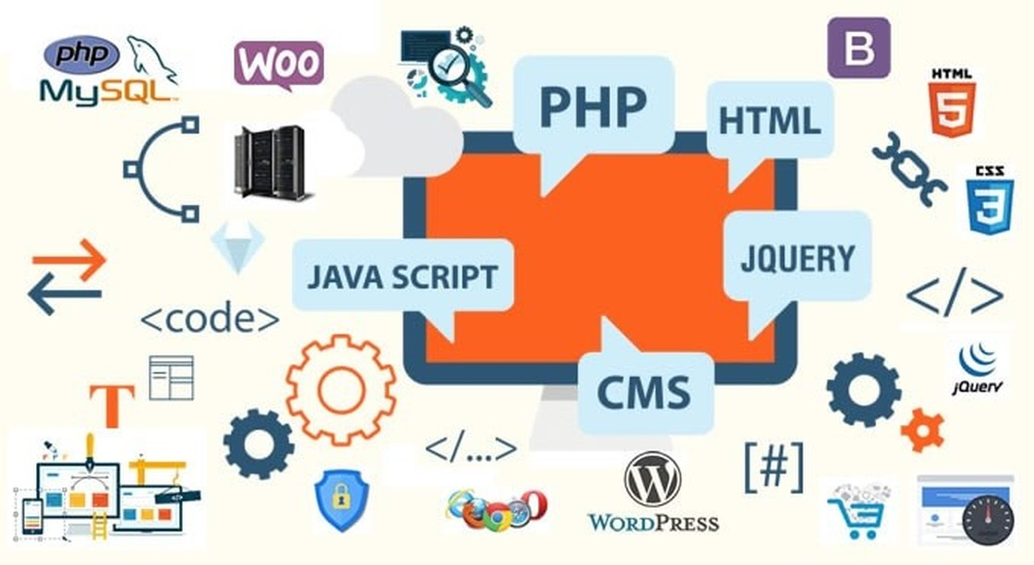
How we deliver software development
 | Digital Consultancy  Expert advisory services across digital domains, helping organisations plan and execute their technology strategy.

How we deliver digital consultancy
 | Real Estate Services  Fee- and contract-based real estate brokerage, management, and consultancy services.

How we deliver real estate services
 | Digital Currency Operations  Cryptocurrency-related activities conducted in full compliance with prevailing laws and regulations.

How we deliver digital currency operations
 | Information Services  Additional information service activities undertaken as they create value for our clients and partners.

How we deliver information services

FLAGSHIP PRODUCT: SMARTCLASS
SmartClass (smartclass.co.tz) is Makutano Digital's AI-powered learning platform, built specifically for Tanzanian students and aligned with the NECTA syllabus. Available on the web and as an iOS app, it gives students an AI tutor and parents real-time visibility into their child's progress.
- AI Tutor (Mwalimu AI) — instant, step-by-step answers in both English and Swahili
- Homework Scanner — solves math and science problems directly from a photo
- AI-generated quizzes and exams — unlimited practice aligned with the NECTA syllabus
- Virtual Physics Practicals — hands-on simulations (projectile motion, Ohm's Law, pendulums) accessible from any device
- Parent Dashboard — real-time progress tracking, goal-setting, and rewards across multiple children on one account
- AI Notes Generator, financial literacy lessons, and personalised career guidance

SmartClass — Virtual Physics Practicals in action

PROFESSIONAL CREDENTIALS & ACCREDITATIONS
[List company or team certifications here — e.g. professional accreditations, regulatory registrations, technology partner certifications (Microsoft, Google, AWS, etc.), or industry association memberships. Remove this section if not yet applicable.]

KEY MILESTONES & TRACK RECORD
A selection of initiatives reflecting our capability to deliver:
- Ilboru Alumni SACCOS — Core SACCOS System (CSS):
Developed the Core SACCOS System powering Ilboru Alumni SACCOS, a savings and credit cooperative founded by alumni of Ilboru Secondary School, Arusha. The system digitises the cooperative's full financial operations — democratic member governance, share and dividend management under the Cooperative Societies Act, a full audit trail, and bilingual (English & Kiswahili) support — built in line with the TCDC Guidelines on Acquisition or Developing a Core SACCOS System (October 2024) and aligned with Bank of Tanzania regulatory requirements.
- [Project/Client 1] — [Brief description of scope, outcome, and impact delivered]
- [Project/Client 2] — [Brief description of scope, outcome, and impact delivered]

LEADERSHIP PROFILES
Makutano Digital is led by a two-member executive team holding overall responsibility for strategy, operations, and client delivery.
[Full Name] — Chief Executive Officer (CEO)
Holds overall responsibility for the company's strategic direction, partnerships, and growth. Degree-qualified. [Add specific degree, institution, and years of experience.]
[Full Name] — Managing Director (MD)
Oversees day-to-day operations, service delivery, and client engagement across all business lines. Degree-qualified. [Add specific degree, institution, and years of experience.]

STRATEGIC PARTNERSHIPS
[List institutional partners, technology vendors, or collaborating organisations here. Remove this section if not yet applicable.]

GET IN TOUCH
Makutano Digital is ready to partner with you on your next digital initiative. Reach out to discuss how our team can support your goals.
Office Location | Makole, Dodoma, Tanzania
Phone | 0745 99 77 11
Email | info@makutano.co.tz
Website | www.makutano.co.tz

