One page – Offlined MSF-Dashboard deployment for ERUs – Typical folder tree

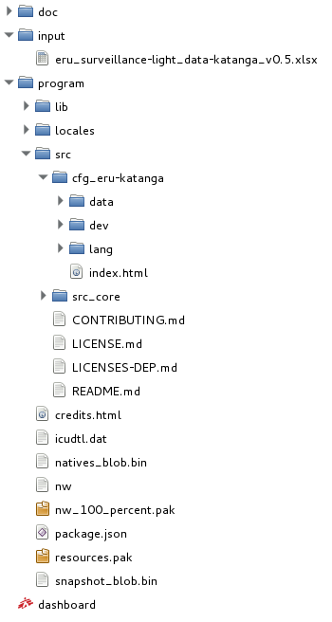  In Reality: | In concept:  ┌ doc  │  ├ input  │ └ [xlsx files]  │  │  ├ program  │ │  │ ├ [nwjs files]  │ │  │ │  │ ├ [package.json file]  │ │  │ │  │ └  src  │ │  │ │  │ ├  cfg_eru-xxx  │ │  │ │  │ │  │ │  │ │  │ └  src_core  │  │  └─ [dashboard shortcut] | In words:  - Where end user doc should be placed  - Where the dashboard takes inputs from (the .xlsx data file – use the template provided in the source files from github: /cfg_eru-xxx/inpu/)  - Folder where:  # The version of nwjs (http://nwjs.io/downloads/) corresponding to your OS should be unzipped.  LTS v0.14.6 is currently used for tests.  # The package.json file (originally in the source files from github: /cfg_eru-xxx/package.json) should be placed  - Where the source files from github (https://github.com/MSF-UK/MSF-Dashboard/releases) should be unzipped.  # The configuration files for your specific version of the dashboard to deploy, contains:  o data files (geojson and population, eventually extra layers)  o developer file (to define the dashboard content)  o language file (to parse text and translations)  o index file (to define the dashboard layout)  # The core source files, common to all dashboards as well as information files.  - The shortcut to run the dashboard (link to /program/nw.exe for windows versions of nwjs)

