Vanarsdel Monthly Business Insights Report for July 2024

Prepared By: Planning Agent in collaboration with CodingAgent and DataAnalystAgent

Report Date: January 28, 2025

# 1. Total Product Sales Performance by Category

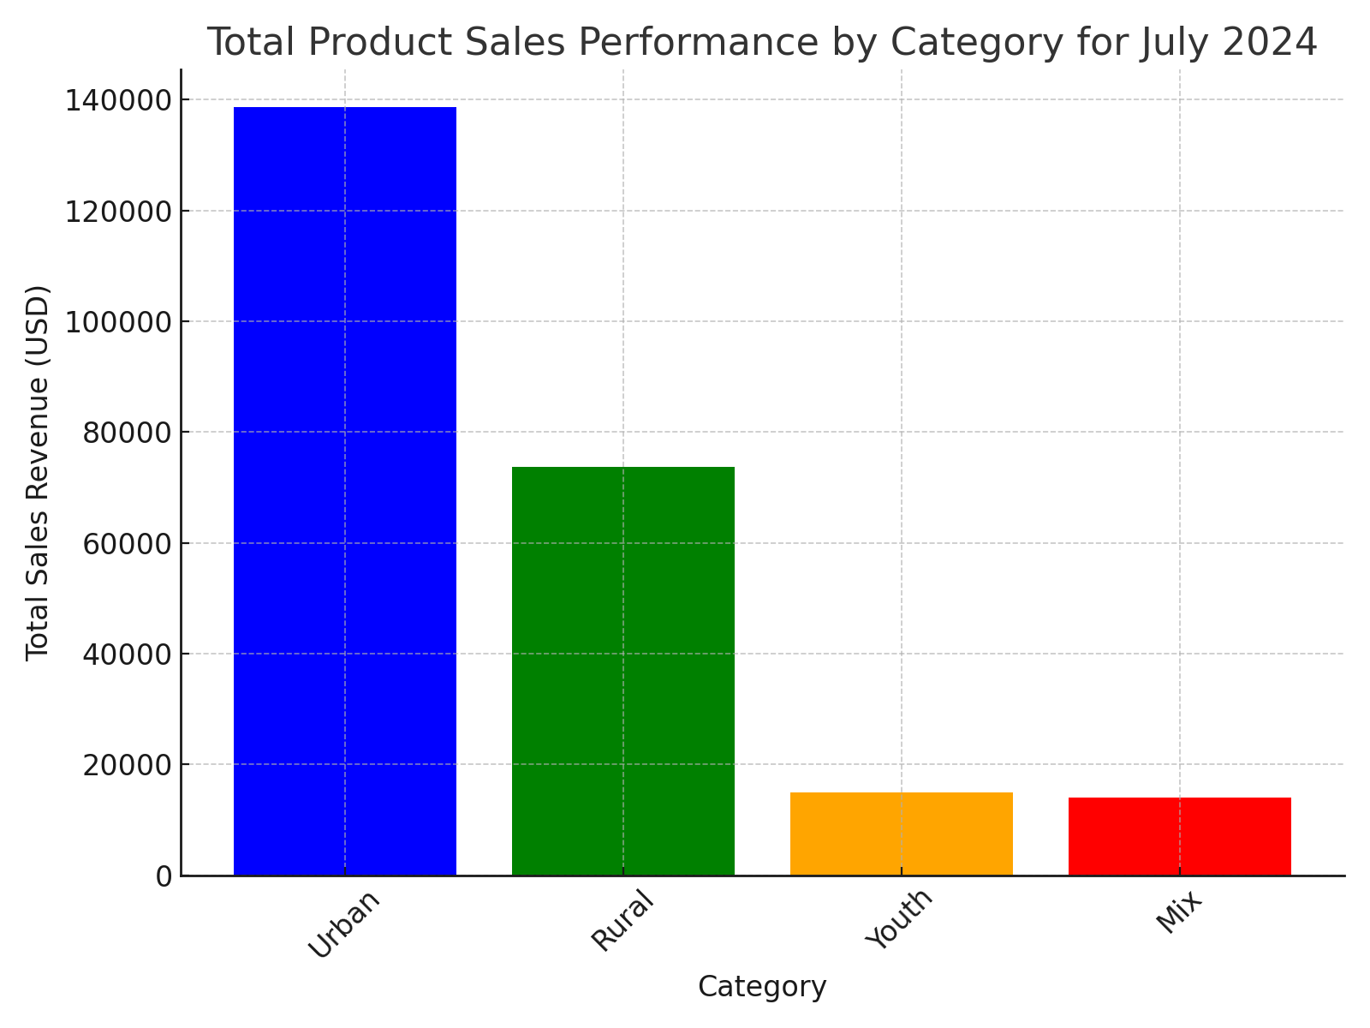

The chart above displays the total sales revenue for each product category for July 2024. The 'Urban' category has the highest sales revenue, followed by 'Rural', 'Youth', and 'Mix' categories. This indicates a stronger market presence and demand for Urban products during this month.

# 2. Total Product Sales by Category Comparison for July 2024 and June 2024

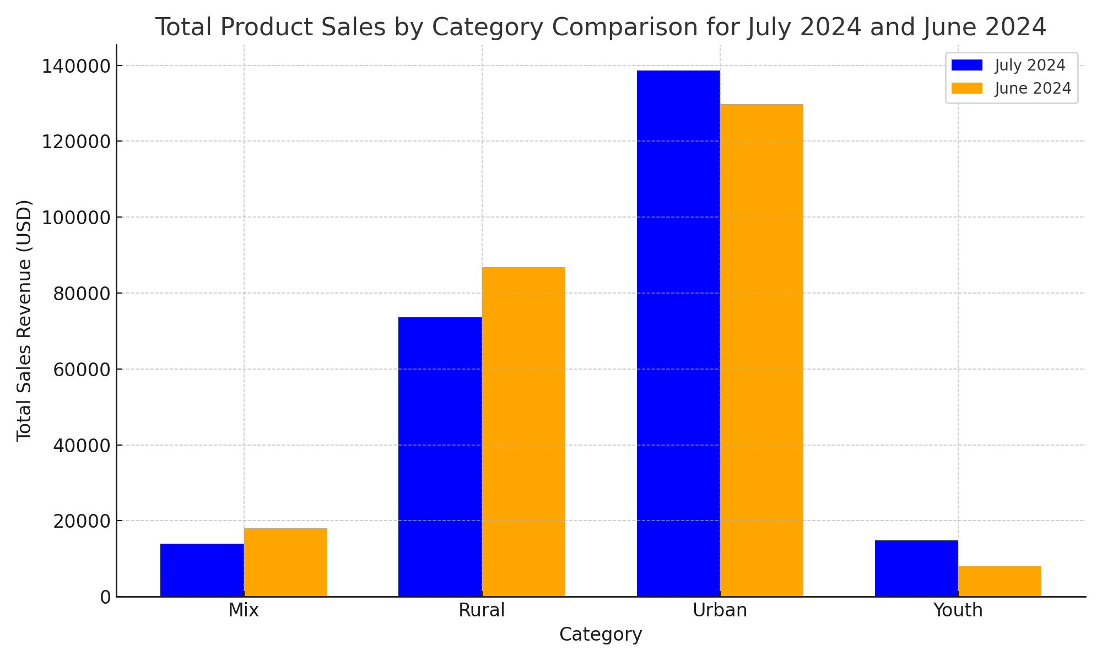

The chart compares total sales revenue by category for July 2024 versus June 2024. The 'Urban' category experienced an increase in sales from June to July, while 'Mix' and 'Rural' categories observed a decline. The 'Youth' category saw a significant increase in sales. Tracking such trends helps in optimizing inventory management and sales strategies.

# 3. Product Performance by Zip Code for July 2024

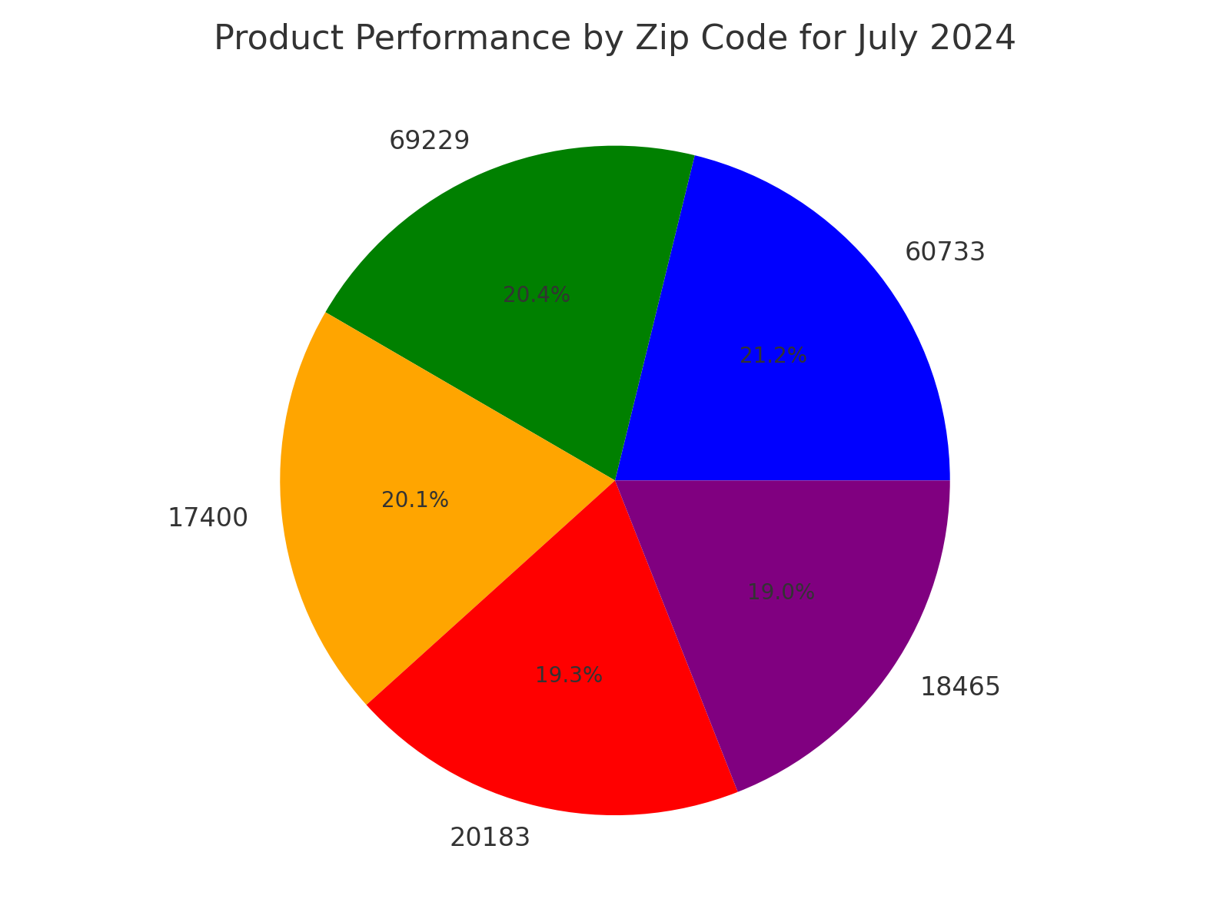

The pie chart highlights the top 5 zip codes by revenue for July 2024. Zip code 60733 generated the maximum revenue, followed closely by 69229, 17400, 20183, and 18465. Identifying and focusing on high-performing regions can enable targeted marketing and sales efforts to sustain and grow revenue.

# 4. Overall Summary & Conclusion

In summary, July 2024 saw strong performance in the 'Urban' product category, which also showed growth compared to June 2024. While some product categories like 'Mix' and 'Rural' experienced decreases in sales, 'Youth' saw a significant upward trend. Region-wise, zip code 60733 led the revenue charts, highlighting a potentially lucrative market. These insights can inform future business strategies and decision-making.