OMS Linux Agent & Container – Log Collector

Monday, May 29, 2017

**PROBLEM STATEMENT**

Our support and field are challenged with supporting Linux for Log Analytics and understanding the proper process for collection of logs for troubleshooting.  In some cases, they know part of the story and can collect “what they know and understand” but we are sometimes lacking the complete picture of log collection to help CSS in troubleshooting (as well as engineering) a customer issue.  While troubleshooting documentation has been created to guide a customer (or OMS supportability CSS engineer) on what to do and where to go, but it is still a bit of a “fishing” exercise.

**PROPOSED SOLUTION**

The troubleshooting document could be brought into a standard script to collect logs for the Linux agent for Log Analytics around specific solutions (such as Containers) or in general if these logs exist.  Ideally the solution would be comprised as a Python script (to support other initiatives in the OMS pipeline) and would zip the contents (“g-zipped” or otherwise for easy transport) to be made available in a common location “/tmp” to share with support when they are triaging an issue.  The end goal of this artifact is to leverage guidance from the OMS engineering team on what standard items need to be collected to ensure proper triage, reducing the amount of time to root cause analysis, and providing our customers a common framework for collecting logs.

**Supported Linux OS:**

* Linux OS and Version (All product supported Linux OS)
* Amazon Linux 2012.09 --> 2015.09 (x86/x64)
* CentOS Linux 5,6, and 7 (x86/x64)
* Oracle Linux 5,6, and 7 (x86/x64)
* Red Hat Enterprise Linux Server 5,6 and 7 (x86/x64)
* Debian GNU/Linux 6, 7, and 8 (x86/x64)
* Ubuntu 12.04 LTS, 14.04 LTS, 15.04, 15.10, 16.04 LTS (x86/x64)
* SUSE Linux Enterprise Server 11 and 12 (x86/x64)

**Supported OMS Linux Agent:**

* OMS Linux Agent Types supported:
* GitHub
* The OMS Agent for Linux is provided in a self-extracting and installable shell script bundle. This bundle contains Debian and RPM packages for each of the agent components and can be installed directly or extracted to retrieve the individual packages. One bundle is provided for x64 architectures and one for x86 architectures.
* Linux Extension
* For Windows and Linux computers, the recommended method for collecting logs and metrics is by installing the Log Analytics agent. The easiest way to install the Log Analytics agent on Azure virtual machines is through the Log Analytics VM Extension. Using the extension simplifies the installation process and automatically configures the agent to send data to the Log Analytics workspace that you specify. The agent is upgraded automatically, ensuring that you have the latest features and fixes. For Linux virtual machines, you enable the OMS Agent. For Linux virtual machine extension.
* Linux Container
* Containerized Linux agent or Linux Extension. Only one agent should be running at all time.

**Log Collector Installation Steps:**

* Download the tool (omslinux_agentlog.tgz from <https://github.com/Microsoft/OMS-Agent-for-Linux/blob/master/tools/LogCollector/download>) and copy to any directory of your choice
* Recommendation is to copy the tool to the user’s home directory (/home/user)
* Untar the archive file to extract OMS Log Collector source files

tar -xvzf omslinux_agentlog.tgz

* Make sure the following files are extracted successfully

omslinux_agentlog.sh

omslinux_agentlog.py

**Note**: You are ready to run the tool now to collect logs

**Log Collector Pre-requisites:**

* Make sure the target Linux server is installed with the following software:
* Python 2.6 and above
* OMS Linux Agent (From GitHub / Linux Extension / Linux Containers)

**Note**: You can use OMS Log collector to collect logs for both **failed and successful** install of OMS Linux Agent

**Log Collector Source File List:**

* omslinux_agentlog.sh

A shell script to check pre-requisites are installed and call the python script to start collecting logs and command outputs

* omslinux_agentlog.py

A python script to collect LOGS and COMMAND Line output for further troubleshooting

**Log Collector Execution Syntax:**

cd /home/<user>

sudo sh omslinux_agentlog.sh [-h] -s <SR Number> [-c <Company Name>]

Examples:

sudo sh omslinux_agentlog.sh -s SR1234567890 -c Contoso

or

sudo sh omslinux_agentlog.sh -s SR1234567890

**Note:**

The tool can be run directly using the python script: (optional)

sudo python omslinux_agentlog.py [-h] -s <SR Number> [-c <Company Name>]

Examples:

sudo python omslinux_agentlog.py -s SR1234567890 -c Contoso

or

sudo python omslinux_agentlog.py -s SR1234567890

**Log Collector Output Files and Directories:**

* All logs are saved under “/tmp/omslogs”
* The tool output is archived under below file name form under /tmp:

omslinuxagentlog-<SR Number>-<UTCDateTime>.tgz

Example:

omslinuxagentlog-SR1234567890-2017-06-14T11:57:01.599947.tgz

* Copy the above file and send it to MS Support for further troubleshooting

|  |  |  |
| --- | --- | --- |
| **OMS Linux Agent Type** | **Folders** | **Files / SubFolder** |
| GitHub | /tmp/omslogs |  |
| Linux Extension | /tmp/omslogs |  |
| /tmp/omslogs/extension |  |
| /tmp/omslogs/extension |  |
|  | /tmp/omslogs/vmagent |  |
| Linux Containers | /tmp/omslogs |  |
| /tmp/omslogs/container |  |

**Tested Linux OS:**

* Below is the list of OS tested for OMS Log Collector:
* CentOS Linux (x86/x64)
* Ubuntu (x86/x64)
* Red Hat Enterprise Linux Server (x86/x64)
* SUSE Linux Enterprise Server (x86/x64)
* Debian GNU/Linux (x86/x64)
* Oracle Linux (x86/x64)

**References:**

* Connect your Linux Computers to Operations Management Suite (OMS)

<https://docs.microsoft.com/en-us/azure/log-analytics/log-analytics-agent-linux>

* Troubleshooting Guide for OMS Agent for Linux

<https://github.com/Microsoft/OMS-Agent-for-Linux/blob/master/docs/Troubleshooting.md>

[https://github.com/Microsoft/OMS-Agent-for-Linux/blob/master/docs/Troubleshooting.md#installation-error-codes](https://github.com/Microsoft/OMS-Agent-for-Linux/blob/master/docs/Troubleshooting.md)

* Linux Extension troubleshooting:

[https://github.com/Azure/azure-linux-extensions/tree/master/OmsAgent#troubleshooting](https://github.com/Azure/azure-linux-extensions/tree/master/OmsAgent)

* Connect Azure virtual machines to Log Analytics with a Log Analytics agent

<https://docs.microsoft.com/en-us/azure/log-analytics/log-analytics-azure-vm-extension>

**APPENDIX:**

**Sample screenshot for OMS Linux Agent Output:**

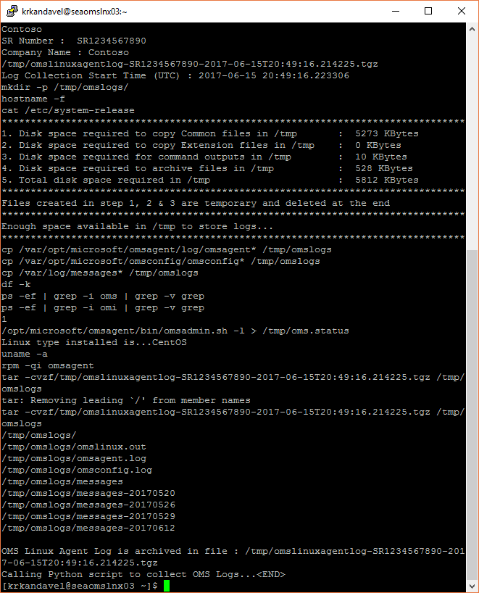

**Sample screenshot for OMS Linux Extension Output:**

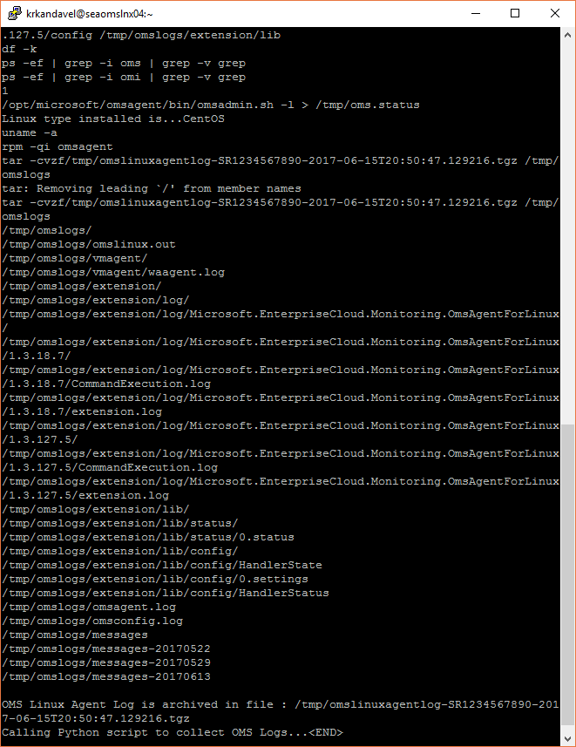

**Sample screenshot for OMS Linux Container Output:**

