Skill 14: Deploying a React Frontend Using Docker Hub and Kubernetes

This experiment consists of 5 steps as follows:

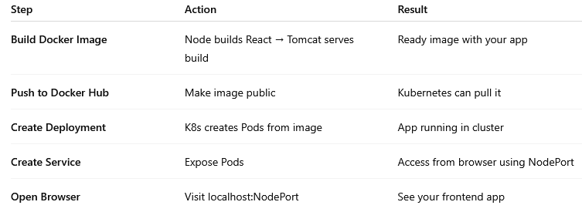

Step1: Build Docker Image for the frontend Project
Download the Docker files from the repository:
https://github.com/Likhithas6/kubernetes3.git
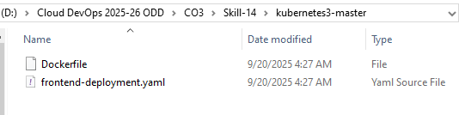
Verify the following code must present in the Docker file
In the following code, github url, no need to change, we can use it existing url directly or you may download, push into your github, and use your github url if you want.
# Step 1: Build stage (Node.js for React/Vite)
FROM node:18 AS build-stage
WORKDIR /app

# Install git to allow repo cloning
RUN apt-get update && apt-get install -y git

# Clone your frontend repo
RUN git clone https://github.com/srithars/s207-ecomm-frontend-docker.git .

RUN npm install
RUN npm run build

# Step 2: Runtime stage (Tomcat for serving)
FROM tomcat:9-jdk17
RUN rm -rf /usr/local/tomcat/webapps/*

# Copy React build output into Tomcat webapps
COPY --from=build-stage /app/dist /usr/local/tomcat/webapps/ecommerce

EXPOSE 8085
CMD ["catalina.sh", "run"]

Verify the following code must present in the “frontend-deployment.yaml” file
apiVersion: apps/v1
kind: Deployment
metadata:
name: frontend
spec:
replicas: 2
selector:
matchLabels:
app: frontend
template:
metadata:
labels:
app: frontend
spec:
containers:
- name: frontend
image: kodavalilakshminarayana/skill14:v1 # ✅ Your image
ports:
- containerPort: 8080 # ✅ Must match app’s internal port
---
apiVersion: v1
kind: Service
metadata:
name: frontend
spec:
type: NodePort
ports:
- port: 8085 # Cluster port
targetPort: 8080 # Container port
nodePort: 30083 # Accessible via http://localhost:30083
selector:
app: frontend

Open the Docker Desktop, and click on the 9 dots which is present top right corner.
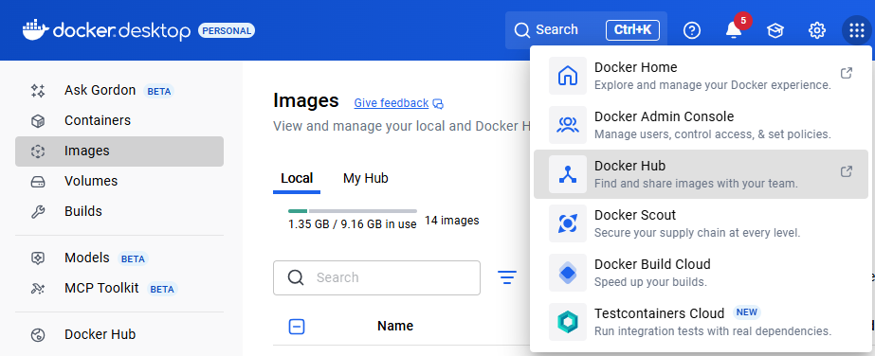
Click on the “Docker Hub”.
SignIn to “Docker Hub” .
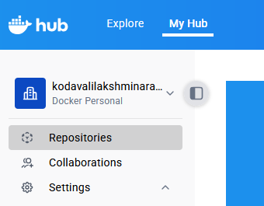

Click on “Repositories” “Create a Repository” Button to create a repository.
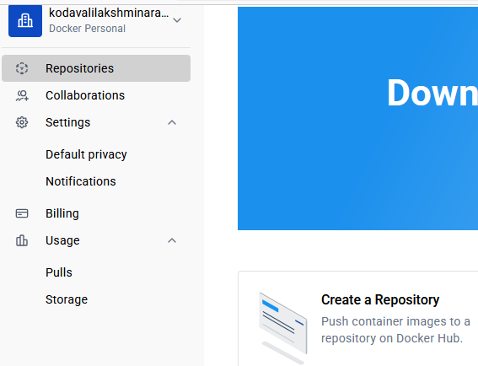
Enter Repository Name as your wish (skill14) and click on “Create” Button
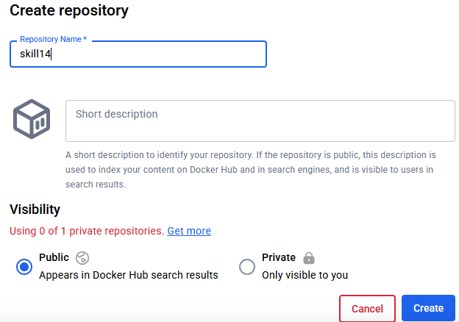
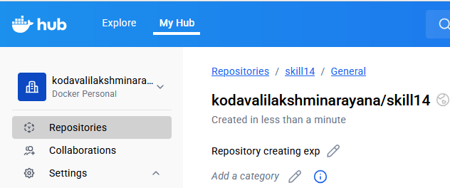
Open Source Code In VS code

In the “frontend-deployment.yaml” file modify the Image name (srithar123) with your docker username in the 17th line as follows.

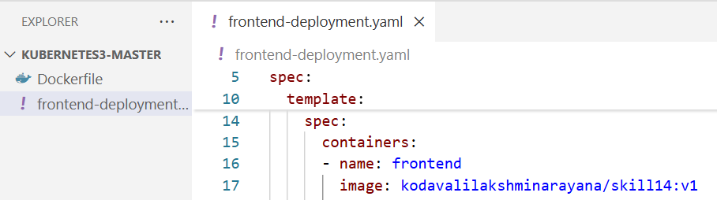

Run The Following Command in the VS Code command prompt:

Note: You must be present in to the folder where the Dockerfile and Yaml files are present to execute the following commands as shown in the above screen shot.

Note: In the below commands, replace the usernamexxx with your docker user name, and dot(.) must be required at the end of the command.

>> docker build -t usernamexxx/skill14:v1 .

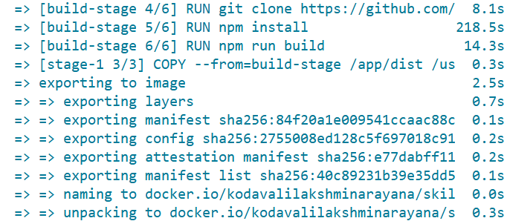

Frontend Image and Containers were created, you can verify in the Docker Desktop as follows:
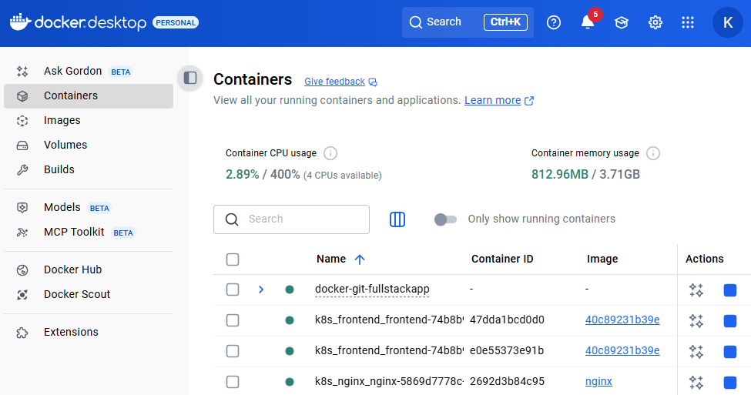

Step2: Push into Docker Hub

>> docker push usernamexxx/skill14:v1

Step3 and Step4: Creating Deployment and Service
Now To Get The Output Through Kubernetes

>> kubectl apply -f frontend-deployment.yaml
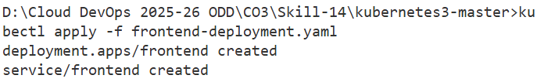

>> kubectl get pods
>> kubectl get svc

//OPTIONAL
>> kubectl get pods
>>kubectl logs <pod-name>

For Example Pod Name We Get After Running Get Pods Command
>> kubectl logs frontend-7b4ddbf5cf-bfssj →POD NAME

Step5: Accessing the Service externally.
//OUTPUT (Type In the browser: http://localhost:30083 )

