Vivekanand Pandey, Team

Microsoft

A WP7 & 8 and Windows 8 App



Table of Contents

**Introduction** 2

Home Page 2

***Settings*** 3

***Locate*** 5

***TrackMe*** 6

SOS Portal (Futuristic) 7

# **Introduction**

With a steep rise in criminal cases in the country, there has been renewed concern over the safety of women like never before. In the current scenario there is a need for proactive safety measures for women and kids which would make them feel safer. Since mobile phones have become ubiquitous these days, they are the best tools be used for security. Creating a WP App which would enable them to send distress signals when they feel threatened or are in need would be a clear deterrent for such incidents. With the advent of advanced mobile handsets and powerful mobile OS like WP8/7.8, creating such an app which provides for tracking, locating, sending distress signals and additionally record evidences are things of reality.

There are already such apps (paid/free) available for other mobile platform’s app-stores:

1. FightBack (Android, Blackberry)
2. Safe (Android, iOS and BlackBerry phones and tablets)
3. Life 360 Family Locator ([Android](http://timesofindia.indiatimes.com/topic/Android) as well as non-smartphones.)
4. Circle of 6 (iOS)
5. SOS Whistle (Android)

The app described here would be a good app in Windows Phone AppStore arsenal which would additionally drive the usability and sales of Windows Phones. It uses the complete ecosystem of Microsoft products (WP, SkyDrive, Bing Maps, and Windows 8 App (futuristic)) which would be a good showcase of how MS Technologies touch everyday lives.

**Design**

## Home Page

Home page for the App would be a Panorama page. The Home panel of the panorama would contain 3 buttons:

1. TrackMe
2. Settings
3. Locate

Panorama pages are typically like this:

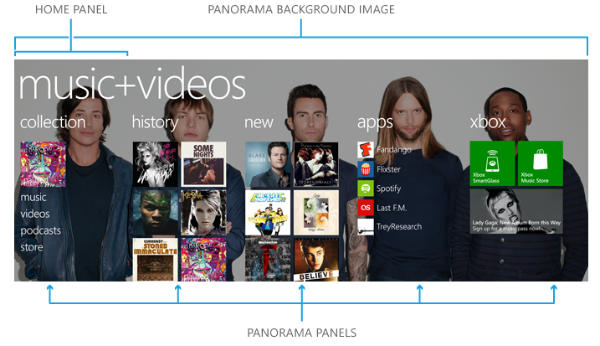

Below is a sample design for the Panorama page of the app.

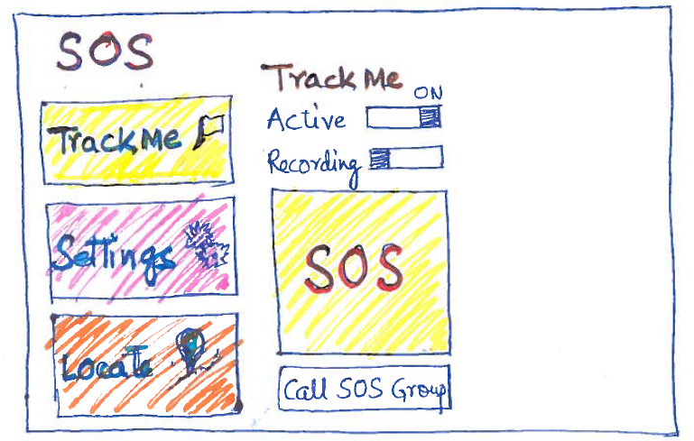

For the purpose of better understanding, let’s start with settings first:

### ***Settings***

This would be a pivot page having three tabs like shown below:

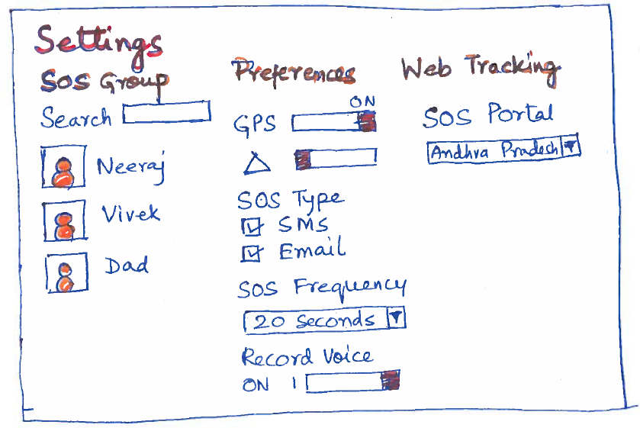

**First tab** of the settings page would be for managing a SOS Group from your contacts, who can quickly react to your distress signal and would help you in any such scenario. This could be family or friends.

**Second tab** would be to save the preferences on how the tracking should be done. The user would be having two choices for tracking:

1. **GPS**: These days most of the WP handsets come with GPS and data plans are also cheap. In such cases users can activate this mode and while the phone would be tracked, the exact Longitude-Latitude information would keep getting tracked.
2. **Cell Phone Triangulation**: In a best-case-scenario, a cell phone’s signal may be picked up by three or more cell towers, enabling the “[triangulation](http://en.wikipedia.org/wiki/Triangulation)” to work. From a geometric/mathematical standpoint, if you have the distance to an item from each of three distinct points, you can compute the approximate location of that item in relation to the three reference points. This geometric calculation applies in the case of cell phones, since we know the locations of the cell towers which receive the phone’s signal, and we can estimate the distance of the phone from each of those antennae towers, based upon the lag time between when the tower sends a ping to the phone and receives the answering ping back.

**References:**

1. <http://searchengineland.com/cell-phone-triangulation-accuracy-is-all-over-the-map-14790>
2. <http://pursuitmag.com/locating-mobile-phones-through-pinging-and-triangulation/>

It would additionally mention what would be the preferred mode of the SOS, whether it would be SMS, Email or both.

The last option for this screen would be allow voice-recording in case of distress, which would be uploaded on the SkyDrive for the user. Since recording voice and uploading to SkyDrive would need a Data plan and would be consuming a lot of bandwidth which can mean cost to the user, this option is kept as configurable and would be turned on by default in case user is on a data plan (having an internet connection enabled on phone).

**Third Tab** would be for the Web Tracking (**SOS Portal**) which Law/reinforcement agencies can use. This tab would talk about one endpoint where the mobile can keep sending signals. This would be in addition to the signals/messages sent to the SOS Group in first tab. The idea is to have one such site having a sub-site for every state in India. There would be a Windows 8 App created which would track it in a portal which should be monitored by an agency who can flag to the Police in case of a distress signal, or better still, can be monitored by state Police cell directly.

### 

### ***Locate***

People who are added in a SOS group can use this option to track as many phone movements. Clicking this would again open a Pivot page.

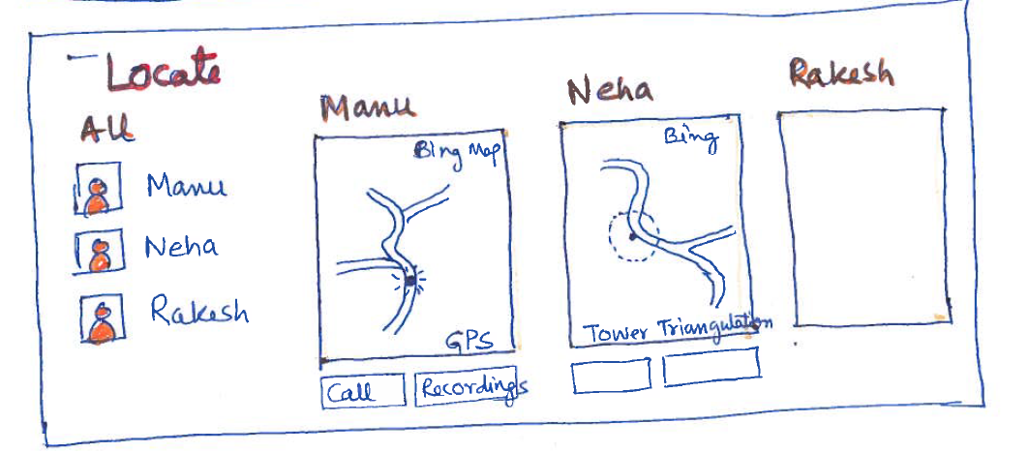

**The first tab** of the pivot page would show all the phones which are being tracked based on the SOS Groups the receiver has been added into. Clicking on any of the tracked contacts would take you to a new tab where you could see the tracked mobile’s position being plotted in Bing Maps. This would be updated real-time based on the movement of the tracked device. The receiver would be having a call button to call the tracked mobile from this screen.

There would be as many dynamic tabs in this Pivot page based on the tracked contacts for the receiver. If the user is additionally receiving this in email, based on the setting on the device, he would be able to track the device by logging into the SOS Portal.

### ***TrackMe***

This is the most important panel of the App Panorama. When user would click the TrackMe button in the home panel of the app, control will move to the second panel of the Panorama and SOS App would get into being tracked mode.

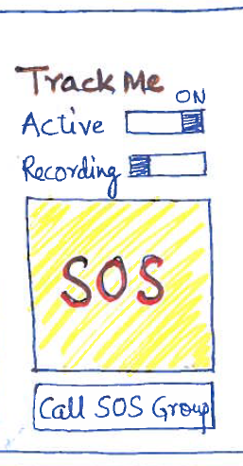

The Active mode for the app would be turned on and it would start sending tracking signals to its SOS Group and SOS portal. The app would continue to run in the background under screen lock and keep sending the location of the device.

There would be one additional toggle button on this screen to start voice recording in case of distress. This option would get enabled only when the user has not turned-off this feature. When turned-on, the phone would additionally start recording voice in short bursts of 30 seconds and will keep pushing it in a designated folder in SkyDrive so that they would be available at regular intervals to the users tracking the device. This option can be used to additionally record evidences when the user is expecting a situation when an alarm should be raised.

The SOS button occupying most of the screen area should be pressed when a distress signal is to be raised. It would do the below things:

1. **Turn-on the voice recording,** if it is not already turned on (provided you are on a data plan and connected to internet).
2. **Start sending messages/mails** (as configured in settings) to the users in the SOS Group every n seconds (configurable), till the user calls back on the number from where SOS is being sent.

“SOS. Track me: <Tracking URL>”

Clicking on the Tracking URL on phone would take user on the Tracker page for the distressed mobile user. From a Windows 8 PC, it would open the SOS Portal and show the details. Users would be able to hear the voice recordings too recorded from the mobile and shared on the SkyDrive of the distressed mobile user.

1. **Start sending SOS/Distress signals to the SOS Portal** for the state, as configured for the user and the Police/reinforcement agency can quickly rush for help based on the Longitude-Latitude of the device.

In case subscriber is not on an Internet connection, the app would continue to send SOS messages at the desired frequency with device coordinates but tracking would not be possible.

This app would keep running in the background even when the screen is locked and when the screen would be un-locked this app would take precedence and show-up. We have to find the possibility to Activate the distress signal by a voice command or by entering a emergency number with a locked screen too.

## SOS Portal (Futuristic)

This portal would be monitored by the Law/reinforcement agencies, who can track the individual mobiles within their circles who have activated their tracking. Having a look at this dashboard, the agency can respond to the distressed people faster and with more accuracy.

