OpenRIMS Release Notes 2023-01-06

Contents

Motivation 1

Bugs fixed 1

Improvements 1

Documentation changes 4

Messages that should be defined 4

Disclaimer 4

# Motivation

The Redmine issues. Most of them are related to simplifying and improving Supervisor’s functionality. The rest are documentation related.

# Bugs fixed

none

# Improvements

<https://redmine.openrims.org/issues/1597> Remove outdated components

Outdated components PersonsList, PersonsSelected, and Amendment have been removed.

<https://redmine.openrims.org/issues/1594>. Access to instant reports.

The new access rules have been implemented:

* Non-logged-in users should access only the plain table (see note below)
* Applicant users should access only to own applications
* A user from NMRA can open details only to applications for which at least one activity is potentially assigned to it

**Important note.**

**Despite it is possible, it is not a good idea to provide instant reports to not-logged-in users. They don’t need real-time data. It will be a good idea to use Google Data Studio instead.**

<https://redmine.openrims.org/issues/1585>. Inspect new messages and, then, add them to Anarme

From this release, all messages/labels will be resolved in the Anarme database. Added 137 lost messages to the resource_messages database table.

<https://redmine.openrims.org/issues/1570>. QA workflow configuration validation - class specific

The data configuration feature is complex and cumbersome. To help the Supervisor perform the data configuration task, the following new features have been added:

* The validation feature will recognize mandatory fields, depending on the variable type. It is impossible to save a variable configuration with not-filled mandatory fields.
* The instant help feature allows one to find out mandatory fields before saving
* The help feature allows you to get the Date Configuration Deference document. From this release, the appropriate version of it will be included in the software.

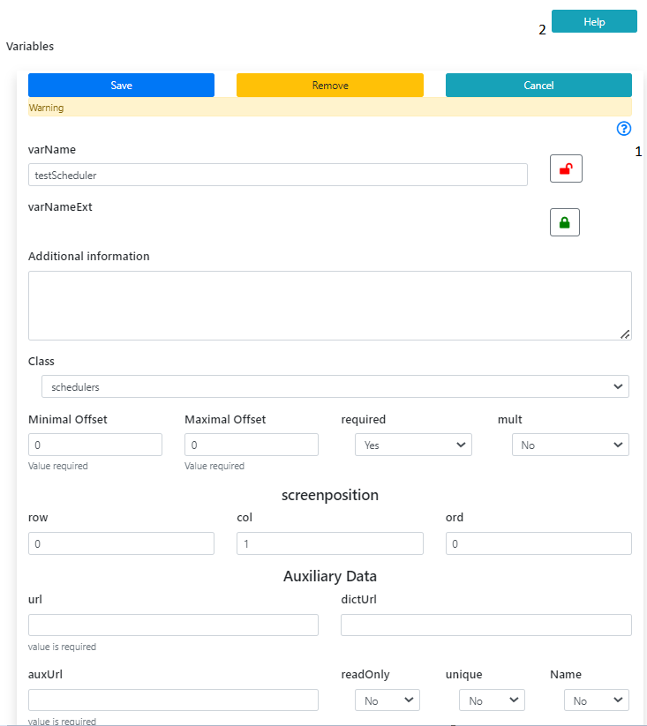

Figure 1 Variable configuration 1- Instant Help, 2 Get the Manual

<https://redmine.openrims.org/issues/1582>. Export/import a dictionary level to/from Excel

This new feature will automate such use cases:

* Translate dictionary data to the local language
* Create a memo or similar document to approve dictionary content
* Fill out the dictionary from any external source, for instance, dosage forms from <https://build.fhir.org/valueset-medication-form-codes.html>.

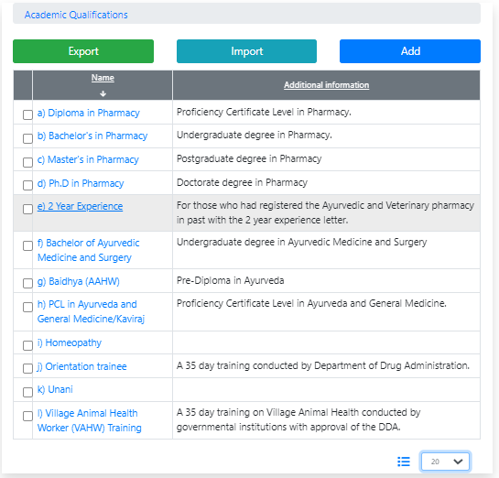

Figure 2 Export and Import features in a dictionary are available only for the Supervisor

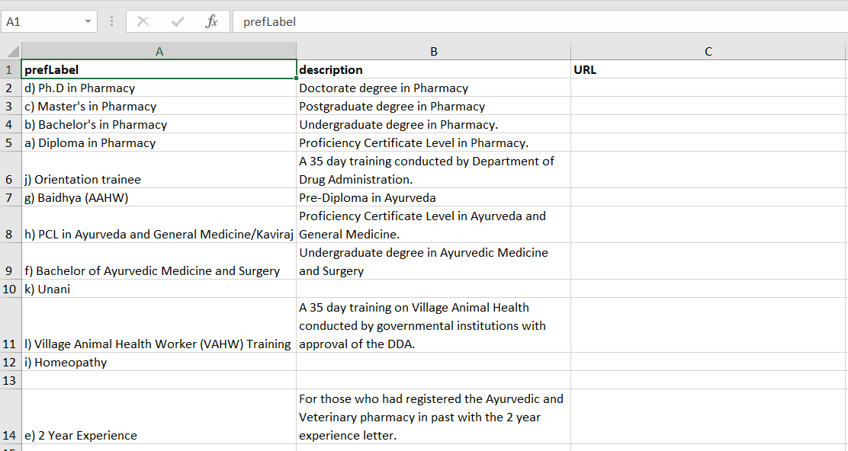

Figure 3 It is recommended to use the Export result as a template for Import

**Please note,**

1. **The feature intends to export/import a current level of a dictionary in the current language.**
2. **If the same “prefLabel” value already exists at the level of a dictionary, the new record will not be added to a dictionary, however, the rest of the fields in the existing record will be replaced.**
3. **An empty line will not be imported**
4. **The non-printable characters will be stripped**

# Documentation changes

<https://redmine.openrims.org/issues/1592> Design specification for the etalon database that will be shared using GitHub

This record contains the attachment “Automation of permission procedures using OpenRIMS.docx” This document contains proposals for examples and wording.

# Messages that should be defined

| **Key** | **Meaning** | **Usage** |
| --- | --- | --- |
| global_import_short | Import | For general import. Known usage – dictionary-level import |
| global_export_short | Export | For general export. Known usage – dictionary-level export |
| warningNMRA | You are not the executor of this application | Open application details by a wrong NMRA employee |
| errorNMRA | NMRA can’t access the application | Open application details, bad application |
| headerImport | Import a level | Dictionary import – file uploader form |
| notReqCols | Column prefLabel is not defined in the Excel import | Dictionary import |

# Disclaimer

All new and improved features have been tested against the particular testing examples.

Thus, this release may contain errors, bad user interface behavior, and inconsistencies. Please, report them to [alex.kurasoff@gmail.com](mailto:alex.kurasoff@gmail.com).