OpenRIMS Release Notes 2023-01-20

Contents

Motivation 1

Bugs fixed 1

Improvements 1

Experemental feature 1

Documentation changes 2

Messages that should be defined 2

Disclaimer 3

# Motivation

Mainly documentation development and GraphQL experimental feature

# Bugs fixed

none

# Improvements

<https://redmine.openrims.org/issues/1593> Date format issue. Unfortunately for locale ne_NP browsers vendors provide the wrong date format. Fixed by a patch.

# Experimental feature

The GraphQL showcase has been implemented. The example gets all registered pharmacies. Will work only on the Nepal database.

To use it:

1. Log in as a guest (applicant)
2. In the site URL replace “guest” to “graphiql”, e.g.:
   * 1. was: <http://pdx2demo.ddanet.org/guest>
     2. should be <http://pdx2demo.ddanet.org/graphiql>
3. Copy the query below to the right screen
4. Start the query (the query below suits only pdx2demo, any other “url” may be different)

query{

loadReportPages(lang:"EN_US", url:"pharmacy.registration", district:null, pharmtype:null){

lang

url

pharmacy

district

address

pharmtype

registerNo

registered

expired

owners

pharmacists

}

}

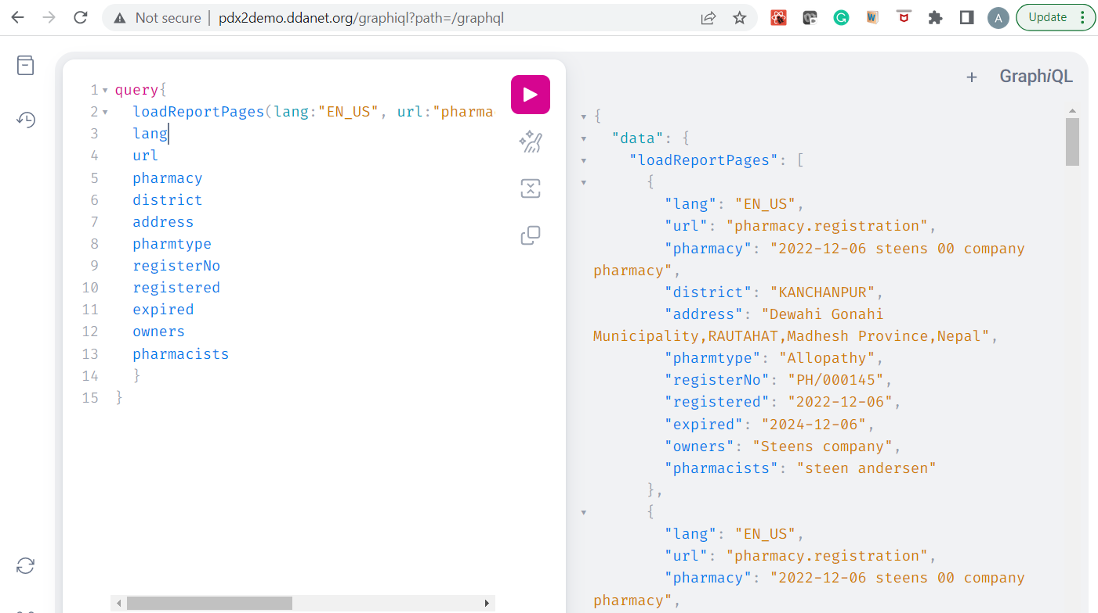

Figure GraphQL showcase

# Documentation changes

<https://redmine.openrims.org/documents/129> completely rewritten

# Messages that should be defined

| **Key** | **Meaning** | **Usage** |
| --- | --- | --- |
|  |  |  |

# Disclaimer

All new and improved features have been tested against the particular testing examples.

Thus, this release may contain errors, bad user interface behavior, and inconsistencies. Please, report them to [alex.kurasoff@gmail.com](mailto:alex.kurasoff@gmail.com).