OpenRIMS Release Notes 2023-02-10

Contents

Motivation 1

Bugs fixed 1

Improvements 1

Branch office EL. 1

Transferring definitions of collaboration from the Sandbox to the Production 2

Documentation changes 2

Messages that should be defined 3

Disclaimer 3

# Motivation

The main goal of this release is the “transfer data configuration” feature. Also:

The new @office convertor to address EL has been implemented. It allows inserting in the document the name of the NMRA branch office that serves a particular address

# Bugs fixed

None

# Improvements

## Branch office EL.

https://redmine.openrims.org/issues/1614

For any address that is defined in the application, it is possible to get the name of the NMRA office that serves this address. For example

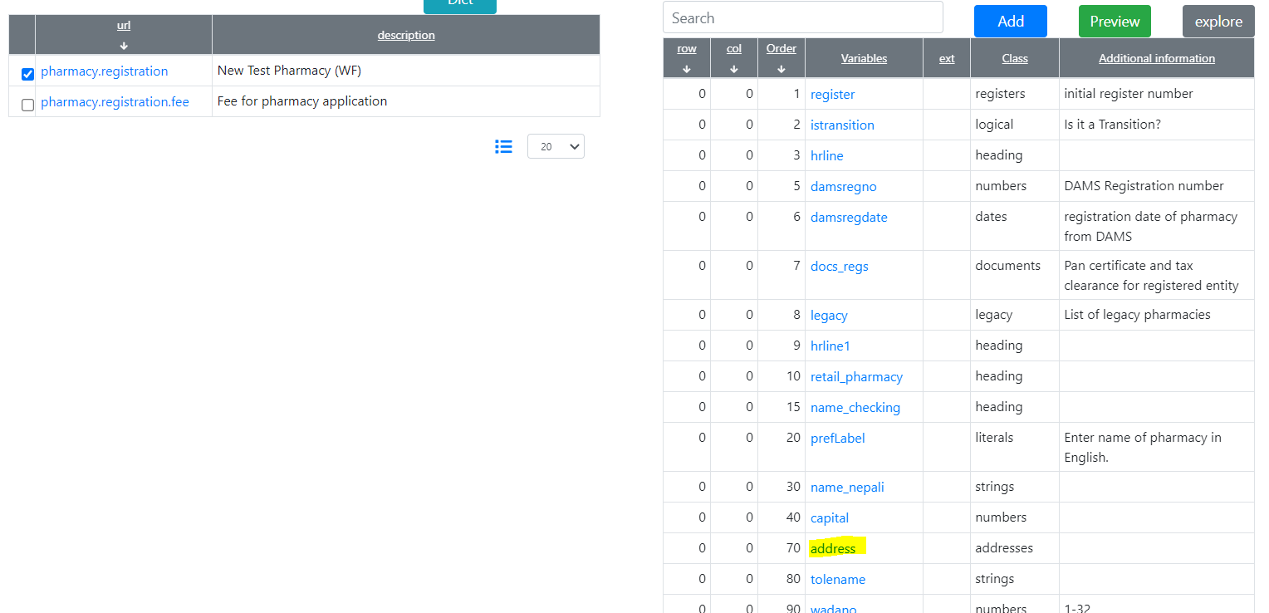

Figure Pharmacy address path is “/address”

The EL expression to get an NMRA office will be ${/address@office}

Please note. The detailed EL Expression Guide is under the approval and will be added to the next release of the software. For current, please use the “HowTo” from here https://redmine.openrims.org/documents/77

## Transferring definitions of collaboration from the Sandbox to the Production

<https://redmine.openrims.org/issues/1600>

The transferring of the collaboration definition consists of two steps :

• Export from the Sandbox

• Import into the Production

The export/import data format is Office Open XML Spreadsheet or XLSX.

It should be noted, that the fully automated transfer seems not a good idea because of the complexity and possible variations of collaboration definitions

The implementation process is scheduled for 3 releases. This document https://redmine.openrims.org/documents/185 reflects its current status.

# Documentation changes

The new HowTO document “Address related EL expressions. HowTo” has been added to the Redmine (<https://redmine.openrims.org/documents/77>)

The new HowTO document “Transferring definitions of collaboration from the sandbox to the production. How To?” has been added to the Redmine (https://redmine.openrims.org/documents/185)

# Messages that should be defined

None

| **Key** | **Meaning** | **Usage** |
| --- | --- | --- |
|  |  |  |
|  |  |  |
|  |  |  |
|  |  |  |
|  |  |  |
|  |  |  |
|  |  |  |
|  |  |  |

# Disclaimer

All new and improved features have been tested against the particular testing examples.

Thus, this release may contain errors, bad user interface behavior, and inconsistencies. Please, report them to [alex.kurasoff@gmail.com](mailto:alex.kurasoff@gmail.com).