OpenRIMS Release Notes 2023-02-17

Contents

Motivation 1

Bugs fixed 1

Improvements 1

Documentation changes 2

Messages that should be defined 2

Disclaimer 3

# Motivation

The goals of this release are:

* Revising the existing EL expressions and creating new improved EL manual
* Improving the existing Administrative Unit Import feature
* The data access control became a more granular

# Bugs fixed

The “picture size” data validation sometimes disabled the import of configuration. Fixed in the code.

<https://redmine.openrims.org/issues/1635>. From this release, it will be possible to re-use the dictionary for many resources.

<https://redmine.openrims.org/issues/1621> The Google Maps coordinates can be copied directly.

# Improvements

<https://redmine.openrims.org/issues/1631>. Allow hiding from an applicant checklist, documents, and dictionaries filled out by NMRA staff. The following releases will add these features to the rest of the components. See <https://redmine.openrims.org/documents/188> for details.

<https://redmine.openrims.org/issues/1633>. The Administrative Units import feature now allows the zoom parameter. Before this, this parameter was hard coded. See the improved document <https://redmine.openrims.org/documents/146> for details.

# Documentation changes

Administrative units’ data import template and help document have been improved. These files can be found below

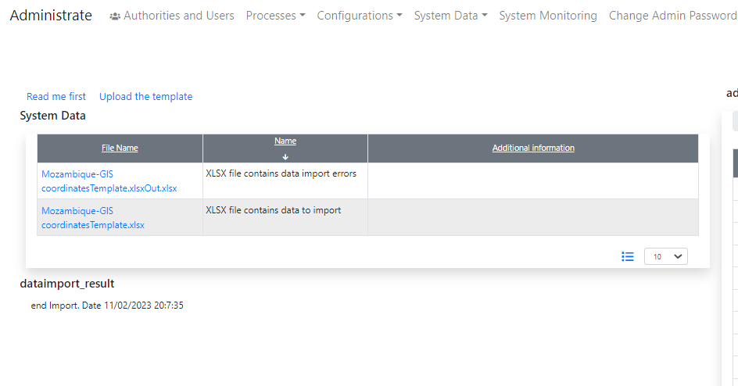

Figure Links "Read me first" and "Upload the template"

Or here https://redmine.openrims.org/documents/146.

The new document “Creation of printable electronic documents in OpenRIMS” is available here <https://redmine.openrims.org/documents/187>. This manual consists of detailed examples and a template creation reference guide.

In the next release, the actual version of this document will be available in form of electronic help.

The new document “How to hide application review data from an applicant.docx” is available here <https://redmine.openrims.org/documents/188>

# Messages that should be defined

None

| **Key** | **Meaning** | **Usage** |
| --- | --- | --- |
| hidechecklist | Hide checklist from Applicant | Activity configuration |
| hidefromapplicant | Hide data from an Applicant | Assembly |

# Disclaimer

All new and improved features have been tested against the particular testing examples.

Thus, this release may contain errors, bad user interface behavior, and inconsistencies. Please, report them to [alex.kurasoff@gmail.com](mailto:alex.kurasoff@gmail.com).