OpenRIMS Release Notes 2023-02-27

Contents

Motivation 1

Bugs fixed 1

Improvements 1

Documentation changes 3

Messages that should be defined 3

Disclaimer 3

# Motivation

The goal of this release is new EL expressions that are collecting data from the current NMRA workflow.

Additionally:

* e-help for EL expressions has been extended and uploaded as a part of the application
* e-help for dictionaries has been created and uploaded as a part of the application

# Bugs fixed

Extra empty lines while dictionary export

# Improvements

In addition to the existing @{/..} and {this/…} EL expressions data sources, the new [${process/activity_url/variable@...}](mailto:$%7bprocess/activity_url/variable@...%7d) data source has been introduced.

Details and usage are available in e-help

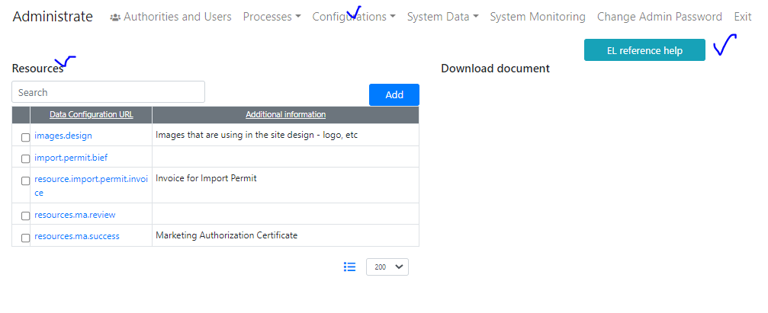

Figure new e-help is available for a Supervisor on the Administrate-Configuration-Resources page

Dictionary management became complex, because of dictionary quantity and the necessity to maintain dictionaries provided along with the software. To simplify this task, new e-help has been introduced:

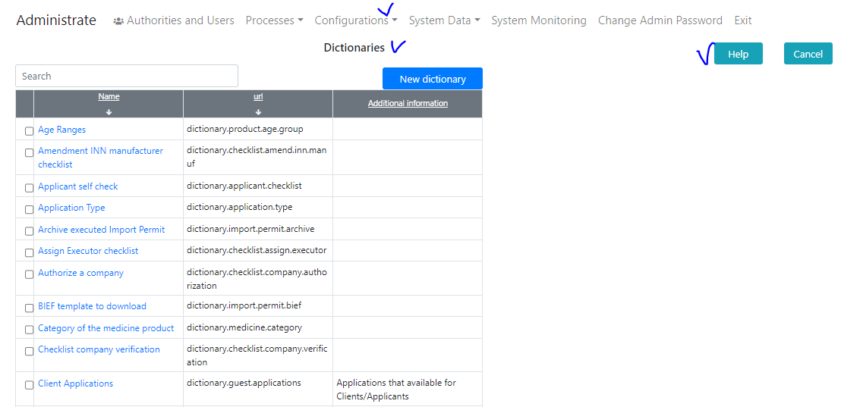

Figure The e-help is available for a Supervisor on the Administrate-Configurations-Dictionaries page

# Documentation changes

|  |  |  |  |
| --- | --- | --- | --- |
| **Document** | **Status** | **Redmine address** | **Wiki Address** |
| OpenRIMS Dictionaries creation/maintenance manual | New | https://redmine.openrims.org/issues/1641 |  |
| Creation of printable electronic documents in OpenRIMS | Improved | https://redmine.openrims.org/documents/187 |  |

# Messages that should be defined

None

| **Key** | **Meaning** | **Usage** |
| --- | --- | --- |
| global_elreference | EL reference help | Resource definition page |
|  |  |  |

# Disclaimer

All new and improved features have been tested against the particular testing examples.

Thus, this release may contain errors, bad user interface behavior, and inconsistencies. Please, report them to [alex.kurasoff@gmail.com](mailto:alex.kurasoff@gmail.com).