OpenRIMS Release Notes 2023-03-06

Contents

Motivation 1

Bugs fixed 1

Improvements 2

Documentation changes 2

Messages that should be defined 3

Disclaimer 3

# Motivation

The goal of this release is resolving of various issues related to the concurrent activities in the collaboration

Issue # 1644. The duplicated activities will not be created after each concurrent activity.

Issue # 1645. The software has been improved to reduce the time to open electronic forms for workflow execution and workflow configuration

Issue 1649. In case of re-assigning an activity to multiple executors, the notes and activity data will be kept for the first new executor.

Additionally:

Issue # 1647. From this release for Guest and Host workflows, at least one follow-up workflow is mandatory. It is necessary to avoid “lost” processes.

Issue # 1638. Literals, dates, and strings may be hidden from an applicant as well as documents and dictionaries. Will be reflected in the e-help and the next release

Issue # 1630. The Administrate menu items have been re-organized as required

# Bugs fixed

None

# Improvements

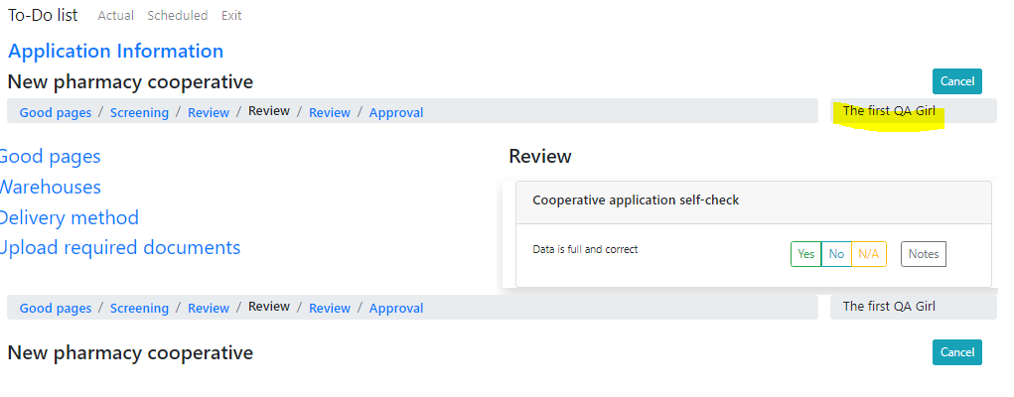

Figure The executor name is shown for the workflow activities

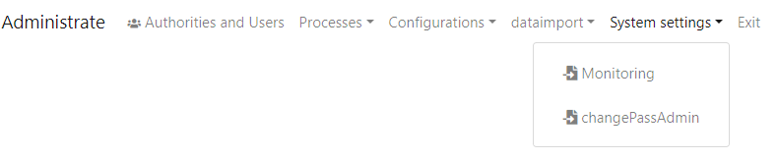

Figure New Administrate menu

# Documentation changes

|  |  |  |  |
| --- | --- | --- | --- |
| **Document** | **Status** | **Redmine address** | **Wiki Address** |
| Electronic form definition reference guide.docx | Changed | https://redmine.openrims.org/documents/129 |  |
|  |  |  |  |

# Messages that should be defined

| **Key** | **Meaning** | **Usage** |
| --- | --- | --- |
| scheduled_requerd | Application configuration error. At least one scheduled follow-up action is required | Finalize Guest or Host application |
| application_nextEv | Scheduled actions | Application information second table |
| systemsetting | System settings | Administrate main menu |

# Disclaimer

All new and improved features have been tested against the particular testing examples.

Thus, this release may contain errors, bad user interface behavior, and inconsistencies. Please, report them to [alex.kurasoff@gmail.com](mailto:alex.kurasoff@gmail.com).