OpenRIMS Release Notes 2023-03-20

Contents

Motivation 1

Bugs fixed 1

Improvements 2

The printable receipt 2

The submissions dashboard 2

Completed and scheduled activities 3

Clickable NMRA Logo 3

Workflow definitions export and import 4

Documentation changes 4

Messages that should be defined 4

Disclaimer 4

# Motivation

The main motivation is improvements in user experience:

* An applicant gets a printable receipt after application submission. This receipt contains necessary reference data. Such user experience practice is inspired by e-banking user experience features.
* All applicant’s submissions can be found in a single submission dashboard (Applications-New Applications)
* The application history data is split up between completed and scheduled. The usage of the application history is sufficiently simplified.
* It is possible to assign an HTTP(s) link to the NMRA logo, regardless of the NMRA logo picture format.

Also, the import collaboration process definition from the MS Excel file has been implemented

# Bugs fixed

Before this release, it was possible to submit an already submitted application. Despite it being disabled on the User Interface level, it was possible to do it manually. From the current release, it is disabled on the service level.

# Improvements

## The printable receipt

After new application submission, an applicant receives a printable receipt

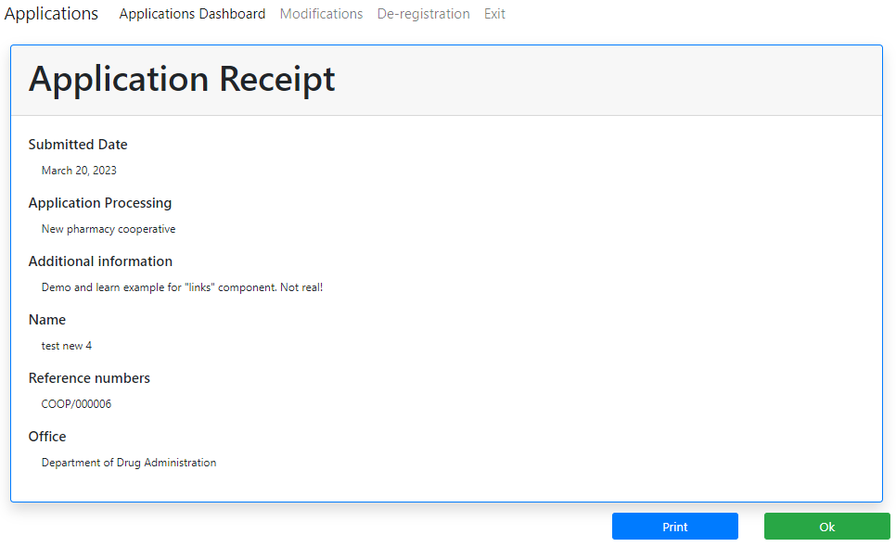

Figure The receipt allows an applicant to keep their records and perform offline collaborations with NMRA if needed

## The submissions dashboard

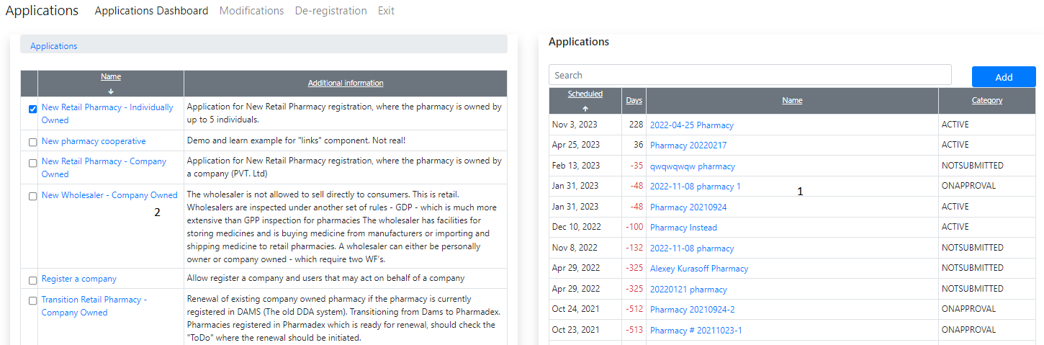

Figure The application's dashboard

1. All application data is available from a single point
2. The selected type of application is stored for an applicant, thus applicant not more needed to click again and again on the same checkbox

## Completed and scheduled activities

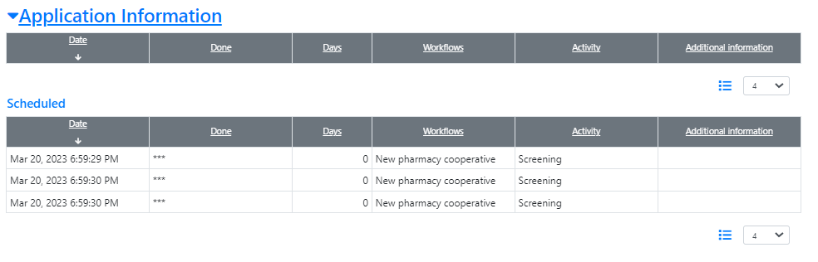

Figure Nothing completed, only scheduled.

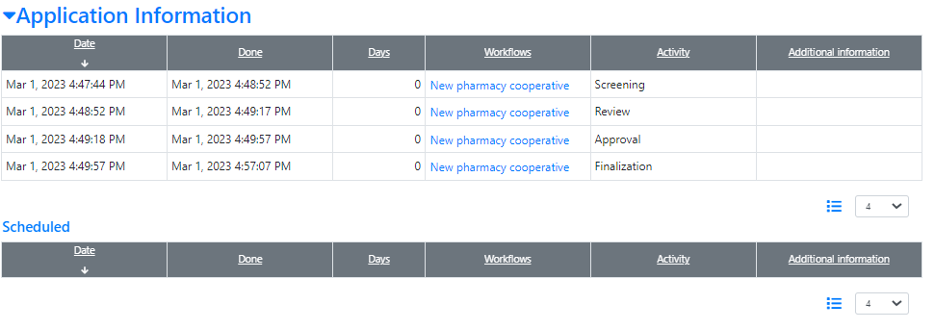

Figure Any scheduled activities, thus the application is not valid already or yet

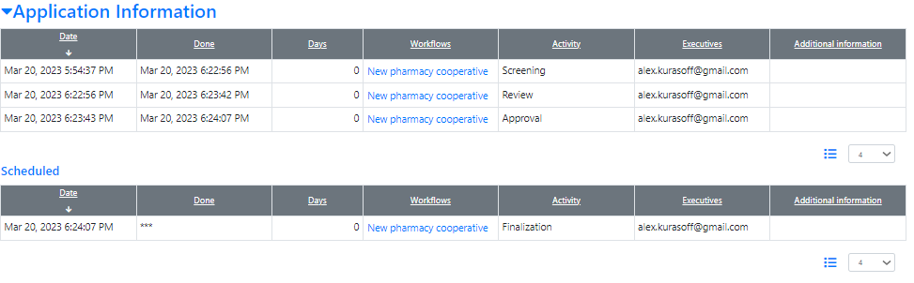

Figure Both completed and scheduled activities

## Clickable NMRA Logo

Chapter 7.1 has been added to the OpenRIMS Deployment Guide

## Workflow definitions export and import

Details are in the new document “How to export workflow definition from the Sandbox and import it to the Production?”

# Documentation changes

| **Document** | **Status** | **Redmine address** | **Wiki Address** |
| --- | --- | --- | --- |
| OpenRIMS Deployment Guide | Chapter 7.1 has been added | https://redmine.openrims.org/documents/116 |  |
| How to export workflow definition from the Sandbox and import it to the Production? | New | https://redmine.openrims.org/documents/193 |  |

# Messages that should be defined

| **Key** | **Meaning** | **Usage** |
| --- | --- | --- |
| references | Reference numbers | submit receipt form |
| office | Office | submit receipt form |
| submitreceipt | Application Receipt | the header for submitting the receipt form |
| logo_url | URL for the NMRA logo. Should start with HTTP, e.g., https://google.com | The common application header |
| NOTSUBMITTED | Not submitted | States of application on the Application Dashboard |
| ONAPPROVAL | On approval |
| ACTIVE | Actual |
| INACTIVE | Not Actual |
| LOST | Undefined |

# Disclaimer

All new and improved features have been tested against the particular testing examples.

Thus, this release may contain errors, a bad user interface, and inconsistencies. Please, report them to [alex.kurasoff@gmail.com](mailto:alex.kurasoff@gmail.com).