OpenRIMS Release Notes 2023-05-26

Contents

Motivation 1

Bugs fixed 1

Issue # 1562 - Dictionary showing a document before upload 1

Support #1673 Default items to show in dictionary needs to be reduced from 20 to 4 1

Improvements 2

Feature #1689 Extend Data Configuration export to Excel 2

Documentation changes 2

Messages that should be defined 3

Disclaimer 3

# Motivation

The main goal of this release is to empower the internal Data Warehouse with the provided data sources. The provided data sources are new database views that in most cases will avoid using SQL for data visualization. The full documentation will be coming next week.

Additionally, this release contains improvements and bug fixes

# Bugs fixed

## Issue # 1562 - Dictionary showing a document before upload

Unfortunately, the example on pdx2dda has been gone. Despite it, we can reproduce similar on our test base using the following test case:

* Applicant 1 added a new application, uploaded a file, and, then, pressed Cancel and logout
* Applicant 2 logged in, added the same type of application, and can see a file uploaded by Applicant 1

It has been fixed; however, we don't make sure that it is the same cause.

## Support #1673 Default items to show in the dictionary needs to be reduced from 20 to 4

Unfortunately, this issue produced many regress bugs, such are:

* Do not allow submit de-registration workflows
* Wrong data usage from the system dictionaries
* etc.

These critical issues have been fixed

# Improvements

## Feature #1689 Extend Data Configuration export to Excel

Before this, a limited number of data references were available on the first page.

Currently, all data references are available:

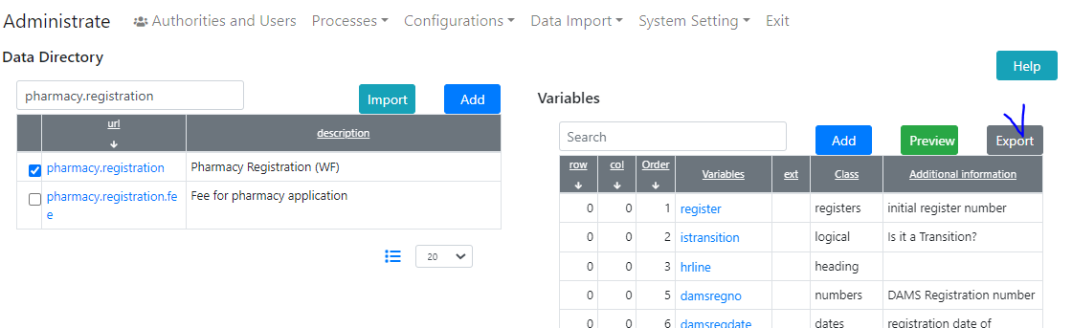

Figure Export Data structure into Excel

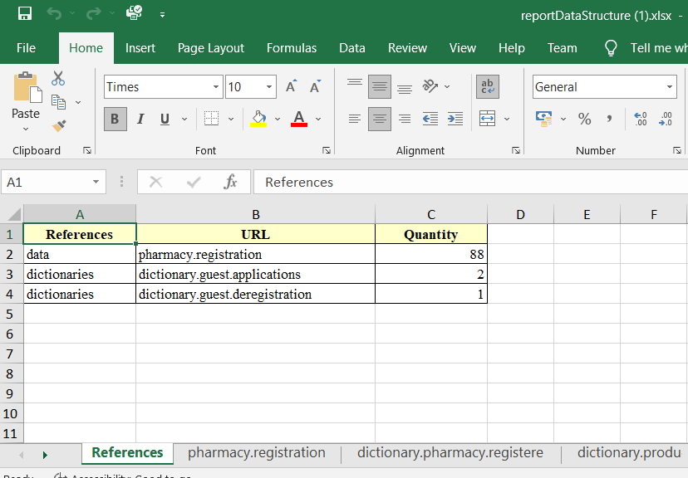

Figure The references for this configuration

# Documentation changes

| **Document** | **Status** | **Redmine address** | **Wiki Address** |
| --- | --- | --- | --- |
|  |  |  |  |
|  |  |  |  |

# Messages that should be defined

| **Key** | **Meaning** | **Usage** |
| --- | --- | --- |
|  |  |  |
|  |  |  |
|  |  |  |
|  |  |  |

# Disclaimer

All new and improved features have been tested against the particular testing examples.

Thus, this release may contain errors, a bad user interface, and inconsistencies. Please, report them to [alex.kurasoff@gmail.com](mailto:alex.kurasoff@gmail.com).