OpenRIMS Release Notes 2023-07-10

Contents

Motivation 1

Bugs fixed 1

Application configuration validation 1

NRA user roles 2

The scheduled activities list 2

Improvements 2

The Decline outcome 2

Documentation changes 2

Messages that should be defined 2

Disclaimer 3

# Motivation

The main goal of this release is improvements in the provided data sets that are allowed:

* Reporting both states and transitions
* Reporting permits classifiers defined by NRA

Additionally

following failures and errors are fixed:

* Application configuration validation function currently works properly in cases when some configuration steps have been de-activated
* Roles for NRA users will not be duplicated in case of removing a new one
* The Scheduled Activities list in the Application Dashboard currently works properly

following improvements are implemented:

* Decline outcome has been implemented for de-registration, pre-inspection, and modification workflows
* The form for public publishing contains all historical records

# Bugs fixed

## Application configuration validation

When a permit application starts, OpenRIMS checks the NRA workflow configuration for it. In case of absence or improper configuration, the software will not allow to start the permit application.

The validation check inspects all configurations of activities. In the previous release, this check may skip activities after an activity that has been removed before.

## NRA user roles

In the previous release, because of a software error, the list of possible user roles may contain duplicate values. It has not any influence on the access control, however improper and annoying. Most often it occurs when removing a role from the user, using the configuration screen.

## The scheduled activities list

The OpenRIMS Application Dashboard provides a business list of scheduled events for all permits. In the previous release, this list may contain events that are already passed.

# Improvements

## The Decline outcome

The Decline is a non-mandatory workflow step that allows rejecting an application in the way required by the legislation. Most often it means the preparation of juridical documents.

Currently, this capability works for all business applications:

* Permit
* Modifications
* De-registration
* Pre-inspections and follow-up inspections

## The form for public publishing

OpenRIMS provides feature to publish permit data for public. This feature has been implemented as:

* Rules to create a GET HTTP(s) query for the form
* A read-only electronic form consists of permit data and history
* URL formula in Google Looker Studio reports

In the previous release the history contains only data accessible for the user. Currently, all history data. The inaccessible data is impossible to expand

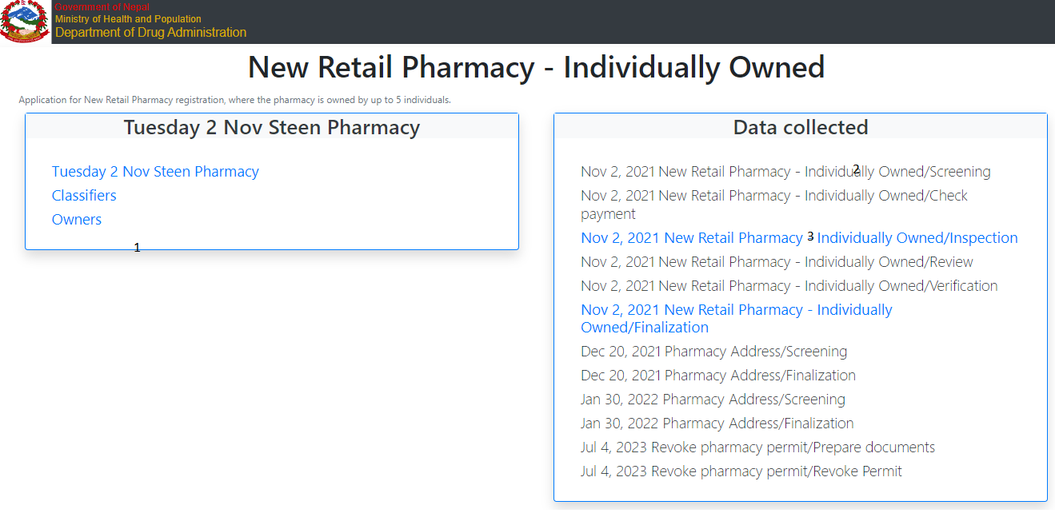

Figure Publicly available data form

1. Application data available for public access
2. History data not for the public access – not expandable
3. History data for public access - expandable

# Documentation changes

**Please, put your attention to the State-Transition diagram that is published in OpenRIMSDataSourcesProvided.docx.**

| **Document** | **Status** | **Redmine address** | **Wiki Address** |
| --- | --- | --- | --- |
| OpenRIMSDataSourcesProvided.docx | Next release | Not defined yet |  |
|  |  |  |  |
|  |  |  |  |

# Messages that should be defined

| **Key** | **Meaning** | **Usage** |
| --- | --- | --- |
|  |  |  |
|  |  |  |
|  |  |  |
|  |  |  |

# Disclaimer

All new and improved features have been tested against the particular testing examples.

Thus, this release may contain errors, a bad user interface, and inconsistencies. Please, report them to [alex.kurasoff@gmail.com](mailto:alex.kurasoff@gmail.com).