OpenRIMS Release Notes 2023-08-14

Contents

Motivation 1

Bugs fixed 1

Improvements 1

Permit publishing form 1

Monitoring ALL filters 2

The Workflow Guide 3

The Report feature allows directory of publicity available Google Looker reports (experimental) 4

Configurations-Reports 4

Report’s usage 5

Documentation changes 5

Messages that should be defined 5

Disclaimer 5

# Motivation

The main goal of this release is a security improvement of the Permit Publishing form

Additionally:

* The search form for the “Monitoring all” feature has been extended and improved
* The electronic help document “Workflow guide” has been added
* The Report feature allows a directory of publicity available Google Looker reports (experimental)

# Bugs fixed

none

# Improvements

## Permit publishing form

1. Only closed and valid permits are publicity available
2. For NRA employees access is restricted by roles and workflows
3. Applicants can fully access all own permits

## Monitoring ALL filters

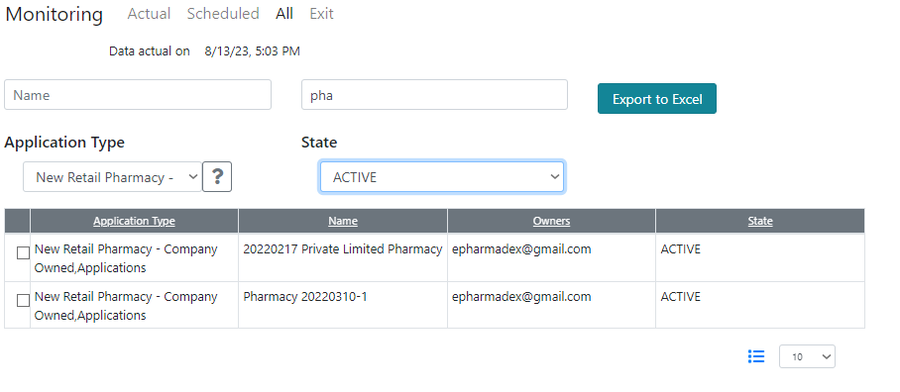

Figure An example of Monitoring-All search capability

## The Workflow Guide

The Workflow Guide is available as the Online Help

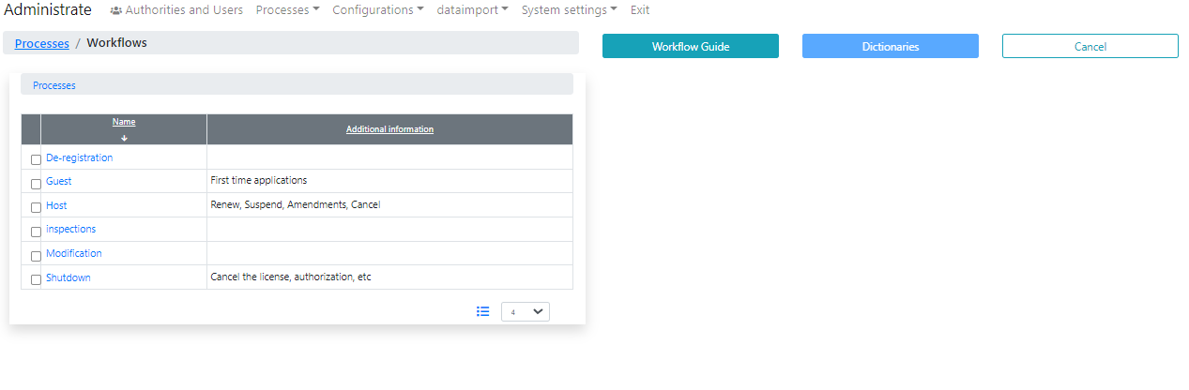

Figure Workflow Guide is available using the button

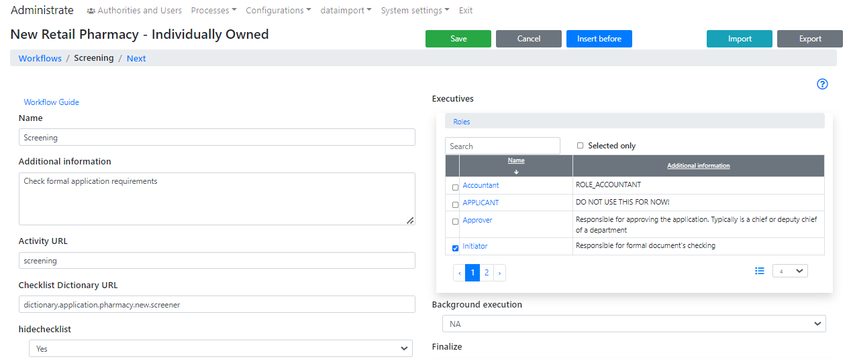

Figure Workflow Guide is available using a link

## The Report feature allows a directory of publicity available Google Looker reports (experimental)

### Configurations-Reports

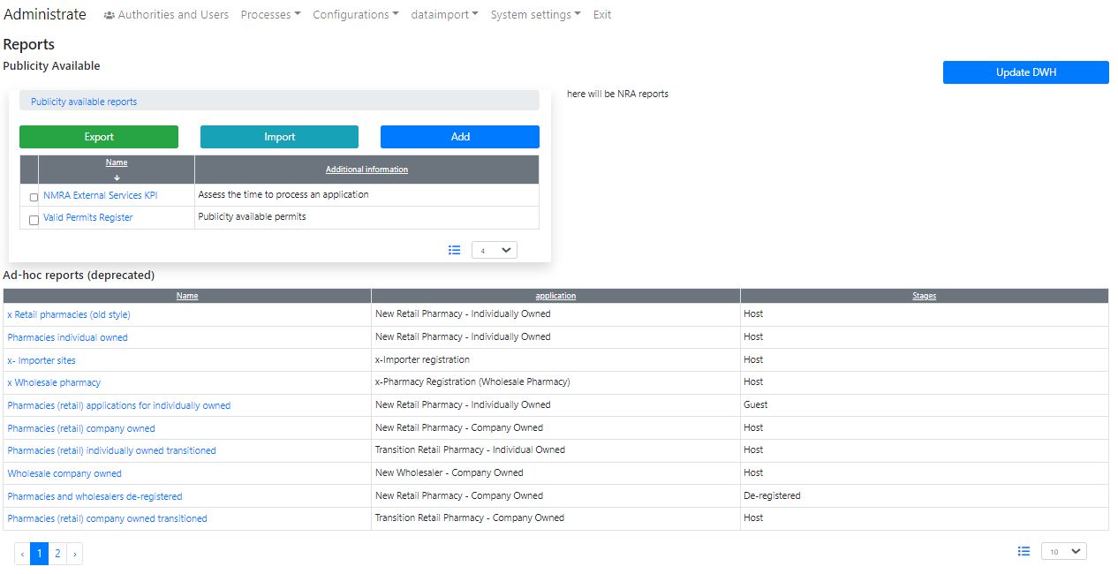

Figure The directory of the reports is the dictionary “dictionary.report. google tools”. Despite the old version of reporting is available, it will not be supported in the future releases.

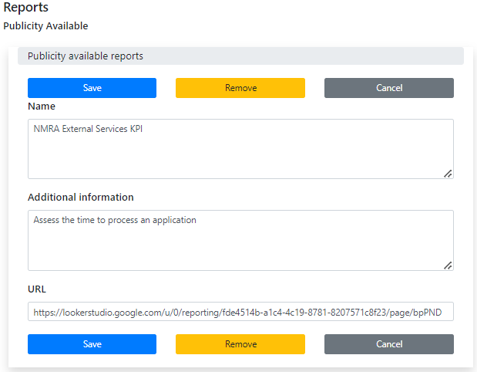

Figure The Item in the report’s directory

### Report’s usage

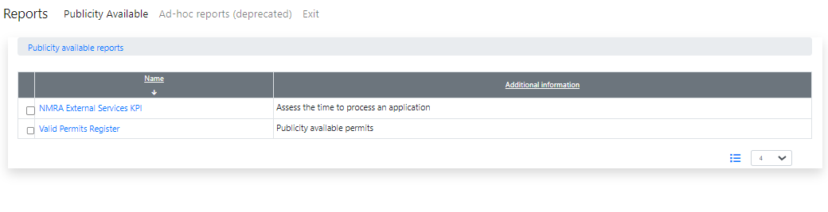

Figure Usage of the reports

# Documentation changes

**Please, put your attention to the State-Transition diagram that is published in OpenRIMSDataSourcesProvided.docx.**

| **Document** | **Status** | **Redmine address** | **Wiki Address** |
| --- | --- | --- | --- |
| Workflow Guide.docx | New | https://redmine.openrims.org/documents/205 |  |
| OpenMRIS Deployment Guide.docx | Changed | https://redmine.openrims.org/documents/116 |  |
|  |  |  |  |

# Messages that should be defined

| **Key** | **Meaning** | **Usage** |
| --- | --- | --- |
| reportOld | Ad-hoc reports (deprecated) | Reports.js |
| externalreport | External Reports | Reports.js |
| workglowguide | Workflow Guide | Workflows.js |

# Disclaimer

All new and improved features have been tested against the particular testing examples.

Thus, this release may contain errors, a bad user interface, and inconsistencies. Please, report them to [alex.kurasoff@gmail.com](mailto:alex.kurasoff@gmail.com).