OpenRIMS Release Notes 2023-09-18

Contents

Motivation 1

Bugs fixed 2

Improvements 2

Resource creation has been simplified 2

Customization of the Rosters of Applications using Looker Studio 5

Custom date format 6

Preview files before download 7

Documentation changes 7

Messages that should be defined 9

Disclaimer 9

# Motivation

The main goal of this release is to allow download workflow definitions from other servers. It allows:

1. Download workflow examples to the Sandbox System just installed
2. Download approved and tested workflow definitions from the Sandbox to the Production server

Additionally:

The component “resources” intends to create documents in docx format using pre-defined templates and application data. Examples are certificates and letters. Before this release configuration process of a “resource” component was complex and cumbersome.

The form of official incoming application rosters varies from country to country. From this release became possible to customize the rosters using external data visualization tools, like the Google Looker Studio

By default, to represent dates in on-screen forms, tables, and printable documents OpenRIMS uses the Medium format for the current user’s locale. From this release, it is possible to customize the representation of dates.

A typical application contains files attached. From this release became possible to preview them using a web browser.

# Bugs fixed

Resources and data import pages do not allow file download. It was a regress error since new access control had been introduced. It is fixed in the current version

# Improvements

Import workflow configuration from another server

Before workflow goes to production it will be necessary to create, test, and approve it in the Sandbox System.

After approval, the workflow definition should be imported to the Production Server. A workflow definition includes:

* Dictionaries
* Resources
* Data configurations
* Workflow configuration

The manual import process is complex, cumbersome, and depends on human factors. Since 2023-09-18 this process has been automated

## Resource creation has been simplified

The component “resources” intends to create documents in docx format using pre-defined templates and application data. Examples are certificates and letters. Before this release configuration process of a “resource” component was complex and cumbersome.

Suppose, we need to create a resource to allow the creation of various letters from NRA to an applicant

**Select "Administrate-Configuration-Resources" and create** t**he templates in the docx format. Use “EL reference help” while creating the templates.**

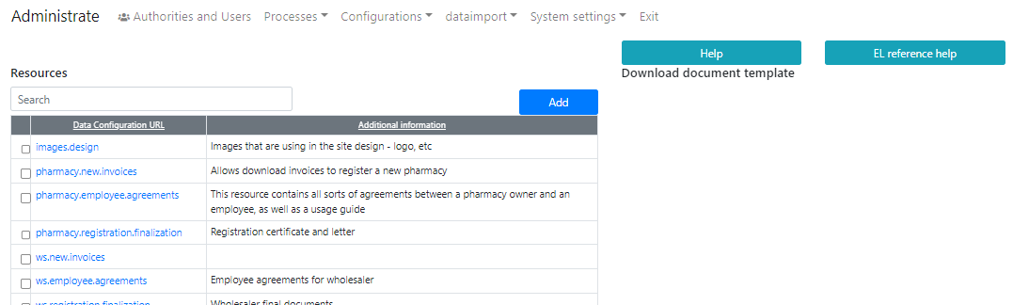

Figure Initial resource configuration screen

**Press “Add” and fill out the form**

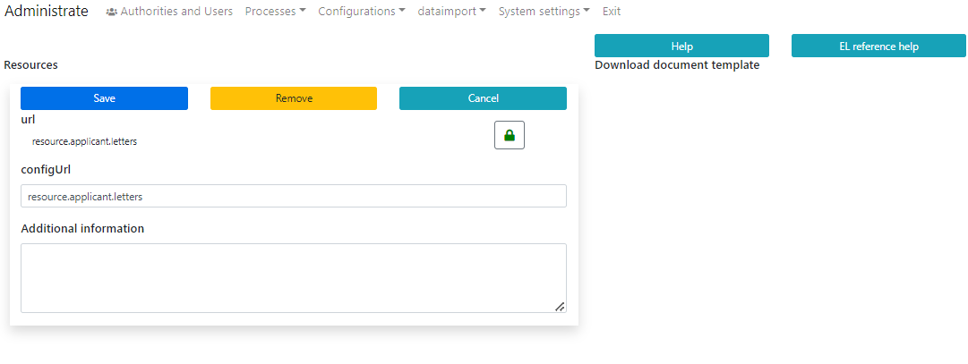

Figure Resource configuration form

**Press “Save to create an empty resource” and, then, find the newly created resource**

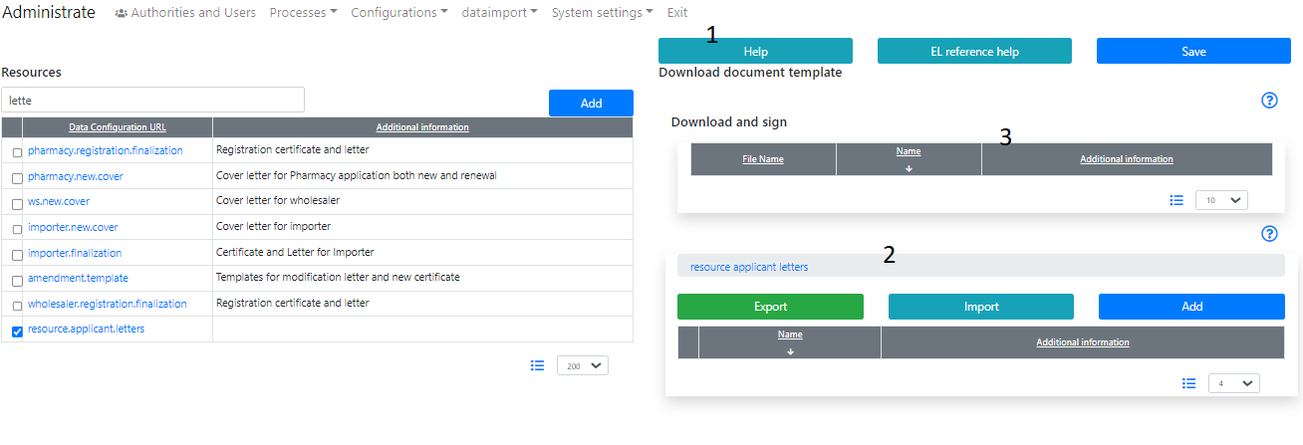

Figure A just created resource

1. This document as the electronic help
2. Templates uploading is not available yet
3. To allow the uploading, add descriptions of them

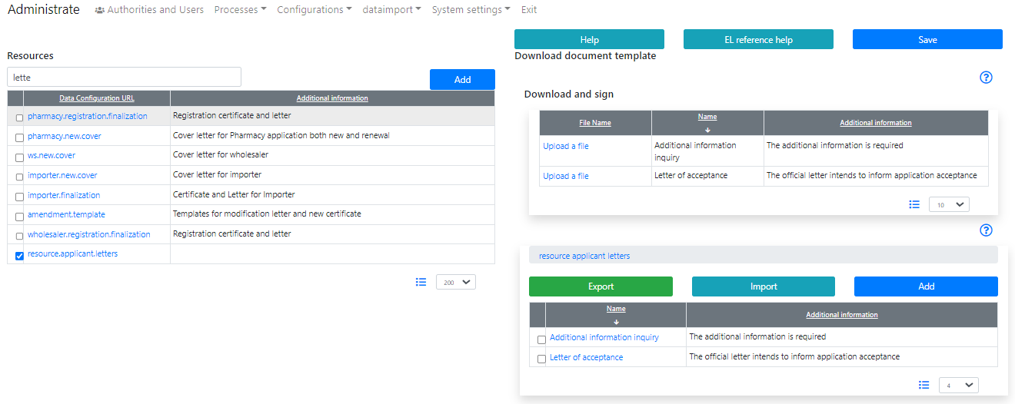

Figure Resource ready to upload templates

**Upload templates in the current language**

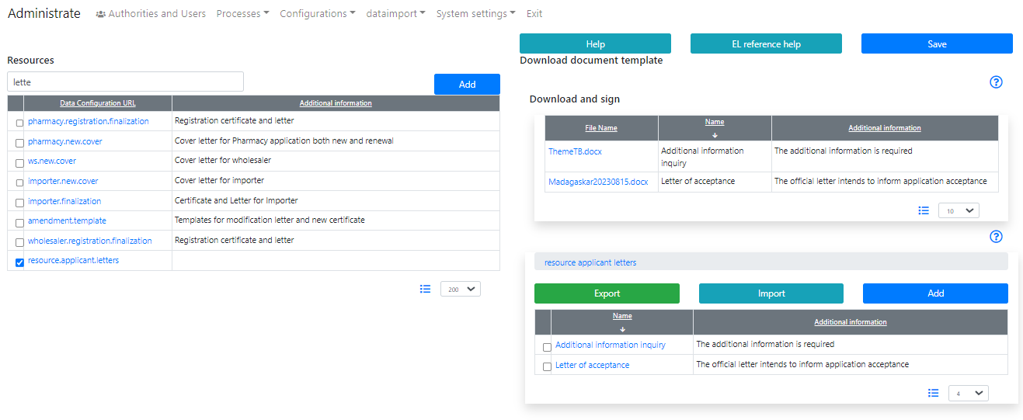

Figure Templates on the current language

**Switch language, and upload the templates in another language**

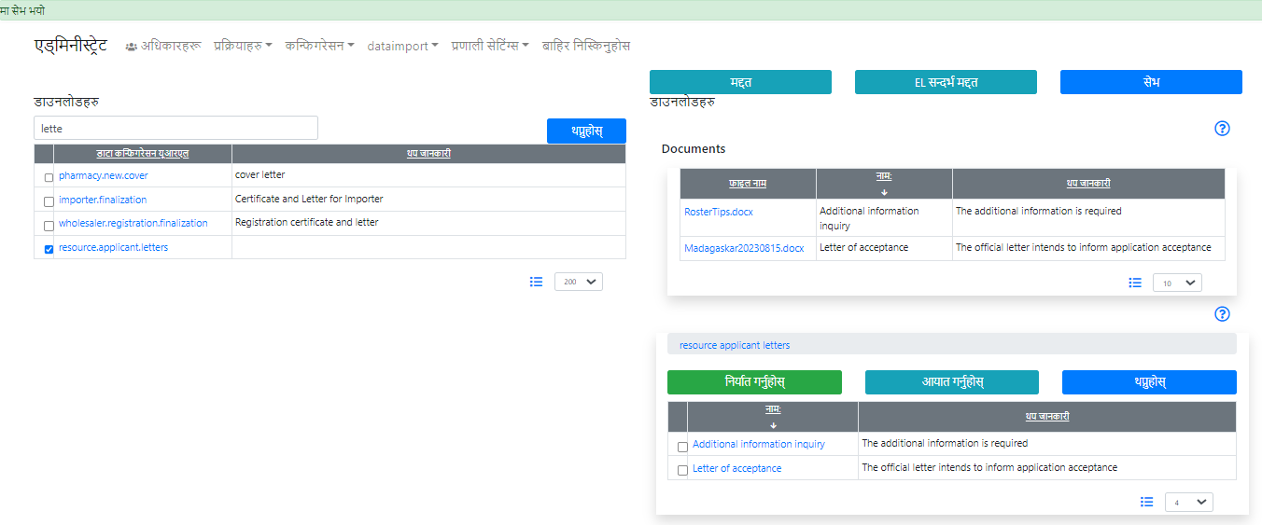

Figure Templates in another language

## Customization of the Rosters of Applications using Looker Studio

OpenRIMS allows automatically assigning numbers to digital documents i.e., applications, certificates, and letters. Moreover, OpenRIMS allows the management of incoming and outgoing documents consistently and uniformly.

The Incoming Application Roster is to ensure uniform inquiries and usage of the incoming applications, regardless of the subject area.

A digital roster is a database report. For reporting the OpenRIMS uses an external Data Visualization tool and the OpenRIMS Data Warehouse.

Here you can find a learning example to study how to use OpenRIMS Data Warehouse and Google Looker Data Visualization tool together.

The learning subjects are:

* The recommended step-by-step roadmap of a data visualization development
* Usage of the OpenRIMS authorization feature in the Google Looker Data Visualization tool
* Usage of the OpenRIMS Data Warehouse data sets as data sources for the Google Looker Data Visualization tool
* Dimensions and metrics in the typical data set
* Usage of the OpenRIMS electronic forms in the Google Looker Data Visualization tool

It is presumed that

* You able to design Google Looker Reports and have the OpenRIMS Supervisor’s knowledge
* The OpenRIMS database is available from the Google Looker Data Visualization tool using the MySQL connector

The example is available at https://lookerstudio.google.com/u/0/reporting/1883d3bc-81ad-42c0-ba2e-2e0cdbbf7387/page/L7ScD

## Custom date format

By default, to represent dates in on-screen forms, tables, and printable documents OpenRIMS uses the Medium format for the current user’s locale. From this release, it is possible to customize the representation of dates.

Please, put your attention, that the date format for input can’t be changed. This is because we use only proven and standard data conversion approaches.

**Select Administrate-Configurations-Custom date format**

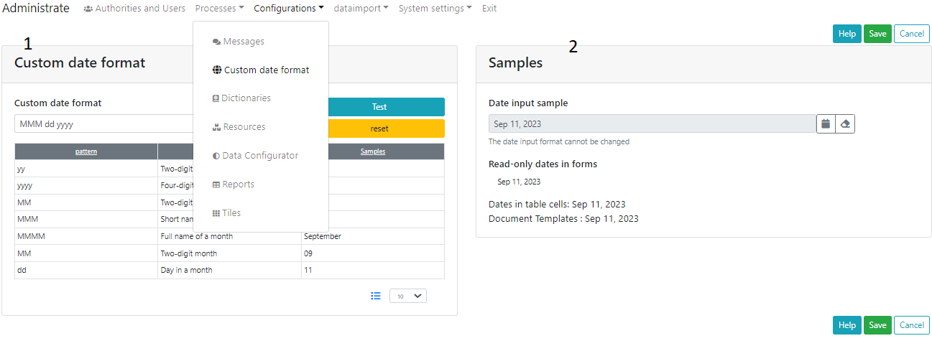

Figure Screen to create custom date formats

1. Define the format
2. Check the format
   1. Field to define the new format
   2. Help table to get format templates

Suppose we will need to change the short name of a month to a full one

Change and press “Test”. In case of satisfaction, press “Save”

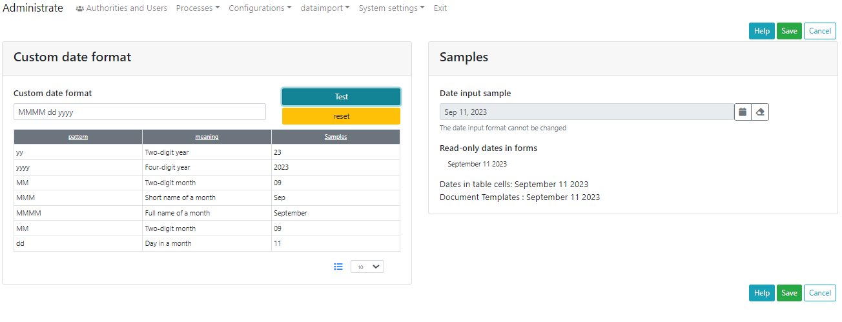

Figure Full name of a month

**Result will be**

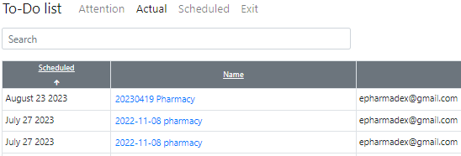

## Preview files before download

Unfortunately, for any basic WEB Browser it is possible only for a limited set of files. The Open Document docx and xlsx do not include to this set.

For Google Chrome the plugin Microsoft 365 plugin does the things. Please, consult a local Microsoft representative regarding the allowance to use it in your country.

# Documentation changes

| **Document** | **Status** | **Redmine address** | **Wiki Address** |
| --- | --- | --- | --- |
| ResourceHelp.docx | New | https://redmine.openrims.org/documents/207 |  |
| CustomDateFormat.docx | New | https://redmine.openrims.org/documents/208 |  |
| OpenRIMSIncomingApplicationsRoster.docx | New | https://redmine.openrims.org/documents/210 |  |
| ImportConfigProcessInstruction.docx | New | https://redmine.openrims.org/documents/211 |  |

# Messages that should be defined

| **Key** | **Meaning** | **Usage** |
| --- | --- | --- |
| formatdate | Date Format |  |
| samples | Samples |  |
| dateInputSample | Input fields are formatted by the browser |  |
| inputformatting | The date input format cannot be changed |  |
| dateDisplaySample | Read-only dates in forms |  |
| tableCell | Dates in table cells |  |
| yy | Two-digit year | SystemService custom formatting |
| yyyy | Four-digit year | SystemService custom formatting |
| MM | Two-digit month | SystemService custom formatting |
| MMM | Short name of a month | SystemService custom formatting |
| MMMM | Full name of a month | SystemService custom formatting |
| dd | Day in month | SystemService custom formatting |
| exchangeconfig | Import workflow |  |
| btn_connect | Connect to the server |  |
| serverurl | Server’s URL address |  |
| invaliddateformat | Invalid date format string |  |
| pub_reports | Publicity available reports | Administrate-Configuration-Reports |
| nmra_reports | NRA available reports |  |
| appl_reports | Applicant available reports |  |
| titlenotexistdictionary | Dictionaries for import |  |
| titleexistdata | Existing data |  |
| titlenotexistdata | Data for Import |  |
| titlenotexistrecords | Records for import |  |
| warningImportDictionary | The selected dictionary will be imported to your server. Continue? |  |
| warningImportResource | The selected resource will be imported to your server. Continue? |  |
| warningImportResConfig | The selected configuration data will be imported to your server. Continue? |  |
| warningImportActivities | The process and its activities will be imported to your server. Continue? |  |
| errorloaddata | Data import error |  |
| error_dataintegrity | Data error on Main-server |  |

# Disclaimer

All new and improved features have been tested against the particular testing examples.

Thus, this release may contain errors, a bad user interface, and inconsistencies. Please, report them to [alex.kurasoff@gmail.com](mailto:alex.kurasoff@gmail.com).