OpenRIMS Release Notes 2023-12-15

Contents

Motivation 1

Bugs fixed 2

Improvements 3

Documentation changes 4

Messages that should be defined 5

Disclaimer 5

# Motivation

Since this release, the data configuration will be stored along with data when the data is saved first time. It allows future changes in the data configurations without losing and/or invalidating the existing data.

Additionally:

* URL Assistance, Language Import, and Google Analytics features to improve the Supervisor experience.
* Configurable application receipt allows more customization possibilities
* The whole software stability is increased, especially for file upload/download

# Bugs fixed

1785 To avoid Error 500, access control rules are fixed in the Monitoring All feature.

**Attention:**

**The feature “Monitoring All” is built upon the Data Warehouse, because the main intention is to monitor reporting data integrity. Please, pay attention to the Actual Data field**

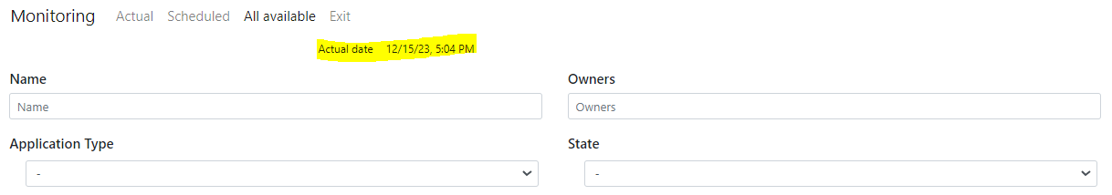

Figure The Actual Data field

**The monitoring feature is not needed for a screener. Please, remove this tile in the screener`s tile configuration.**

# Improvements

1762 URL Assistance. The URL definition is not a clear task. Also, the validation of new URLs is absent. The new URL Assistance feature allows us to define URLs in a systematic, proper, and easy way as well as validate URLs against the Regular Expression pattern.

1717, 1780 Electronic data configuration is currently stored along with data when data is saved first time. It allows us to avoid errors related to:

* Changes in a data configuration may “hide” existing data, usage resources that can`t be generated documents, and ask to use new mandatory data that is not defined
* Changes in workflow configurations may result in the loss of previously filled checklists and disable the possibility of generating certificates and other documents

1714. Supervisor’s feature to allow the upload of User Interface messages and labels in the local language

1723. Application submission receipt may be customized using docx with EL expression as any other template document.

Additionally:

1776. File upload/download features are implemented using POST instead of GET. It allows more parameters passed to the server in HTML form.

1765 Google Analytics usage is allowed. The new application.properties parameter pharmadex.google.analytic4.id=ID_RECEIVED_FROM_GOOGLE has been introduced

1783 Proposals for various implementations of modification workflows asked by the Nepali team.

1777 Button (control) panel in the dictionary UI has been improved to a more aesthetic and compact look

1770 The access to the draft application will be enabled only for applicants

1795 Additional views have been added to the database to improve efficiency and reduce code complexity

1782 For modification (amendment) application electronic form loading time has been improved

# Documentation changes

| **Document** | **Status** | **Redmine address** | **Wiki Address** |
| --- | --- | --- | --- |
| OpenRIMS Modification Workflows.pptx | new | https://redmine.openrims.org/documents/219 |  |
| DefinitionLocalLanguage.docx | new | https://redmine.openrims.org/documents/220 |  |
| CreationPrintableElectronicDocumentsOpenRIMS.docx | revised | https://redmine.openrims.org/documents/187 |  |
| configuration.resource.images.docx | new | https://redmine.openrims.org/documents/221 |  |
| WorkflowManual.docx | revised | https://redmine.openrims.org/documents/205 |  |

# Messages that should be defined

| **Key** | **Meaning** | **Usage** |
| --- | --- | --- |
| url_assistance1 | Select domain and sub-domain | URLAssist |
| url_assistance2 | Fill out a new URL and click OK | URLAssist |
| url_exists | URL already exists | URLAssist |
| error_url | The URL syntax is malformed | ValidationService |
| assist | Assist | URLAssist |
| url_dictionary_error | For dictionaries, URLs should start with a dictionary. | URLAssist |
| forbiddendomain | Forbidden domain in URL. | URLAssist |
| langreplcanceled | Language replacement canceled | ImportLocales |
| importLocales | Replace a local language | ImportLocales |
| templatedownload | Download a template | ImportLocales |
| locales | Locales | ImportLocales |
| flags | Flags | ImportLocales |
| files | Files | ImportLocales |
| oldlanguage | Previous language | ImportLocales |
| newlanguage | Replaced to | ImportLocales |
| imported | Imported | ImportLocales |
| total | Total | ImportLocales |
| updated | Updated | ImportLocales |
| askforimportrun | Do you want to replace the local language? | ImportLocales |
| res_key | Key(language) | ImportLocales |
| res_value | Message | ImportLocales |
| key | Key | ImportLocales |
| value | Messages | ImportLocales |
| translated | Translated Messages | ImportLocales |
| Items | Items | Resources.js |
| previewunavailable | The preview is not available | URLAssist |
| notaccess | Sorry, You have not enough right to complete this operation | general |

# Disclaimer

All new and improved features have been tested against the particular testing examples.

Thus, this release may contain errors, a bad user interface, and inconsistencies. Please, report them to [alex.kurasoff@gmail.com](mailto:alex.kurasoff@gmail.com).