OpenRIMS Release Notes 2024-01-26

Contents

Motivation 1

Bugs fixed 1

Improvements 1

Documentation changes 3

Messages that should be defined 4

Disclaimer 4

# Motivation

The goal of this release is the implementation of the various supporting activities

# Bugs fixed

Bug #1812 - URL assistance does not allow "traditional" http/https URLs. It is necessary for "heading" component configuration

# Improvements

| **Issue** | **Subject** | **Description** |
| --- | --- | --- |
| 1789 | Should we add GIS to the reportclassifier? | Currently, GIS data is available in the “reportclassifier” table. The field is ItemAltLabel |
| 1778 | prepare new application.properties | The application.properties in the distributive contains detailed commentaries |
| 1773 | Disable more than one level in workflow definition dictionaries | Items in any workflow definition dictionary do not allow levels. See also #1796 |
| 1800 | URL assistance manual | The PDF manual is added as an electronic help |
| 1799 | Red color for outdated applications | On workflow start forms the list of allowed processes contains processes allowed to run and the outdated process. Currently, the outdated processes are marked in italic format and gray color, instead of the bold red as was before. |
| 1790 | Repeat thing load efficiency tests for stored configuration | The duration of page loading has been improved. |
| 1796 | Introduce new Boolean singleLevel=false in the dictionary DTO | Some dictionaries, like roles, workflow definitions, etc. should not allow more than one level. |
| 1804 | Place the Google logo on the login screen to the application | Currently, the Google logo is included in the executable file. |
| 1803 | Check stored config against thingthing | We doubted that the stored configuration works properly. |
| 1802 | Add Looker Report reference (help document) to Administrate-Report | The document has been improved and added. |
| 1788 | Search for “lost” messages | Some labels and messages may be used by the software codes, but not defined in the database. The result is an ugly user interface. From this release, all undefined messages can be uploaded to XLSX format, and, then, resolved. The details are in the electronic help in the Administrate-Configurations-Messages |
| 1805 | Technical Description with Roadmap to feature development enhancing the existing multi-modification feature | Consultant Agreement #: 24MSH0368. Deliverable # 1 https://redmine.openrims.org/documents/224 |
| 1808 | Technical Description with Roadmap to feature development enhancing the possibility of using PDF/HTML in the system - specifically generating a PDF/HTML of the final certificate | Consultant Agreement #: 24MSH0368. Deliverable # 2  https://redmine.openrims.org/documents/225 |
| 1807 | Technical Description with Roadmap to feature development on cross-field validations | Consultant Agreement #: 24MSH0368. Deliverable # 4  https://redmine.openrims.org/documents/226 |
| 1797 | EL without a converter | An EL expression consists of a data source and a data converter, i.e., ${/data@convertor}  The typical error is an absence of the converter in the EL expression. The error message regarding the absence of the converter has been added |
| **1801** | **Process Import feature improvement** | **This feature didn't pass Quality Assurance; thus, it is excluded temporarily. Will be restored ASAP** |
| 1772 | Reassign in batch not completed activities from one employee to another | A new feature has been added to the menu “Administrate-Authorities and Users” Electronic help is provided |

# Documentation changes

| **Document** | **Status** | **Redmine address** | **Wiki Address** |
| --- | --- | --- | --- |
| URLAssistant.docx | New draft | https://redmine.openrims.org/documents/223 |  |
| OpenRIMSDataVisualization.docx | Improved | https://redmine.openrims.org/documents/213 |  |
| OpenRIMSCorrection.docx | New | https://redmine.openrims.org/documents/224 |  |
| Technical Description with Roadmap to feature development on cross-field validations.docx | New | https://redmine.openrims.org/documents/226 |  |
| Technical Description with Roadmap to feature development enhancing the possibility of using PDF.docx | New | https://redmine.openrims.org/documents/225 |  |
| UserExperienceLanguages.docx | New | https://redmine.openrims.org/documents/227 |  |
| ReassignActivities.docx | New | https://redmine.openrims.org/documents/228 |  |

# Messages that should be defined

Since this release all unresolved messages are available using the new UX “Lost Messages” feature.

This feature is available in Administrate-Configuration-Messages

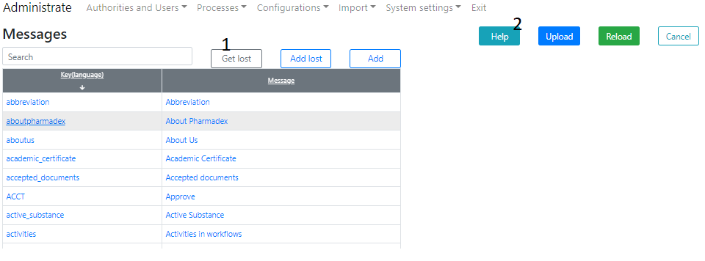

1. Get unresolved messages in XLSX format
2. Get help to learn the follow-up actions

# Disclaimer

All new and improved features have been tested against the particular testing examples.

Thus, this release may contain errors, a bad user interface, and inconsistencies. Please, report them to [alex.kurasoff@gmail.com](mailto:alex.kurasoff@gmail.com).