Pharmadex 2. Release Notes 2021-05-15

Contents

Motivation 2

Pre-requisite 2

Internationalization notes 2

Demo release particularities 3

New features 3

Public organizations 3

Motivation 3

Where to find it? 4

Walk down and up the public organization chart 5

Edit organization data 5

Add new organization 6

Executives 8

Suspend 9

Dictionaries 11

Motivation 11

Where to find it? 11

Find a dictionary 12

Navigate 12

Add and edit a node 15

Suspend a node 16

Edit a dictionary definition 17

Add a dictionary 20

Subscription to the service 21

Motivation 21

Where to find it? 22

How to use 23

What’s next 23

# Motivation

The establishment of a regulatory system following Good Regulatory Practices defined by WHO is a complex process. The important part of this process is the selection and adaptation of the software tool. Pharmadex 2 software should allow usage in core regulatory processes without additional coding and database changes by qualified experts.

Nevertheless, Pharmadex 2 software should be adapted to the notions developed while Good Regulatory Practice establishment. Moreover, it helps to develop the notions.

Pharmadex 2 should provide general implementations for the following notions:

1. Subjects of regulatory processes - business entities, public organizations, representative persons in business, and executives in public organizations
2. Classifiers, i.e., administrative division, responsibilities of Subjects, the government established classifiers of business, ATC classifier, etc.
3. Objects of regulatory processes, i.e., electronic forms, electronic documents, checklists, etc.
4. Workflows in which Subjects collaborate using objects.

This release intends to discuss the preliminary implementation of

* Subject – public organizations
* Classifiers – electronic dictionaries
* Objects – Electronic form allows business Subject to subscribe to Pharmadex 2 services.

# Pre-requisite

You must have a Gmail account.

# Internationalization notes

Pharmadex 2 can support many languages at once. The current demo version supports US English and Portuguese.

To switch languages, please use the language selector in the upper right corner



Language support assumes:

* On-screen labels, messages, currency and date formats, etc.
* Data input.

The data input support assumes that Pharmadex 2 stores input data separately for each language. It means implementation of the following scenario:

User turn on US English, input a text, and save it

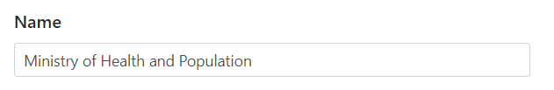

User switch the language to Portuguese; data will be the same because the new input fills data for all languages

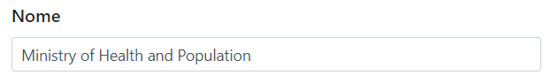

Users may type this data in Portuguese and, then save the input. Data will be stored in two languages

US English

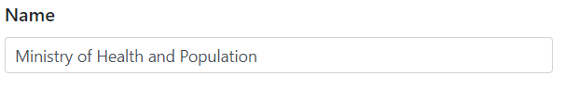

Portuguese

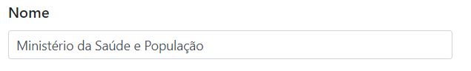

# Demo release particularities

This release may contain errors, bad user interface behavior, and inconsistencies. Please, report them to [alex.kurasoff@gmail.com](mailto:alex.kurasoff@gmail.com).

You may do with the data whatever you want. The data will be restored to the initial state periodically.

# New features

## Public organizations

### Motivation

Pharmadex 2 is a tool that helps to implement Good Regulation Practice recommended by WHO. To support the principles of Good Regulatory practices, Pharmadex 2 must provide actual and complete information regarding public organizations, executives, and their responsibilities in regulatory processes.

Pharmadex implements this feature by the “Authorities” module. This module provides a database and tool to keep this database actual. This tool may use only Supervisor users.

### Where to find it?

Log in as Supervisor[1].

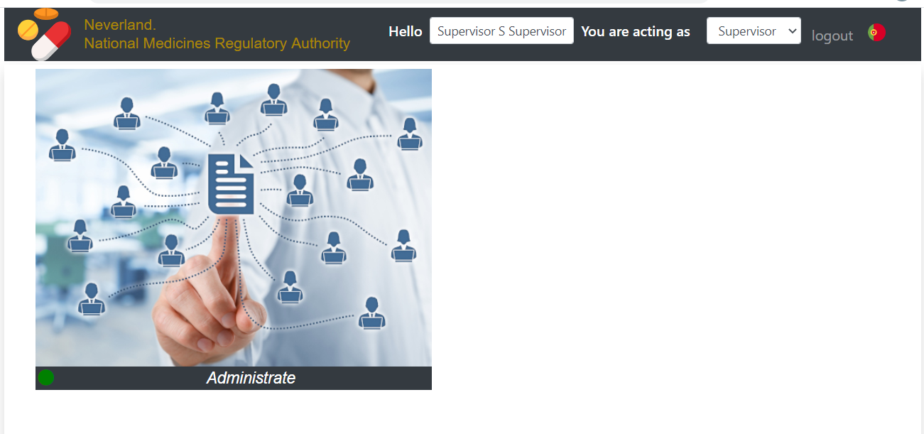

Move mouse over the picture, select “more”, and, then select “Authorities”

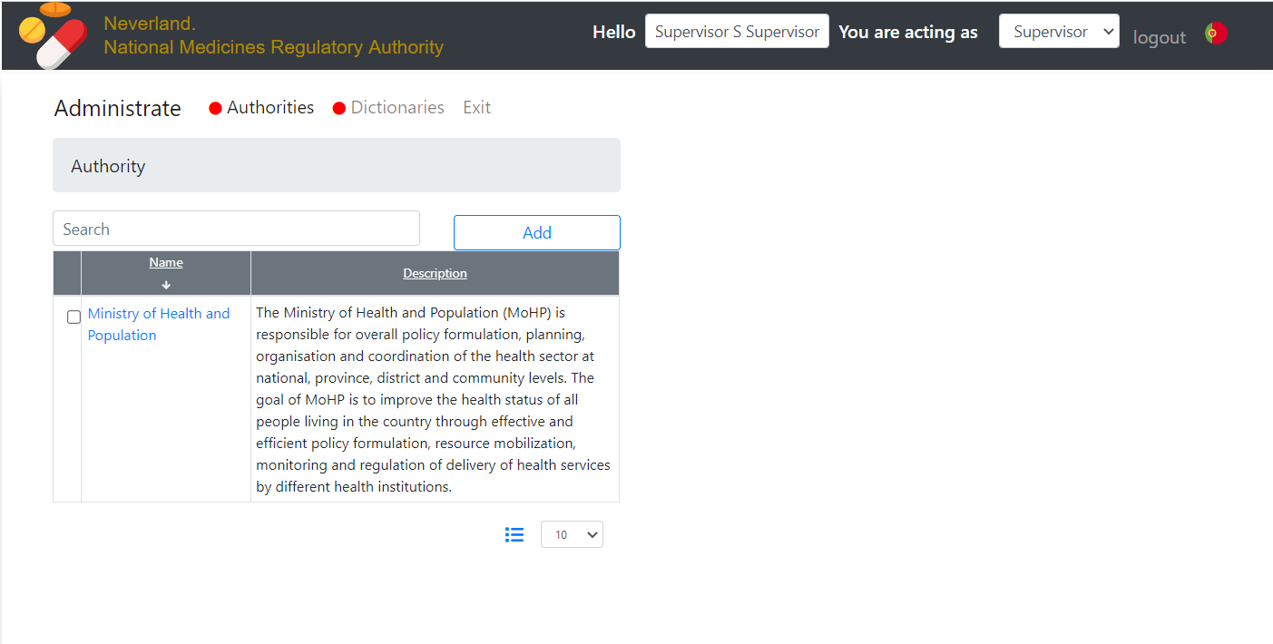

### Walk down and up the public organization chart

Select an organization to expand to the next level and to access executive’s data

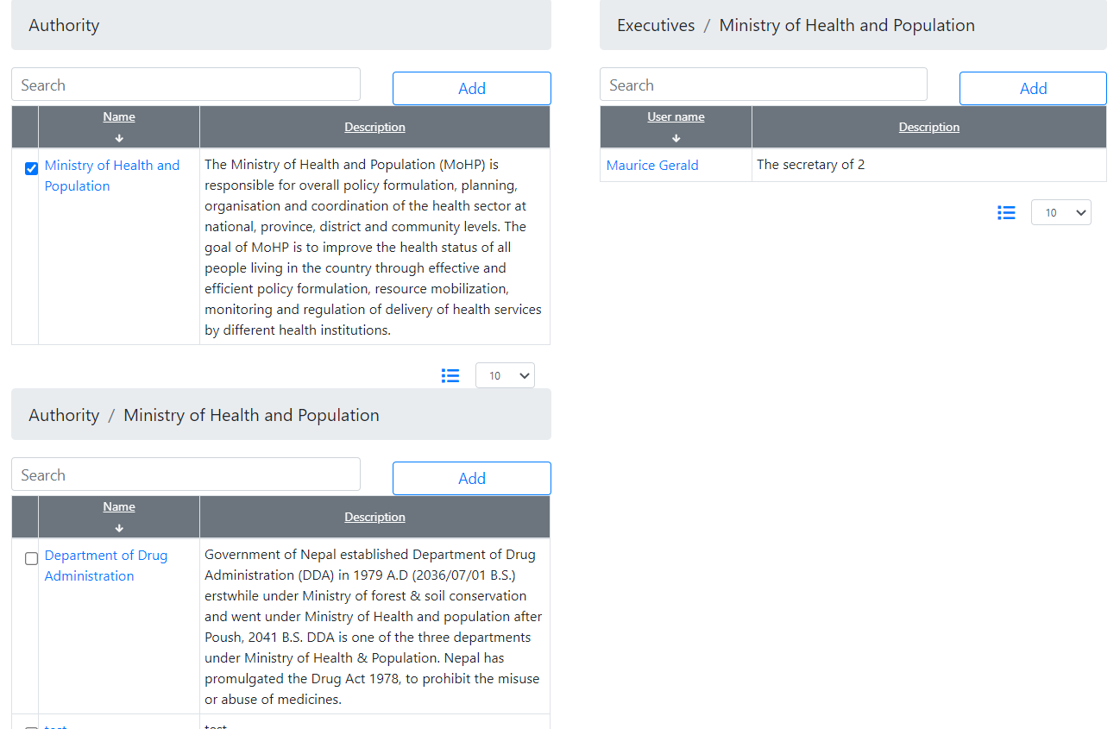

To walk up, please, de-select an authority.

### Edit organization data

To edit organization data, please click on the organization name.

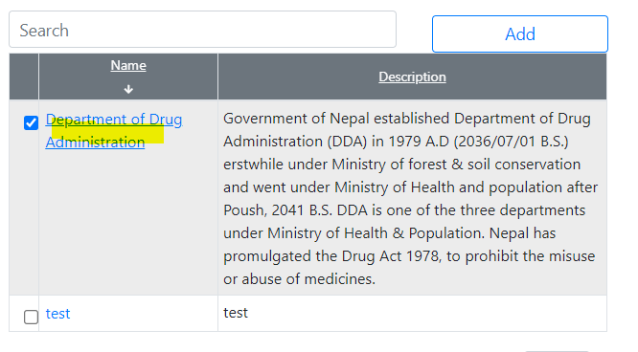

In the demo release, we provide a minimal possible set of public organization data. This set may be expanded by Supervisor following the needs.

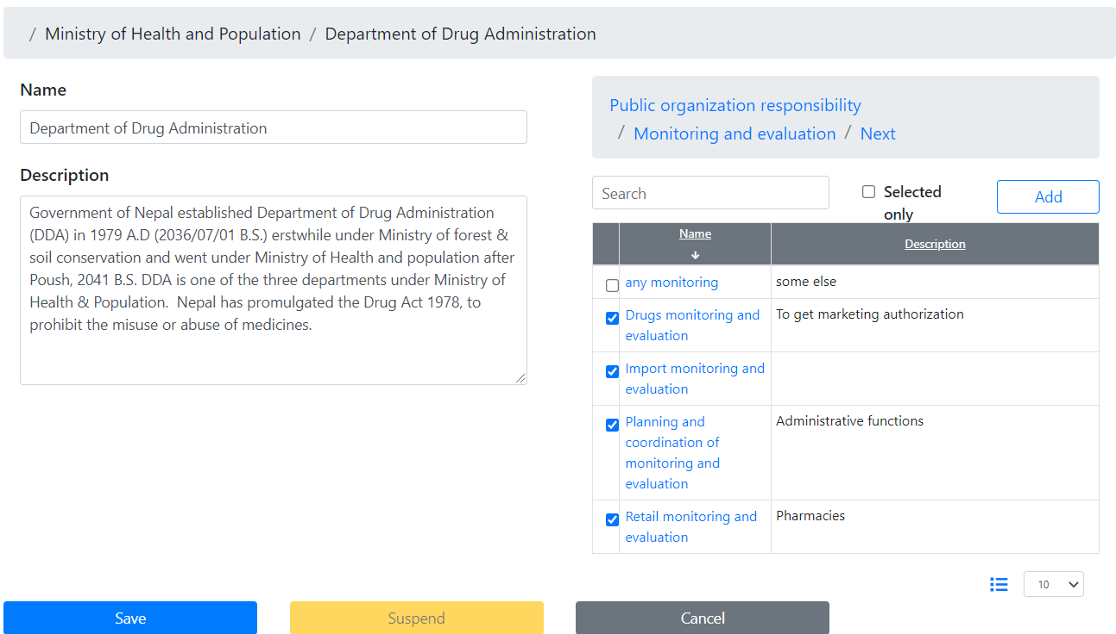

The most valuable feature of this form is the public organization responsibilities dictionary placed to the right of the form. This dictionary allows a selection of one or more responsibilities of public organization and, even, add the definition of other responsibilities. The details described below in sub-chapter “Dictionaries”

You may save or cancel your input. The suspend feature is described below.

### Add new organization

Press Add to add an organization or a division to the level in the organization chart. Please, consider the following example:

We want to add a new department to the Ministry of Health and Population.

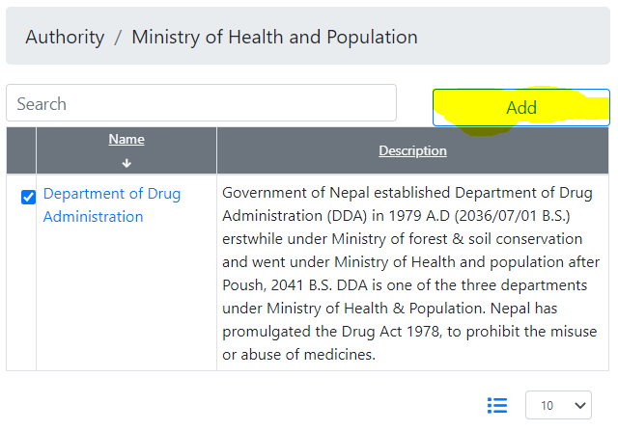

First of all, input Name and Description

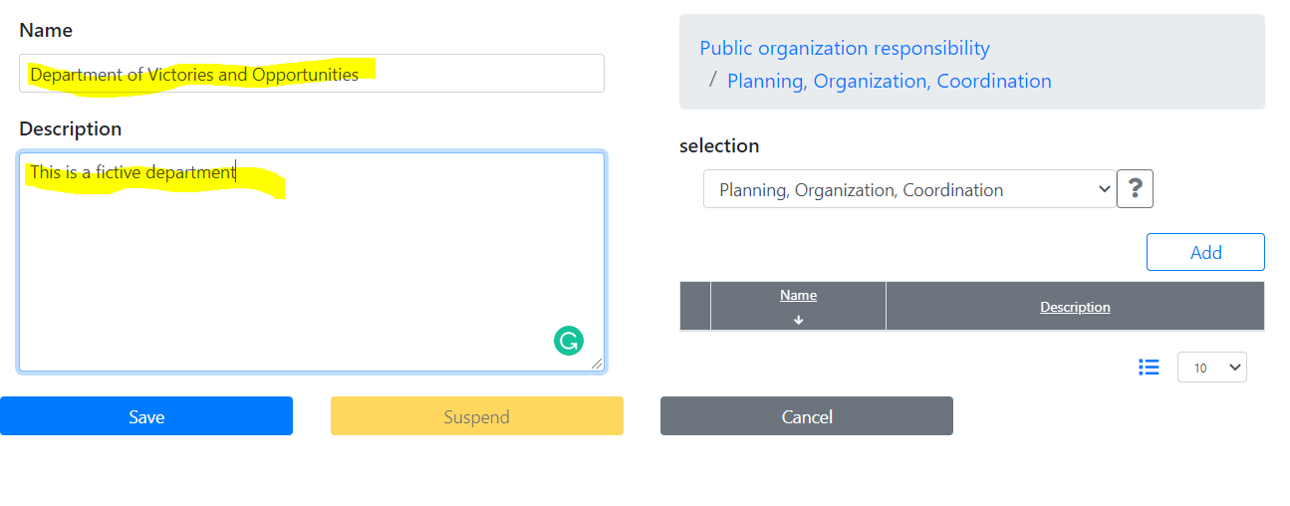

Then, we will see that Pharmadex 2 proposes us “Planning, Organization, coordination” responsibility. We can change it by click on “Public organization responsibility” or add a new sub-category to the “Planning, Organization, Coordination”. Let’s add a new one

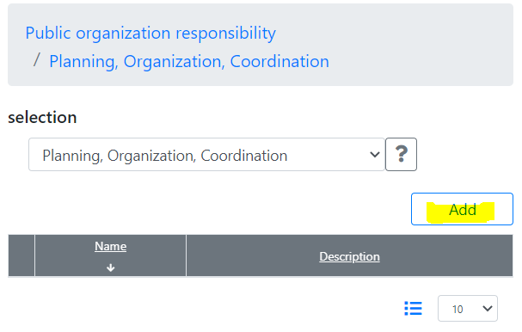

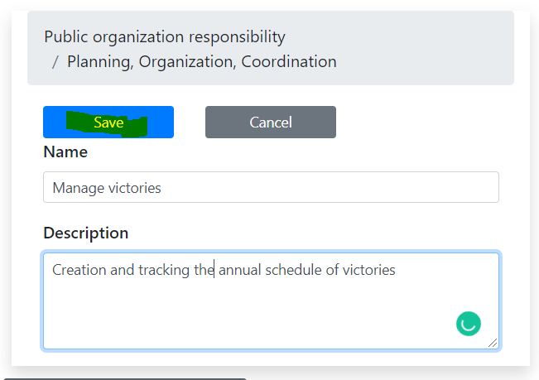

Check the newly created entry and press “Save”

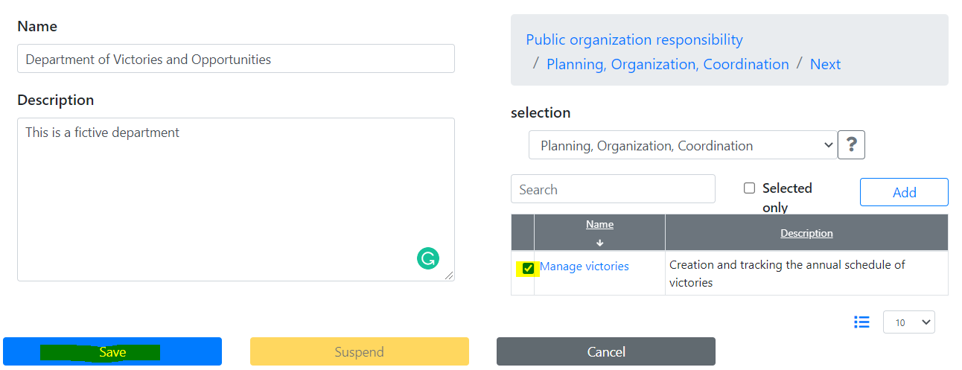

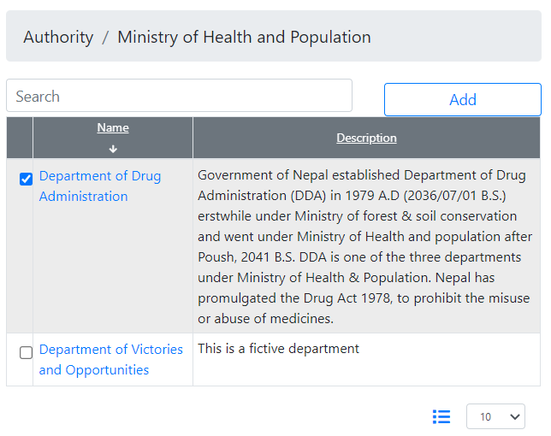

### Executives

For current we provide a minimal set of executive data. This set may be expanded by Supervisor following the needs.

Please, select any executive at the right side of the screen

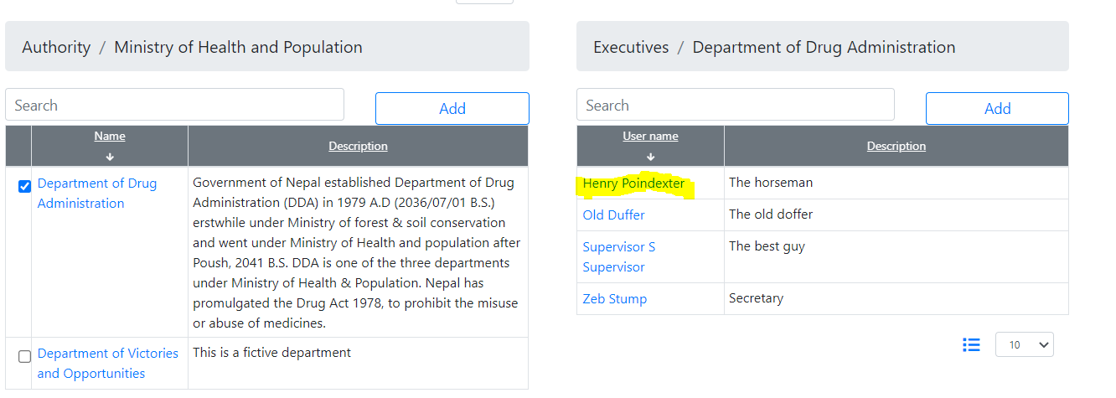

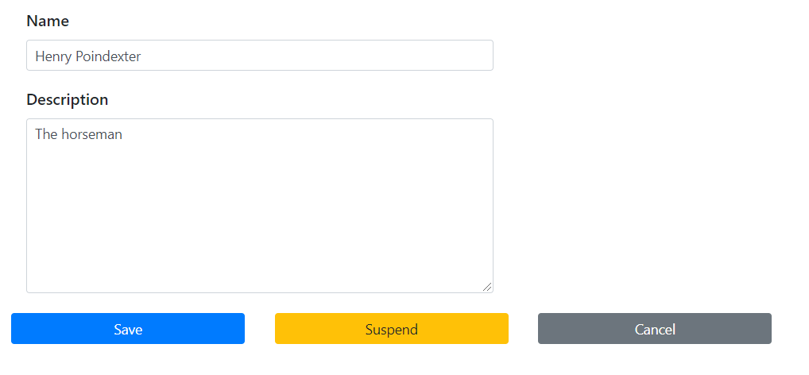

The actions below the screen mean:

* Save – save changes to Name and Description
* Suspend – make this executive unavailable for this organization, but available to include to another. It is useful when the executive will change the organization or will be fired.
* Cancel is stop editing without save changes

### Suspend an organization

The suspension means to make this organization (department, etc.) unavailable in all future registration processes. It is impossible to delete it from the database, for many reasons.

Only organizations at the end of the organization chart may be suspended. Please, consider the following scenario:

This department no longer needed and should be suspended

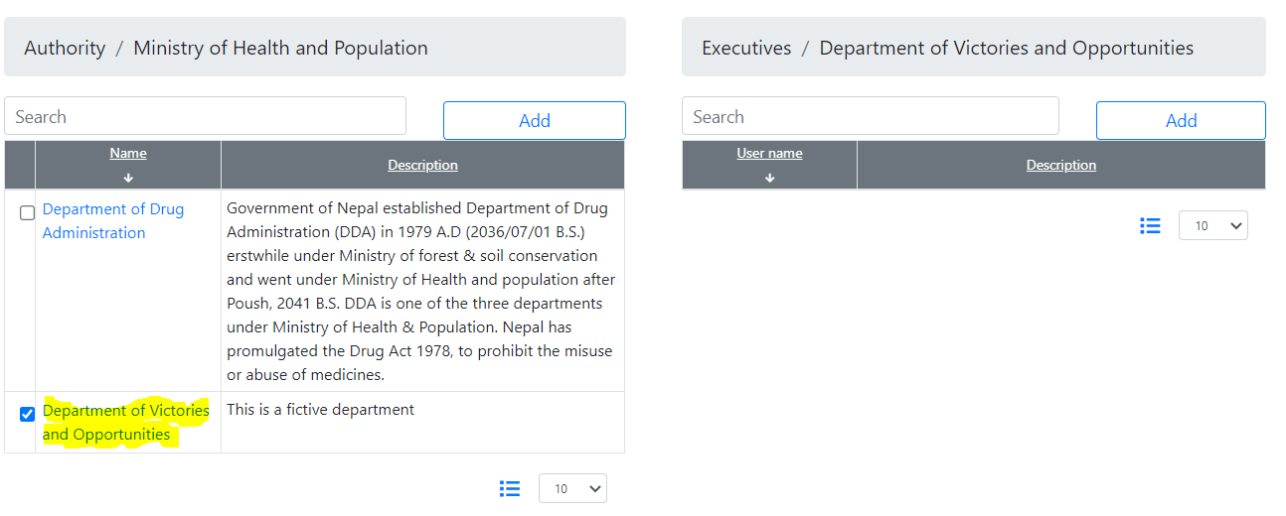

It is possible to suspend it because any child departments are defined

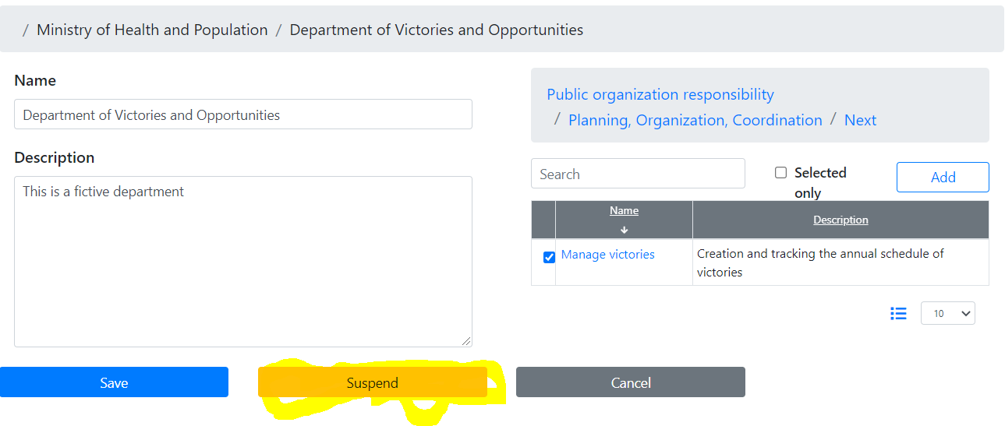

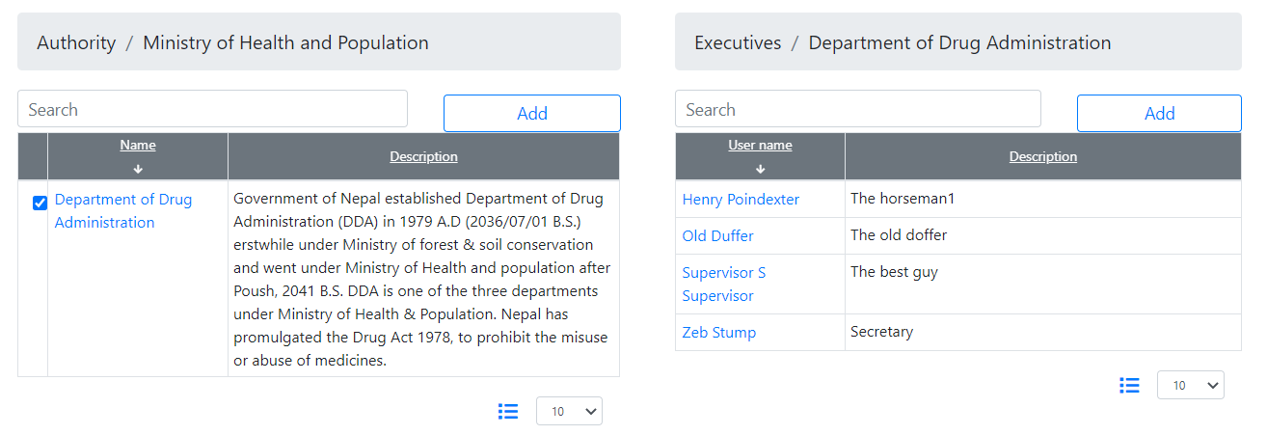

## Dictionaries

### Motivation

The regulatory authority processes should be formalized. The important part of formalization is the development of classifiers.

The development of classifiers assumes the determination of which classifiers should be implemented to Pharmadex 2 and how. The implementation of a classifier is an electronic dictionary.

A dictionary is a tool that allows users to select one or more right values of a notion.

The Supervisor can define any convenient set of dictionaries without the need for coding and making changes to the database structure.

### Where to find it?

Log in as Supervisor[2]

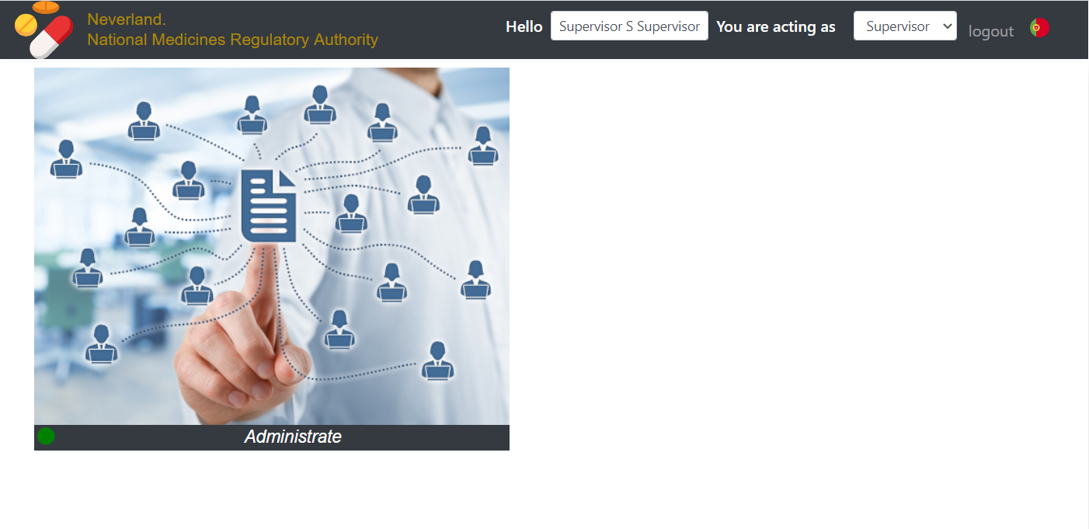

Move mouse over the picture, select “more”, and, then select “Dictionaries”.

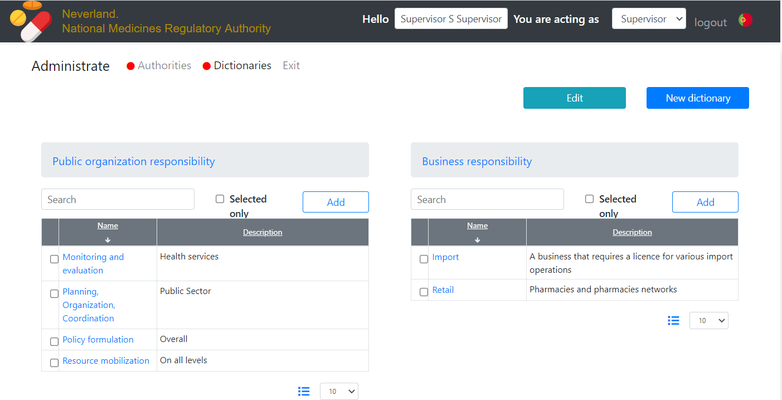

### Find a dictionary

All dictionaries are on this page. Scroll up and down to find a dictionary.

### Navigate on a dictionary

Any dictionary is a data tree. At any given moment you can see only one level of the data.

For example:

This dictionary partially represents a classifier - Nepal administrative division. Initially, you can see the first level – provinces.

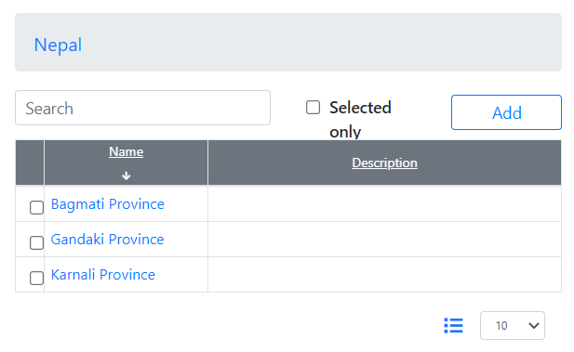

You may select a province, and, then, press “Next” to get a next level – districts in this province.

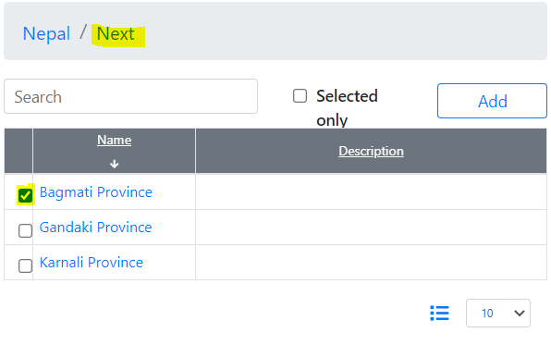

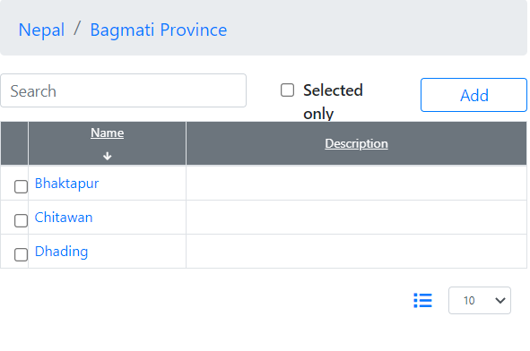

Select a district, and, then, press Next again to see communities in the district. However, there are no communities defined yet.

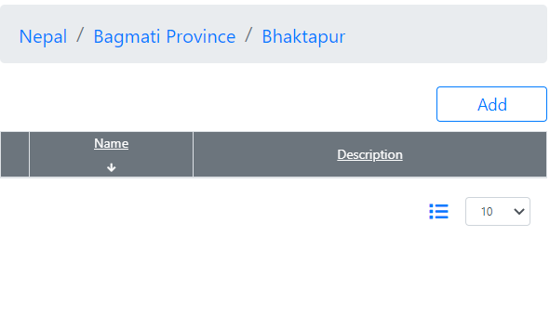

You may navigate back by selecting any item in a path.

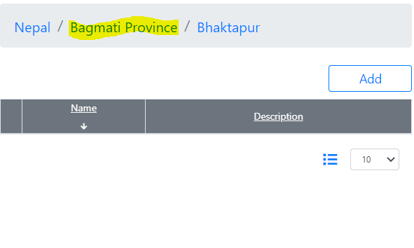

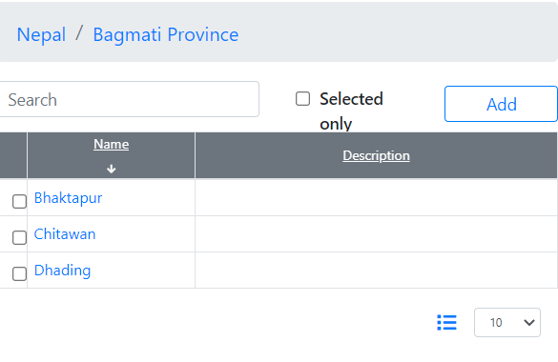

### Add and edit the data

To create the content of a dictionary and to keep a dictionary actual you can add new and edit existing choices. Let’s use the example above:

There are no communities defined. Please, press “Add”

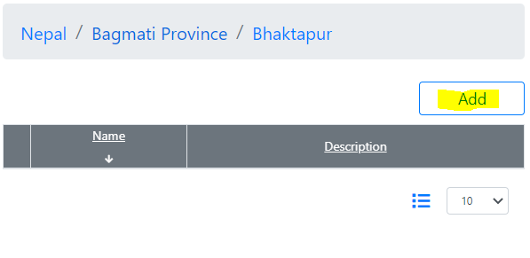

Fill out the form below, and, press “Save”

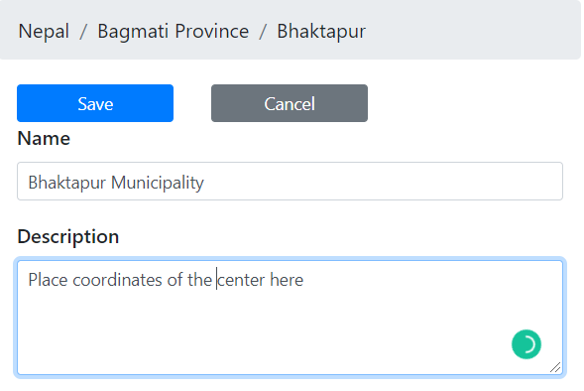

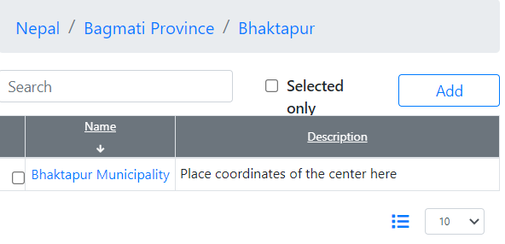

To edit a choice, please click on the node and fill out the form. The following actions are above

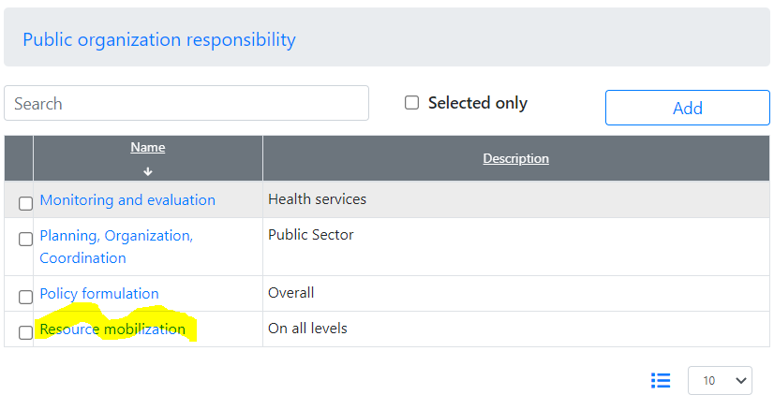

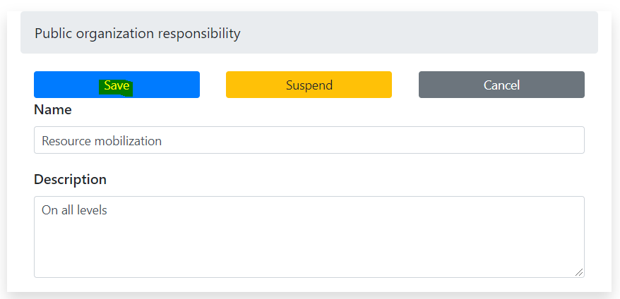

### Suspend a choice

Some choices in the dictionary (items in the classifier) may become no longer actual. These choices can’t be deleted from the database, because of possible references. You may declare a choice as unavailable.

For example:

Suppose, “Resource mobilization” is no more a possible Public Organization responsibility.

Let’s find it, and, then, click on it

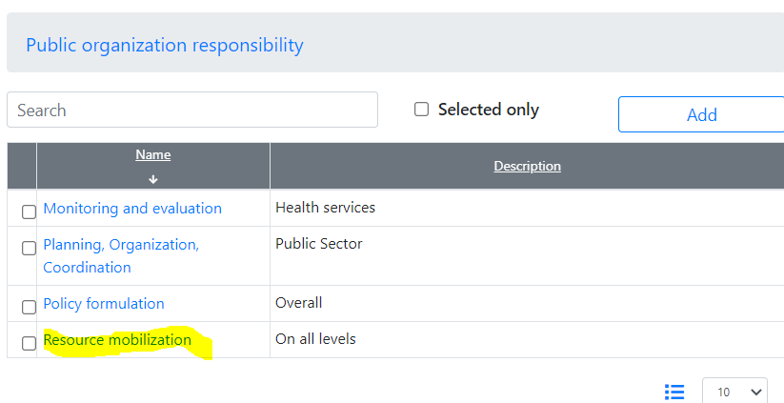

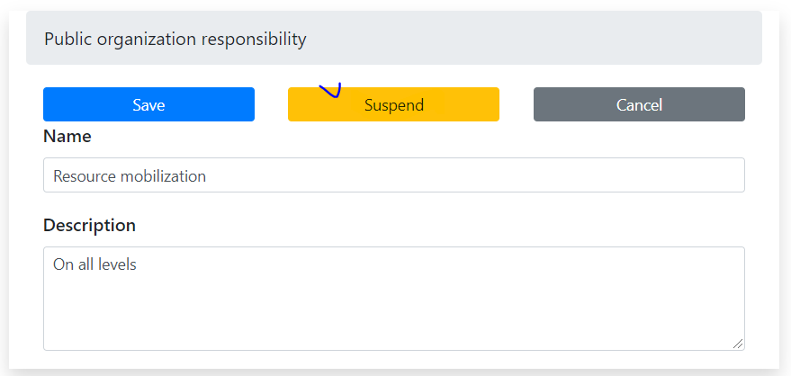

A button “Suspend” is active. It means that this choice doesn’t have any child and can be suspended. Otherwise, you should suspend all child nodes manually.

The result should look like this:

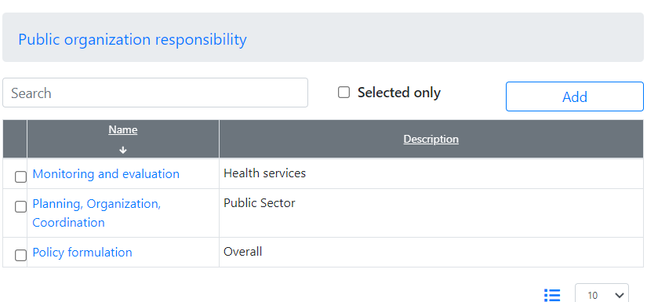

Be careful, for now, it is impossible to restore the suspended choice.

### Edit a dictionary definition

Each dictionary should be defined in the system using the following parameters:

* URL – unique “address” in the system, should be starting from word “dictionary”
* Name – the human-read name of a dictionary. It will be a good idea to keep this name unique too.
* Description – Description of a dictionary.

To edit a definition of a dictionary, press the “Edit” button, and, then, search for a dictionary definition

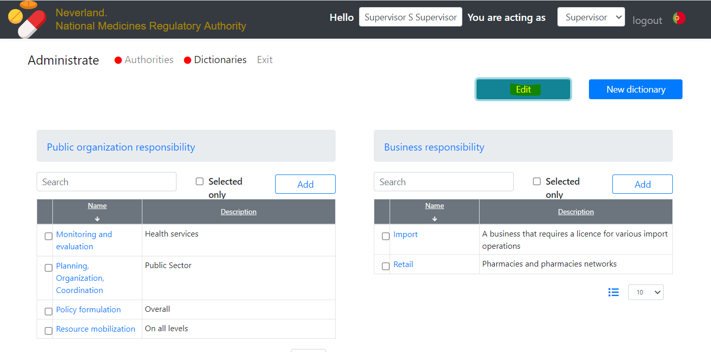

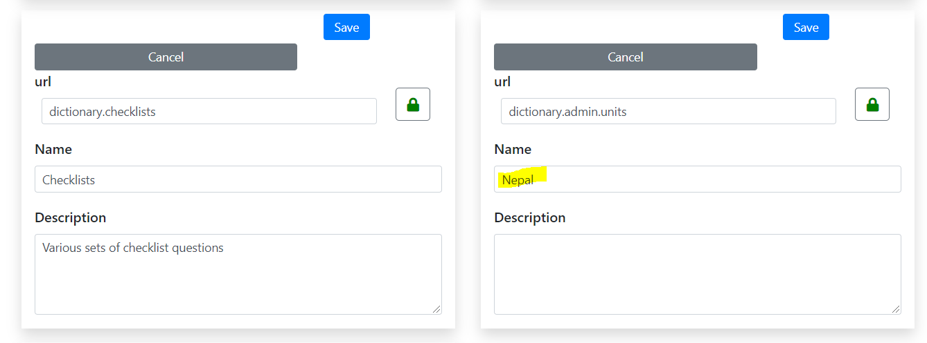

Please, put your attention to that field “URL” is protected from accidental change. In general, this parameter shouldn’t be changed.

The most common usage of this feature is to edit a name of a dictionary or introduce the name to another language. Let’s switch a language[3], press “Edit”, and, then, find out a dictionary. Fill out the name and press “Save”

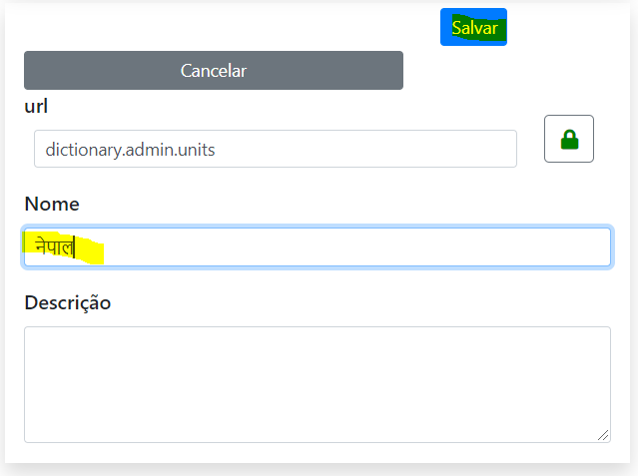

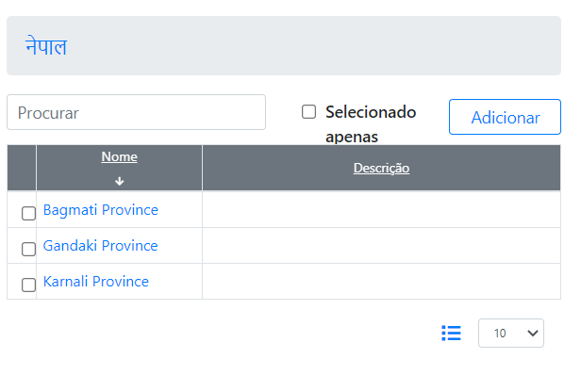

For US English the name is still in English

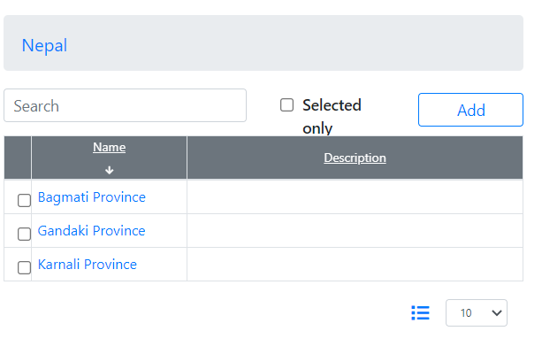

### Add a dictionary

To add a new dictionary, please press “New Dictionary”

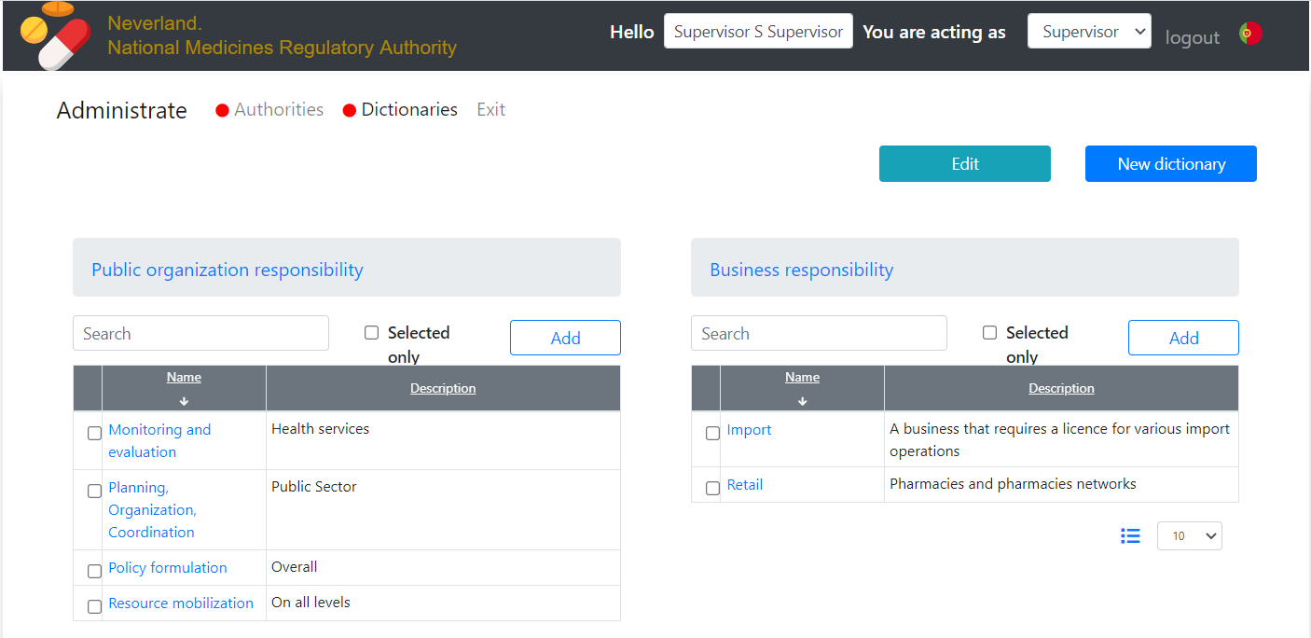

Ant, then, please fill out a form. Do not forget to unlock the “URL” field.

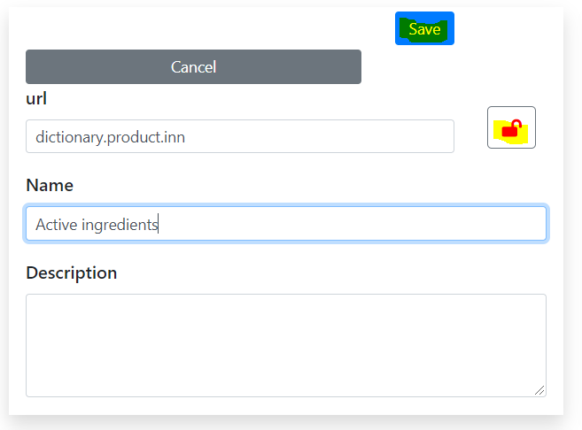

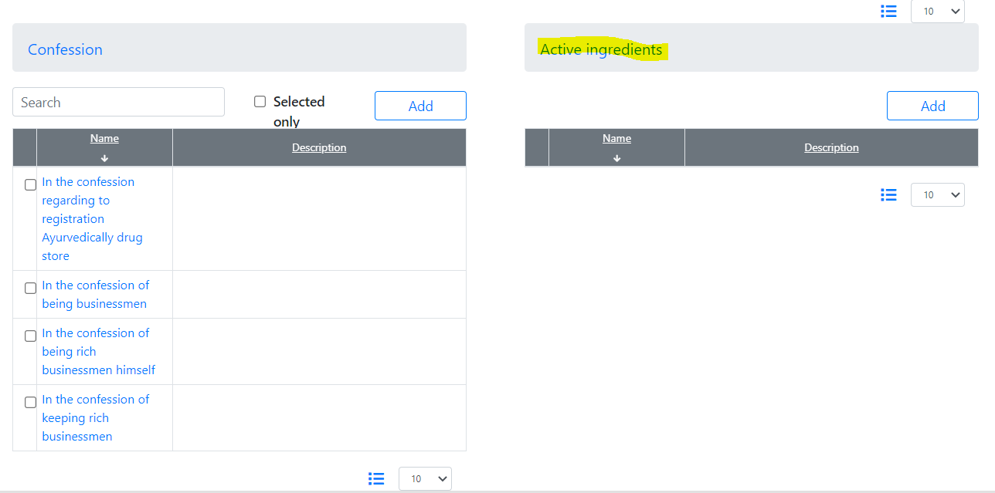

## Subscription to the service

### Motivation

Any business Subject may subscribe to electronic services provided by Pharmadex 2. The subscription means a possibility to use services electronically as well as receiving notifications and newsletters.

The initiator of subscription is the Subject. To initiate a subscription, the Subject should log in to Pharmadex 2 using a Gmail account and submit a form. Any Gmail account is suitable.

### Where to find it?

You must have a Gmail account. Please, log in with it using the “Join Community” menu:

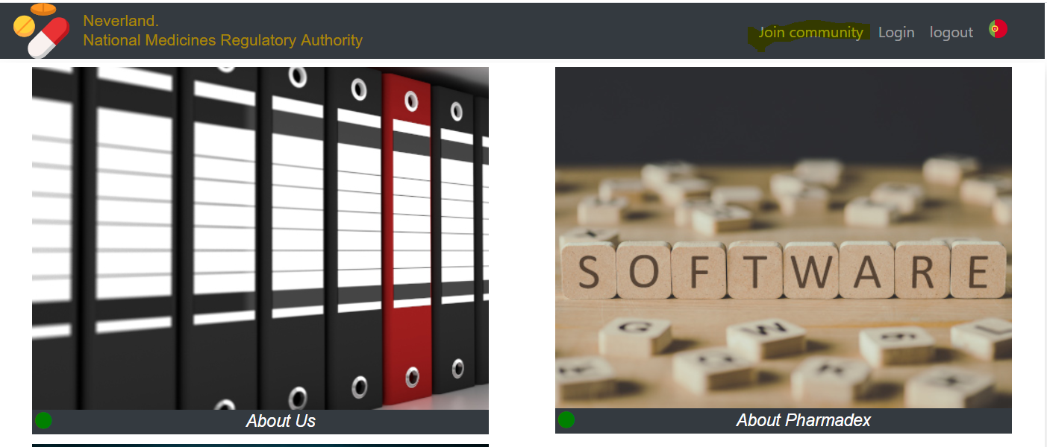

Select a Gmail login from the following form and, then receive a page for a guest[4]. The system is greeting you. Please, press “Join community” again.



### How to use

You will see the electronic form. This form is for illustration purposes only. The real form should be configured by the Supervisor in the following releases of Pharmadex 2.

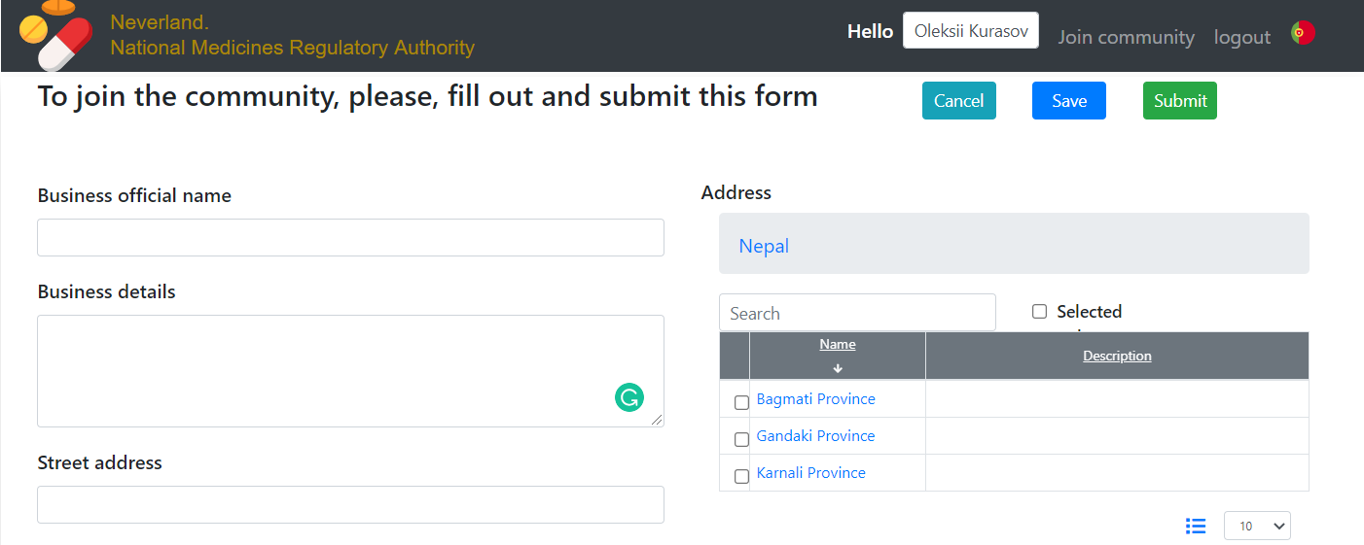 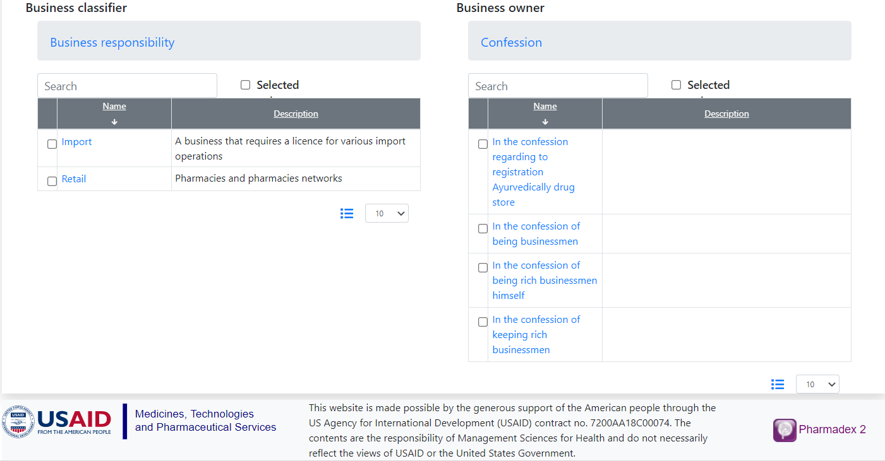

Please, fill out it and press “Save” Please, put your attention on the usage of dictionaries.

The “Submit” function is not implemented in this release.

The data entered into the form will be available only for the Supervisor and owner of the Gmail account.

# What’s next

The next release will be:

Subjects – business entity, business entity representatives, executives

Classifiers – improvements in dictionaries

Objects – form for a subscriber, electronic documents

Workflow – register business Subjects as a subscriber

Others – definition of the object by Supervisor

1. Please, provide me your address in Gmail. I’ll arrange this access shortly
2. Please, provide me your address in Gmail. I’ll arrange this access shortly
3. Imagine that is a switch to Nepali
4. In case you are using this Gmail for Supervisor as described above, please change address in Web browser address line to pharmadex.irka.in.ua/guest