Pharmadex 2. Release Notes 2021-05-15

Contents

Motivation 1

Pre-requisite 1

Demo release particularities 1

Workflow terms and definitions 2

Workflow configuration 2

Where to find? 2

How to use? 4

Activity goals configuration 4

Workflow implementation 4

What is implemented? 4

Where to find? 4

How to use? 5

Initialization 5

Tracking 8

What’s next 9

# Motivation

This release intends to discuss the preliminary implementation of a workflow. An initiator of a workflow should have the ability to initiate any available workflow and track it in real-time.

An example is New Pharmacy Registration Workflow.

# Pre-requisite

You must have a Gmail account.

# Demo release particularities

A workflow form in this release does not contain all data and features required. The related components, such are file uploaders, checklists, maps, etc., will be added later.

This release may contain errors, bad user interface behavior, and inconsistencies. Please, report them to [alex.kurasoff@gmail.com](mailto:alex.kurasoff@gmail.com).

You may do with the data whatever you want. The data will be restored to the initial state periodically.

# Workflow terms and definitions

A Workflow is a sequence of activities that collects and processes a set of data to achieve a well-defined goal.

* The implementation of workflows in Pharmadex 2 is suiting the only workflow that possible in core processes of a National Medicines Regulatory Agencies (NMRA).
* Activity is an atom job for one person that consists of processing data from the previous activities and collecting new data to achieve a well-defined goal.
* Activities may run concurrently.
* A set of NMRA goals of activities is well defined. Minimal is “Initialization”, “Review” and “Archive”. Some goals can be merged into a single activity ( Table 1)
* Data form for each activity depends solely on workflow goal

Table

| **#** | **Goal** | **Description** | **Data processed** | **Data Collected** |
| --- | --- | --- | --- | --- |
| 1 | Initialization | Collect initial data for NMRA by a business entity | As defined in the national legislature | As defined in an on-screen form |
| 2 | Acceptance | Check initial data presentation | The initial data sent by a business entity | Notes of presentation if ones. Check the payments. |
| 3 | Screening | Check initial data completeness | The initial data sent by a business entity | Notes of presentation if ones. |
| 4 | Review | The substantive check of the initial data | The initial data sent by a business entity | Notes regarding the substantive check, if ones |
| 5 | Solution | Formulation the result of workflow | The review result | Formulation of the results |
| 6 | Archive | Entry the solution into force. Completeness of the legal actions. | The formulation of the result. | The results of legal actions are completed. Payments from a business entity. |

# Workflow configuration

## Where to find it?

Log in as Supervisor, and open

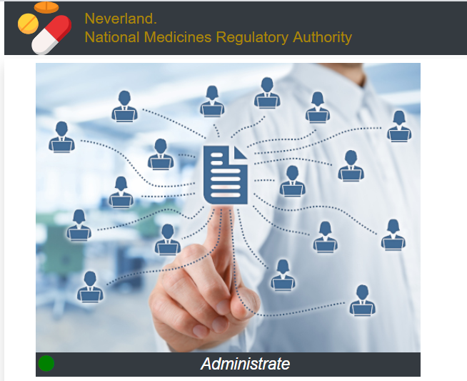

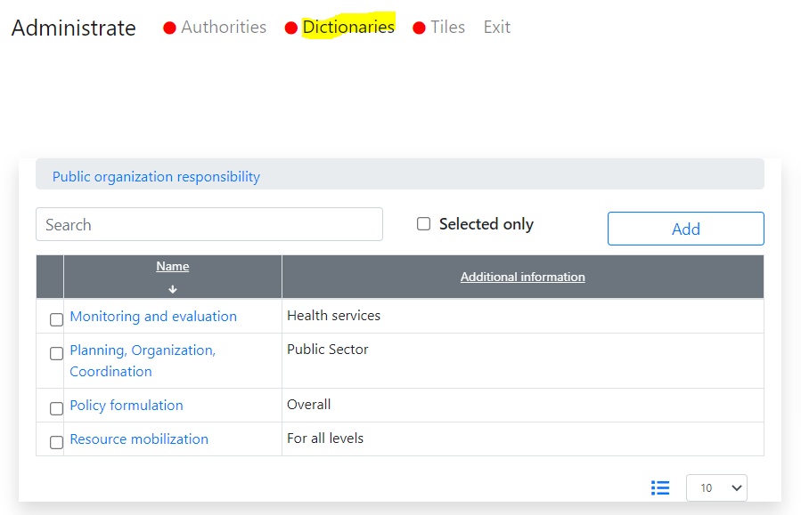

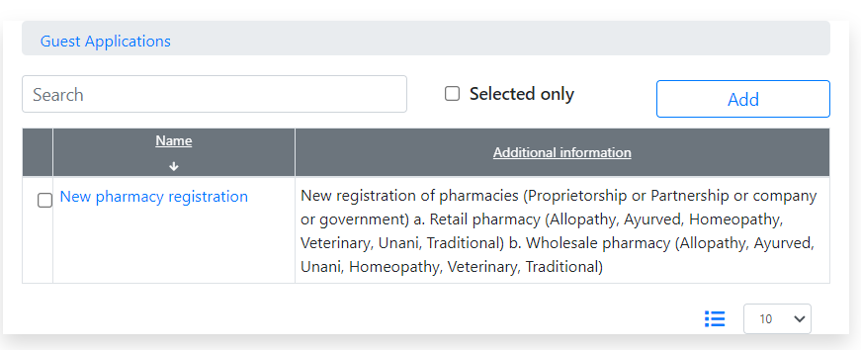

Please open and explore it.

## How to use it?

Any new workflow will be added as a new record to this dictionary. The record should look like

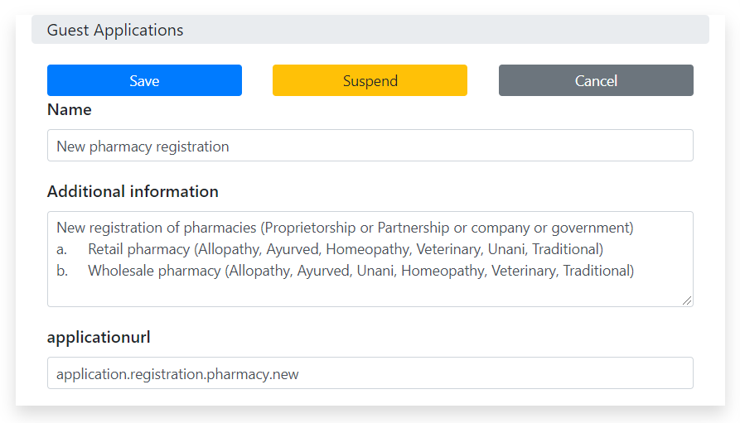

## Activity goals configuration

Activity goal configuration consists of

1. General data
2. Electronic form components
3. Form actions

Currently all the above are configured by the temporary software mock, thus not available for users.

# Workflow implementation

## What is implemented?

For new pharmacy registration is available:

* The goal “Initialization”.
* Transit to a goal “Screening”
* The workflow tracking by an initiator

## Where to find it?

Log in using a free[1] Gmail account.

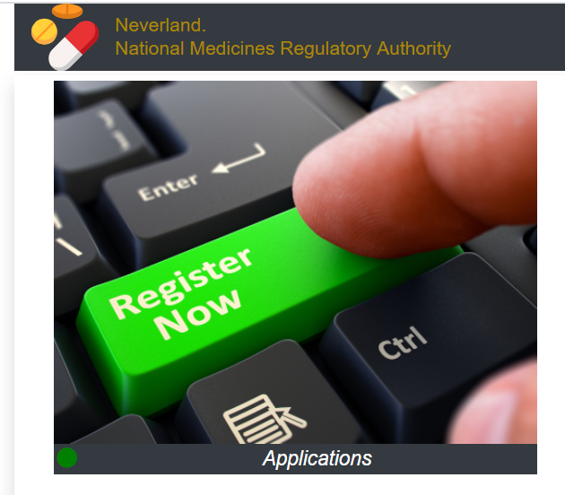

## How to use it?

### Initialization

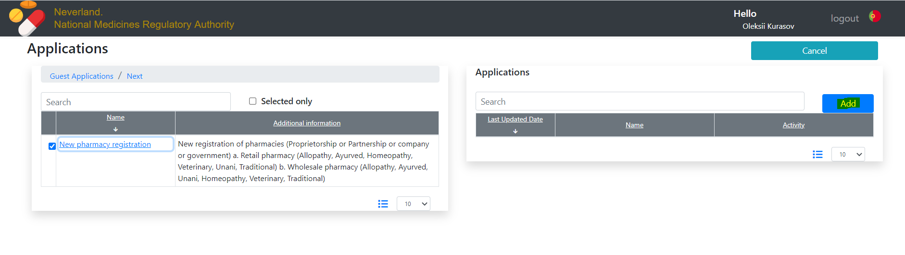

And, then, press Add

Fill out the form

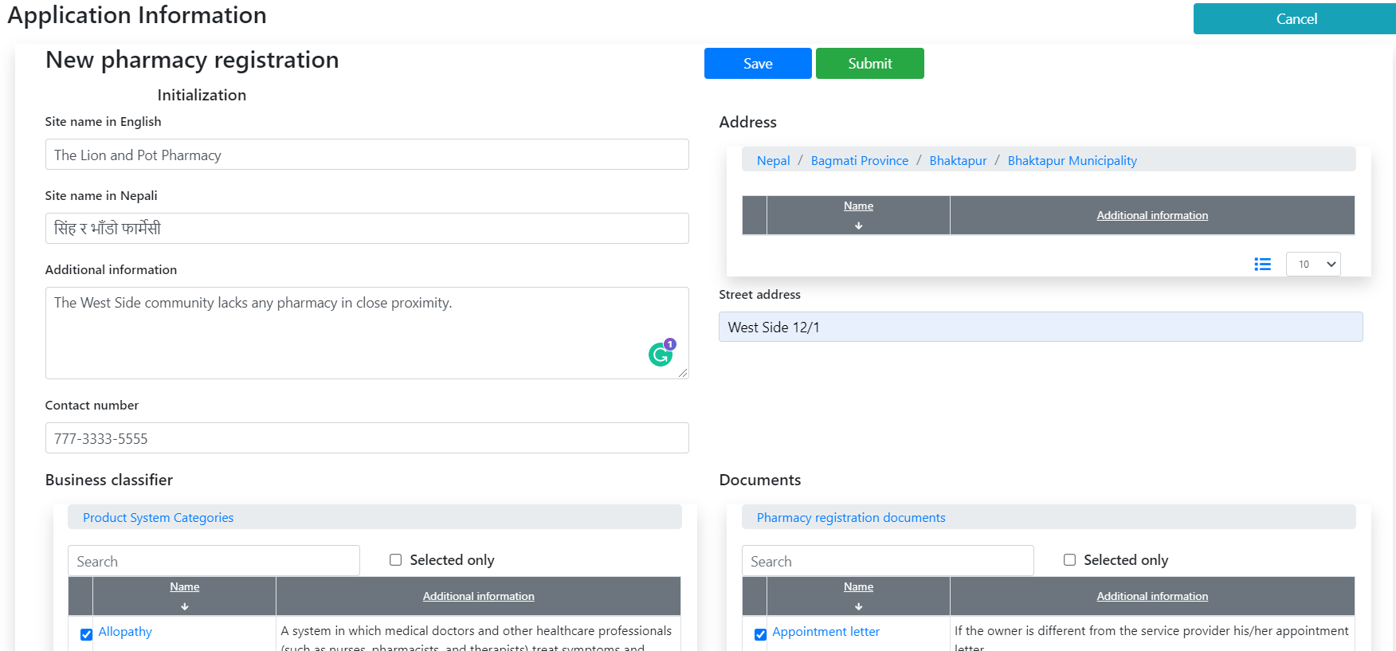

And, then, press Save or Submit.

The button “Save” means that you may add or revise data and submit it later.

The button “Submit” means that you will pass all data to NMRA

Let’s press “Save”

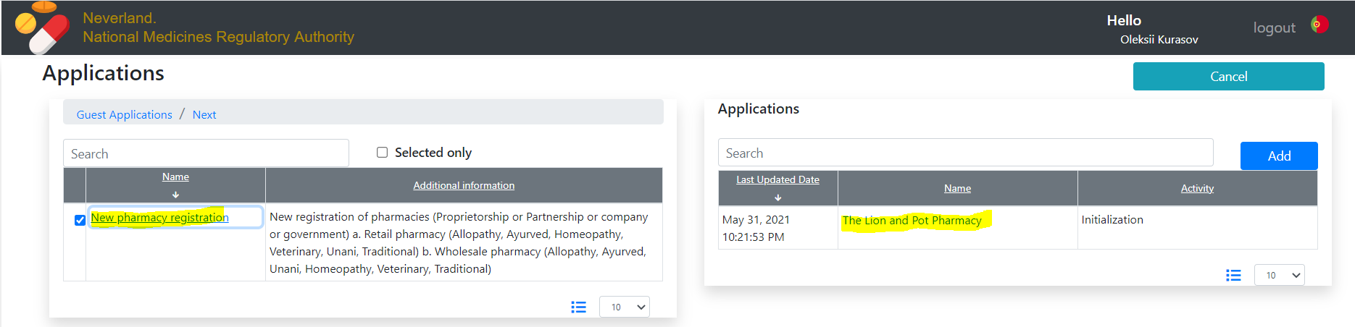

You can open it again by click on the name in the right table, and, then, Submit

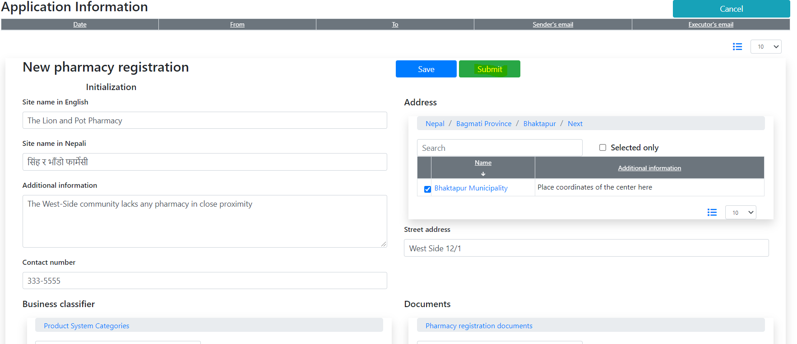

Then, you will see a confirmation screen

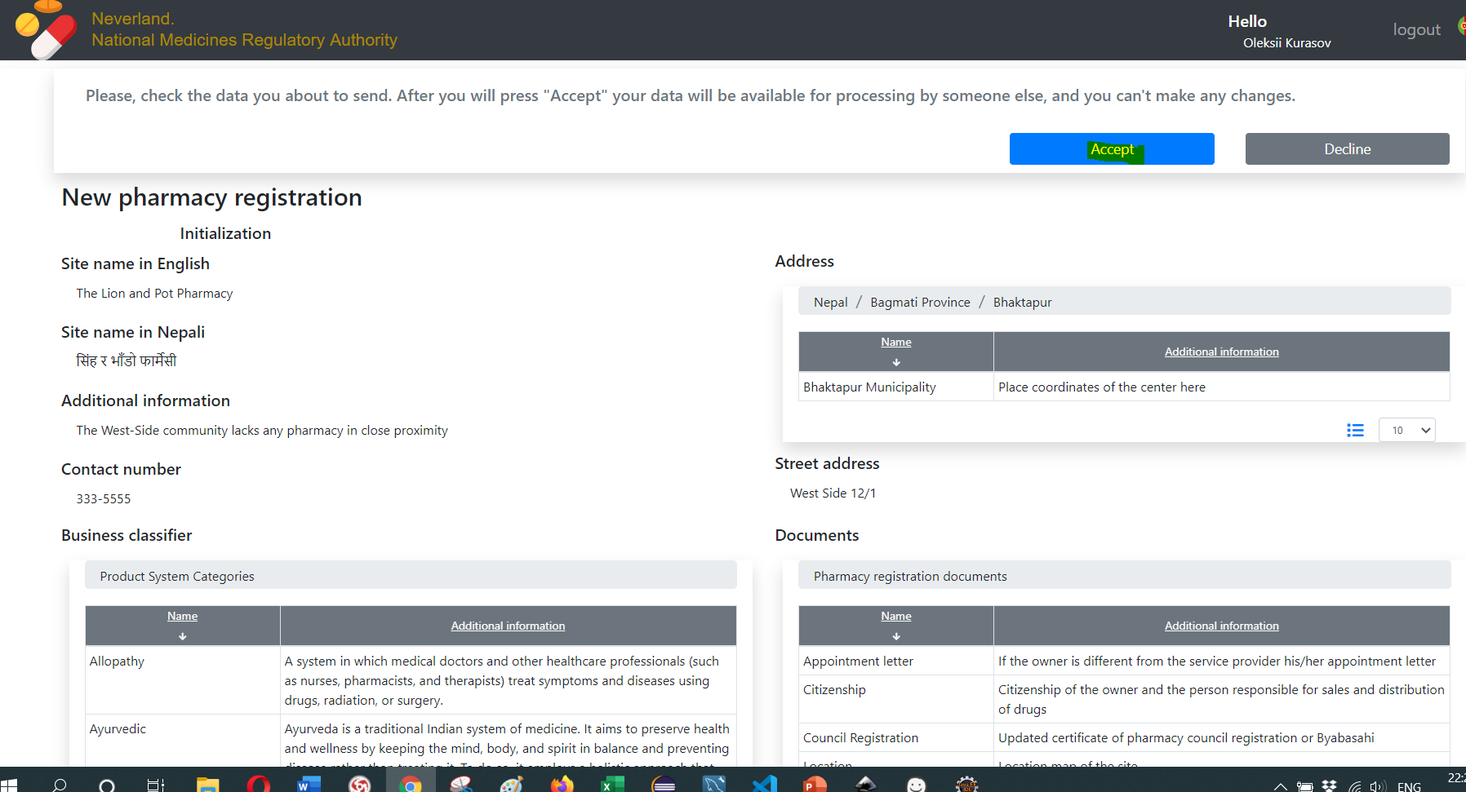

Press “Accept”. The application will come to activity with the goal “Screening”

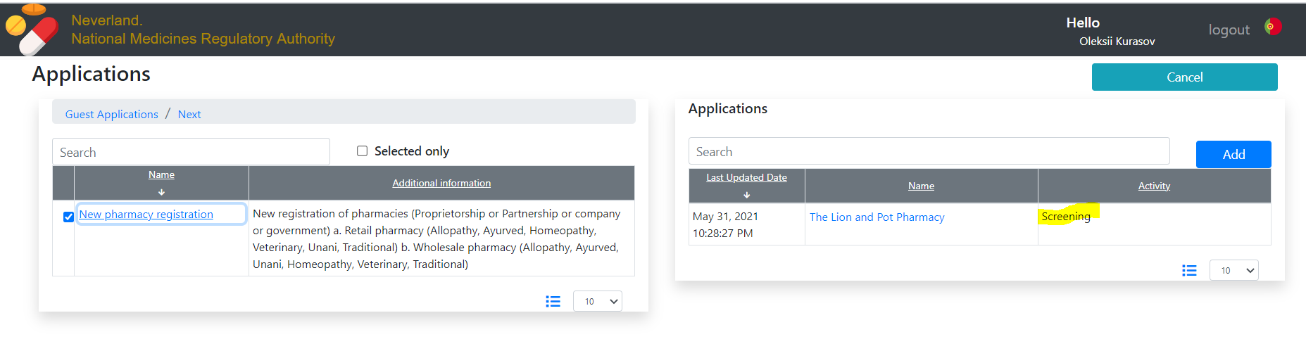

### Tracking

The initiator (a business entity) can track the completeness of an application. Please, click on the name in the right table.

On the top, you can see all application track. At the bottom is placed data collected on the current activity. For this example – nothing collected yet.

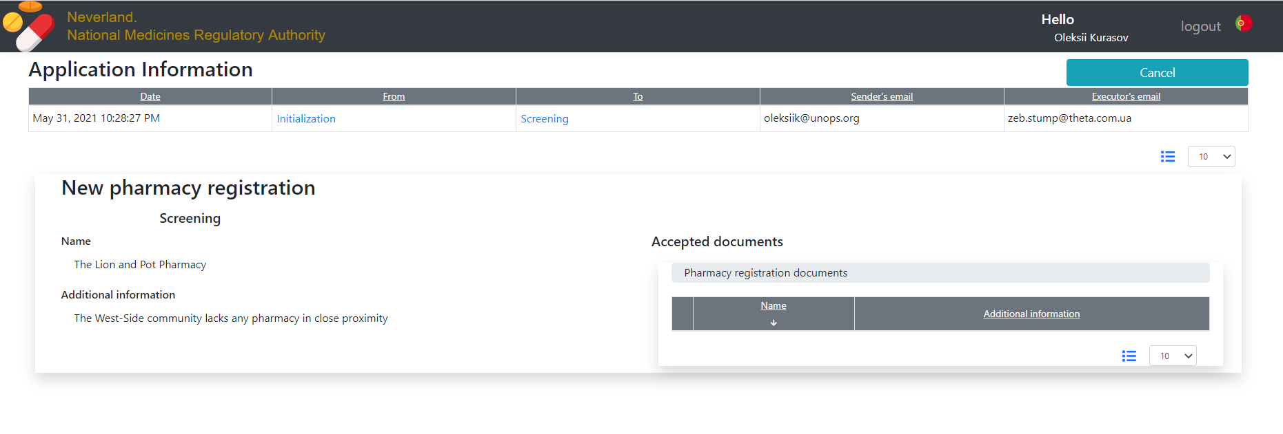

You can reference data from the other goals. In this case – Initialization by click on it in the tracker

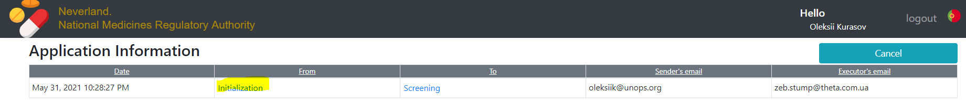

You will still see the current activity and, in addition, the selected one

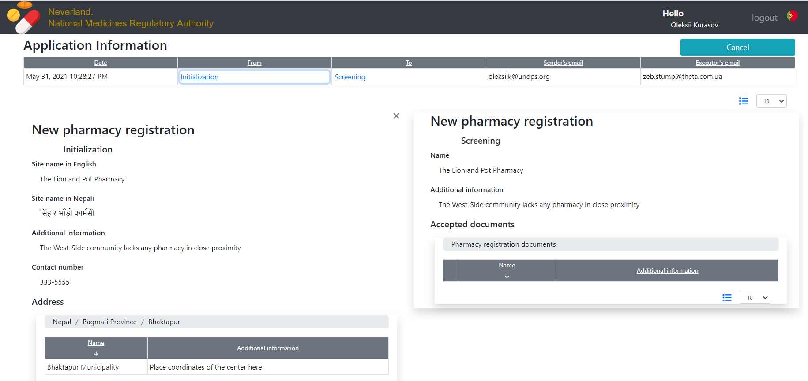

Thus, the tracking feature allows you to see the latest and any other activity at once.

In the future, this way will be organized look the following activities.

# What’s next

Will be determined on Jun 1, 2021.

1. It means not defined for Supervisor