Pharmadex 2. Release Notes 2021-06-07

Contents

Motivation 1

Pre-requisite 1

Demo release particularities 1

New features 2

Supervisor tool 2

Manage 2

Configuration 2

Components 3

Processes 5

Reports 8

Documentation 8

# Motivation

This release demonstrates user management and workflow implementation approaches. Nevertheless, the main intention of this release is to illustrate the proposed Work Breakdown Structure of the project.

# Pre-requisite

You must have a Gmail account.

# Demo release particularities

A workflow form in this release does not contain all data and features required. See the Roadmap for reference.

This release may contain errors, bad user interface behavior, and inconsistencies. Please, report them to [alex.kurasoff@gmail.com](mailto:alex.kurasoff@gmail.com).

You may do with the data whatever you want. The data will be restored to the initial state periodically.

# New features

## Supervisor tool

### Manage

This release demonstrates persons/user management. To check this feature you should log in as Supervisor. Please ask [alex.kurasoff@gmail.com](mailto:alex.kurasoff@gmail.com) in case of any difficulties.

Select Administrate – Authorities and inspect any user’s record.

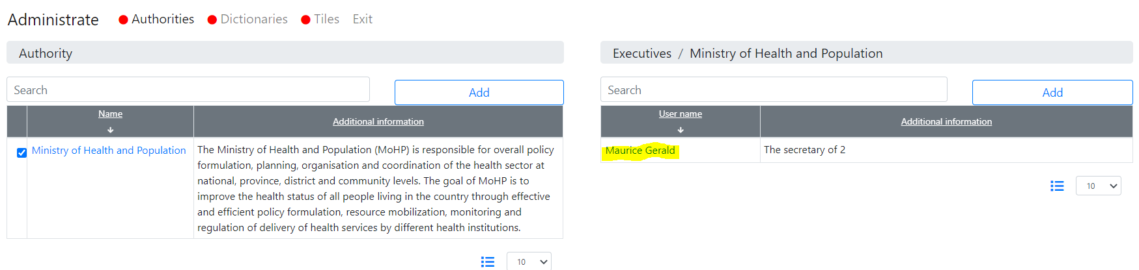

This feature allows assign roles and responsibilities for a user, as well as enable or disable access for any user, including applicants.

### Configuration

**Dictionaries** – “User roles” and “Pharmacy registration documents”.

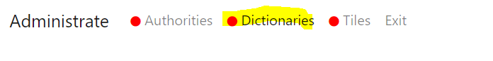

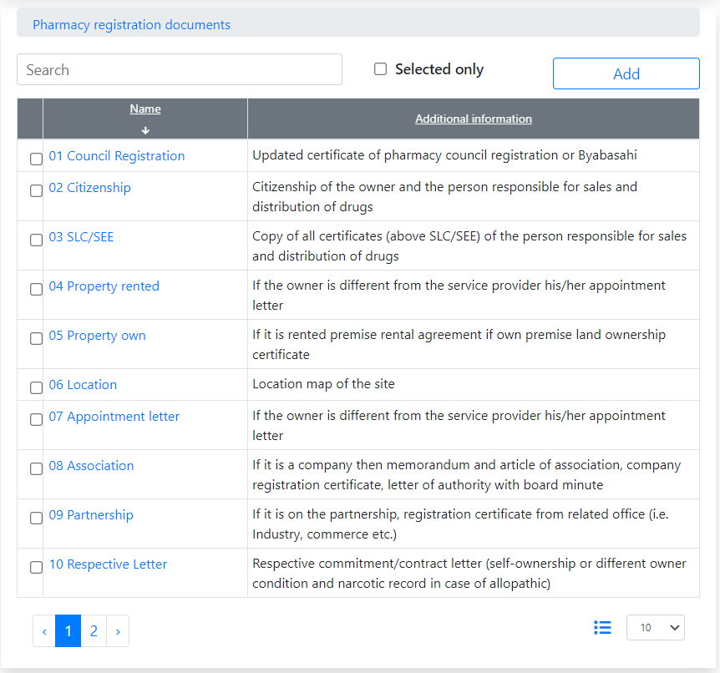

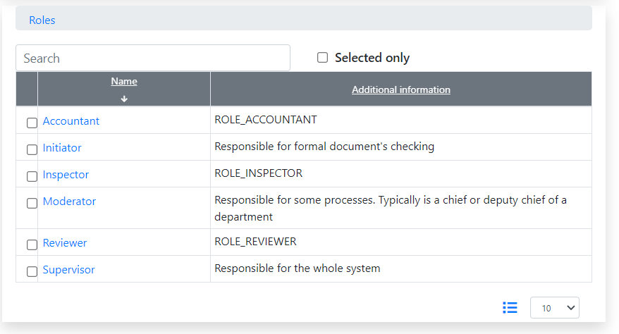

## Components

**File storage approach.**

Mainly, files are copies of electronic documents or pictures. Currently, the files are related only to an applicant.

In the next step, we will add relations to applicant’s sites and employees.

**File storage component**

The file storage component can be created using any one-level dictionary as a list of document categories. To get it, please log in as an applicant user and start a new application.

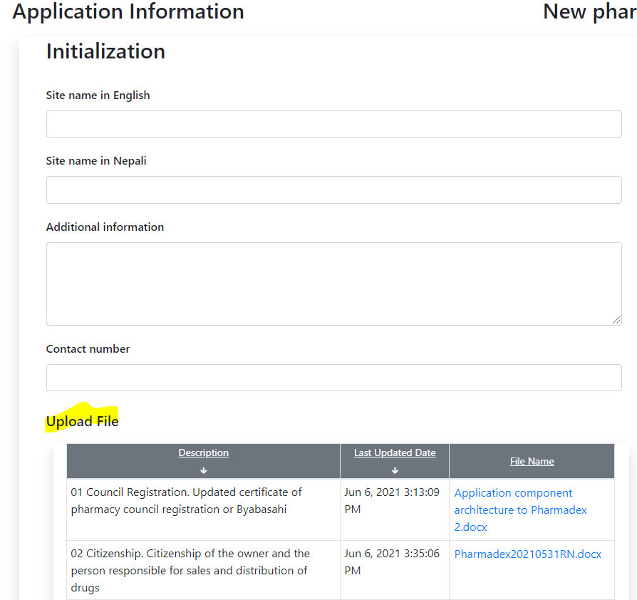

It is possible to upload new or replace the existing files. Please, note, that for current, the files will be related only to an Applicant, not site, not applicant’s persons.

**Workflow actions approach**

In general, we do not need a hardcoded list of possible actions, like screening, review, inspection, etc. However, we will need a list of all possible actions in an activity. The list is:

* Save
* Return to Applicant
* Submit
* Reassign expert

We need these actions hardcoded, because of the unique algorithm of implementation for each.

**Workflow actions component**

Looks like a series of buttons. Each button initiated its algorithm in Pharmadex 2. A supervisor will configure which buttons should be shown for which activity.



## Processes

Currently implemented straight cycle of application processing from submitting to an applicant to review. The rest of the activities will be implemented in the next release.

To process an application:

* Login as an applicant (any Gmail)
* Start a new application
* Submit it until the review state.

An example is below:

Start

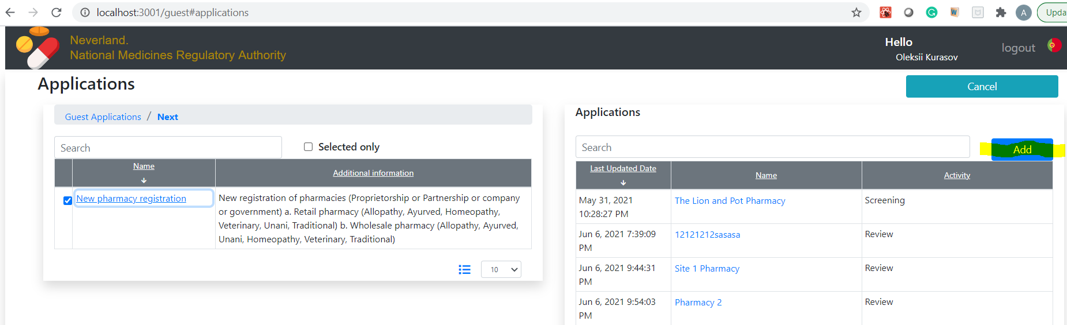

Fill out and submit

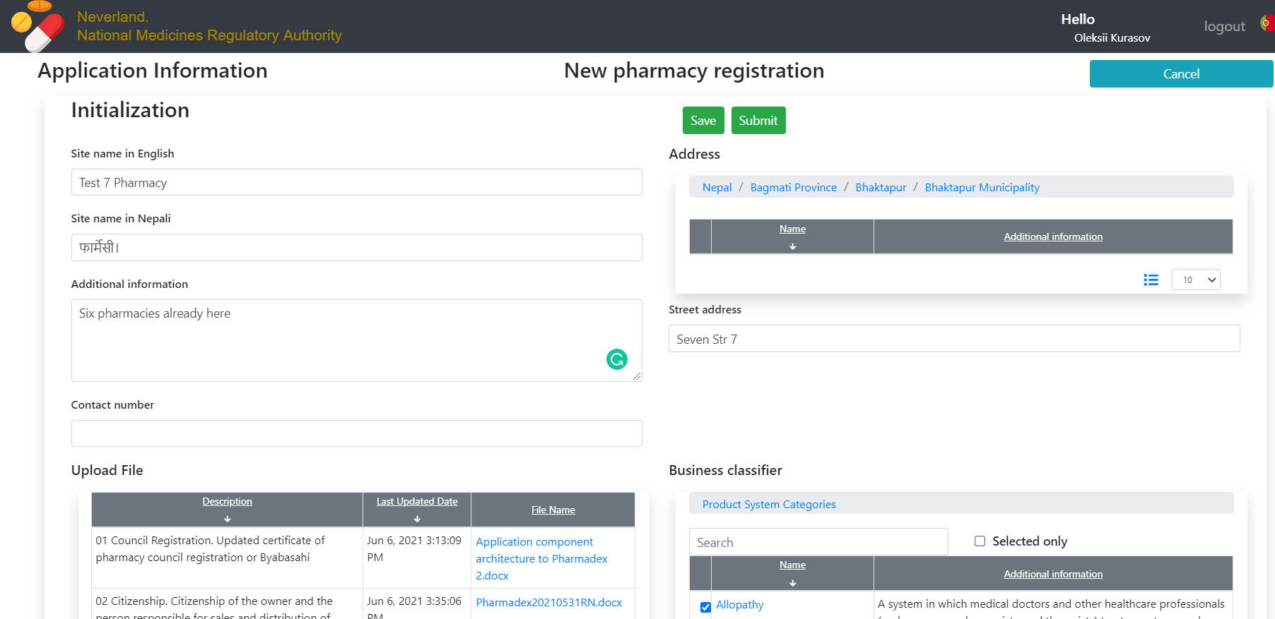

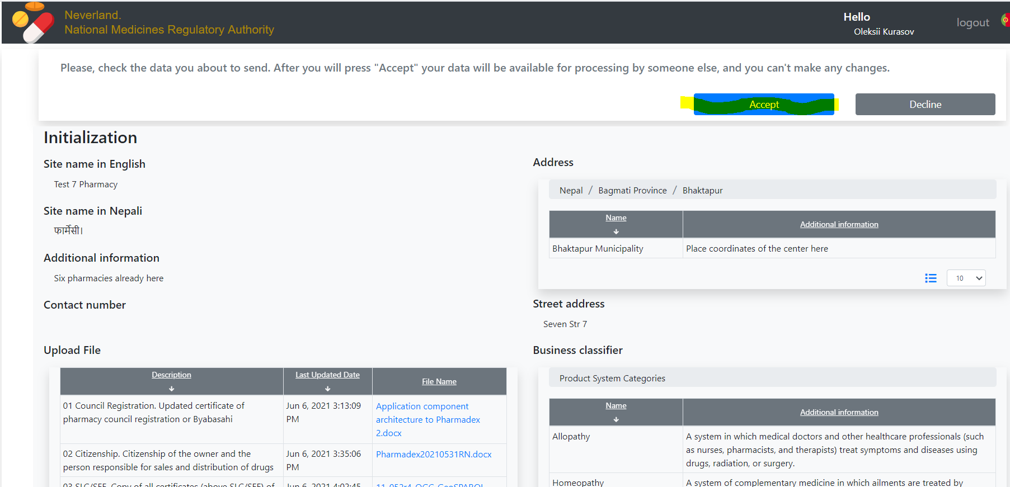

log in as a Screener. It is administrative login with multiply roles

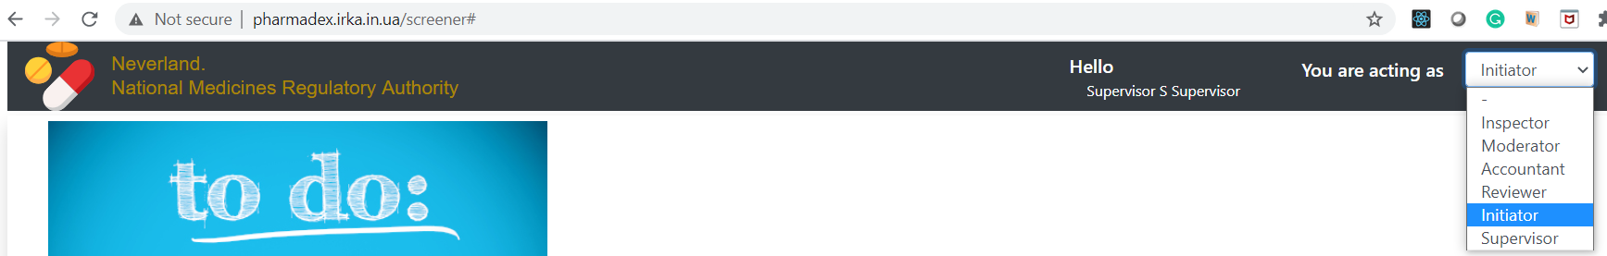

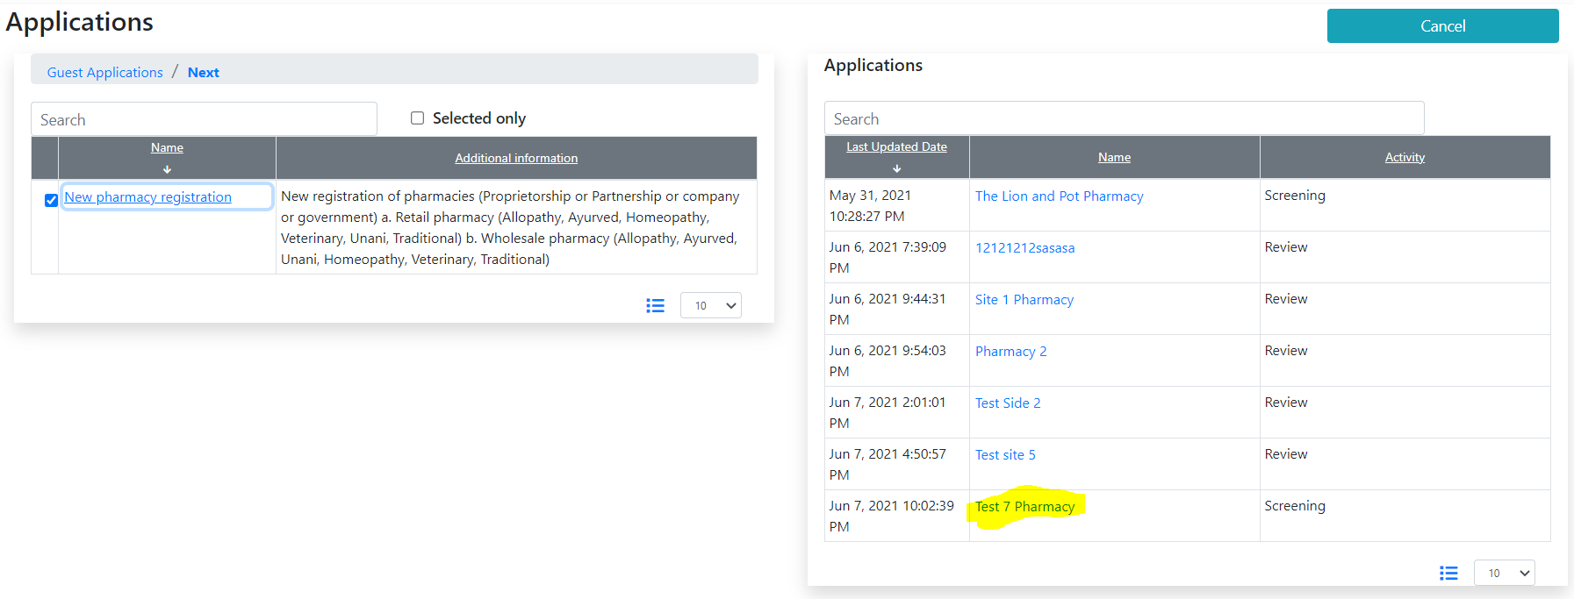

Fill out the checklist under “Applications” and submit it

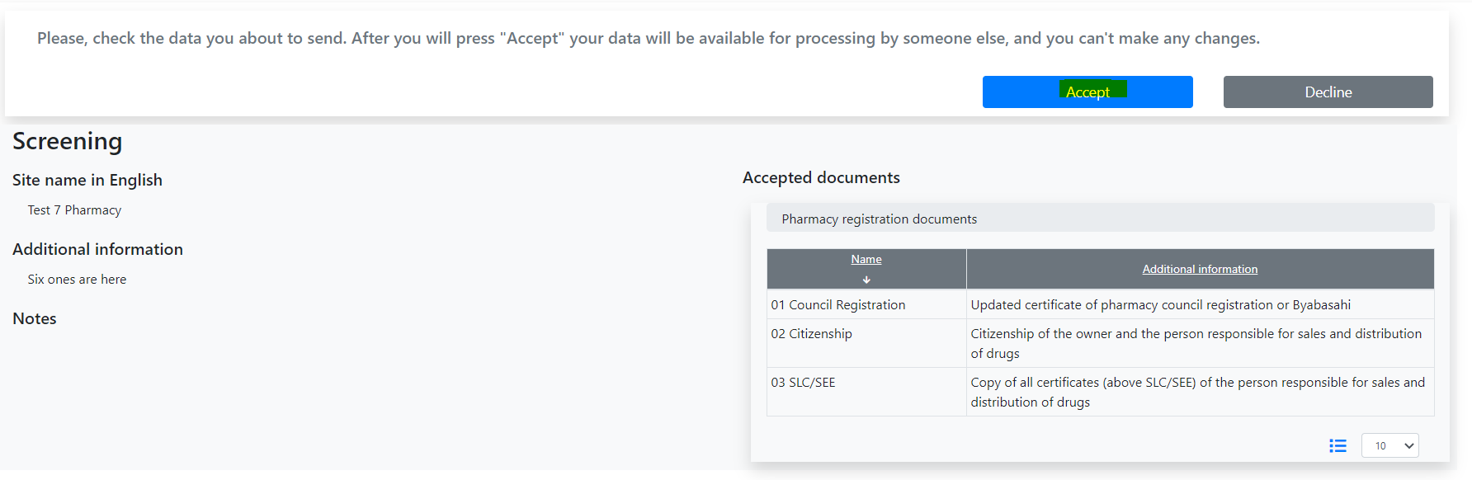

Change role to Reviewer

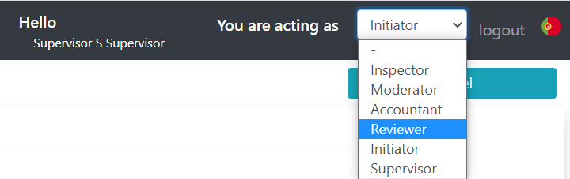

Open an application

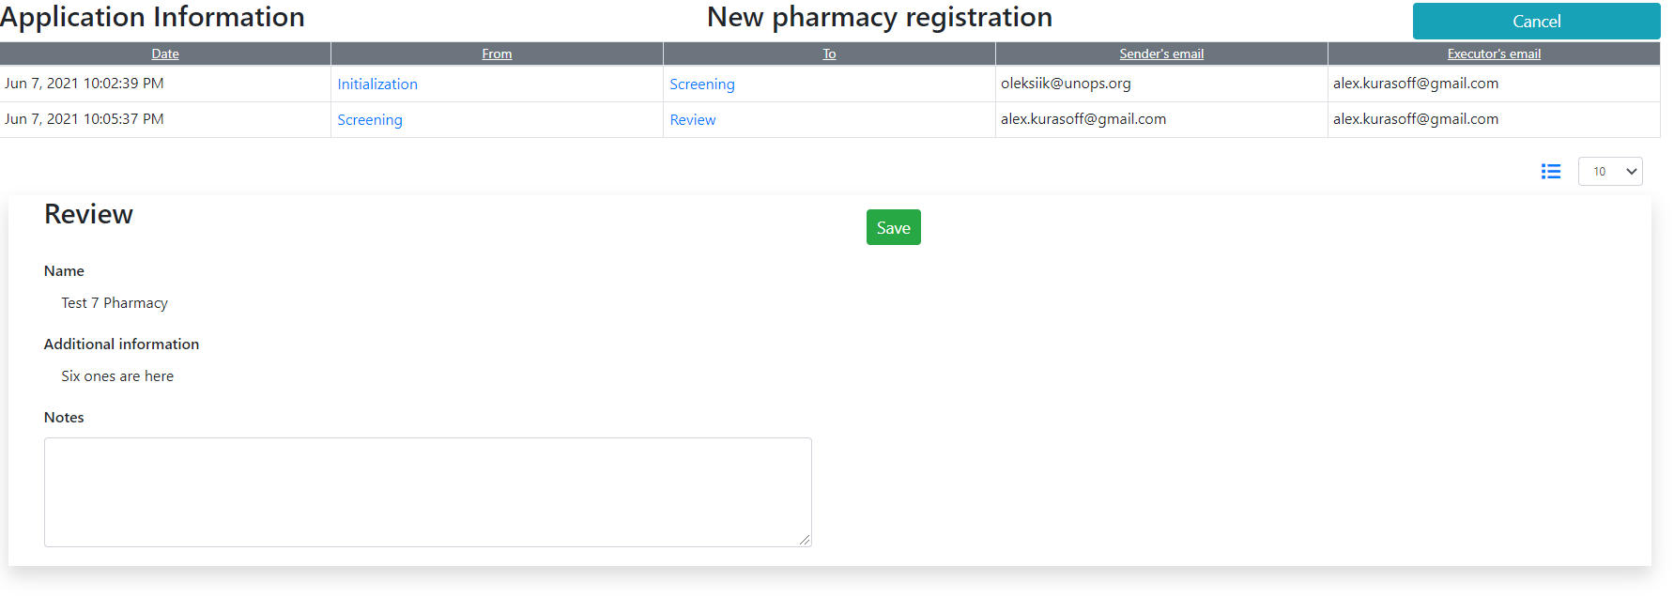

to be concluded…

Please, put your attention to the history table at the up of the screen.



You can open data from any activity that passed

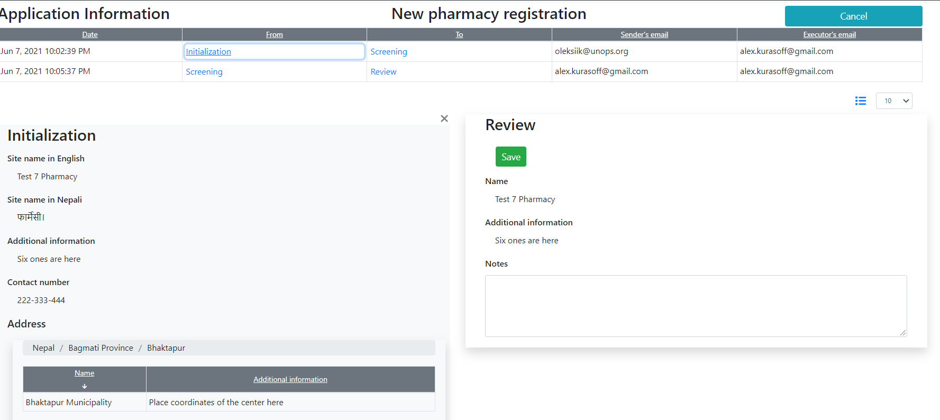

## Reports

To support user files and activity history have been developed SQL queries and stored procedures that in the future will be used for reporting.

## Documentation

Nothing new yet.