Pharmadex 2. Release Notes 2021-06-27

Contents

Motivation 1

Pre-requisite 1

Demo release particularities 1

New features 2

Supervisor tool 2

Manage 2

Configuration 2

Components 3

Processes 5

Reports 8

Documentation 8

# Motivation

An applicant has to fill out a huge amount of cumbersome data. The data is huge because consists of up to 60 fields. The data is cumbersome because of 5 completely separate data input elements – from plain good text input fields to Spatial data placed on the Google Map.

We propose:

* To split this complex data input into logically coupled and relatively easy sub-forms
* To use a pre-defined sequence guide to fill out the data
* To minimize quantity, behavior, and look of visual data input elements
* To split the current process into 3 different depends on the pharmacy category – A, AB ABC

This release contains two examples that should be executed in sequence:

* Site information is divided into two sub-forms
* Person data – the owner of a pharmacy that is divided into two sub-forms

# The demonstration provided seems not perfect, however, gives us the background to future development.

# Pre-requisite

You must have a Gmail account.

# Demo release particularities

This release contains only application initiation forms. The next steps seem unpractical before discussing this one.

This release may contain errors, bad user interface behavior, and inconsistencies. Please, report them to [alex.kurasoff@gmail.com](mailto:alex.kurasoff@gmail.com).

You may do with the data whatever you want. The data will be restored to the initial state periodically.

# How to start

Log in as a plain applicant, using a Gmail account. Select Applications-Start, New pharmacy registration-Add.

The first sub-form allows to fill up a piece of general site information as well as address and geo-spatial data.

To input geospatial data, please, select the administrative unit

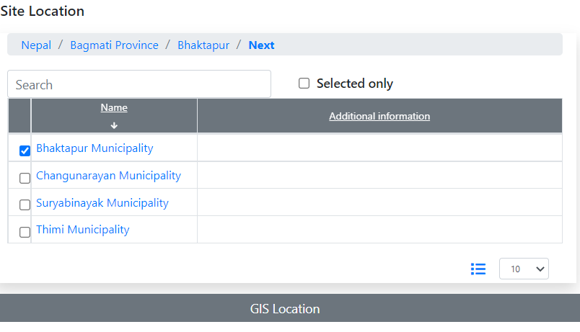

and then, press the GIS Location button.

You may put a marker on the map and, then, press a Save button

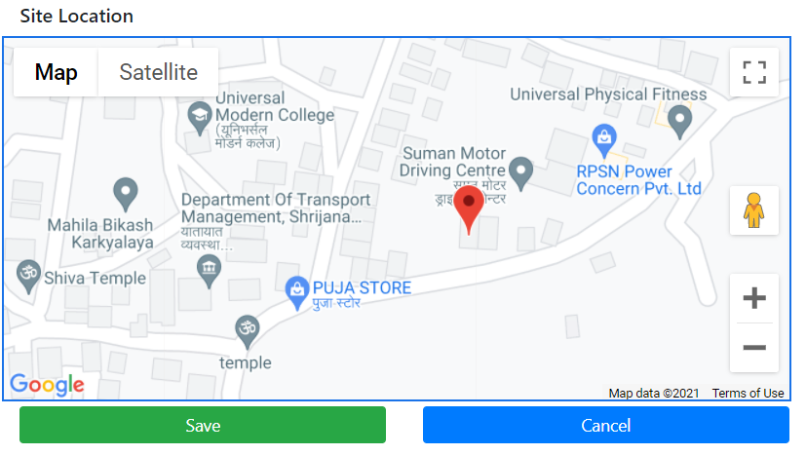

Please note, that the data input validation rule requires a definition of both – administrative unit and geo-spatial data.

After filling in all data, press Next on the upper bar

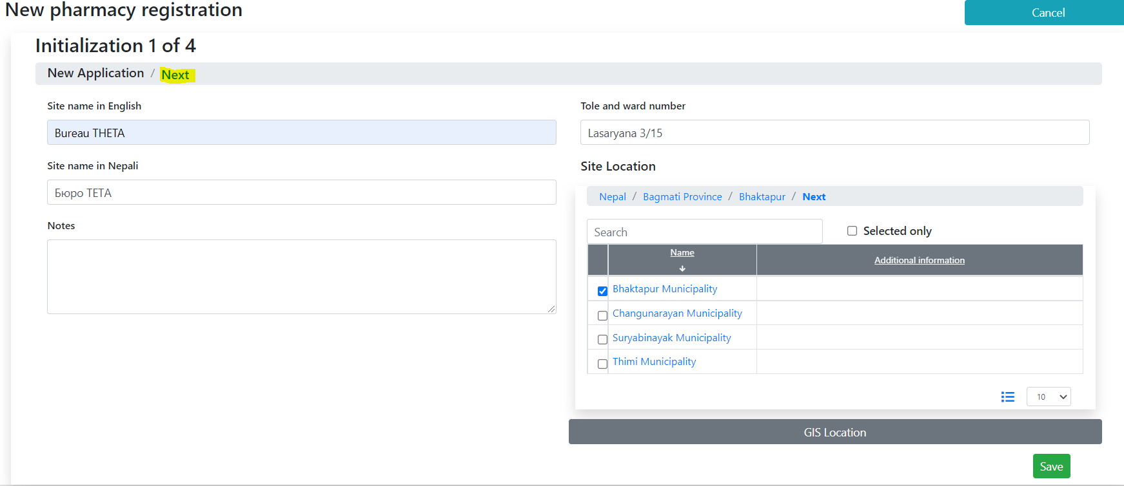

# How to use

You can do with this form whatever you want. Please try to get how to use them. Your impression will be very important for usability improvement