Pharmadex 2. Release Notes 2021-07-04

Contents

Motivation 1

Pre-requisite 2

Demo release particularities 2

How to start 2

How to use 2

Checklist data 3

Checklist component and the dictionary 3

# Motivation

To pass the registration process smoothly, an applicant should provide DDA qualitative information. The information should be, at least, complete and free of contradiction.

The completeness of information means that information should contain all data required by legislation and no more.

The Pharmadex 2 provides an electronic tool to help create qualitative information:

1. Electronic forms:
   1. Set of data fields to fill out or select from pre-defined
   2. Data validation rules
   3. On-screen data layout
2. Predefined sequences to fill out the electronic forms
3. Data in the database available for re-use
4. On-line guides and references

The tool is highly configurable. The main challenge is to decide the best approach of configuration.

Currently, the configuration tasks are:

1. The current new pharmacy registration process is complex and cumbersome. Thus, it will be a good idea to split it into well-documented manageable workflows with data input as to specific as possible. The splitting should be based, for example, on pharmacy size.
2. The SRS document contains uniform data input forms wireframes for the owner, manager, and dispenser. It will be a good idea to make them specialized.
3. Maybe it will be necessary to regroup sub-form data in a more logical and manageable way.

While configuration tasks completion it is necessary to keep the right balance between formality and informality by using not only formal data validation rules but also online guides and references. For example:

* Brief and clear explanation for each workflow
* Descriptions of the data choices
* Descriptions of file upload, include, but are not limited which are mandatory and in which cases. Reference to form numbers etc.
* Clear and comprehensive self–check checklist with a brief and clear description of which item.

**The current demo version contains the first iteration of the data input sub-forms sequence. It should be considered as a base of the improvements. It should not be considered as the production software.**

# Pre-requisite

You must have a Gmail account.

# Demo release particularities

This release may contain errors, bad user interface behavior, and inconsistencies. Please, report them to [alex.kurasoff@gmail.com](mailto:alex.kurasoff@gmail.com).

You may do with the data whatever you want. The data will be restored to the initial state periodically.

# How to start

Log in as a plain applicant, using a Gmail account. Select Applications-Start, New pharmacy registration-Add.

Please, access the latest data input step (“Conclude”). It is a good candidate for the user interface for DDA staff.

# How to use

Please, fill out data to the step “Conclude”

## Checklist data

The checklist on the conclude form contains data from the dictionary defined by Supervisor. To edit it, please log in as Administrator and, then, edit this dictionary

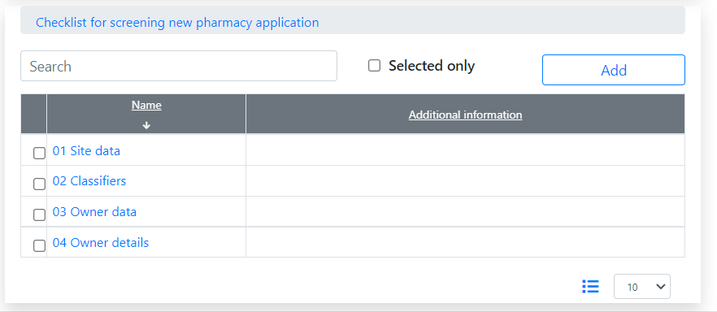

Select to expand

click to edit

## Checklist component and the dictionary

