Pharmadex 2. Release Notes 2021-07-11

Contents

Motivation 1

Pre-requisite 1

Demo release particularities 1

How to start 1

How to use 2

Question to discuss 5

Next release 5

# Motivation

The previous demo version has been reviewed. The following has been planned for the next release:

* Provide the ability to add more than one owner to an application in case of partnership
* Provide the ability to add all pharmacy staff members to an application.
* Clarify document lists, checklists data, validation rules, the text of labels, etc., to be understandable for DDA staff
* Resolve common issues, like filters by file types, some user’s interface improvements, etc.

**The current demo version contains the second iteration of the data input sub-forms sequence. It should be considered as a base of the improvements. It should not be considered as the production software.**

# Pre-requisite

You must have a Gmail account.

# Demo release particularities

This release may contain errors, bad user interface behavior, and inconsistencies. Please, report them to [alex.kurasoff@gmail.com](mailto:alex.kurasoff@gmail.com).

You may do with the data whatever you want. The data will be restored to the initial state periodically.

# How to start

Log in as a plain applicant, using a Gmail account. Select Applications-Start, New pharmacy registration-Add.

# How to use

Please, fill out data to the step “Conclude”. Please, put your attention to the data input of pharmacy owners and employees.

We keep the same “breadcrumb” data navigation approach to provide:

* possibility for a user to use the existing experience
* possibility to fill-out complex data in short manageable paces

The only difference is the “data input loop” that looks like:

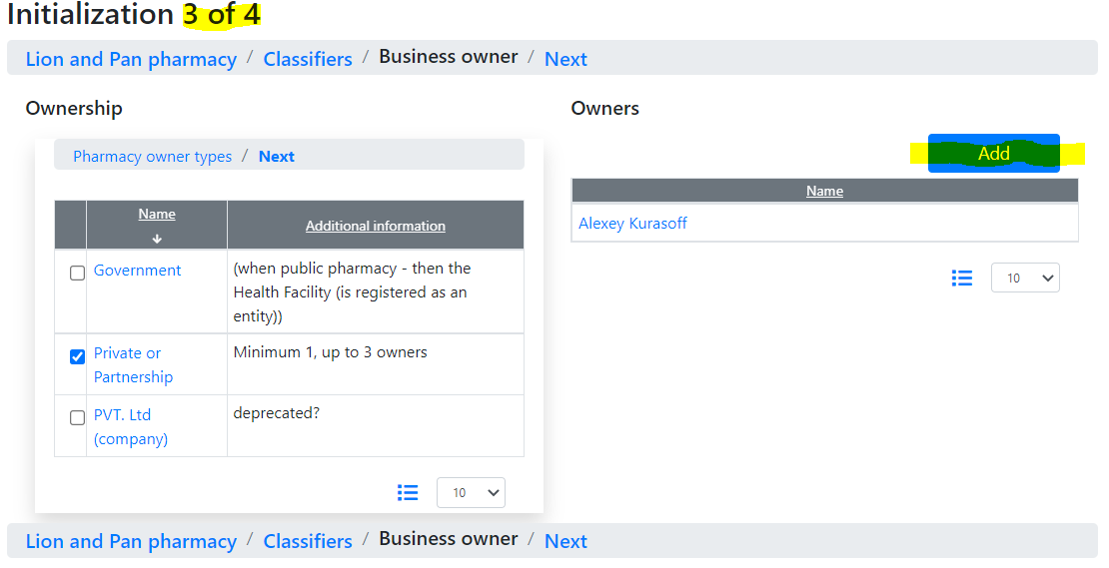

Press Add

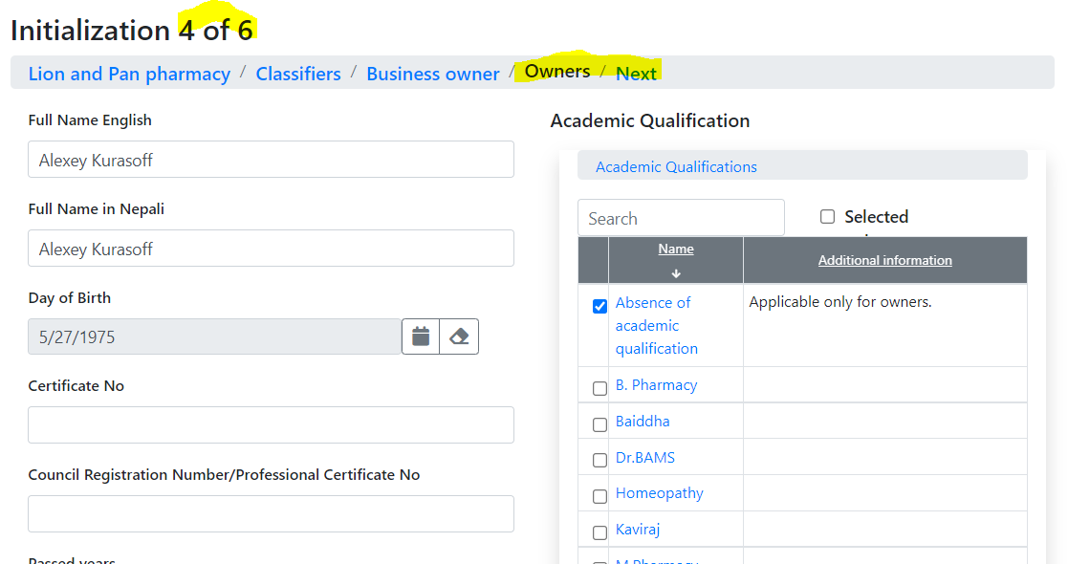

Press “Next”

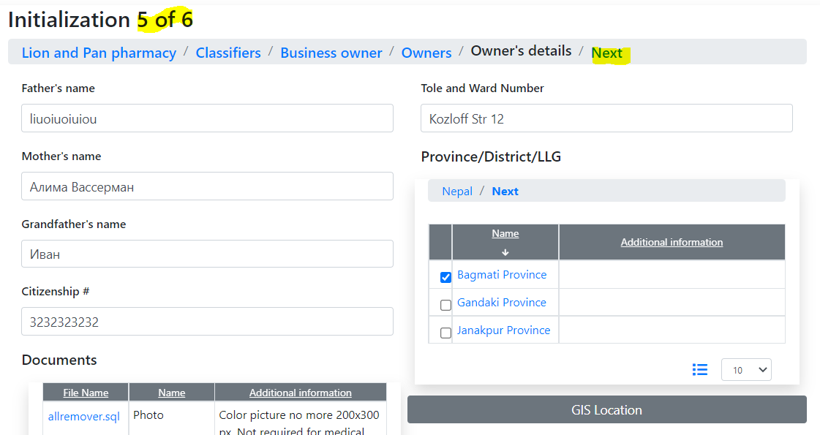

Press “Next” and return to the beginning of the loop

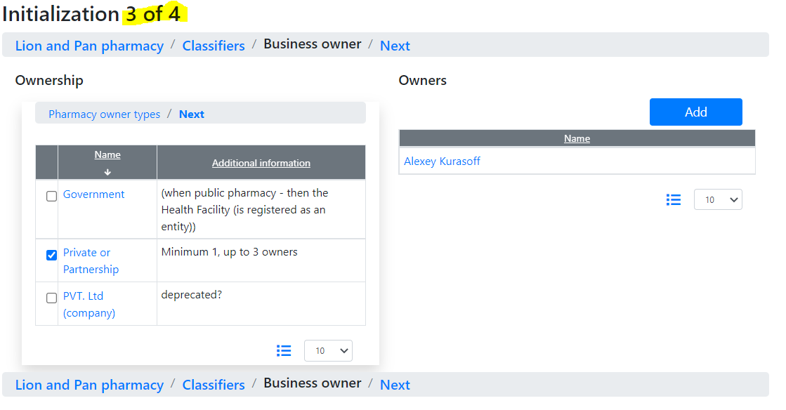

To avoid the long, unmanageable data in the read-only mode, the read-only representation also provides new functionality. Consider the “Conclude” step.

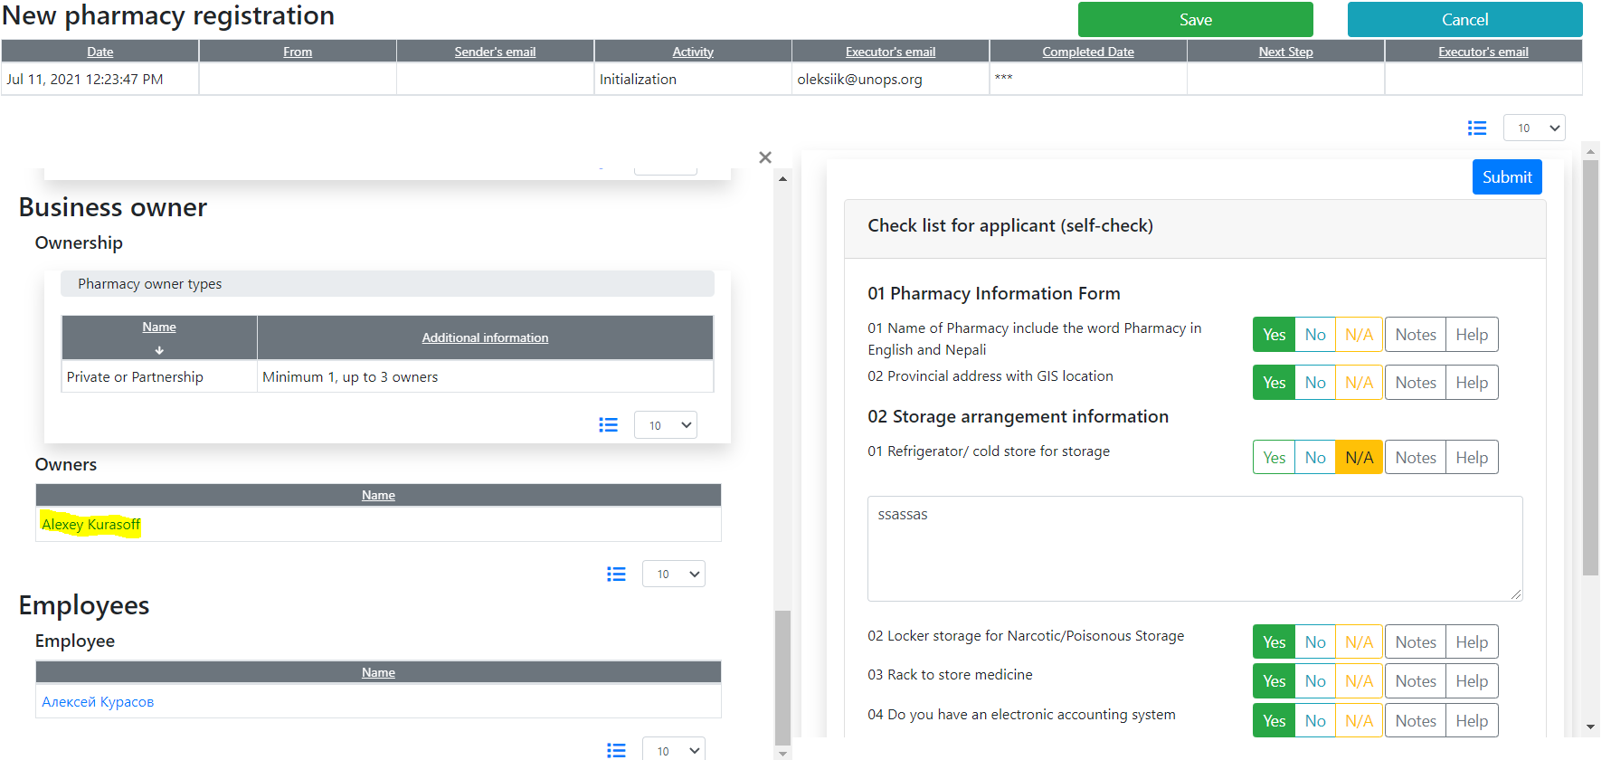

Click on the owner to expand the data



# Question to discuss

Issue 718 is still unclear. We’ve never seen such functionality in web applications. The proposal is to implement it using a sequence of steps. Will be its worth implementing in such a complex way?

# Next release

We hope that the second iteration of the application’s data input approach will be acceptable. Therefore, the workflow implementation is planned for the next demo release.

This implementation is supposed to be very similar to the “Conclude” step.