Pharmadex 2. Release Notes 2021-07-18

Contents

Motivation 1

Pre-requisite 1

Demo release particularities 2

Workflow configuration 2

Where to find 2

How to use 4

Current limitations 4

What’s next 4

Workflow execution 5

Where to find 5

How to use 5

Create and submit 5

Execute the workflow 7

Current limitations 9

What’s next 10

# Motivation

The most critical issue in Pharmadex 2 is workflow configuration and execution. In the previous version, we demonstrated how to manage initial application data.

This version contains:

* Workflow configuration feature
* Workflow execution feature

**The current demo version contains the first iteration of the workflow–related features. It should be considered as a base of the improvements. It should not be considered as the production software.**

**In addition, all existing improvement issues have not been implemented here, because workflow features are more priority.**

# Pre-requisite

You must have a Gmail account and know the login and password for the admin user.

# Demo release particularities

This release may contain errors, bad user interface behavior, and inconsistencies. Please, report them to [alex.kurasoff@gmail.com](mailto:alex.kurasoff@gmail.com).

You may do with the data whatever you want. The data will be restored to the initial state periodically.

# Workflow configuration

## Where to find

Log in as system administrator. Select Administration and, then Workflow.

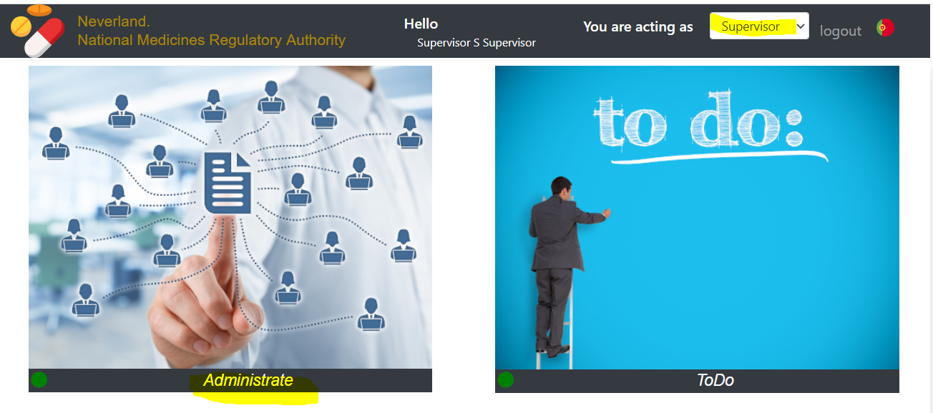

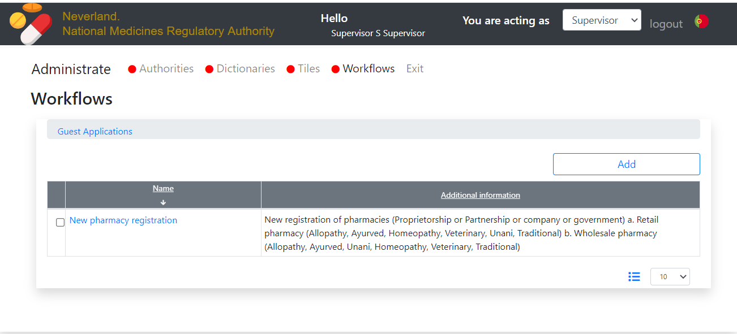

You may edit workflow name and description

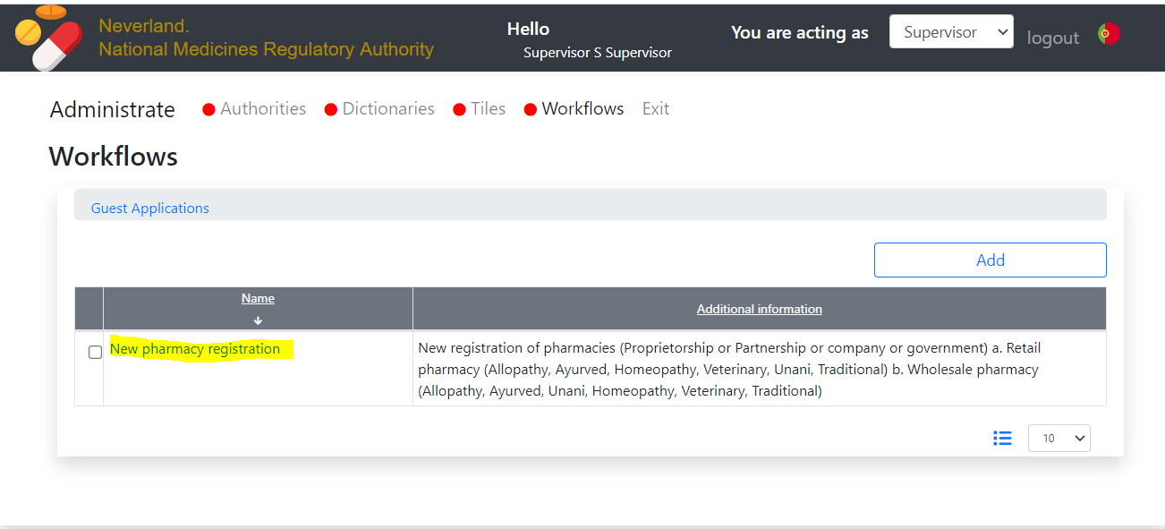

or edit workflow steps

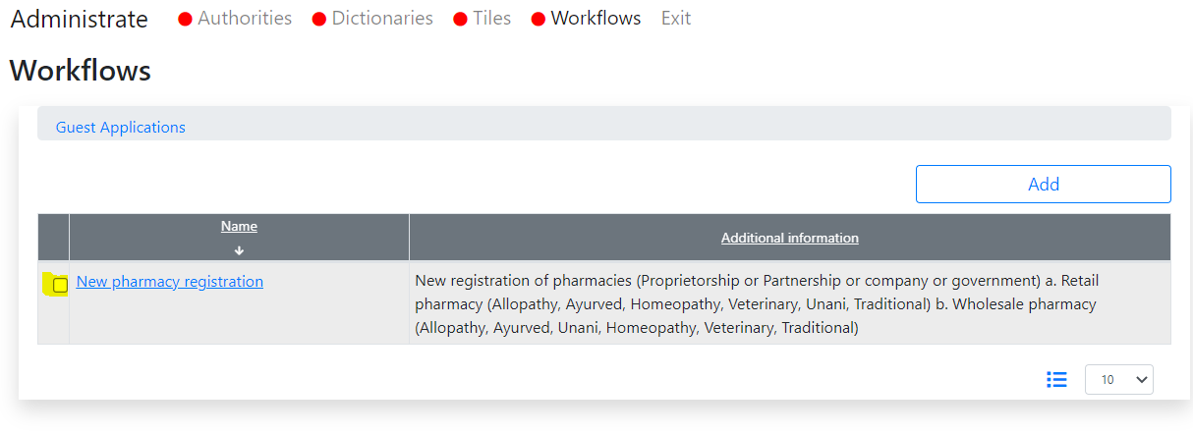

## How to use

The configuration screen is below. This screen allows assigning user roles for each step of a workflow as well as :

* Places to store data
* Data input templates
* Execution order – background or concurrently or in sequence.

**Detailed information will be provided in the manual. Please do not change anything.**

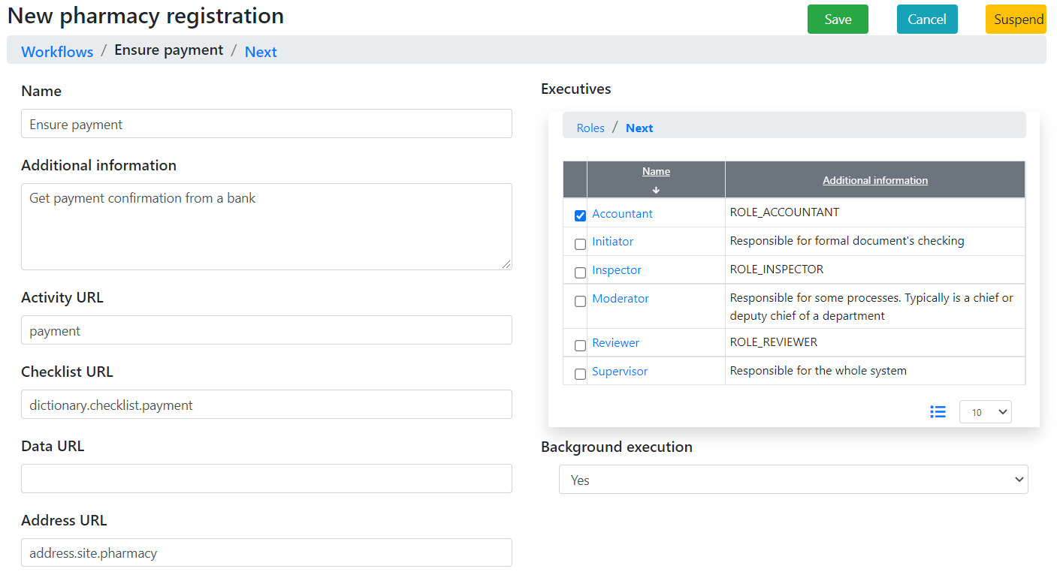

**When, after pressing Next you will see an empty form, it means the end of the workflow definition.**

## Current limitations

You can suspend (remove) workflow steps, however cannot insert. It will be implemented in the next version, therefore, please do not suspend anything.

## What’s next

Possibility to insert steps. Workflow configuration manual as a part of common Administration Manual.

# Workflow execution

## Where to find

You will need your google login as well as an admin login.

First, please log in as an applicant (google log in) and start an application, i.e., fill out forms until the “Conclude” screen

## How to use

It is recommended to run this task from two browsers. One with admin login, second with google (applicant) login.

### Create and submit

Fill out the checklist and press the “Submit” button.

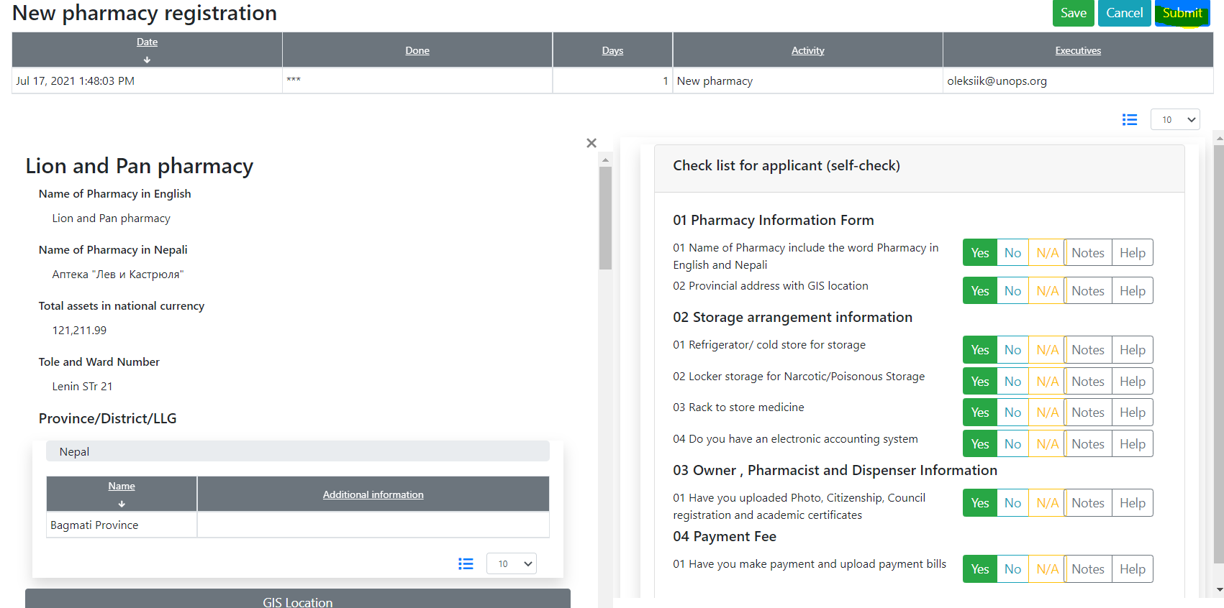

Your application is submitted” You can trace the execution

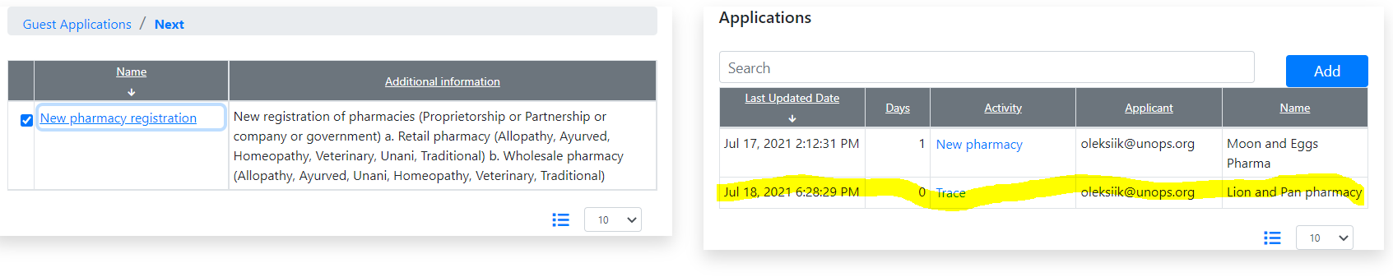

All data are read-only

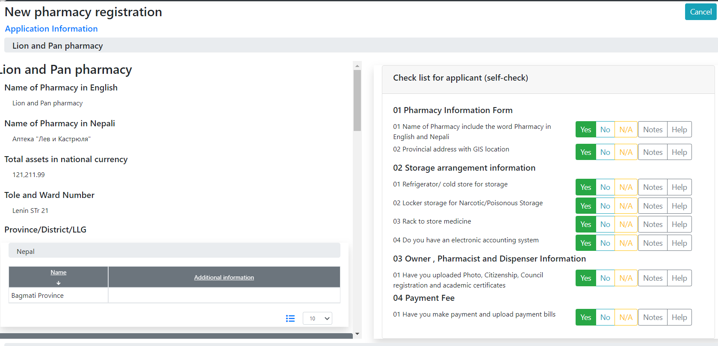

If you expand application information, you will see full application state report

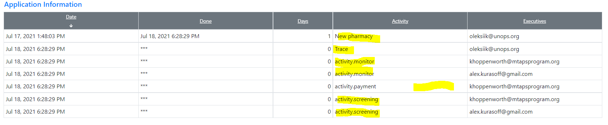

It means:

* You submitted an application
* Both supervisors are monitoring the application
* The accountant office is waiting for receiving money
* Screeners are assigned.

### Execute the workflow

Log in as an admin user. Open ToDo screen

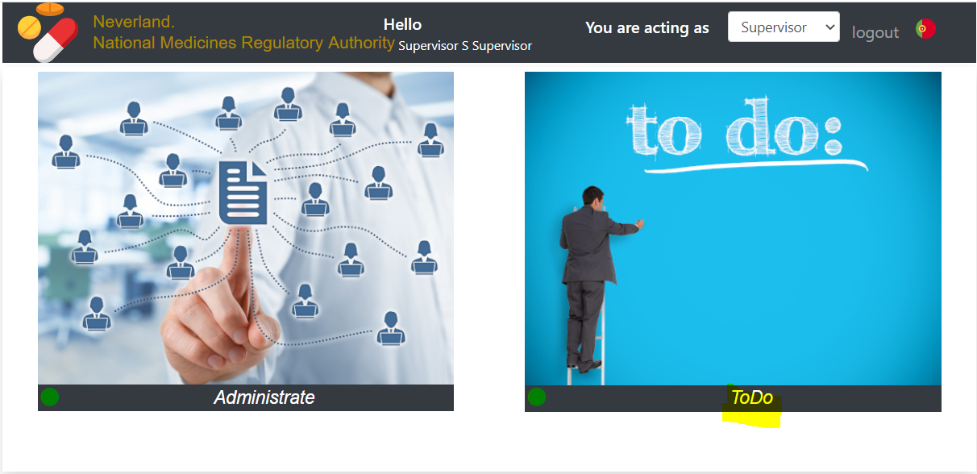

Admin user has many roles. Therefore, it will see near all activity assignment

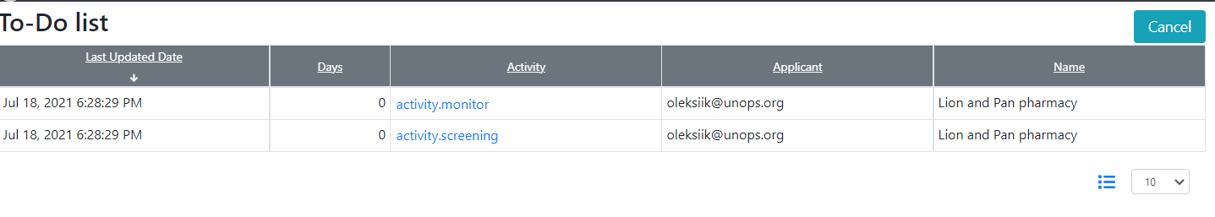

There is no activity assignment for the accountant because Pharamdex 2 selects the accountant closest to the future pharmacy. IT is defined in the workflow configuration.

For the current demo, monitoring activity for the Admin is the same as “Trace” for the applicant. In the future, Admin will have a possibility to reassign any future activity, etc.

Let’s, execute screening. There are two screens. On the first, the screener can see the result of the applicant’s self-check. On the second, a screener can fill out their checklist. Please, fill out and press “Submit”

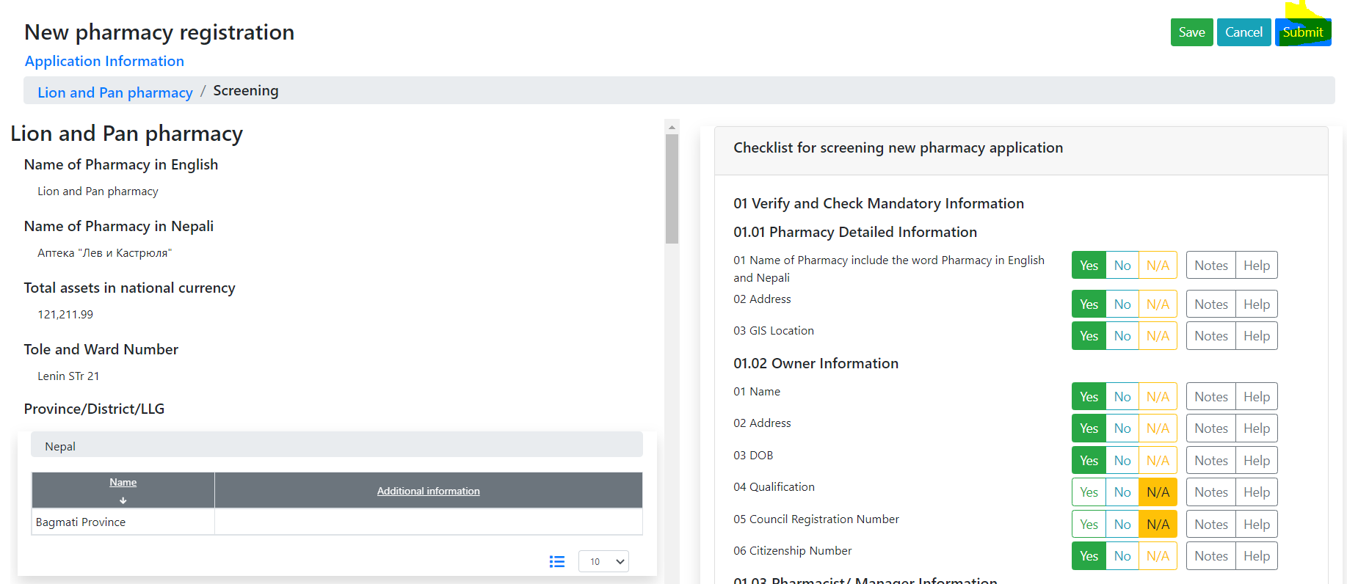

The application is under review.

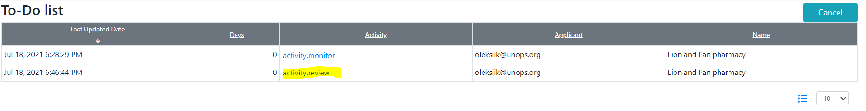

Each step reflects in the trace and the detailed application report. Therefore, the application is manageable for both – Admin and Applicant.

Please, click on “activity. monitor” or log in as an applicant and select “Trace”

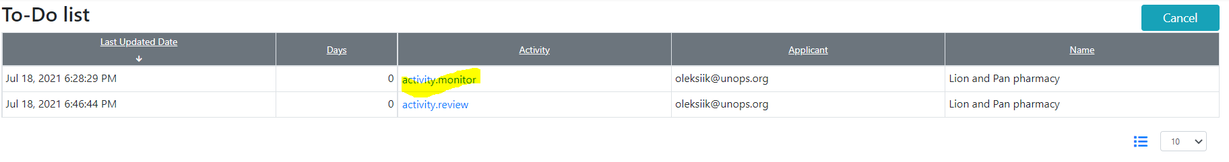

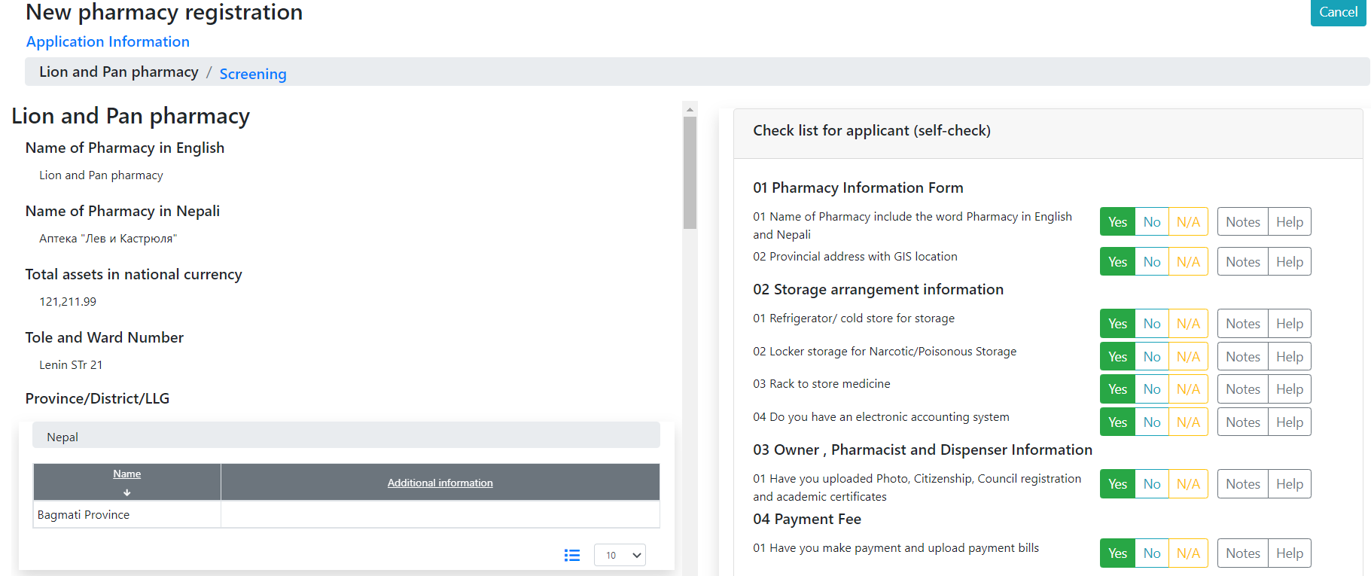

and

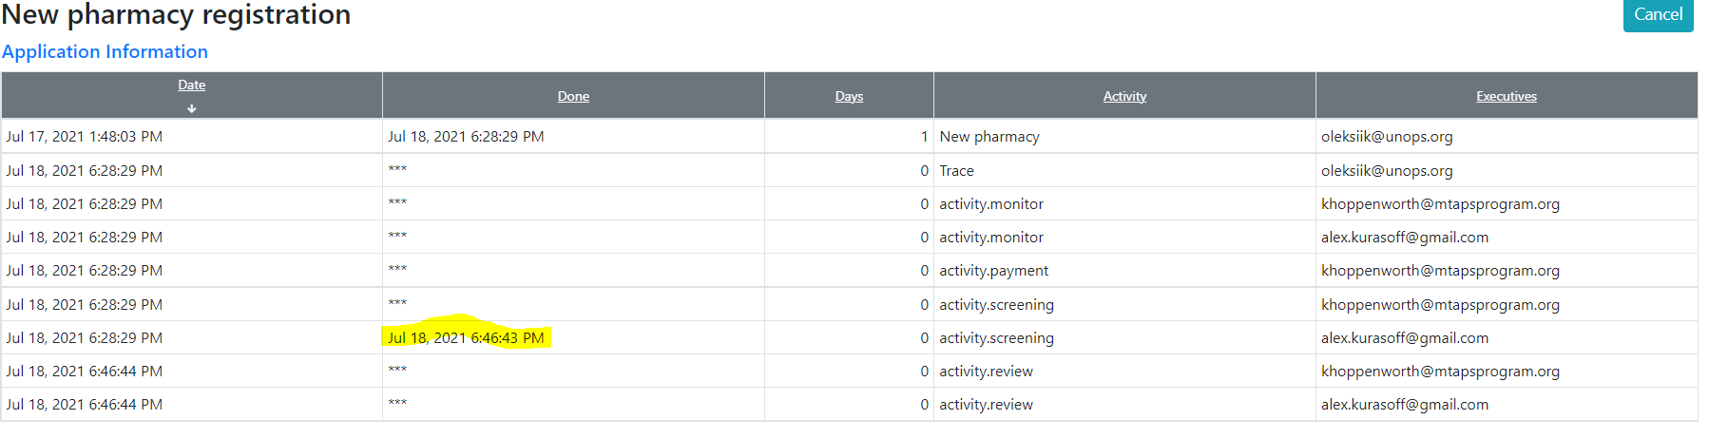

Let’s go until the “Finalization”. Please, put your attention, the accountant fill-out payment data concurrently

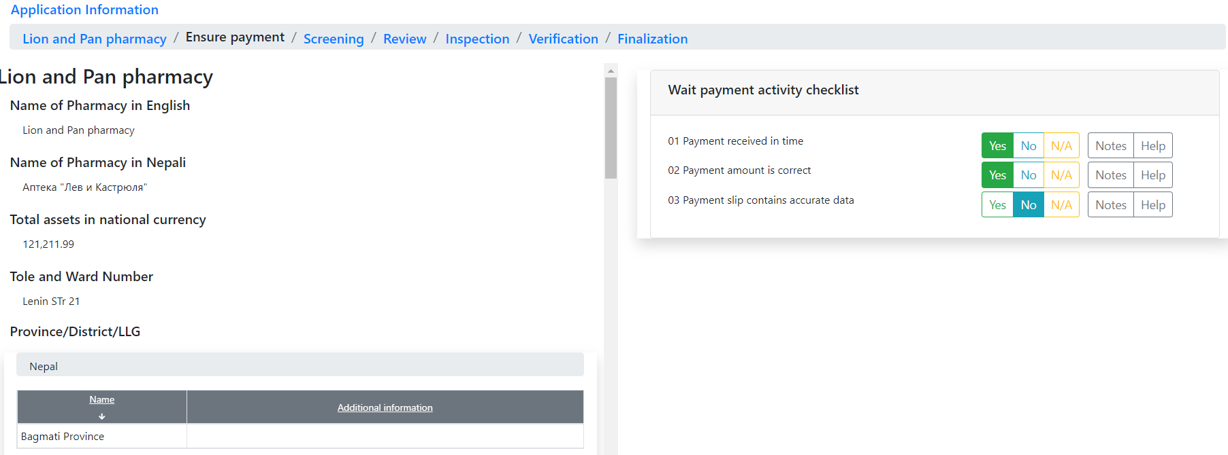

## Current limitations

Data forms for Workflow executors, like inspection report uploading, etc., don’t work yet.

## What’s next

Data input forms and actions on Finalization.