Pharmadex 2. Release Notes 2021-07-25

Contents

Motivation 1

Pre-requisite 2

Demo release particularities 2

Data configuration 2

Motivation 2

Where to find 2

How to use 2

Workflow data 5

Motivation 5

Where to find 6

Data 6

Configuration workflow 6

Configuration data 6

How to use 6

Data related issues in Redmine 7

What’s next 7

# Motivation

The main requirement from the customer is to re-define data in data forms.

For current, data forms definitions are unstable. It is normal because it is impossible to predict all required data fields, their semantic, labels, and validation rules at once. In addition, it is agreed to implement ASAP data input forms while workflow execution and the certificate document generation.

Therefore, this demo contains a dedicated configuration of data for both application and workflow data.

Application data definition derived from the requirements received as a result of the latest workshop. Workflow data are data that are supposed to be gathered while workflow execution.

In addition to the previous one, this release contains:

* Data configuration feature
* Proposal of configuration data for application and workflow.

**All proposed data structures are not the final solution, however, may be used as a base for improvements**

# Pre-requisite

You must have a Gmail account and know the login and password for the admin user.

# Demo release particularities

This release may contain errors, bad user interface behavior, and inconsistencies. Please, report them to [alex.kurasoff@gmail.com](mailto:alex.kurasoff@gmail.com).

You may do with the data whatever you want. The data will be restored to the initial state periodically.

# Data configuration

## Motivation

To provide the possibility to create country-specific data input forms and data storage without programming.

## Where to find

Log in as system administrator. Select Administration and, then Data Configuration.

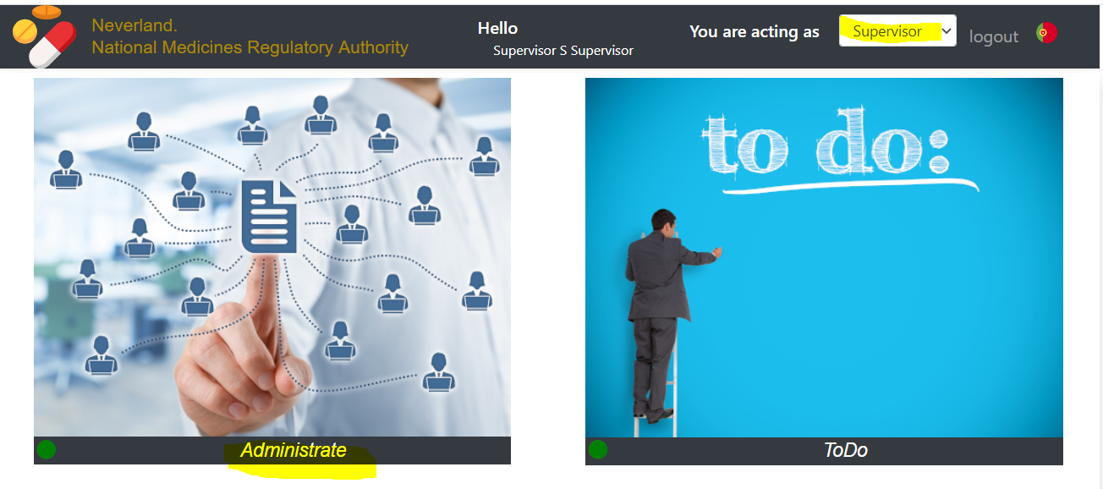

## How to use

For current, the data configuration manual is not ready yet. Therefore, you can only take a glance at this feature. Let’s consider a configuration of pharmacy registration data and data forms.

First, the pharmacy site data should have a unique name to be distinct from other data. This address is called URL (Universal Resource Locator). The address for the pharmacy site is “pharmacy. site”. Click on the checkbox to open it:

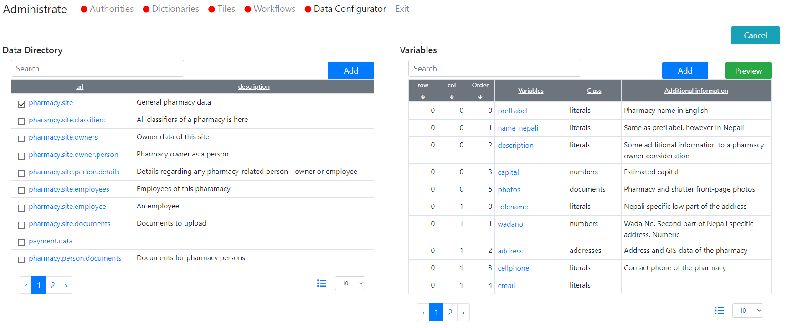

You can see data and electronic form elements definitions and may preview a form.

The definition will be described in the corresponded manual. Let’s only take a quick look at the main features. Click on “prefLabel” in the right table. The data is below. This data is a definition of the field “Name” in the pharmacy input form and contains the following:

varName – unique name of this data as well as a “key” for an on-screen label.

class – literal means a text string or block. Also, available numbers, classifiers, yes/no/not applicable logical, file uploads, person lists, addresses, even, other forms (things) will be available on the next tabs.

The rest are validation rules, screen positions in two columns layouts, and some auxiliary data.

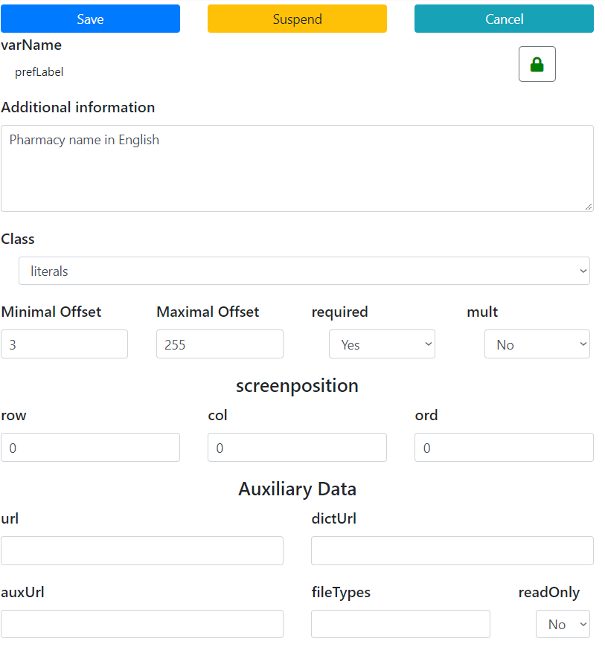

To access it, please

1. Change” mult” to “yes”
2. Save
3. Run Preview.

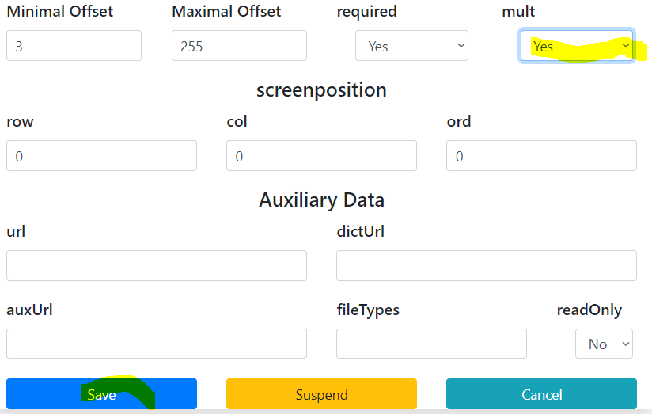

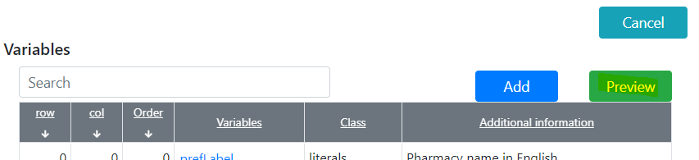

Result will be

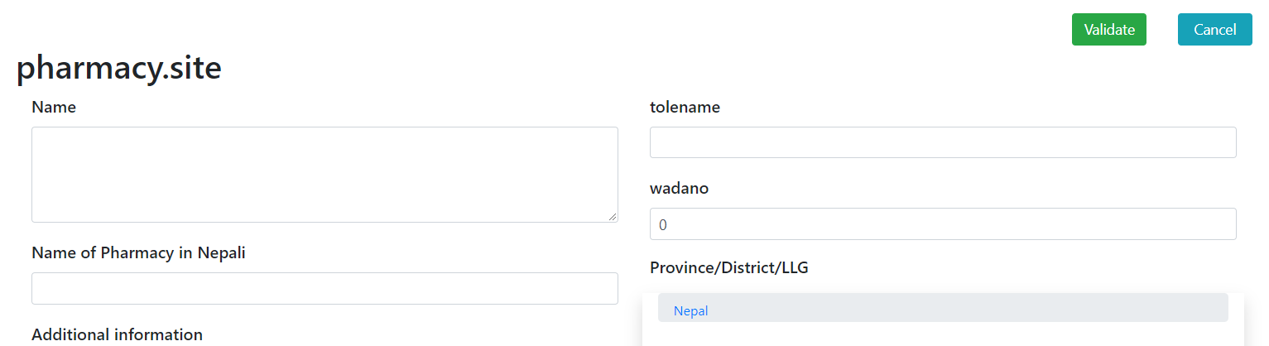

Press Validate to see validation rules

**Please, do not forget to return No to mult in the configuration.**

**Ultimate data configuration and user manual will be prepared later.**

# Workflow data

## Motivation

Workflow participants should have the possibility to add vital registration information, such are important dates, sums, documents, comments, etc.

This possibility supports by workflow and data configuration features.

## Where to find

### Data

Forms to input data may be found on “inspection” and “finalization steps of new pharmacy registration workflow.

### Configuration workflow

log in as administrator and, then open workflow configuration on tab “inspection”

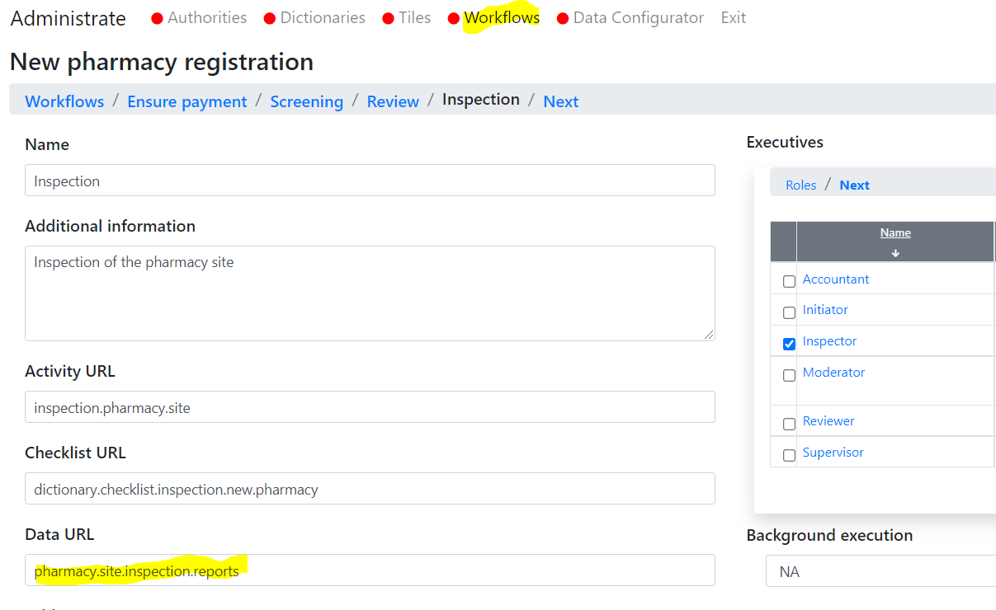

### Configuration data

This “pharmacy.site.inspection.reports” can be found and previewed in the Data Configurator

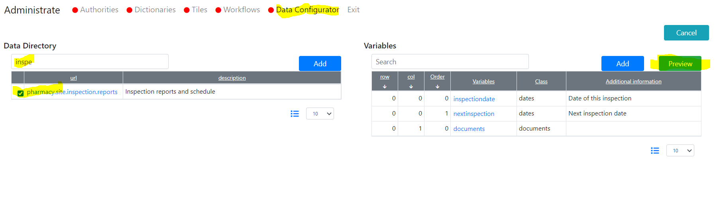

## How to use

To use it please, wait for a manual. It will come soon.

# Data related issues in Redmine

These issues are partially completed using the tools above. The rest of them are scheduled for next week.

# What’s next

The rest of the data issues and the document generation feature.