Pharmadex 2. Release Notes 2021-08-01

Contents

Motivation 1

Pre-requisite 1

Demo release particularities 2

Resources 2

Where to find 2

Features 3

Usage of resources 3

Logo 3

Guides 3

Templates 4

Approach 4

How to explore them 4

Invoices 5

Agreements 5

Letter and Certificate 6

# Motivation

The current main requirement is auto-creation documents using data from the database. To resolve it we’ve added the possibility to create and maintain file resources.

The file resource is a computer file in a defined format that can be used for:

* as a logotype of the application
* as an online guide and/or help document
* as a template for document auto-creation

**All proposed data structures are not the final solution, however, may be used as a base for improvements**

# Pre-requisite

You must have a Gmail account and know the login and password for the admin user.

# Demo release particularities

This release may contain errors, bad user interface behavior, and inconsistencies. Please, report them to [alex.kurasoff@gmail.com](mailto:alex.kurasoff@gmail.com).

You may do with the data whatever you want. The data will be restored to the initial state periodically.

# Resources

## Where to find

Log in as system administrator. Select Administrate and, then Resources.

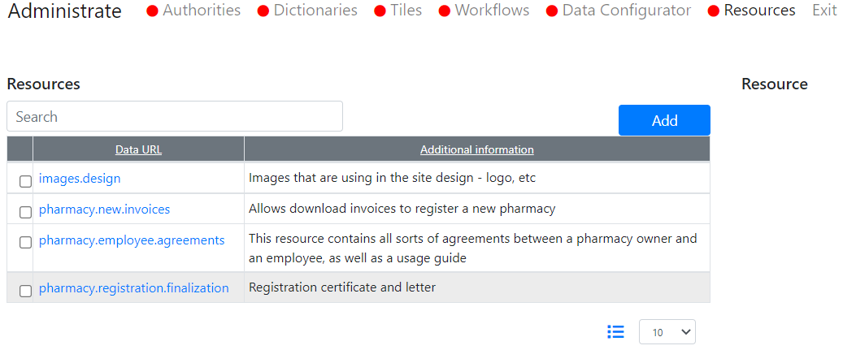

To get a list of files managed by a resource, click on a checkbox

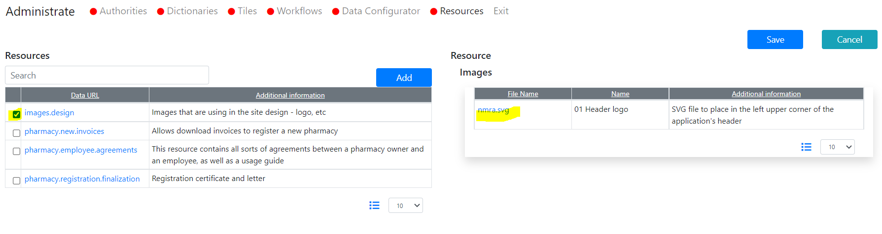

To get a description of a resource, click on a link

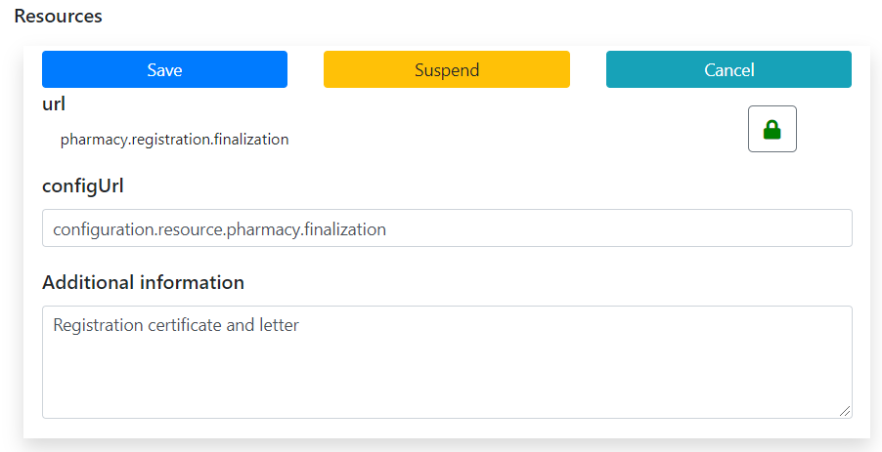

## Features

* Any given resource keeps distinct files for each language used. Therefore, we can use language–sensitive logos, guides, and help pages as well as document templates.
* Resource image.log is special, the rest of the resources are subject to definition

# Usage of resources

## Logo

Here (http://redmine.inka.in.ua/documents/65), you can find the logo of DDA converted to SVG format. You can download and replace the current logotype. After replacement, please, reload the browser window.

## Guides

There is only one guide currently uploaded. You can find it on tab “Agreements” while new pharmacy application creation.

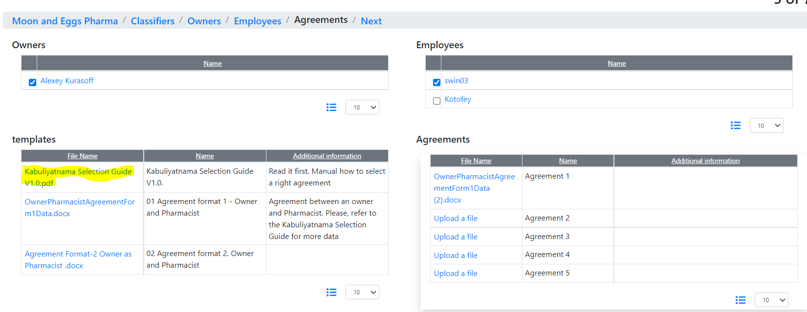

## Templates

### Approach

Templates are plain MS Word files contains text, pictures, and Pharmadex2 EL-Expressions. Just before the user downloads resource-template, Pharmadex 2 reads them and, then, replaces EL-expressions with real values from the database.

The full guide will be available soon. A brief guide is available here http://redmine.inka.in.ua/documents/66.

### How to explore them

You can download/reload templates here:

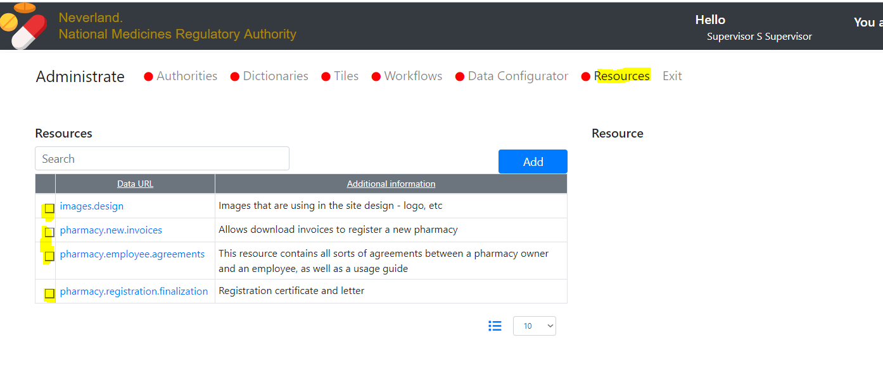

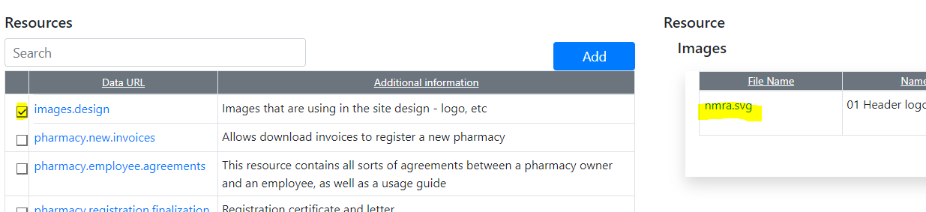

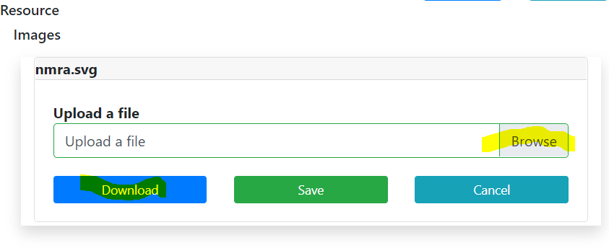

download

Replace

### Invoices

These are invoices from page “Payment” while new application definition.

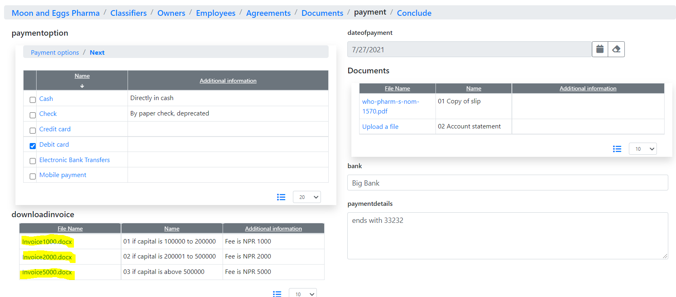

Click on any and download ready use invoice. Put your attention to Payment Details. Try to change the language.

### Agreements

Can be found on page “Agreements” while the new Application definition.

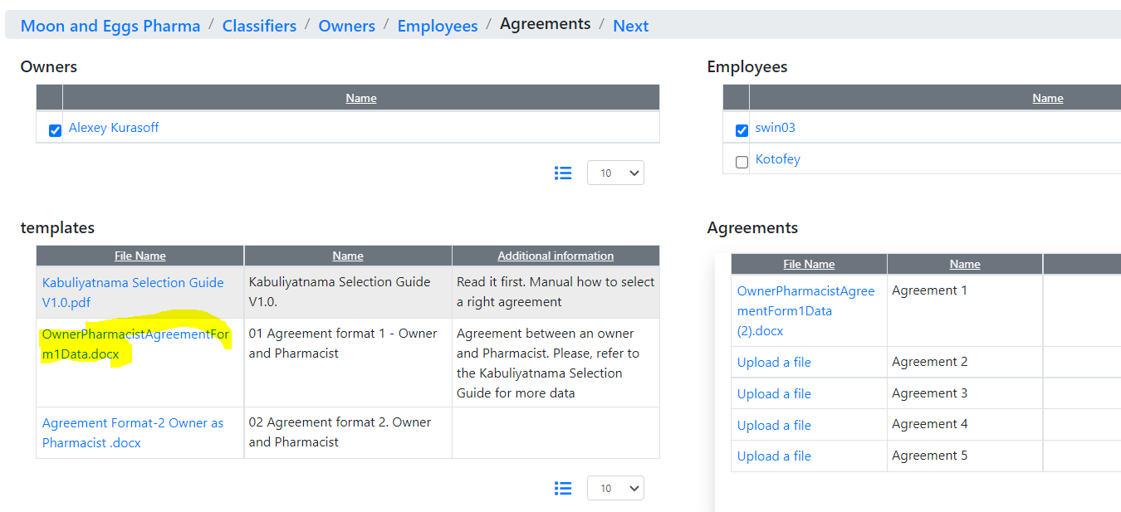

Unlike invoices, this file contains only EL expressions. Fill free to create any text and, then insert these expressions to it. Then, please re-load the resource file and try again. The filename doesn’t matter.

### Letter and Certificate

To try them, you should have an application in the workflow in the Finalization job, like below

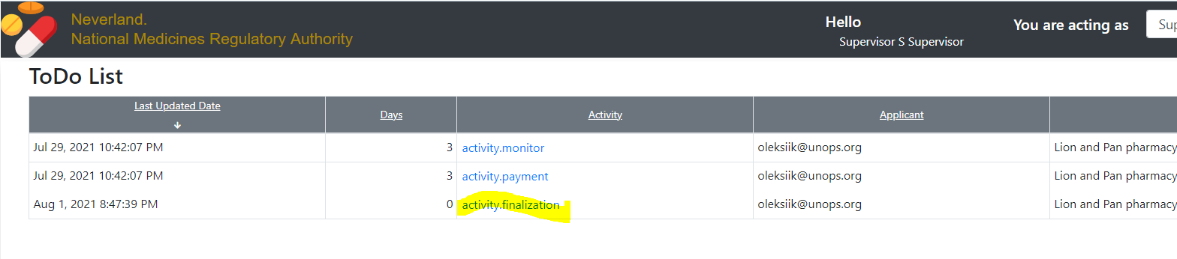

On the Finalization page, you can download the «intermediate» of the Letter and the Certificate.

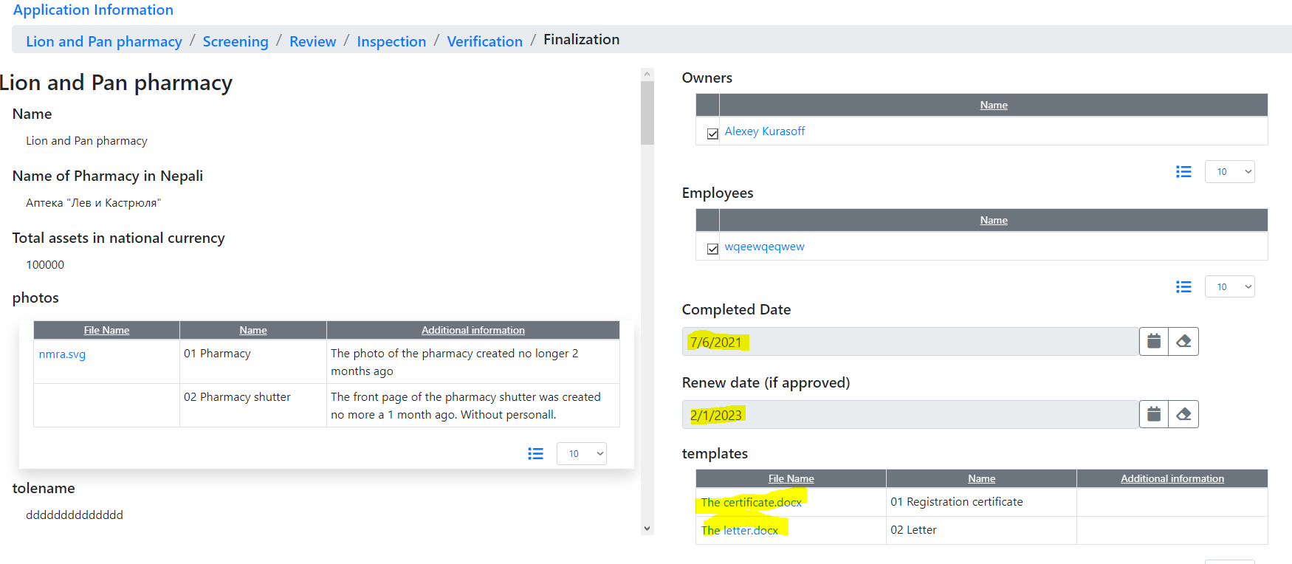

Indeed, to create real documents, please create them using text and EL-expressions provided and, then upload them.