Pharmadex 2. Release Notes 2021-08-08

Contents

Motivation 1

Pre-requisite 2

Demo release particularities 2

Features for a workflow executor 2

Features for Supervisor 3

Configuration of the features 6

Relation to Workflow Configuration 6

Additional features in this release 6

Labels and messages 6

Motivation 6

Where to find 7

An example 7

Nepal Administrate Units 8

Motivation 8

Where to find 8

Additional job required 9

# Motivation

The workflow engine was implemented as a linear chain of jobs with possibilities to use concurrent and background jobs. It is s a good starting point, however not enough for workflow management.

The real workflow management assumed such features for the system supervisor and workflow executors:

1. Pass job to the next step of workflow for concurrent or non-concurrent execution
2. Re-assign the executor of the current workflow job
3. Start a new job that is not declared as a next step, but vital for the whole process
4. Cancel a job that has been recognized as useless or extra
5. Finish the whole workflow with a positive or negative outcome

In addition to this release added:

1. Possibility to edit on-screen labels and system messages in all languages
2. New, complete Nepal Administrative Units database, imported from the MS Excel file provided.

**All proposed data structures are not the final solution, however, may be used as a base for improvements**

# Pre-requisite

You must have a Gmail account and know the login and password for the admin user.

# Demo release particularities

This release may contain errors, bad user interface behavior, and inconsistencies. Please, report them to [alex.kurasoff@gmail.com](mailto:alex.kurasoff@gmail.com).

You may do with the data whatever you want. The data will be restored to the initial state periodically.

# Features for a workflow executor

If the workflow executor is the last concurrent executor of some workflow job (or simple a single executor of this job), after pressing the “Submit” button, the following control form will appear:

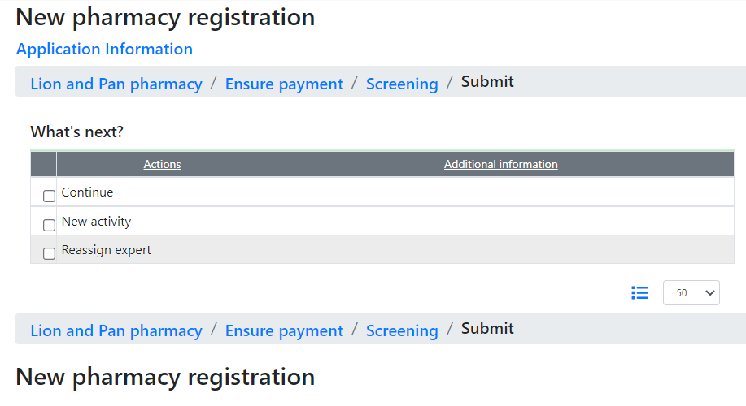

Above is a full set of features available to the executor:

“Continue” means continue from any step of the workflow, by default – regular.

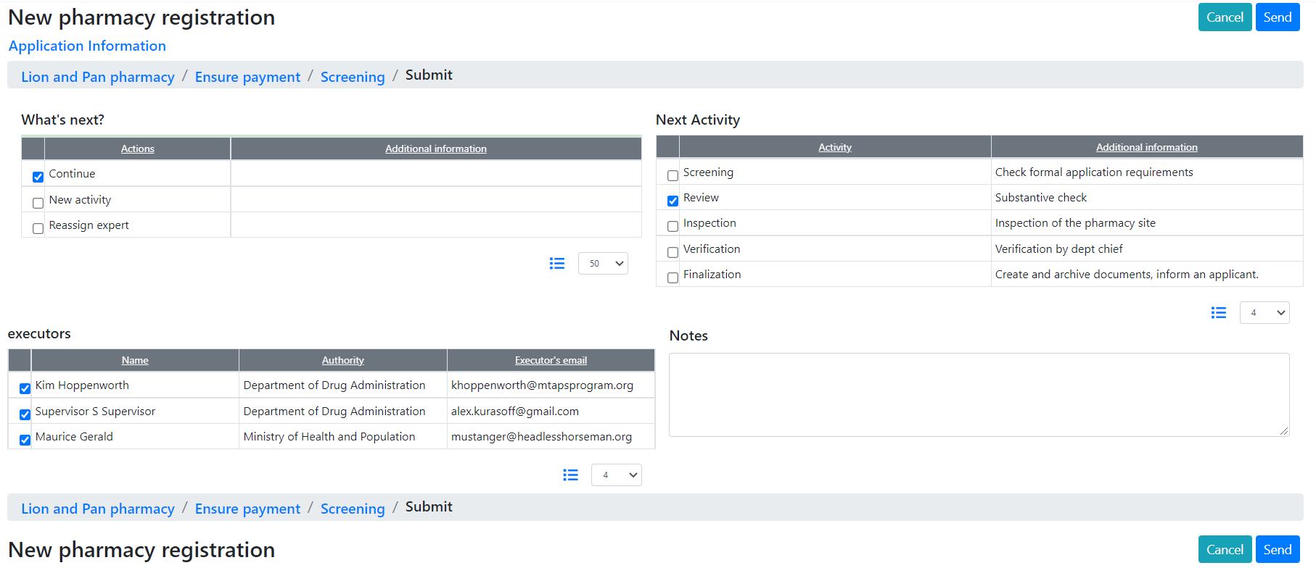

“New activity” allows to run any activity concurrently

“Reassign expert” allows to cancel the current activity and run an activity of the same type for others experts.

Fill free to select experts from the list.

# Features for Supervisor

While a workflow executor uses this feature to manage follow-up jobs, the Supervisor can solve similar tasks for the whole workflow.

Any workflow that is running is available for the Supervisor from a special monitoring activity that can be found in the To-Do list[1].

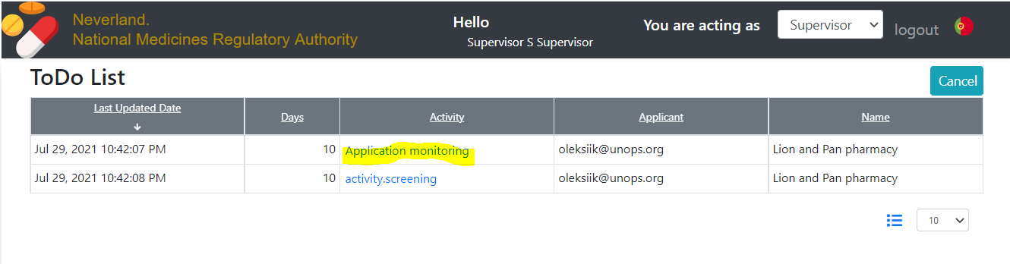

This feature provides to Supervisor access to the workflow execution protocol. This protocol looks like a regular workflow activity screen, however does not allow to make any changes to the workflow data.

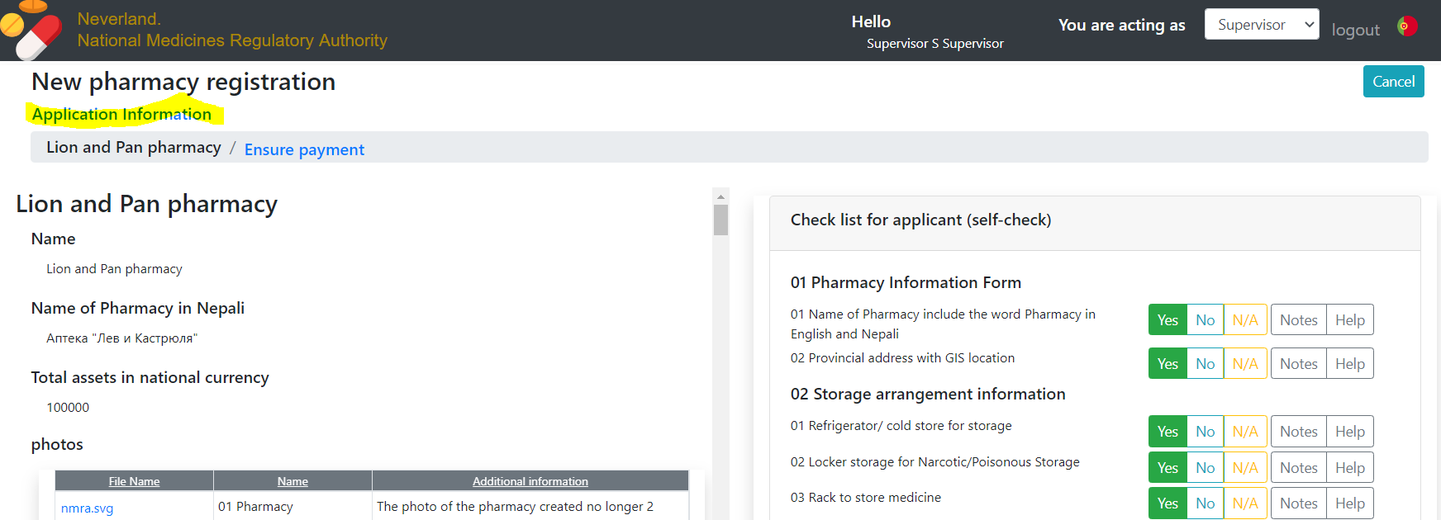

The link “Application Information” allows Supervisor to get full control on workflow execution, but not on workflow data.

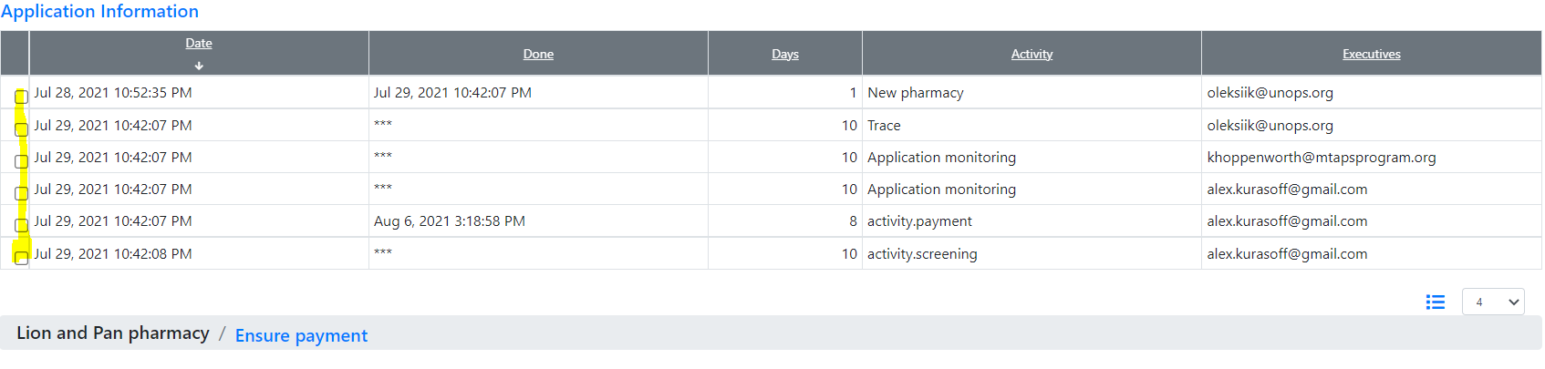

For this particular case:

* The application has been submitted on Jul 29 by the applicant
* The applicant can trace the application processing in a real-time
* Two supervisors can monitor this application
* Payment is received, the accountant has confirmed
* The screener received the job on Jul 29, however didn’t do anything.

To get control, Supervisor should click a checkbox for any activity that does not trace or monitoring

The actions are almost the same as for the applicant, however for any activity in the workflow. Let’s add a new concurrent screener

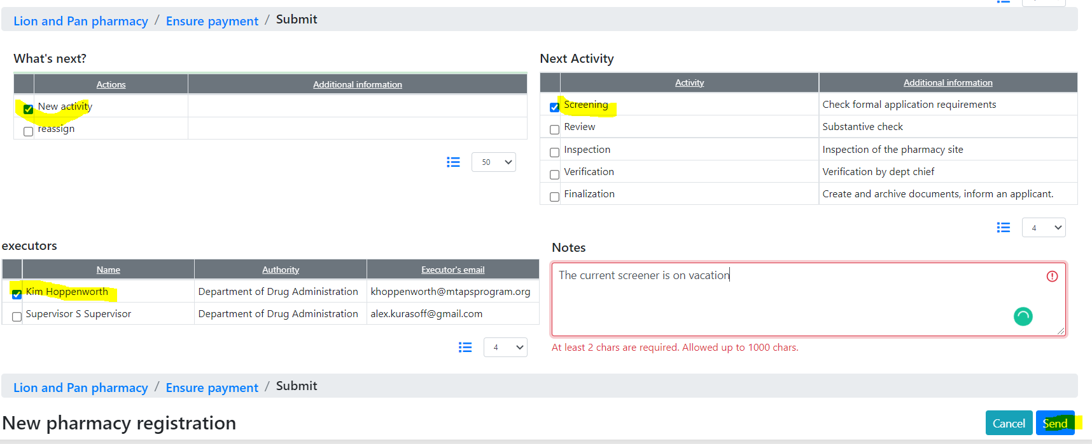

The new assignment has been added.

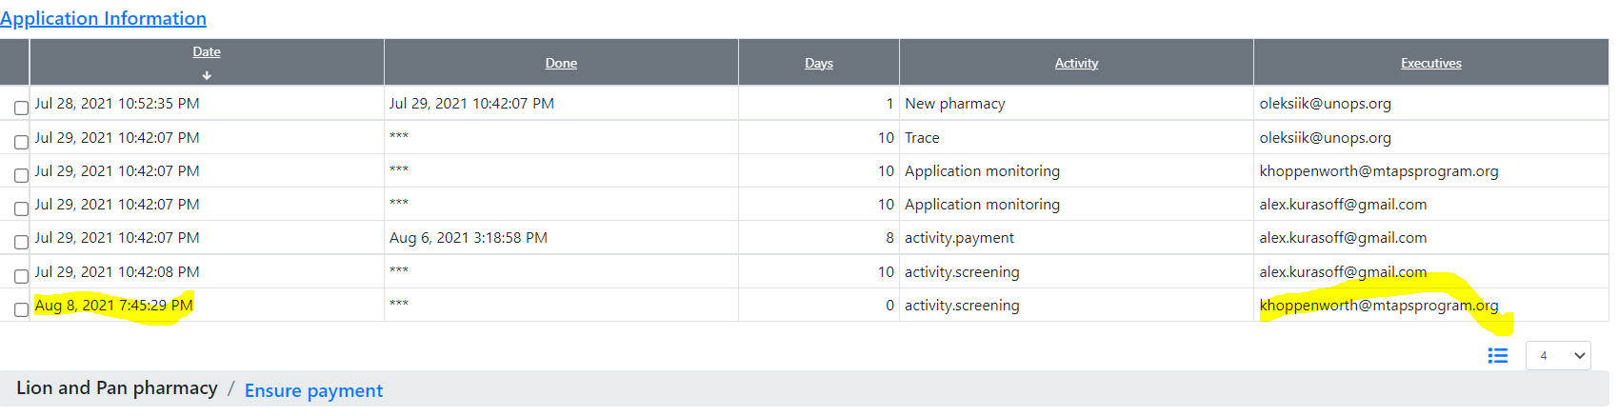

# Configuration of the features

The list in the “What’s Next” table is configurable. You can change the names of actions and add any descriptions to them in any available language. However, you can’t add new actions.

To do this, open Dictionaries and find the “Submit Actions” dictionary. This dictionary has been automatically created by Pharmadex 2 software.

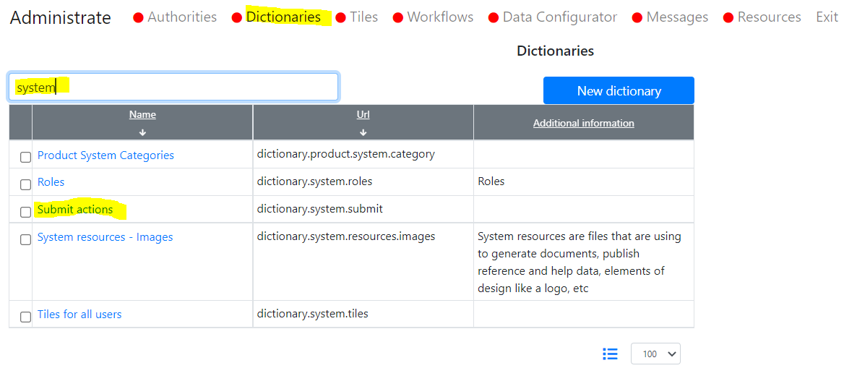

Fill free to edit names and descriptions of actions. These changes will be reflected for workflow executors and the Supervisor.

# Relation to Workflow Configuration

The workflow management features built upon the Workflow Configuration data

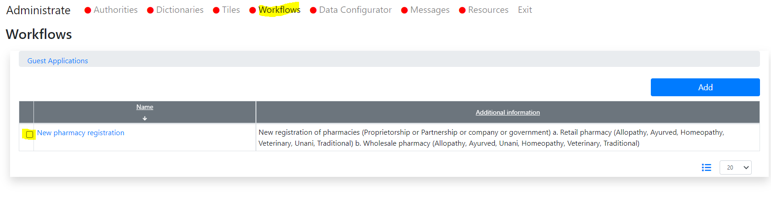

# Additional features in this release

## Labels and messages

### Motivation

Some labels in on-screen forms are ill-defined.

### Where to find

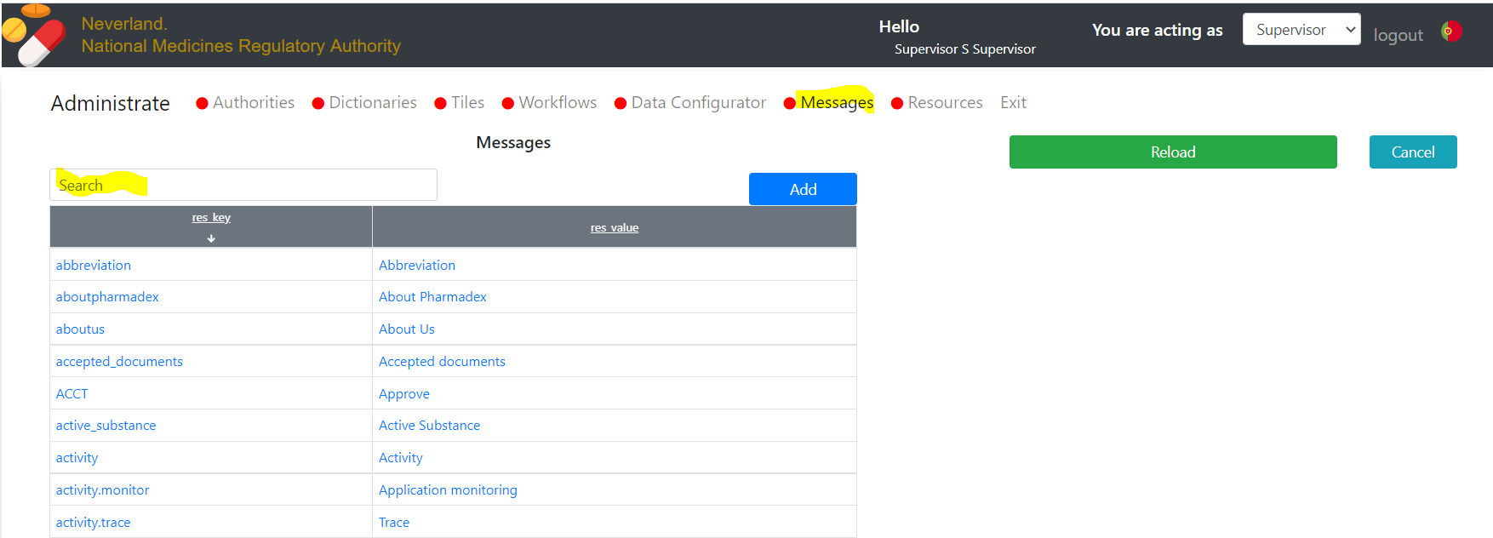

### An example

Suppose, you want to change the cumbersome message “You are acting as” too short “You are:”

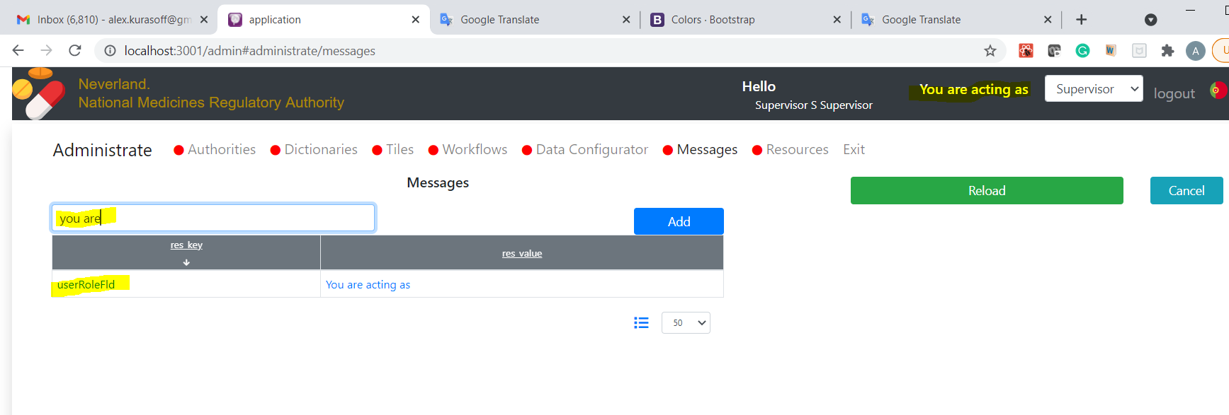

Click on it

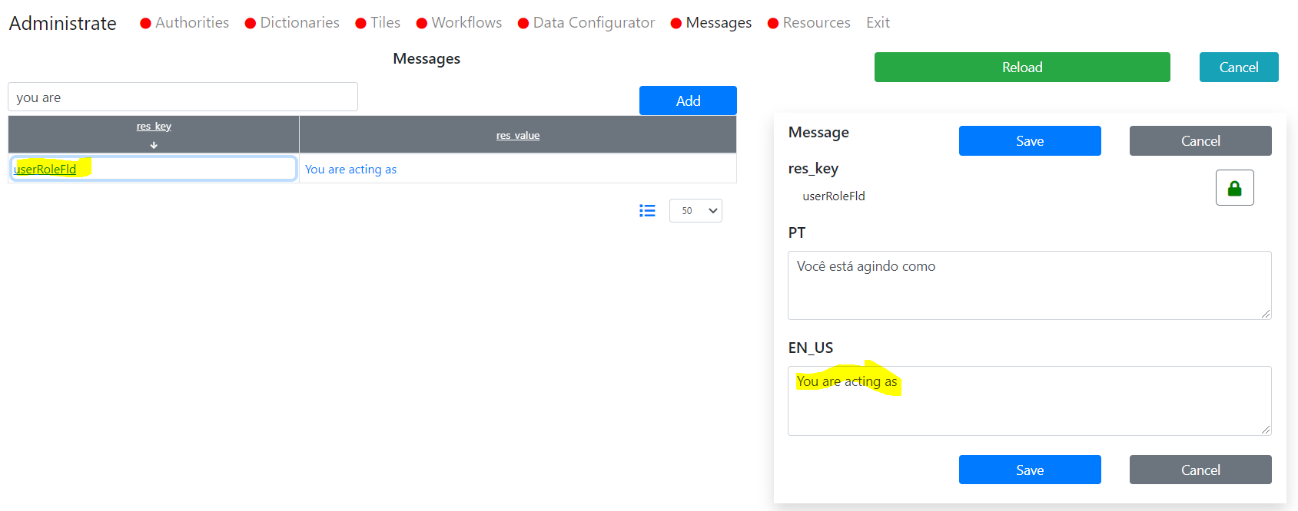

Change it

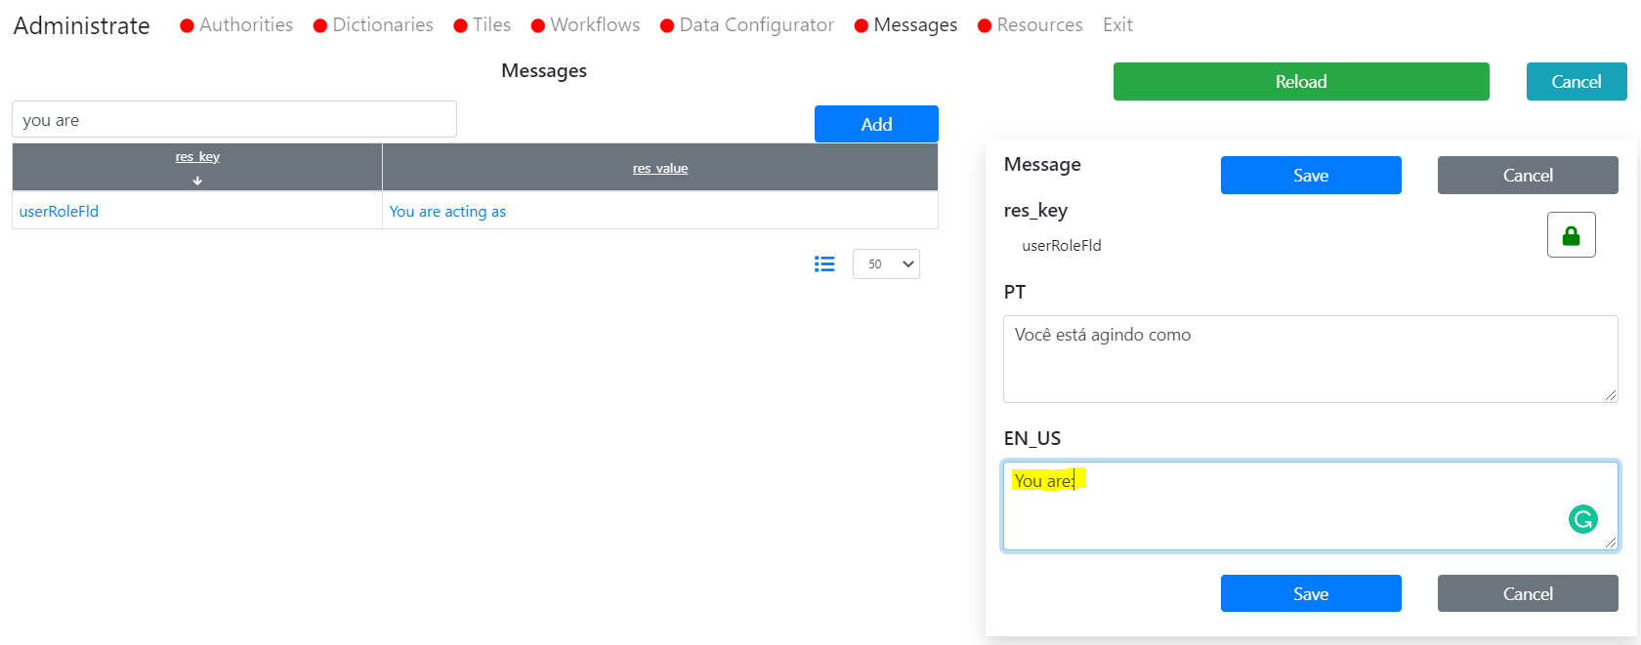

Save it. Result will be

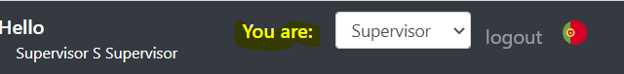

# Nepal Administrate Units

## Motivation

We need the most recent and full Administrative Units database that contains spatial data.

## Where to find

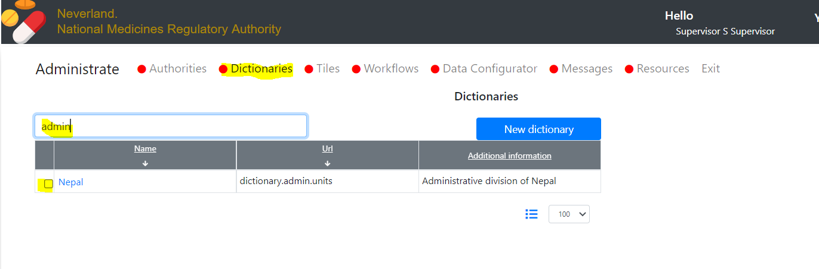

Fill free to edit entries. Please note, the checkbox is the choice, the link in the navigation

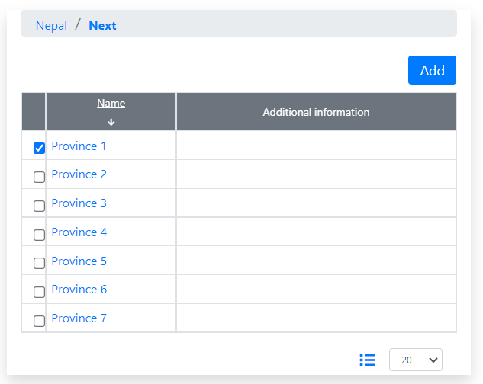

The dictionary is bi-language.

## Additional job required

This dictionary contains both spatial data and zoom data. However, for some Municipalities centers and zoom needed to be tuned. To check it, please, start the new application as an applicant user and try:

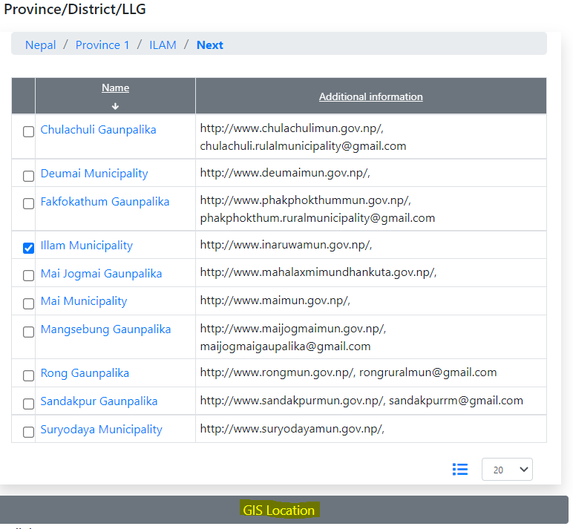

The zoom is not good

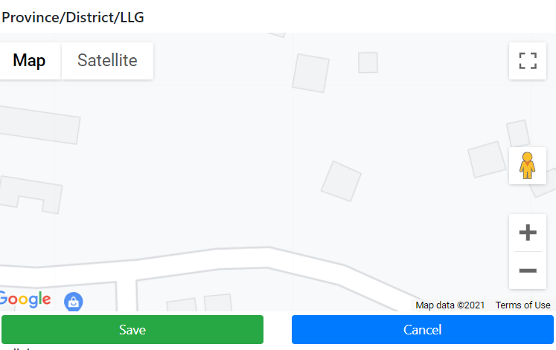

Change it by the Supervisor feature

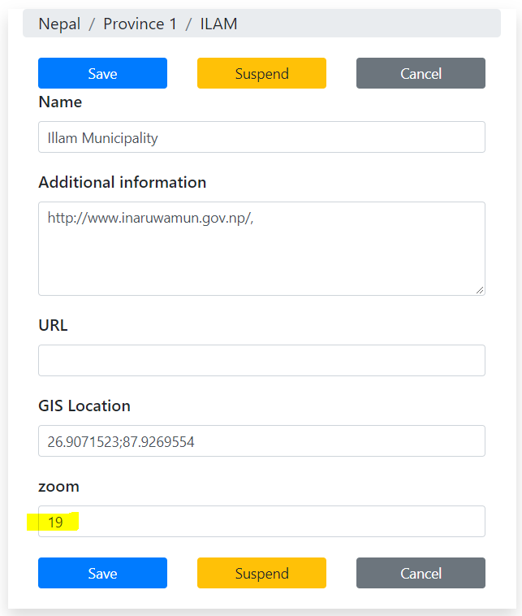

To 17

The result will be better:

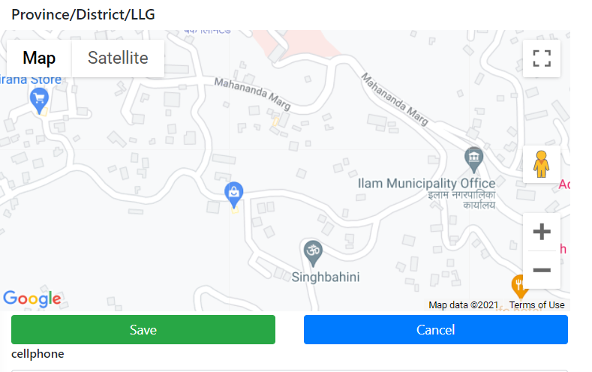

1. In future release we will separate them