Pharmadex 2. Release Notes 2021-08-15

Contents

Motivation 1

Pre-requisite 1

Demo release particularities 2

How it works? 2

Where to configure the processes and the scheduled jobs? 5

Data and schedulers 5

Inspection and Renew workflows 8

# Motivation

The lifecycle of any object registered by NMRA passes such life cycle stages:

1. Initialization
2. Approval
3. Periodical scheduled actions, like renewal and inspections
4. Withdrawal

Pharmadex 2 software should provide data service at each stage of the object’s lifecycle. Until the current release only stages 1 and 2 are under the Pharmadex 2 services.

This release introduces services for stage 3. To demonstrate this we’ve implemented Inspection and Renew workflows.

**All proposed data structures are not the final solution, however, may be used as a base for improvements**

# Pre-requisite

You must have a Gmail account and know the login and password for the admin user.

You should get at least one application to the review step of the workflow

# Demo release particularities

This release may contain errors, bad user interface behavior, and inconsistencies. Please, report them to [alex.kurasoff@gmail.com](mailto:alex.kurasoff@gmail.com).

You may do with the data whatever you want. The data will be restored to the initial state periodically.

Because of sufficient changes and additional features, the user interface for Supervisor has been improved.

# How does it work?

Please, shit your application from Review to Inspection state.

The inspection data will look like

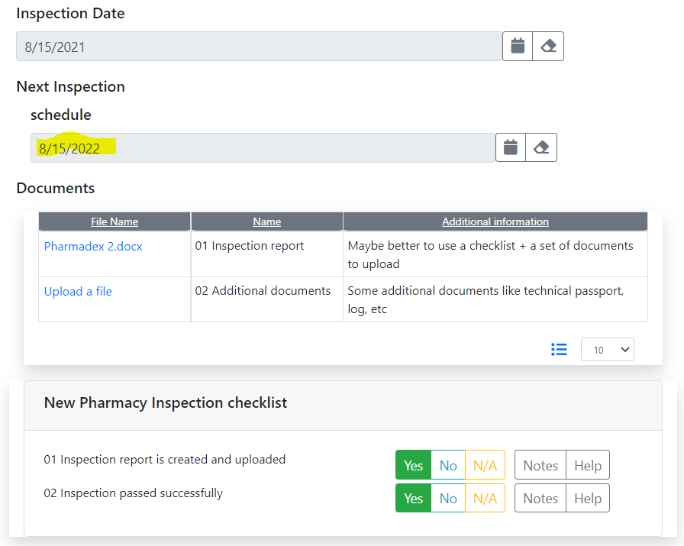

The new component “Scheduler” allows to schedule the next event on the third stage of the lifecycle. Indeed, in case if the application will be approved.

Then, shift the application until the Finalization step

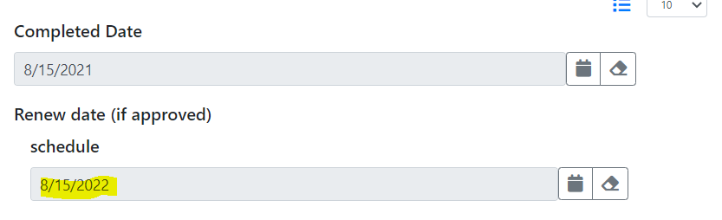

In this step, you will see the next Scheduler that allows you to assign Renew date.

Then, make the application approved, i.e., upload any file as a document, fill out the checklist, and, then, press Submit button.

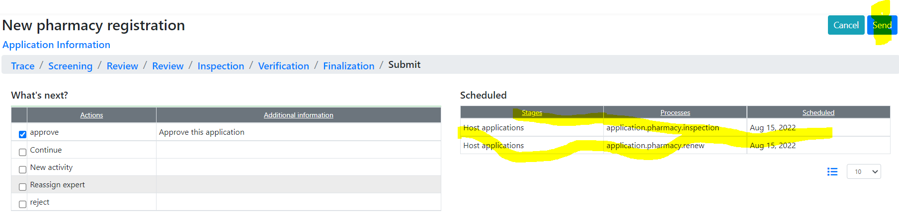

You will see which processes have been scheduled and when.

Press the Send button. The “Scheduled” part of the To-Do list will contain our future scheduled jobs.

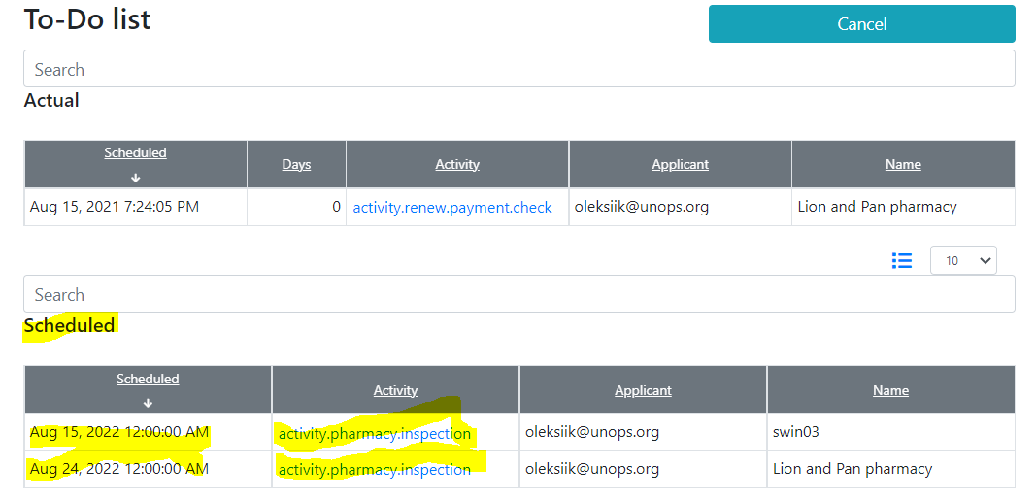

The new feature “Monitoring” contains all processes that you are tracing and supervising

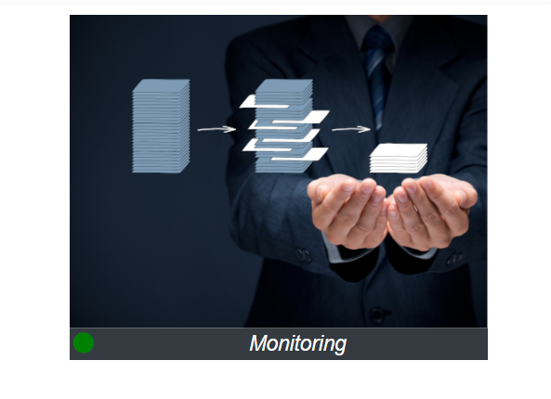

This feature also contains data about current and scheduled trace and supervising jobs. Please note, that each activity is under our control.

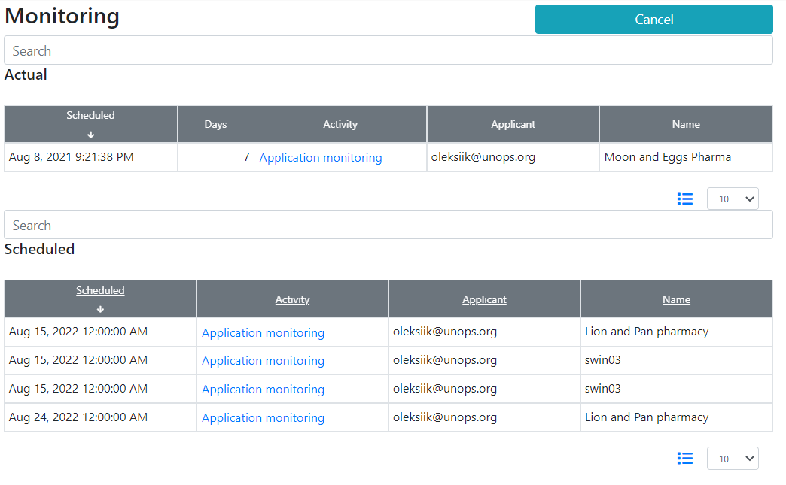

# Where to configure the processes and the scheduled jobs?

The new Inspection and Renew workflows have been configurated using the existing Process configuration and Data Configuration features. The detailed manual will come next week. Below, you can find a short explanation.

## Data and schedulers

Administrate-Configurations-Data Configurator

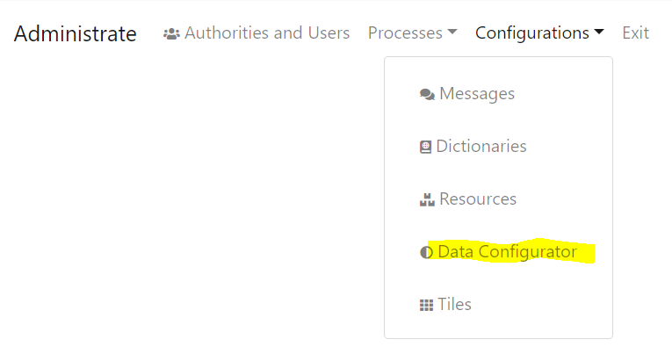

The configuration of the first “inspection” scheduler is under “pharmacy. inspection.reports” URL

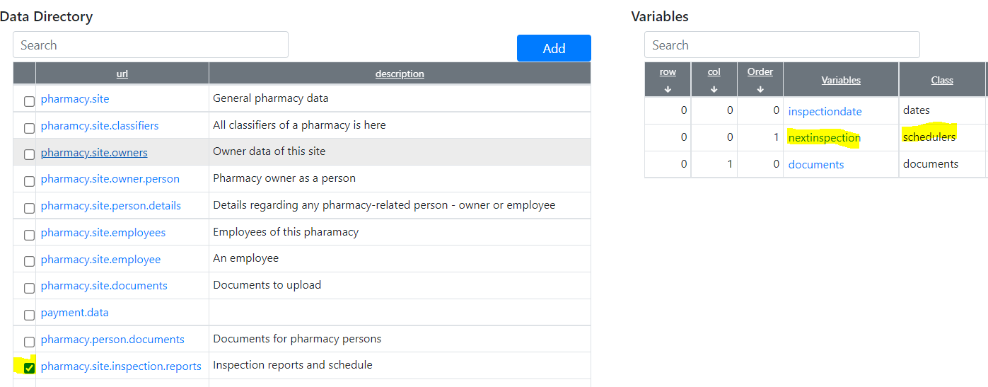

The configuration is

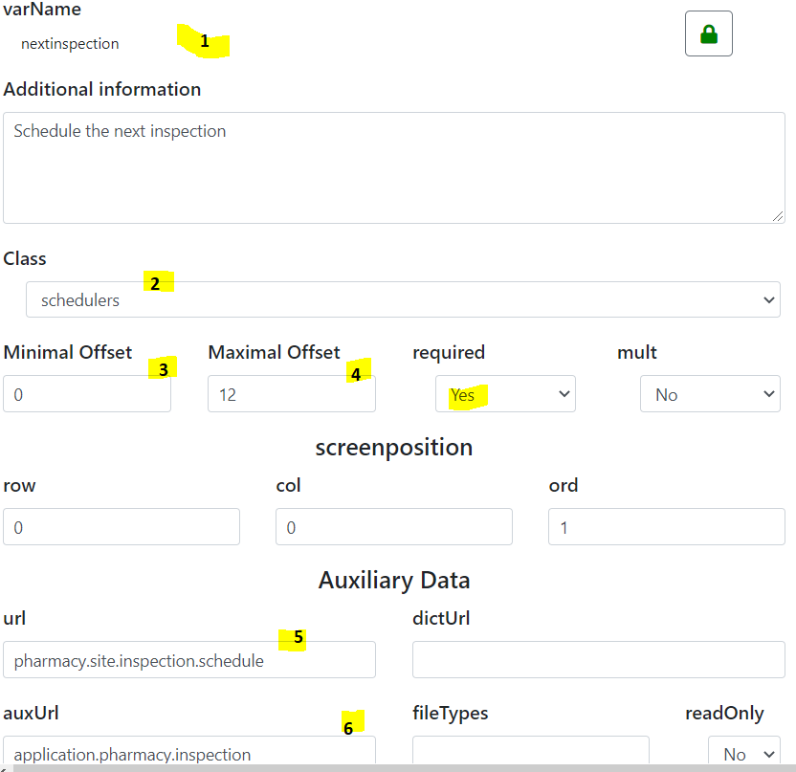

1. The label on the top
2. It is a scheduler
3. Min allowed months before the event
4. Max allowed months before the event
5. Where to store data for reports
6. Which workflow will be started on the date defined in this scheduler in the case of approval?

The configuration of the second “Renew” scheduler

## Inspection and Renew workflows

The configuration of new Inspection and Renew workflows can be found under Administrate-Processes-Workflows

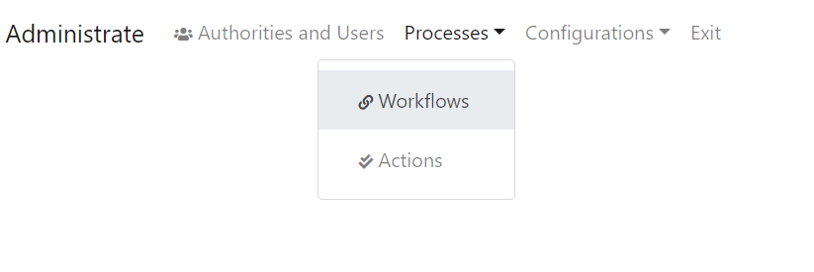

First, select processes or lifecycle stages. You can change these names as you want.

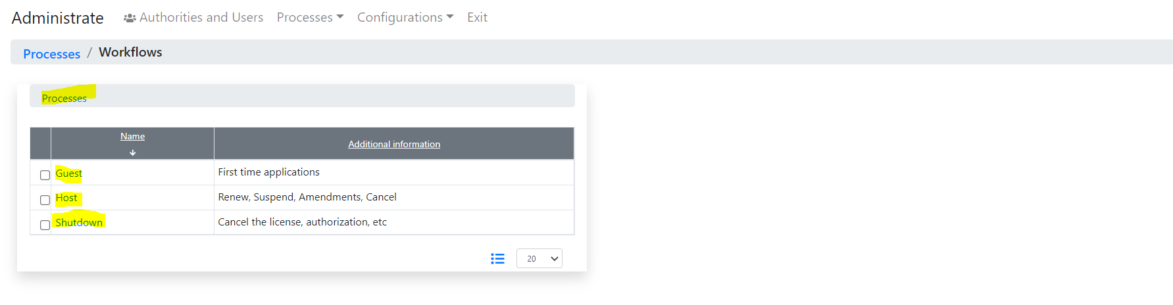

For example, the Guest stage contains a configuration of well known “New Pharmacy Registration” workflow.

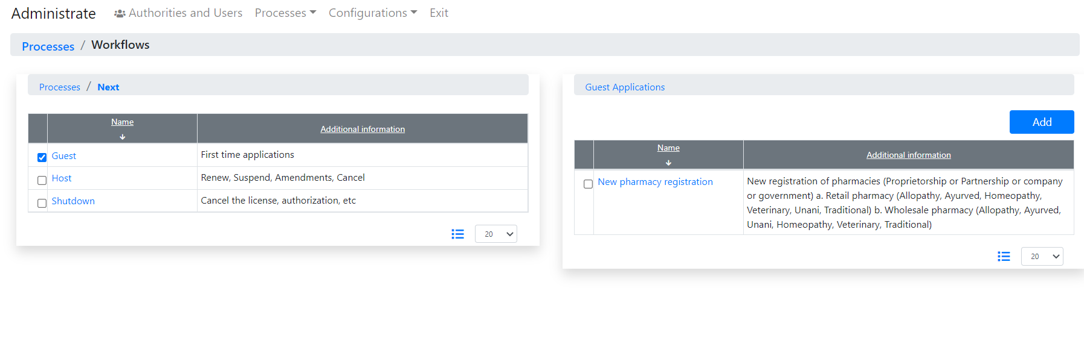 The Host stage contains configurations of Inspection and Renew workflows

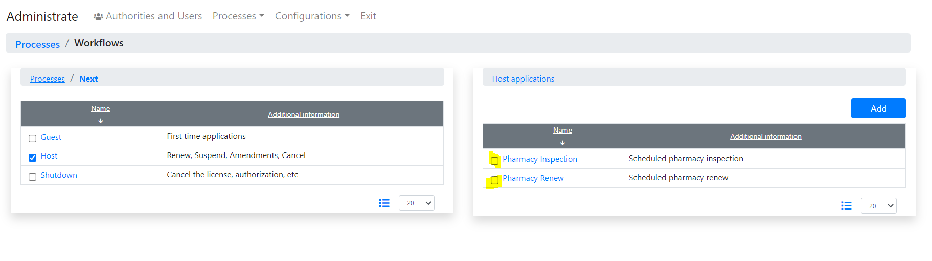

Please, check checkboxes to explore them. **Please, do not change anything!**