Pharmadex 2. Release Notes 2021-09-05

Contents

Motivation 1

Pre-requisite 1

Demo release particularities 2

The amendment workflow – 1st part 2

Definition 2

Where to find 3

How to use 4

The mockery of renewal and de-registration processes 5

Definition 5

Where to find 6

How to use 6

A printable copy of the whole application 7

Definition 7

Where to find 7

How to use 8

# Motivation

Under the current work plan have been implemented:

* The amendment workflow (1st part, issue #892)
* The mockery of renewal and de-registration processes (issue #888)
* A printable copy of the whole application (issue #755)

In addition,

* all planned for this week improvements have been resolved
* 3 critical errors have been fixed

# Pre-requisite

You must have a Gmail account and know the login and password for the applicant user. The admin user is highly appreciated, however, there are no additions to the admin features.

To check the amendment feature, from your applicant login should be available at least one finalized object to create an amendment to it.

To check the printable copy of an application, you should create a new application, in case you do not have one as an applicant.

# Demo release particularities

This release may contain errors, bad user interface behavior, and inconsistencies. Please, report them to [alex.kurasoff@gmail.com](mailto:alex.kurasoff@gmail.com).

The workflow implementation contains mistakes.

The database will not be reset to the initial state until the notification.

**Please do not make any configurations, except labels and dictionaries translation.**

# The amendment workflow – 1st part

## Definition

The amendment process intends to manage changes in the existing objects. Currently, these objects are pharmacies and wholesaler’s and importer’s facilities.

The goal of the amendment process is to provide to the National Regulatory information regarding changes that occurred or going to occur. The National Regulatory may use this information to plan follow-up actions.

The amendment workflow should be initiated by an applicant under the national legislative requirements.

Under the work plan, the current software release has been implemented the first part of the amendment workflow – start the workflow by an applicant. The second part will consist of actions on the National Regulatory side.

## Where to find

Log in as an applicant and select “Applications-Amendments”

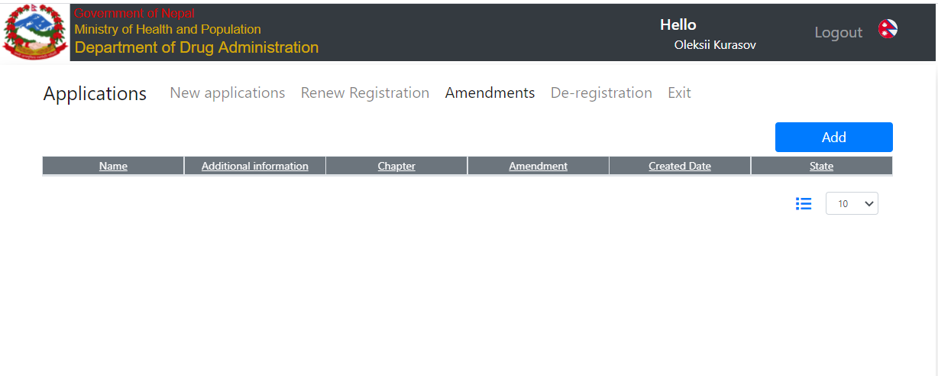

For current, there are no submitted workflows, thus, press Add to initiate a new one. If you will see an empty table, it means that you need to finalize at least one object – pharmacy, importer, or wholesaler. To do this, please, register an object and, then execute the registration workflow, include the finalization activity.

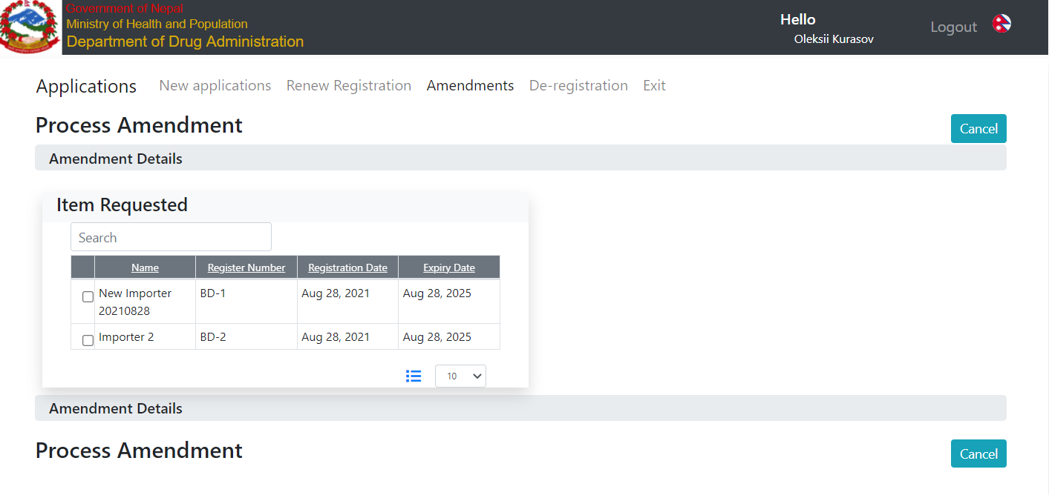

## How to use

Select the object to amend. The system will propose to select a chapter of the object’s data to amend. This data classifier is from the Data Configuration Supervisor’s feature. The supervisor can disable any chapter to amend.

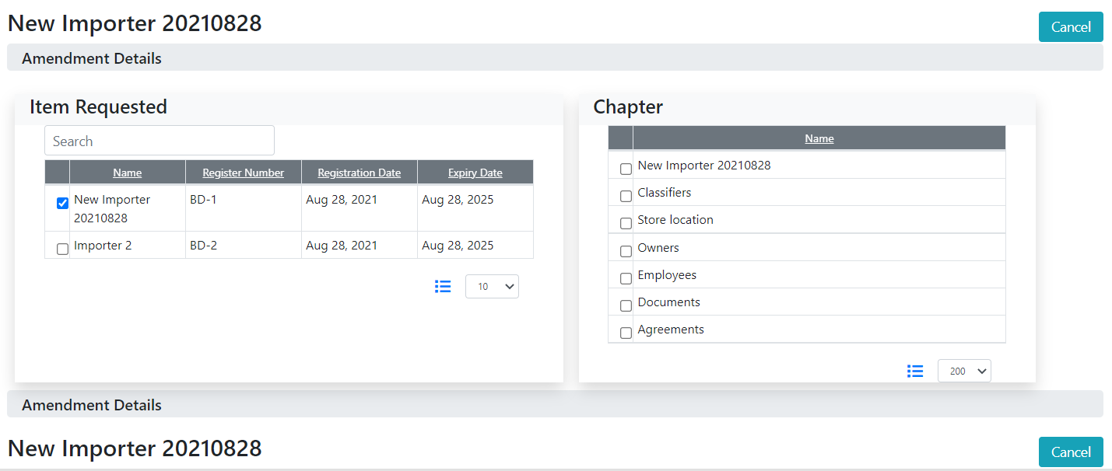

Select a chapter to amend. The system will propose to change the data in the chapter. You can change any data the same way an applicant input the new data. You can amend only one chapter at a time. It is to avoid a mess in the amendment.

Suppose the store location address has been changed

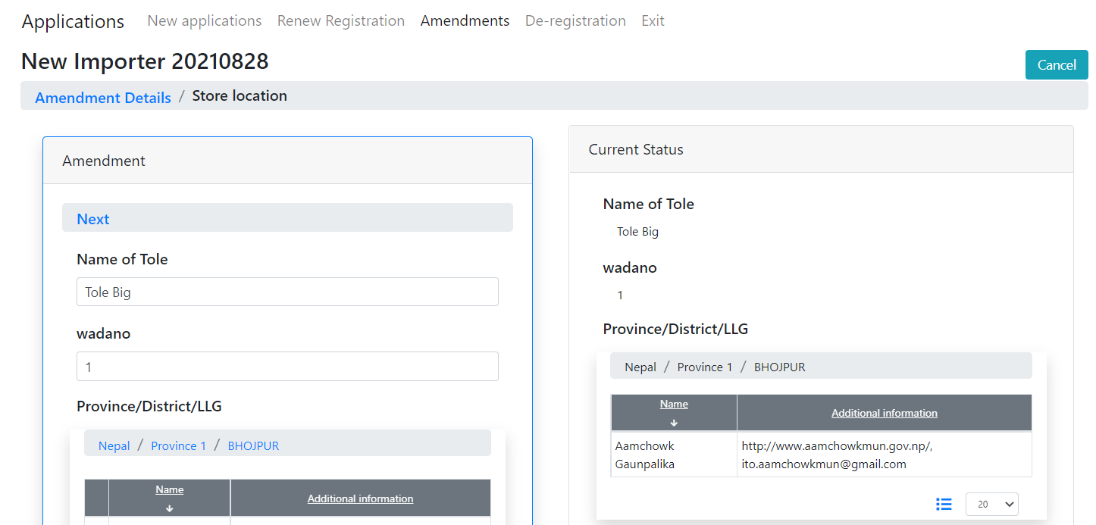

Fill free to create any changes. The changes will not be stored in the database until the amendment will be submitted to DDA. Press Next when changes will be completed.

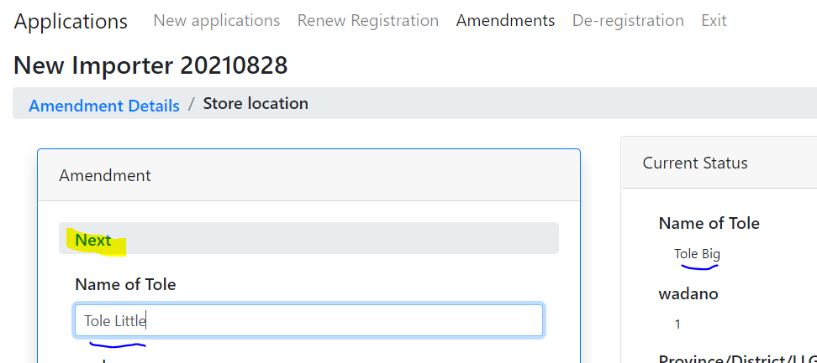

The system will provide the last screen – Submit. On this screen, you can revise the amended data and press “Submit” or return to the previous step to edit data. Please note, all your changes will be rolled back when you will return to the previous step.

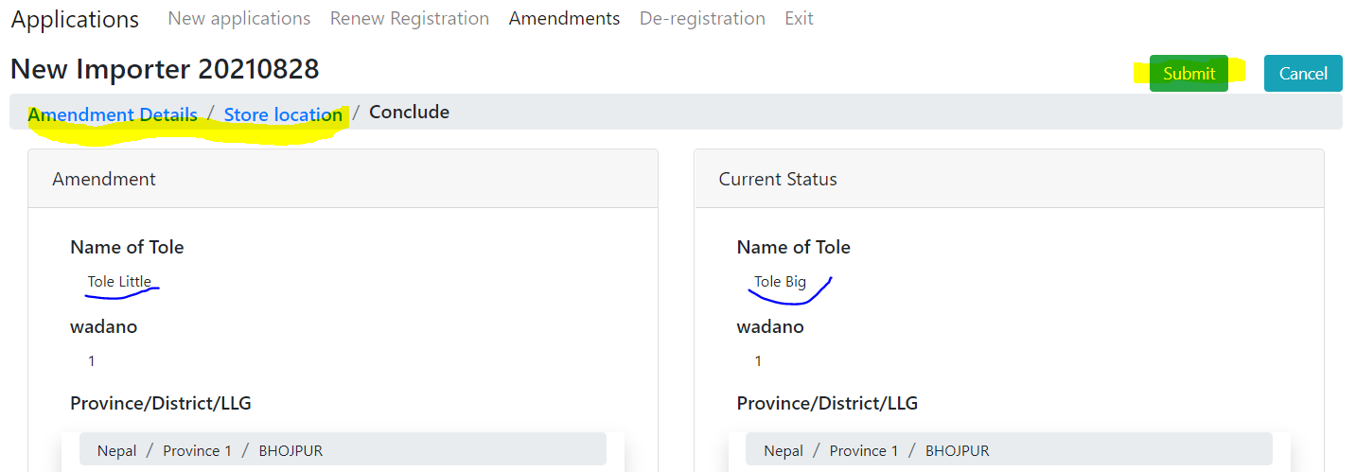

# The mockery of renewal and de-registration processes

## Definition

The existing pharmacies are registered in DAMS. From day one using Pharmadex we need the renew (register) these pharmacies.

For these renewals, we plan to register them using the NEW pharmacy application and ask the pharmacy owner to enter all data about his pharmacy - including upload a copy of the existing certificate and tax form. This way the pharmacy is in the system and onwards will be renewed as scheduled.

To introduce to future users these features, the interface mockery has been created.

## Where to find

Log in as an applicant and select “Applications”. The system will direct you to the “New Application” screen. You may also select “Renew Registration” or “De-registration”

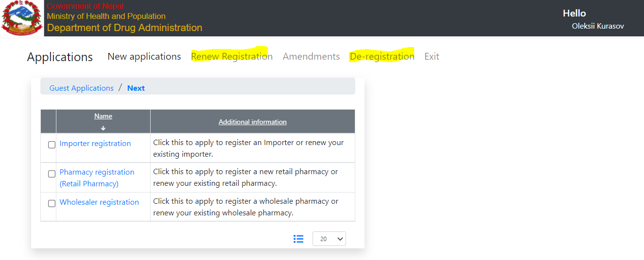

## How to use

Select a type of application, upload required files, and press Add

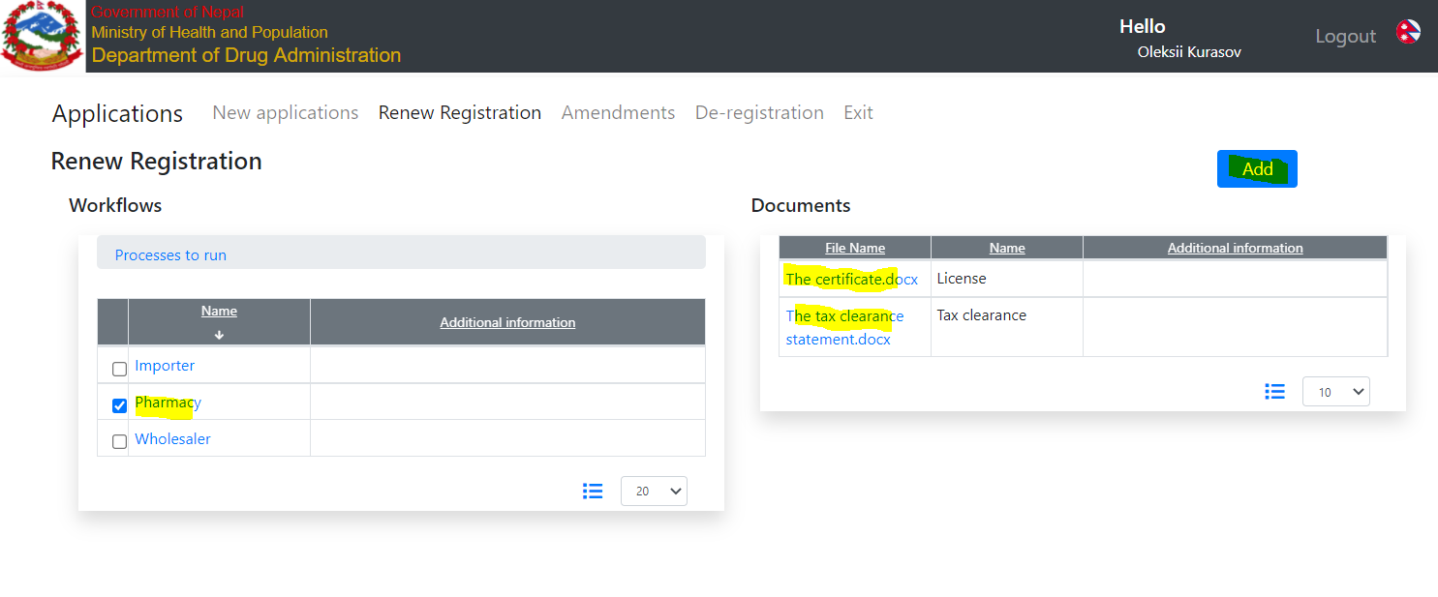

The screen will appear.

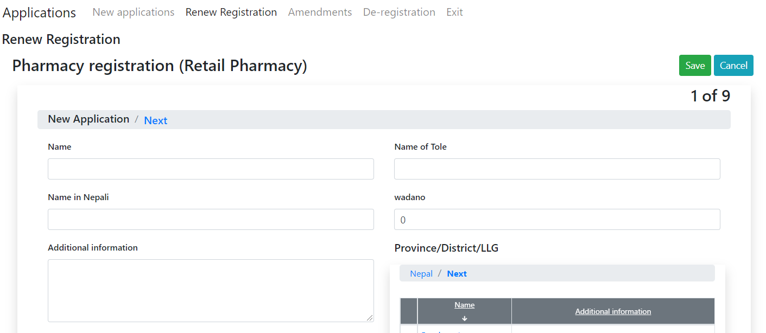

# A printable copy of the whole application

## Definition

An applicant should prepare a signed printed copy of it and store the electronic copy of the signed document in the database.

## Where to find

Log in as an applicant, open an application and set the latest step before “Conclude” (Cover)

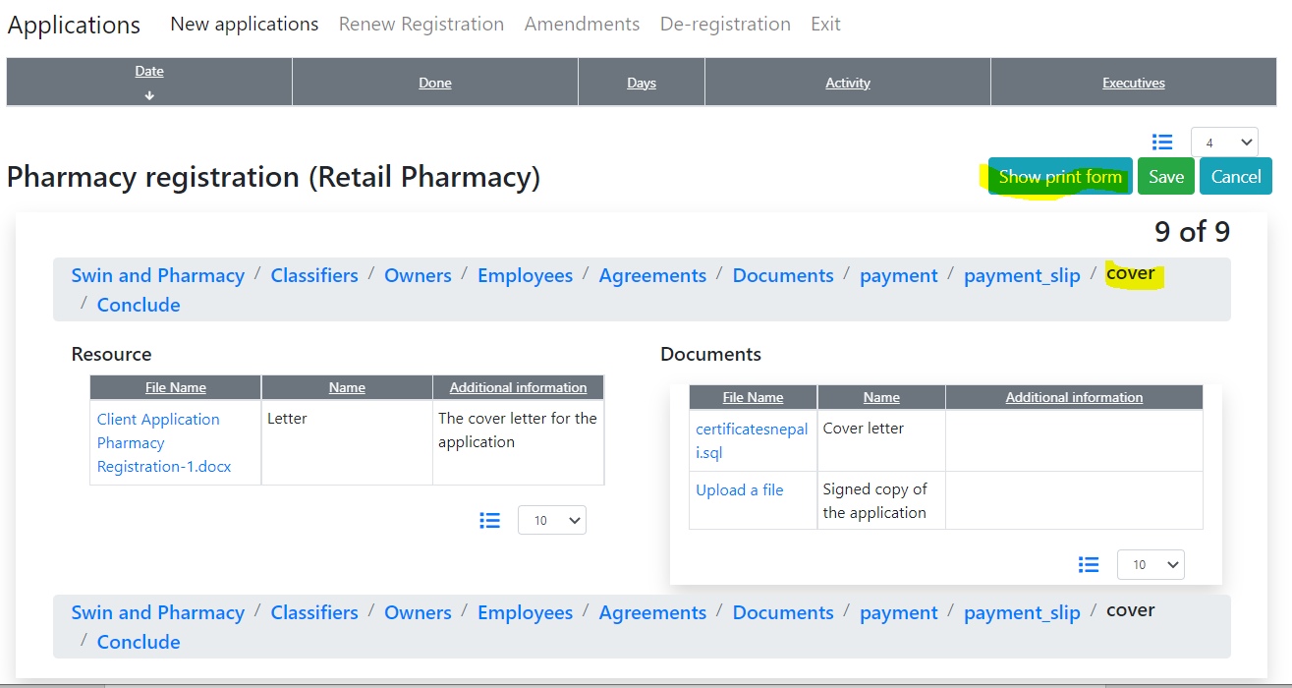

## How to use

Press the “Show print form” button, wait a while and ensure that an application is filled correctly. It is possible to change anything in this step.

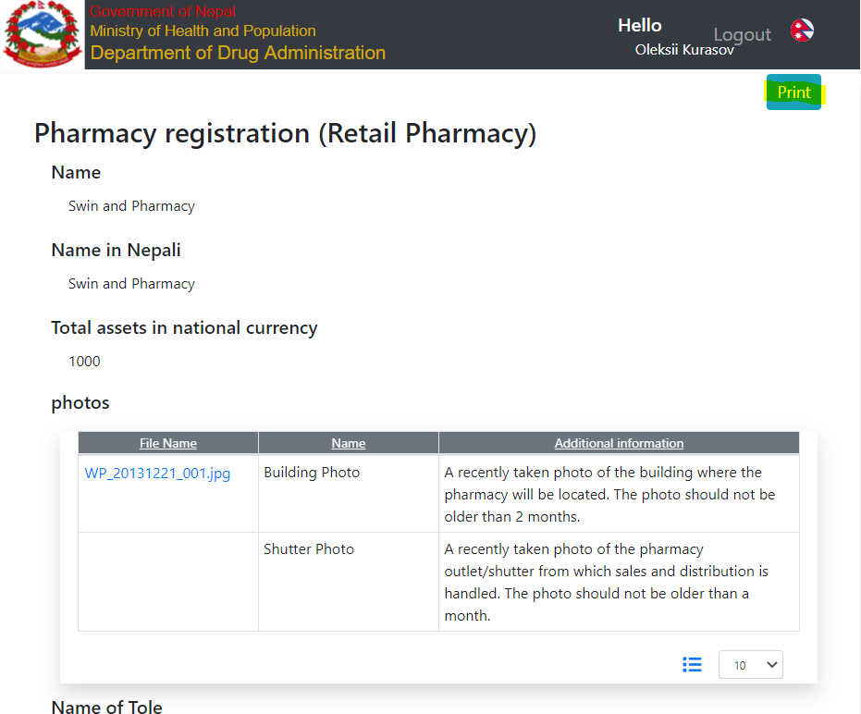

Then, press the “Print” button. The standard print dialogue will appear.

The file will be saved under the name of “application.pdf”

You can select a printer or save this document to PDF

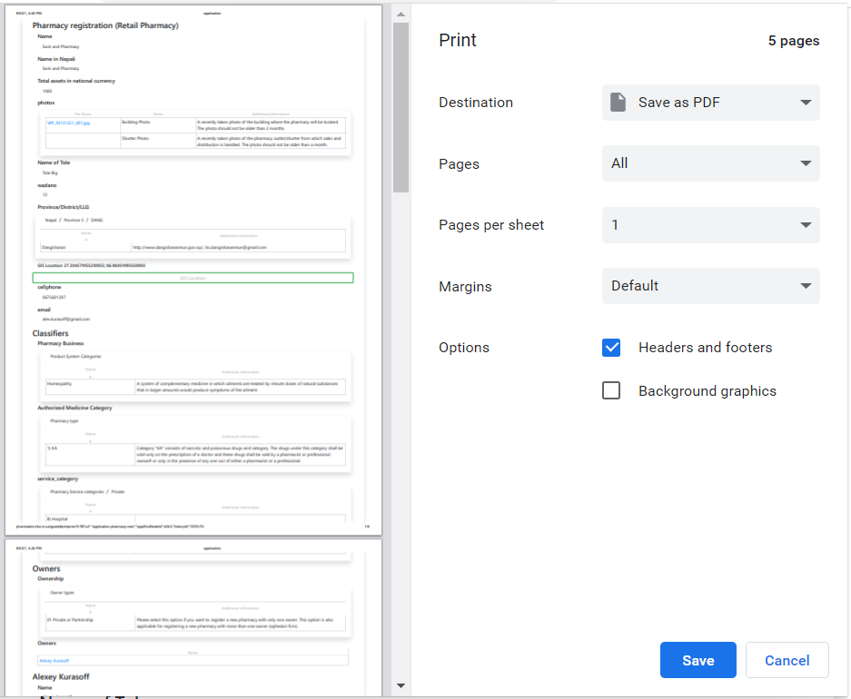

**Important notice:**

**We can’t create the PDF file directly on the server in PDF format, because of Adobe font’s usage copyright restrictions.**