Pharmadex 2. Release Notes 2021-09-12

Contents

Motivation 1

Pre-requisite 1

Demo release particularities 2

Reports 2

Where to find 2

How to use 2

Navigation 2

Search and sort 3

Export to Excel 5

Drill-Down and print 5

Multi-languages 6

Configuration 6

# Motivation

The main development in this release is a report feature. It is the most convenient and uniform way to resolve #645

In addition,

* all planned for this week improvements have been resolved
* critical errors found in dictionaries have been fixed
* critical errors found in workflow implementation has been fixed

# Pre-requisite

You must have a Gmail account and know the login and password for the supervisor user.

# Demo release particularities

**The test objects may not contain registration and inspection data.**

This release may contain errors, bad user interface behavior, and inconsistencies. Please, report them to [alex.kurasoff@gmail.com](mailto:alex.kurasoff@gmail.com).

The workflow implementation contains mistakes.

The database will not be reset to the initial state until the notification.

**Please do not make any configurations, except labels and dictionaries translation.**

# Reports

## Where to find

The tile “Reports is available for any user, except the public, yet. Will be available for public users shortly after discussion.



## How to use

### Navigation

Open the report tile and then clarify which report you want to see.

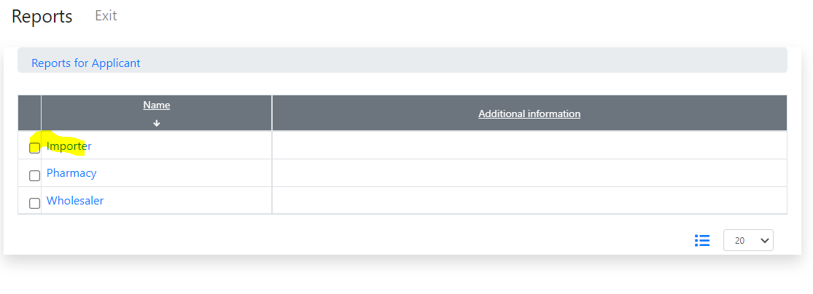

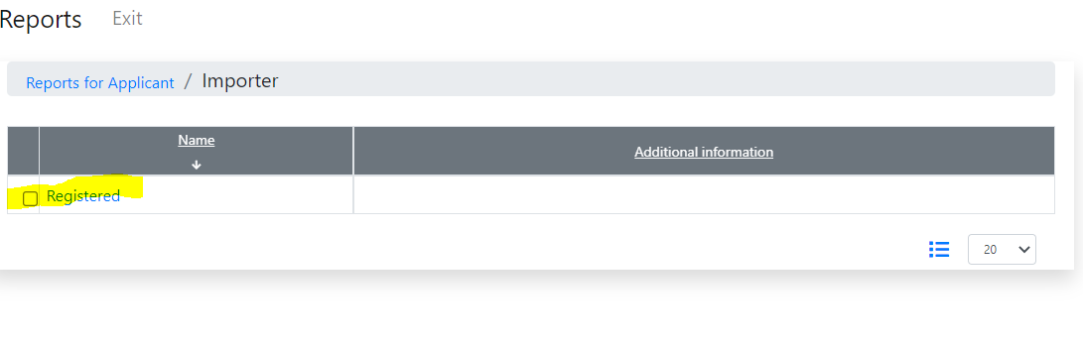

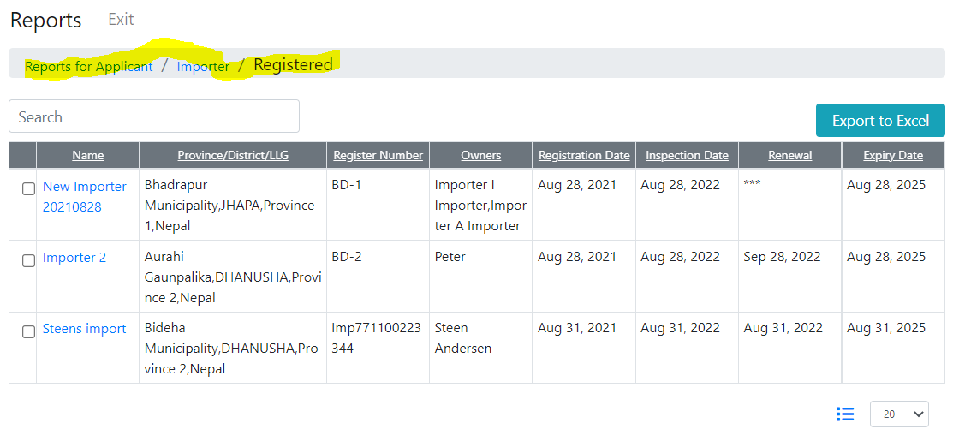

You can navigate back and forth.

### Search and sort

You can search data by all columns and by any column.

Suppose, you need to get all pharmacies in a district BHOJPURI. The search is not case-sensitive.

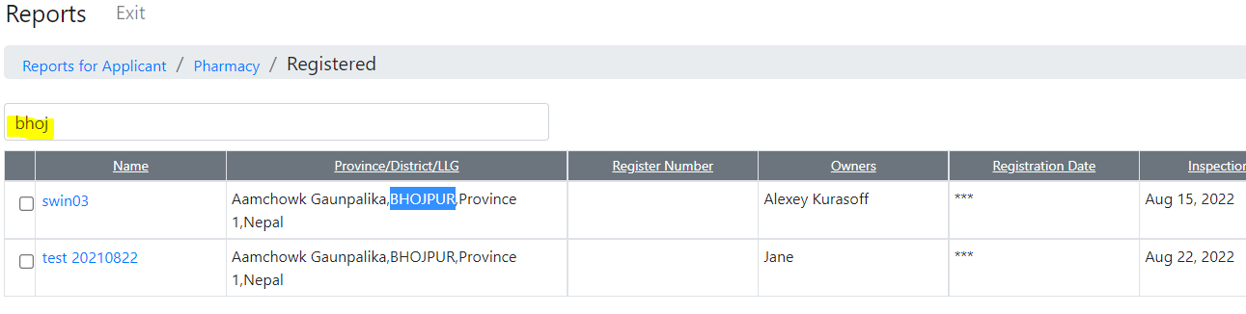

Suppose, you need to sort data by address and, then by names. To do this:

Clean up the search condition, if one

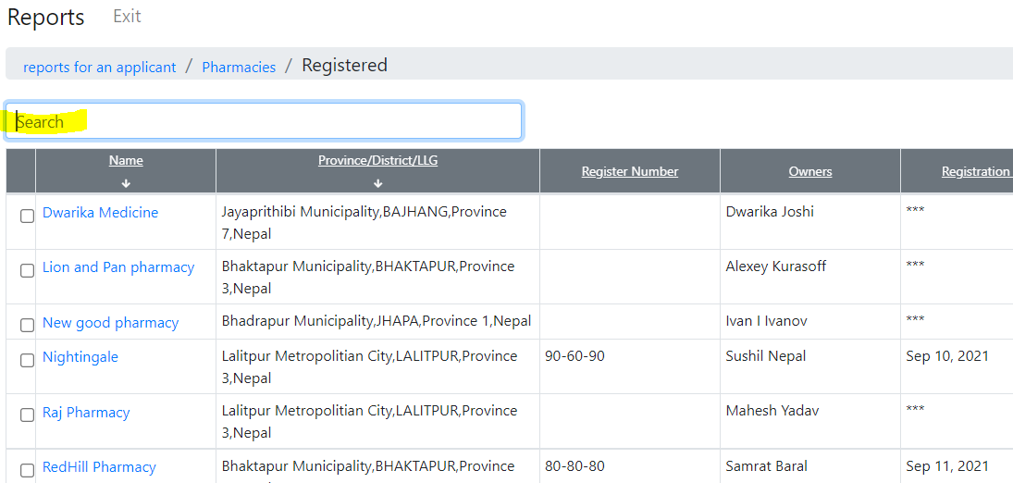

Drag the address column by mouse to the first position and turn on sorting in the columns

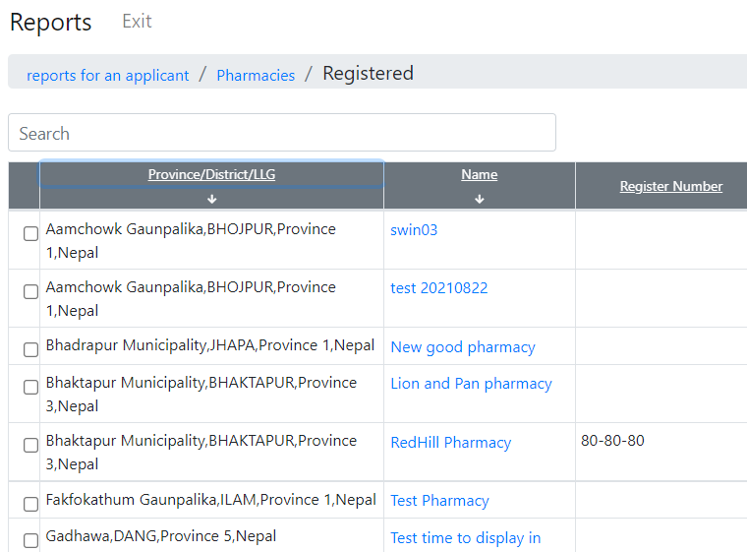

### Export to Excel

You may export the report to MS Excel. All filters, sort, and columns changes will be kept.

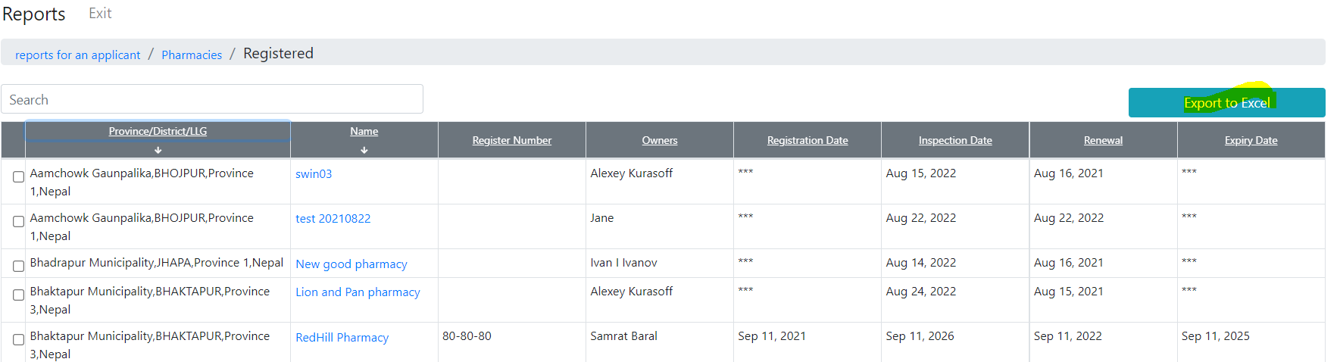

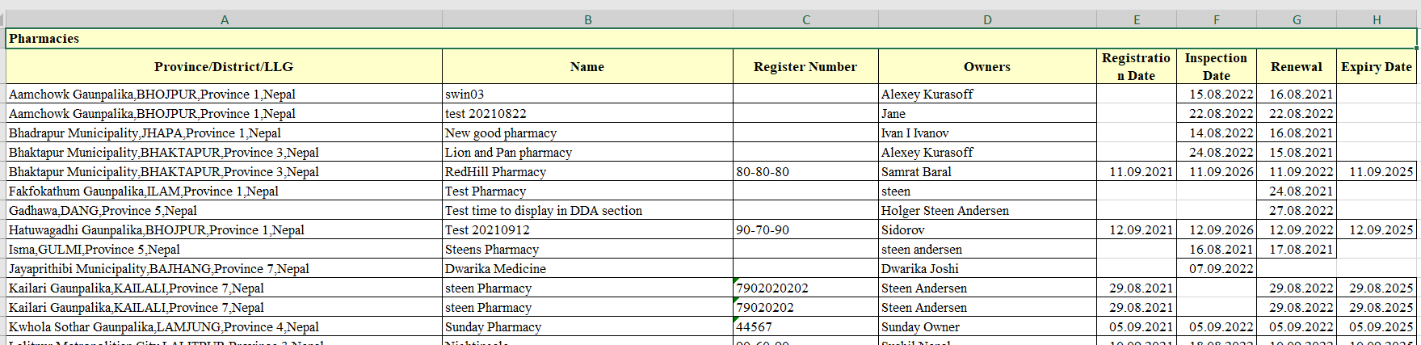

### Drill-Down and print

You may open to view any application from the report and print a copy. To do this, click on a link in the “Name” column.

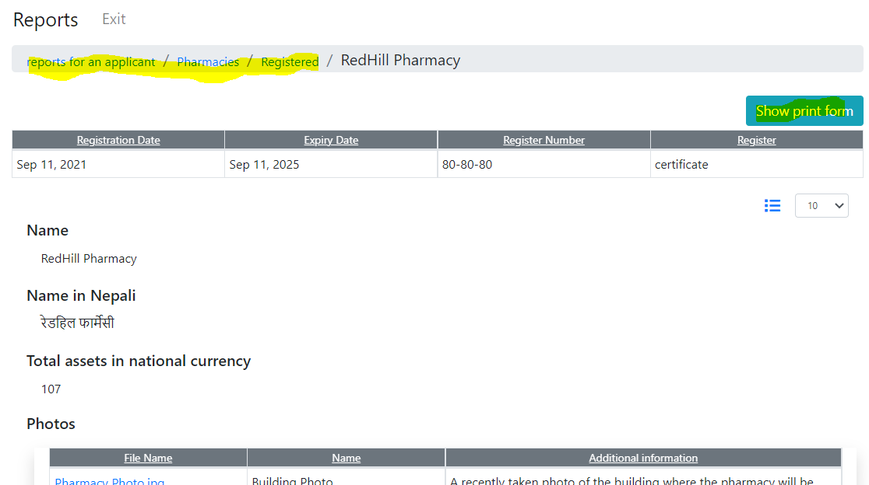

## Multi-languages

Switch language will work for reports as well as for any Pharmadex 2 screen

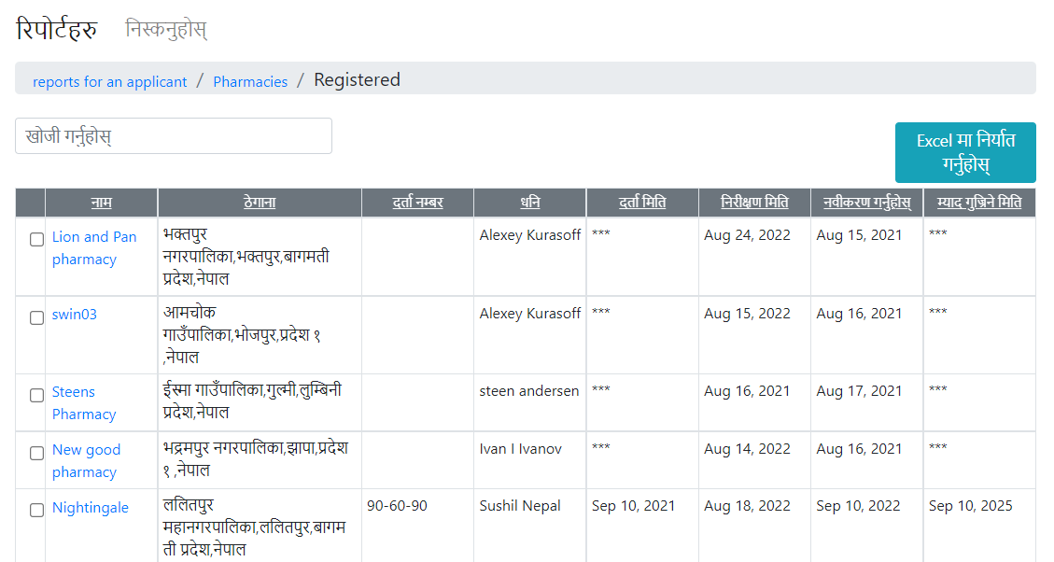

## Configuration

The report set for each user role is individual. To see it, switch to the Supervisor account and, then, open Configurations-Dictionaries. Reports for each role of a user are configured separately.

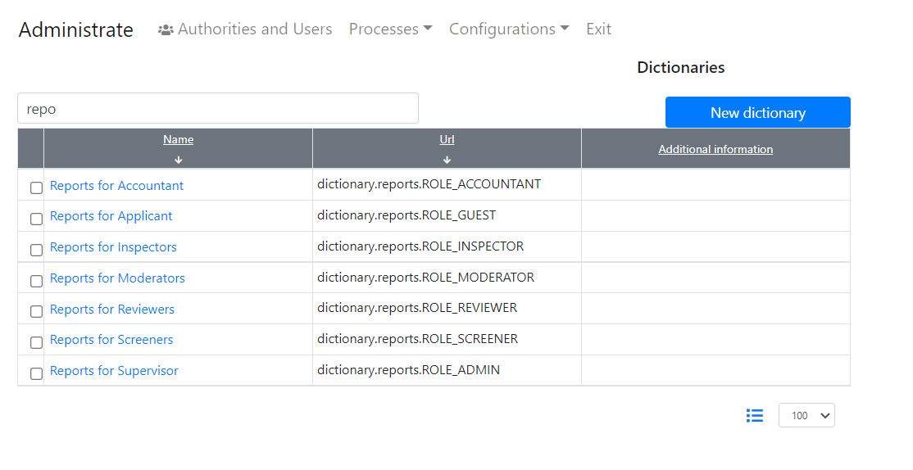

The configuration of the reports for current is hardcoded. The version that allows configuration by the supervisor will come in a week.