Pharmadex 2. Release Notes 2021-09-19

Contents

Motivation 1

Pre-requisite 1

Demo release particularities 2

Amendments 2

Where to find 2

How to use 3

What’s next 6

Workflow Editor 6

Where to find 6

How to use 7

# Motivation

The main goal in this release is the continuation to develop the modification feature, e.g. amendment applications:

* An amendment application keeps copies of previous data and amended data.
* Changes to the actual data have been disabled before the modification will be approved (except the file upload)
* For an applicant, it is possible to save the amendment application before submitting it to NMRA.
* For an amendment, the application is mandatory to fill out the area of the modification and notes.

In addition, the workflow editor feature has been improved. Currently, it is possible to insert new workflow steps before the current ones.

# Pre-requisite

You must have a Gmail account that has not been registered in the Pharmamadex 2 database. You should know the login and password for the supervisor user.

# Demo release particularities

This release may contain errors, bad user interface behavior, and inconsistencies. Please, report them to [alex.kurasoff@gmail.com](mailto:alex.kurasoff@gmail.com).

The workflow implementation contains mistakes.

The database will not be reset to the initial state until the notification.

**Please do not make any configurations, except labels and dictionaries translation.**

# Amendments

## Where to find

Log in as an applicant and select Applications-Amendments

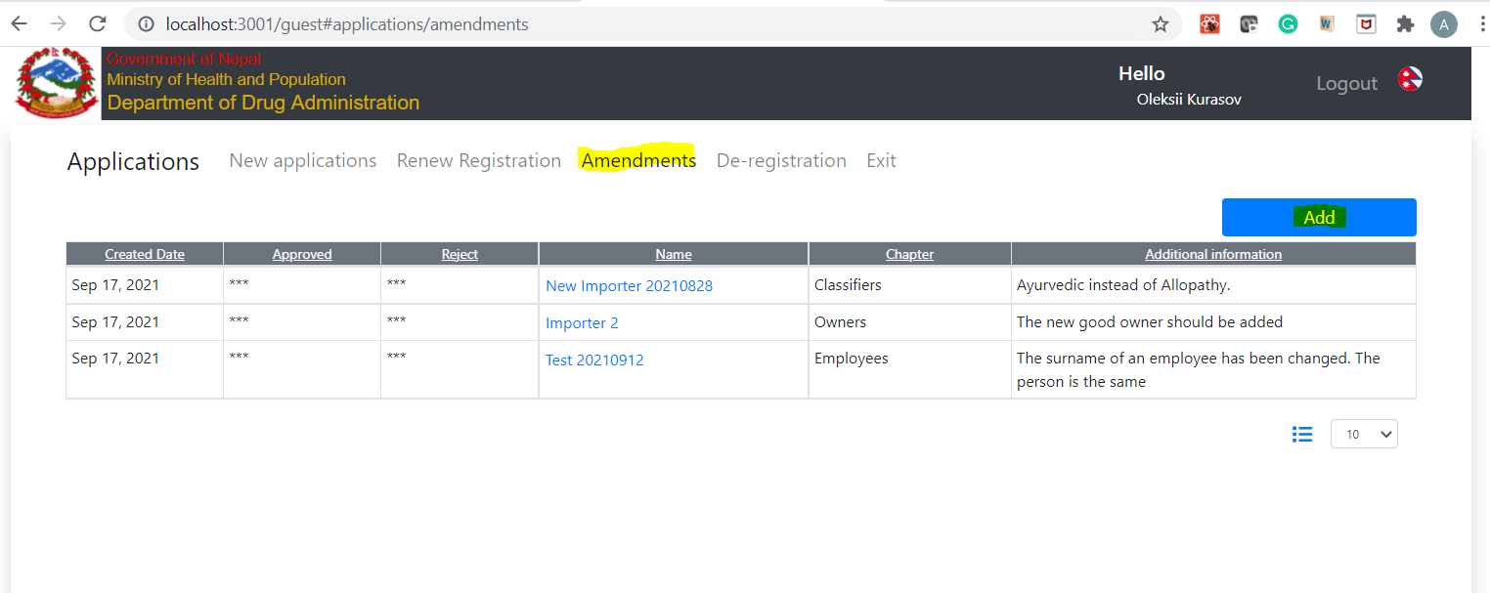

## How to use

Press Add or select a stored amendment. Then, select an object to amend from the list of the objects registered by you

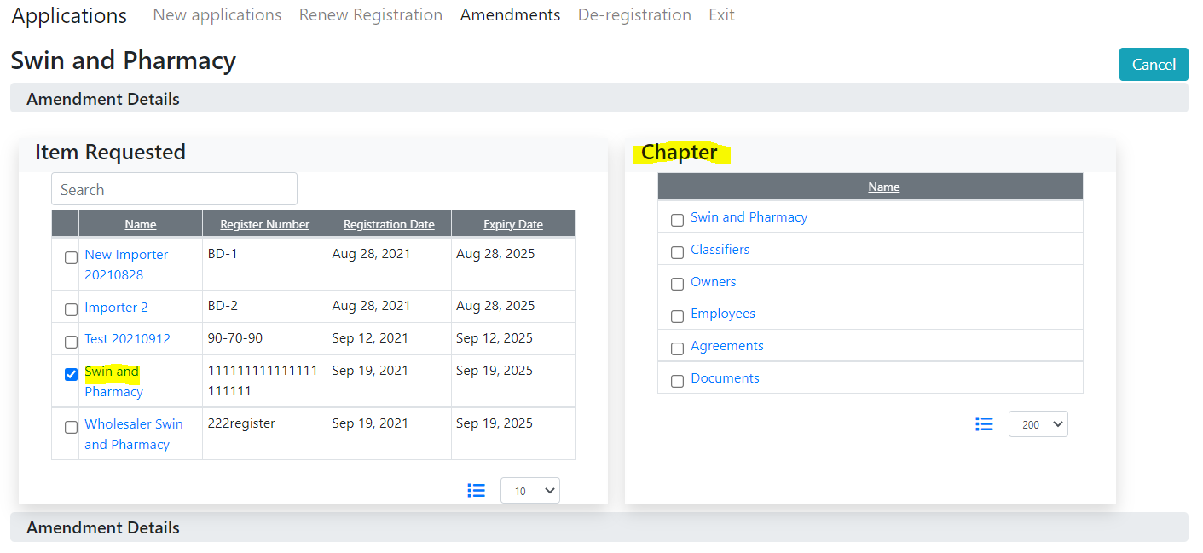

Select a chapter (a group of the object data) to amend. You can select only one. Then, change the data. Changes you will make will not update the actual object’s data. Suppose you’ve changed the Product system category

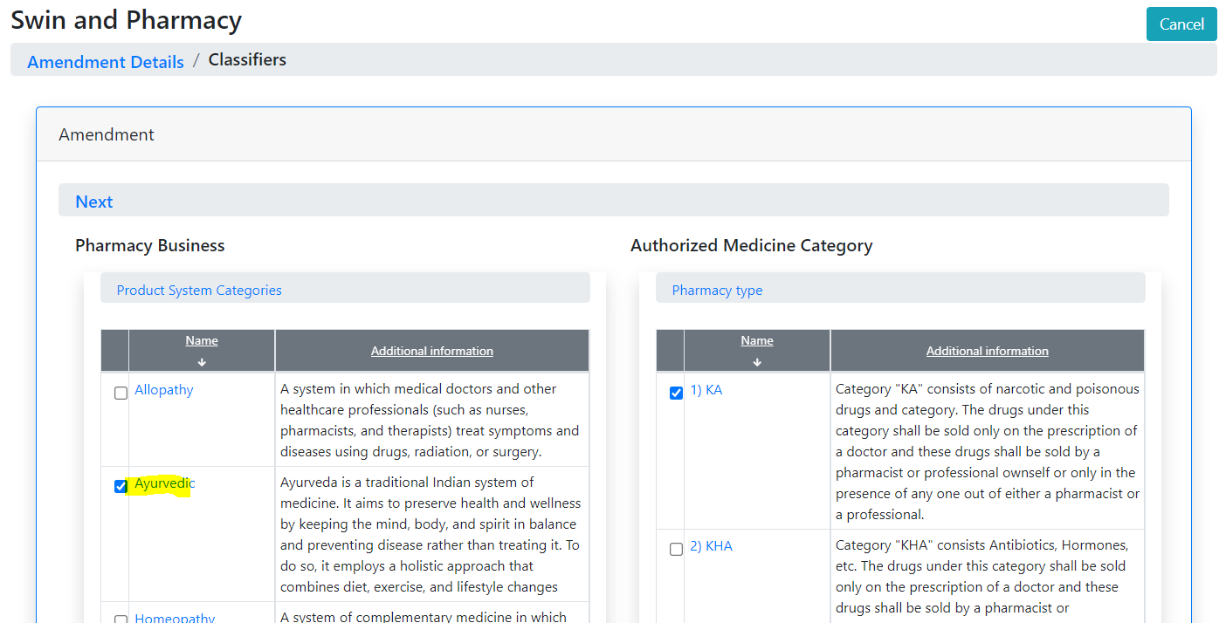

Press Next. The following page consists of three parts

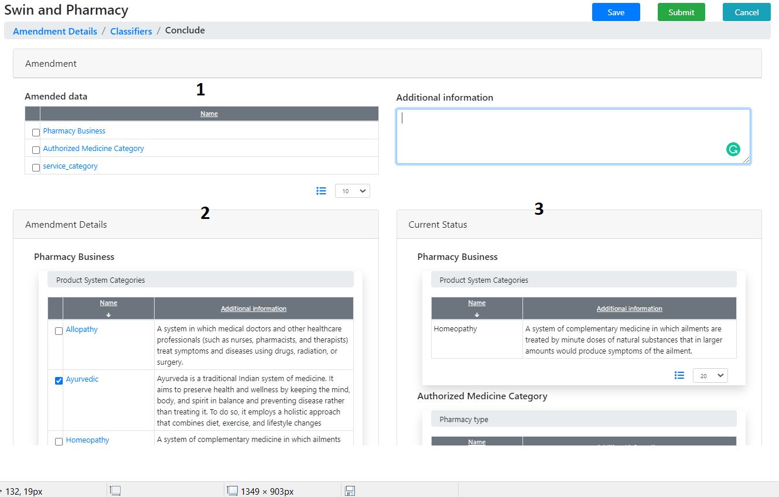

1. The information on which data should be amended and why
2. Amended data
3. Current data

Fill out part 1 and press Save. The amendment will be stored for future use

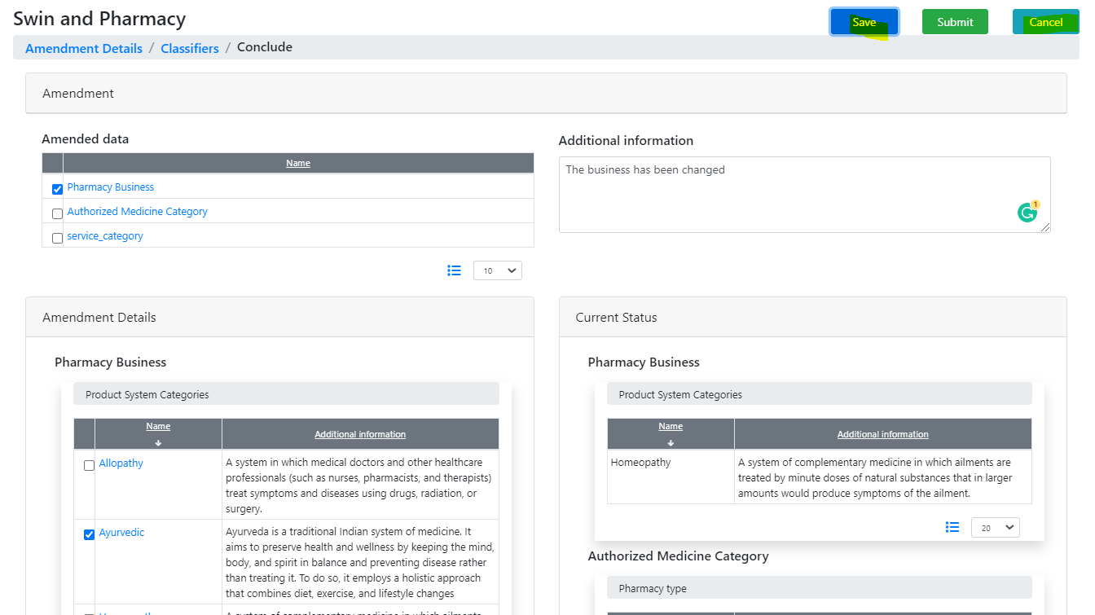

Press “Cancel”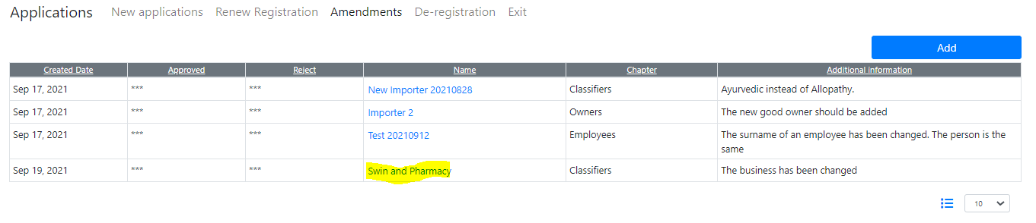

Click on the saved amendment to get the data you just define.

## What’s next

Amendment implementation is the most complex part of Pharmadex 2. Thus, the workflow to approve and implement the amendment will be created in the next steps. The family of amendment workflow will be placed in the “Host” stage of the application’s lifecycle (see below).

# Workflow Editor

## Where to find

Log in as an administrator and select “Administrate-Process-Workflows”. The screen below reflects the currently defined stages of the application lifecycle.

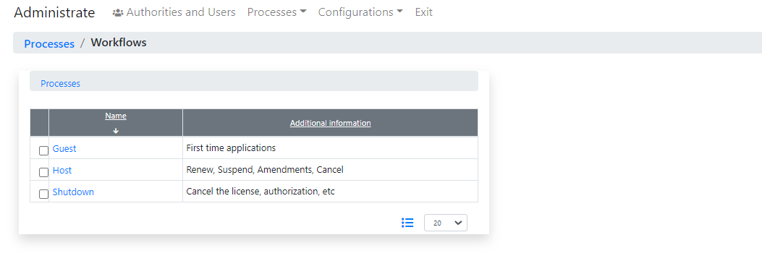

* The Guest item provides access to workflows that intends to register new objects.
* The Host item provides access to the post-registration workflows
* The Shutdown item provides access to de-commission workflows

## How to use

**Please, do not add/insert new steps and change URLs and roles. The supervisor guide regarding these features will come soon**

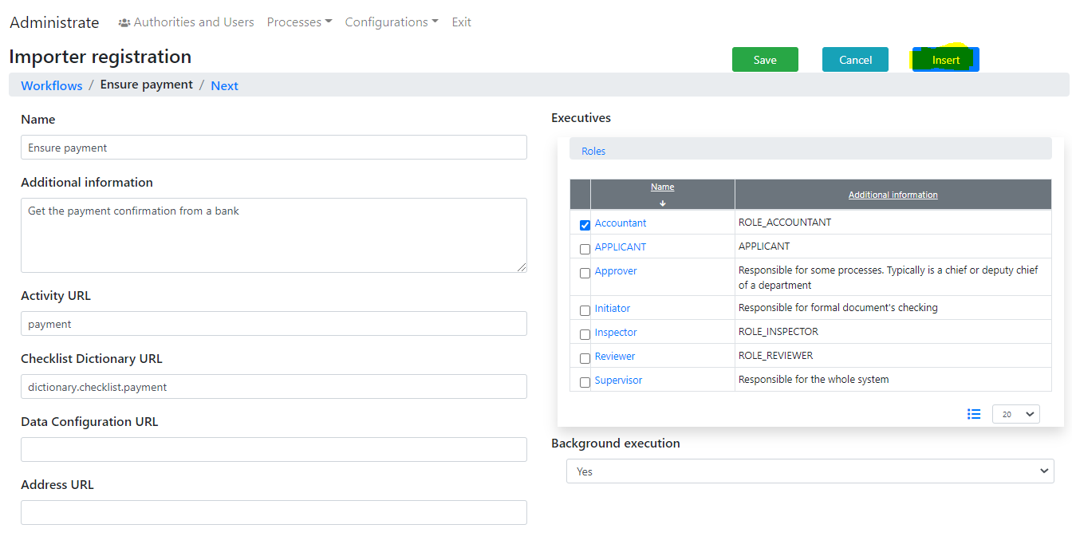

**The new button “Insert” allows inserting new workflow steps before the current. Please do not use it before you will confident about what you are going to do.**