Pharmadex 2. Release Notes 2021-09-26

Contents

Motivation 1

Pre-requisite 2

Demo release particularities 2

Application history 2

Motivation 2

Where to find 2

How to use 3

Applicant’s view 4

Declare the Pharmacist 5

Where to find 5

The example 5

Changes in the process 6

Owner definition screen is simplified 6

The employee definition screens are unified with the owner definition 7

New screen to declare the pharmacist has been developed 9

Changes in configurations 9

Simplified owners screen 9

New qualification screen 10

Changes to employees screens 10

New Pharmacist screen 11

Re-designed “pharmacy.site” class 12

# Motivation

The main goal in this release is the continuation to develop the modification feature, improving the reporting feature, and start to develop workflows for existing pharmacies/wholesalers.

However, the modification feature and implementation of the existing pharmacies/wholesaler features are incidental before implementation feature #920 - Copy owner details to Pharmacist/Dispenser form. It is because the implementation of this feature has a sufficient impact on the user interfaces, algorithms, and data structure.

Feature #920 has been implemented in the sandbox environment and the case of approval will be transferred to the testing environment in a day.

# Pre-requisite

You must have a Gmail account that has not been registered in the Pharmamadex 2 database. You should know the login and password for the supervisor user.

# Demo release particularities

This release may contain errors, bad user interface behavior, and inconsistencies. Please, report them to [alex.kurasoff@gmail.com](mailto:alex.kurasoff@gmail.com).

The workflow implementation contains mistakes.

The database will not be reset to the initial state until the notification.

**Please do not make any configurations, except labels and dictionaries translation.**

# Application history

## Motivation

It is necessary to track the application history on all steps of a workflow.

## Where to find

Application history information can be found in ToDo and Monitoring features. Open a record related to any activity

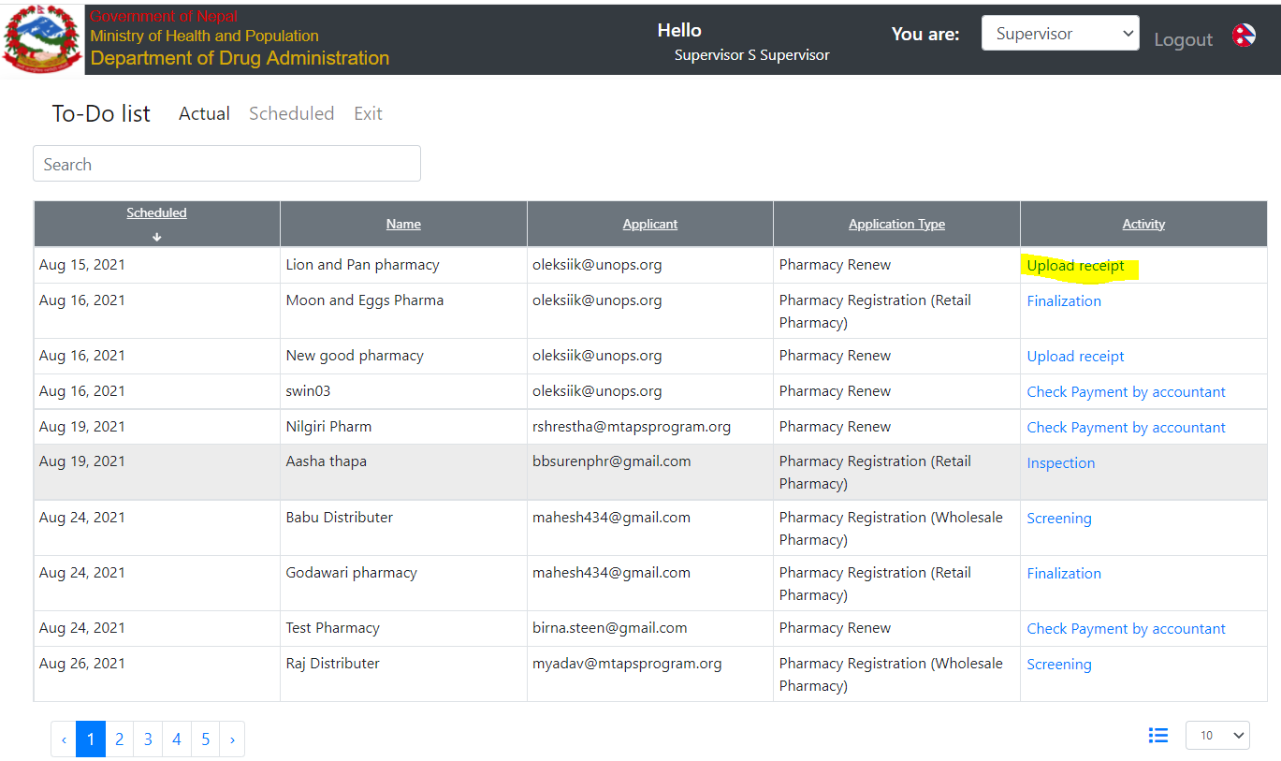

This record will provide data about the activity. Click on “Application Information” to see the full application history

## How to use

Click on “Application Information”

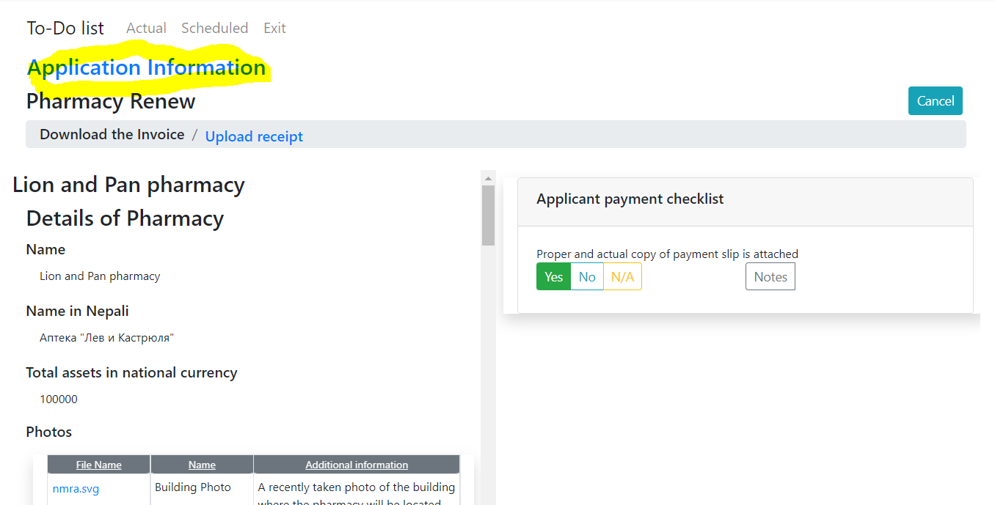

All history is available. Click on any activity to see details.

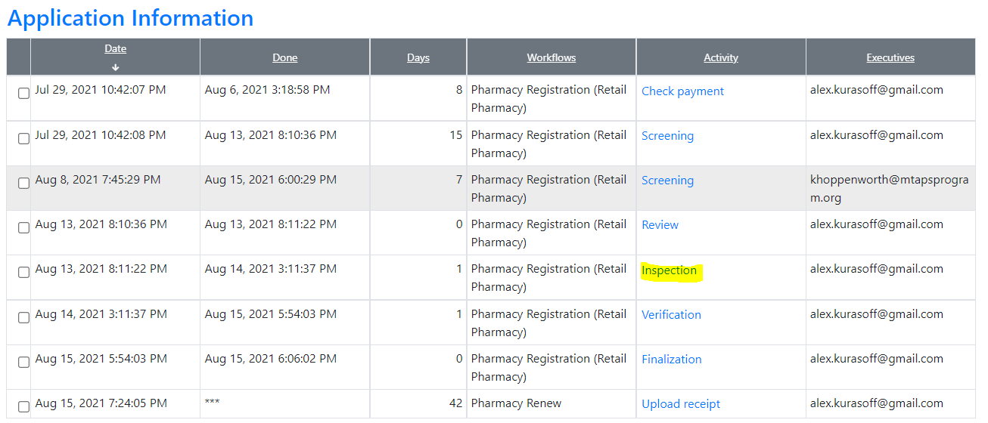

A detailed inspection history will be available. Press Next to close

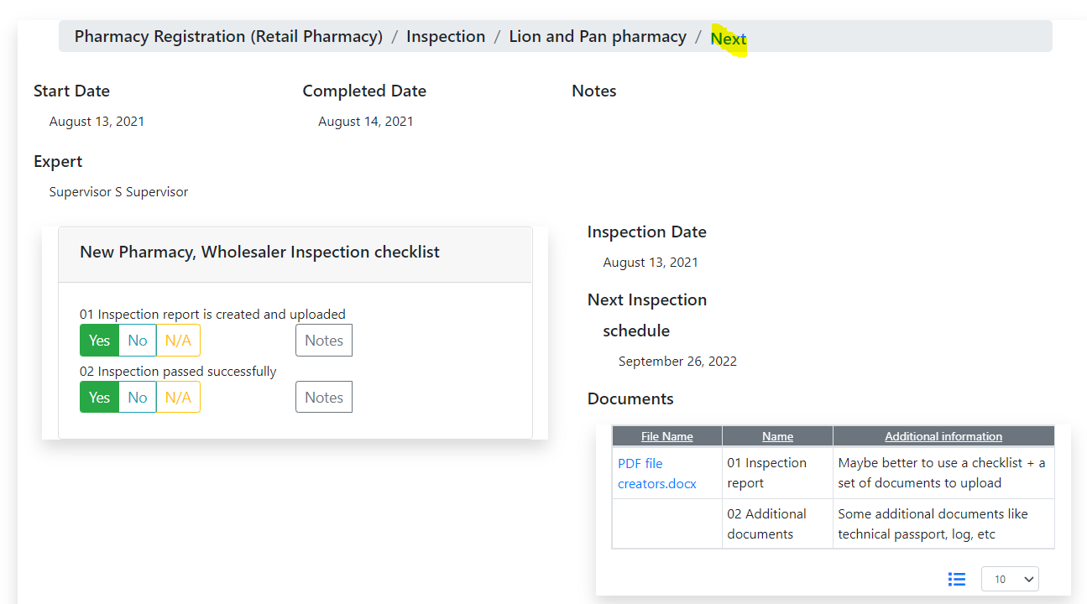

## Applicant’s view

The applicant's view of the application history is reduced. Please, log in as an applicant and open ToDo or Monitoring feature.

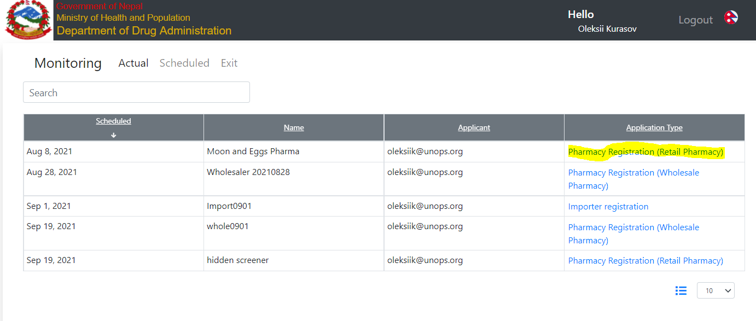

Applicant can’t see DDA executor

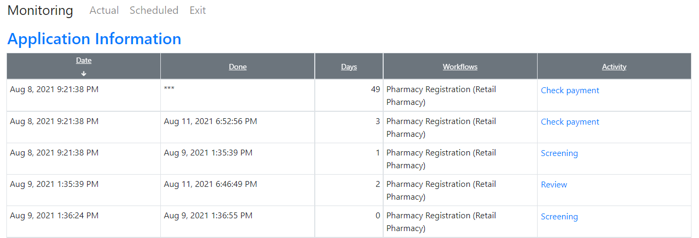

however, can see checklists and can download inspection reports

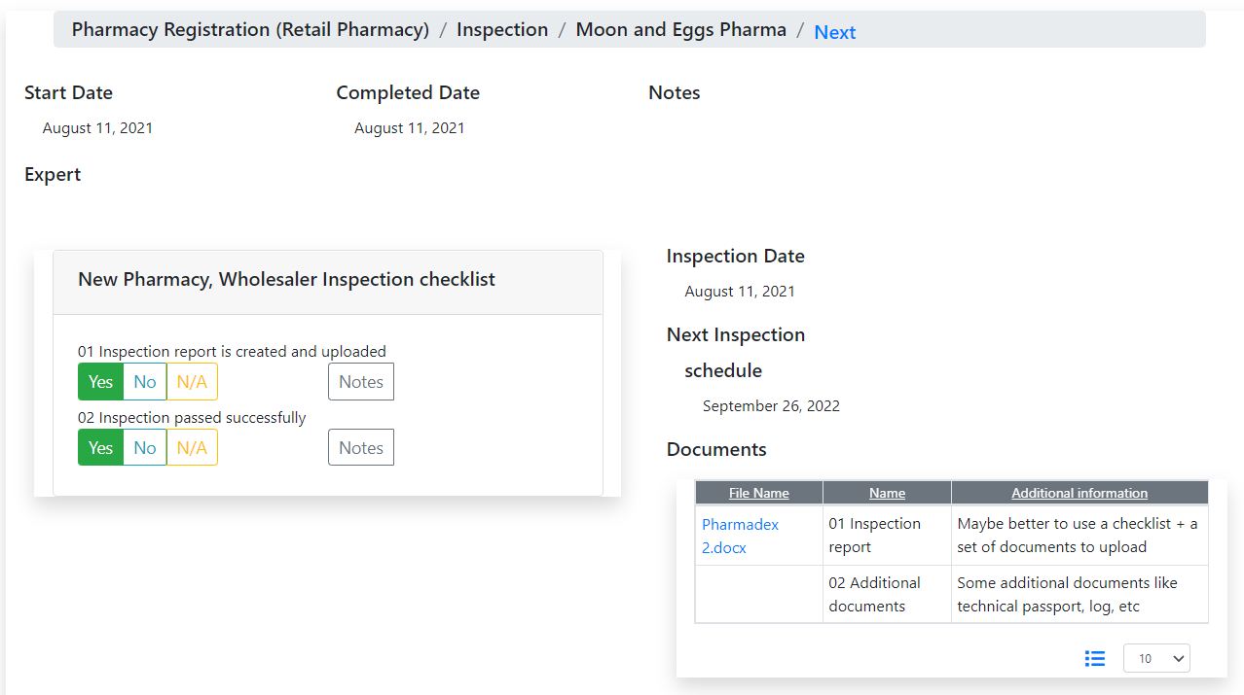

# Declare the Pharmacist

## Where to find

Currently, it is implemented in the developer’s sandbox, that unavailable for testing outside the development environment. It may be moved to the development environment in a day in case there is no demonstration to DDA is in the schedule this week.

## The example

An example is a new pharmacy registration process.

## Changes in the process

### The owner definition screen is simplified

The new screen to define owners does not contain the choice to select a type of owner. Currently allowed only persons as owners.

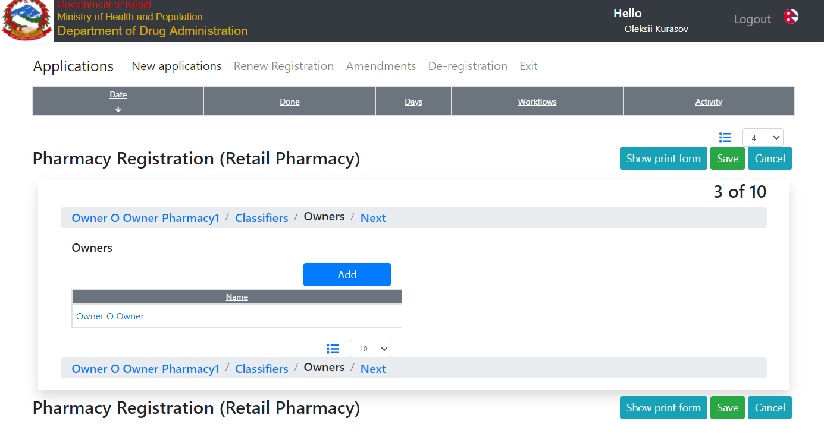

### The employee definition screens are unified with the owner definition

Screens for input employee data currently are the same as for the owner, except an additional screen “Qualification”

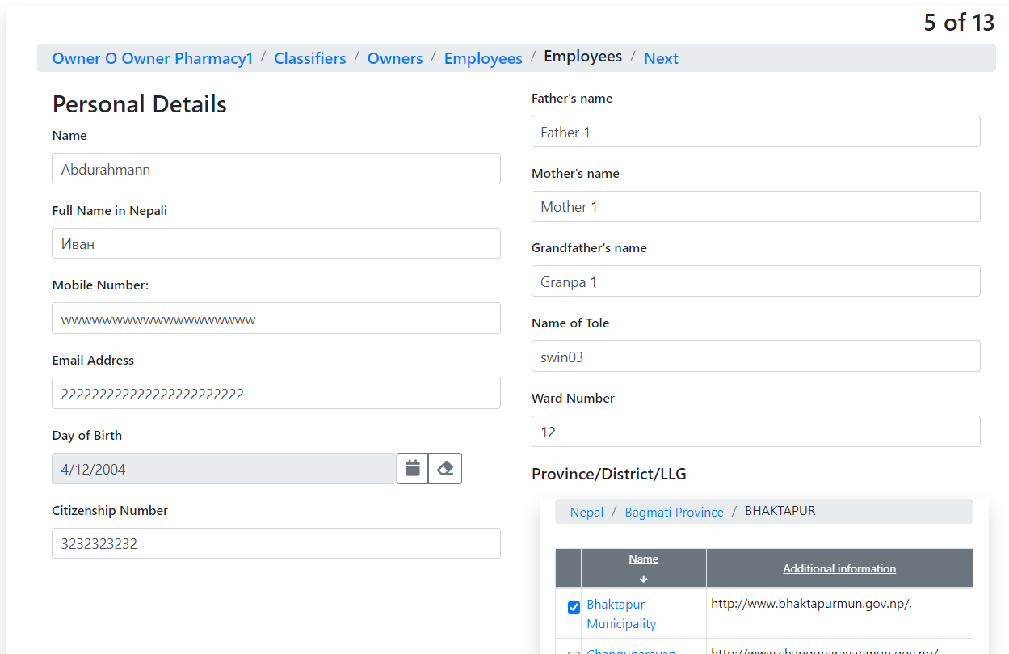

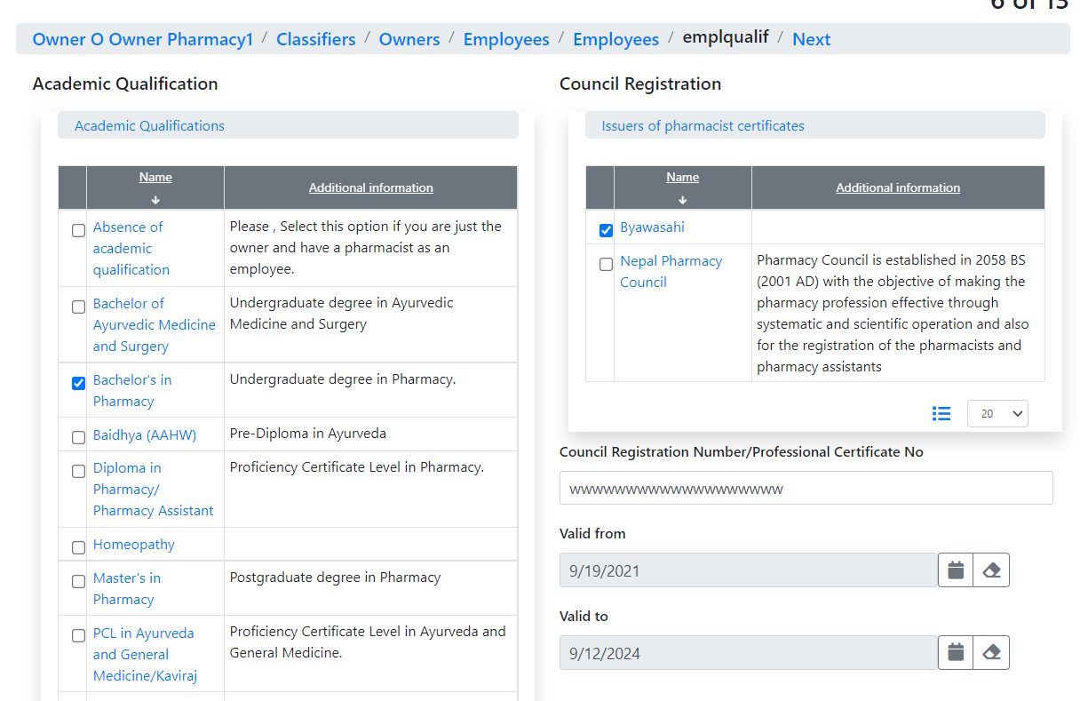

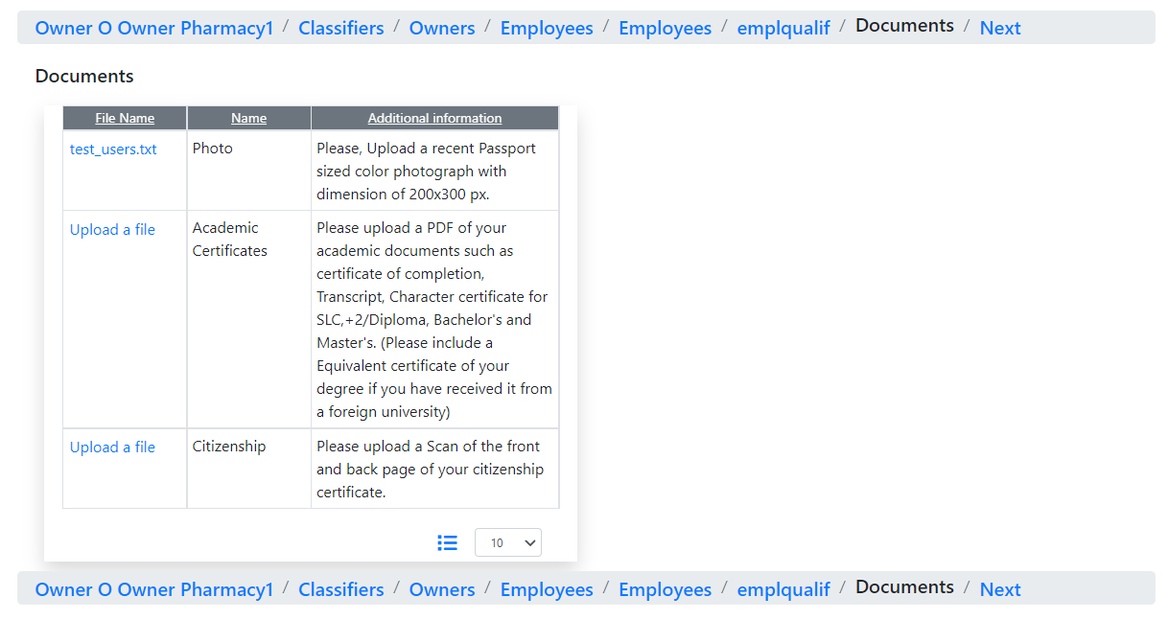

### New screen to declare the pharmacist has been developed

To declare a pharmacist the applicant can select one of the previously defined persons – owners and/or employees

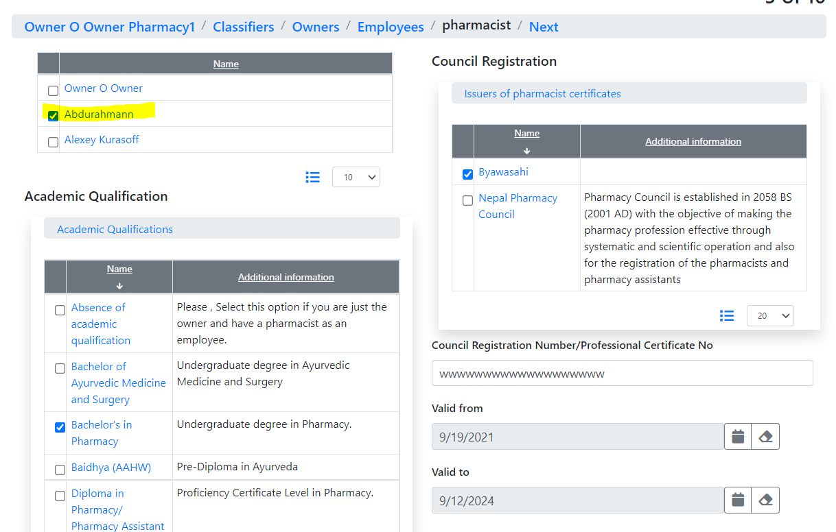

For employees, the qualification data comes from the database. For owners – should be defined manually.

## Changes in configurations

### Simplified owners screen

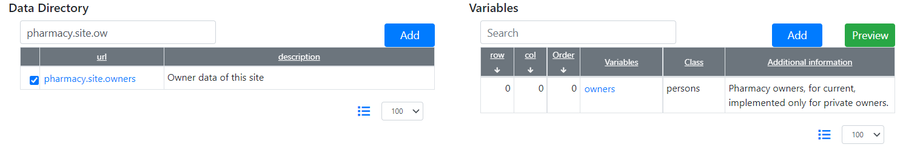

### New qualification screen

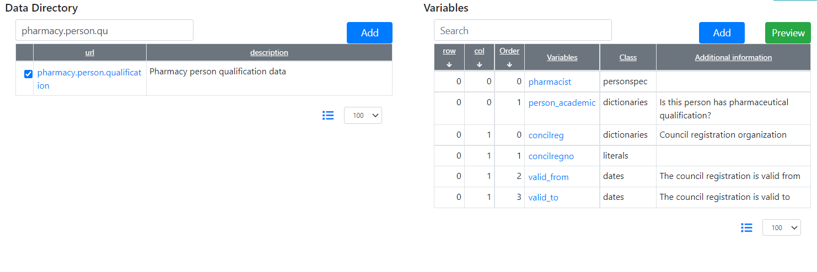

### Changes to employees screens

Fully unified with the owner

Employee

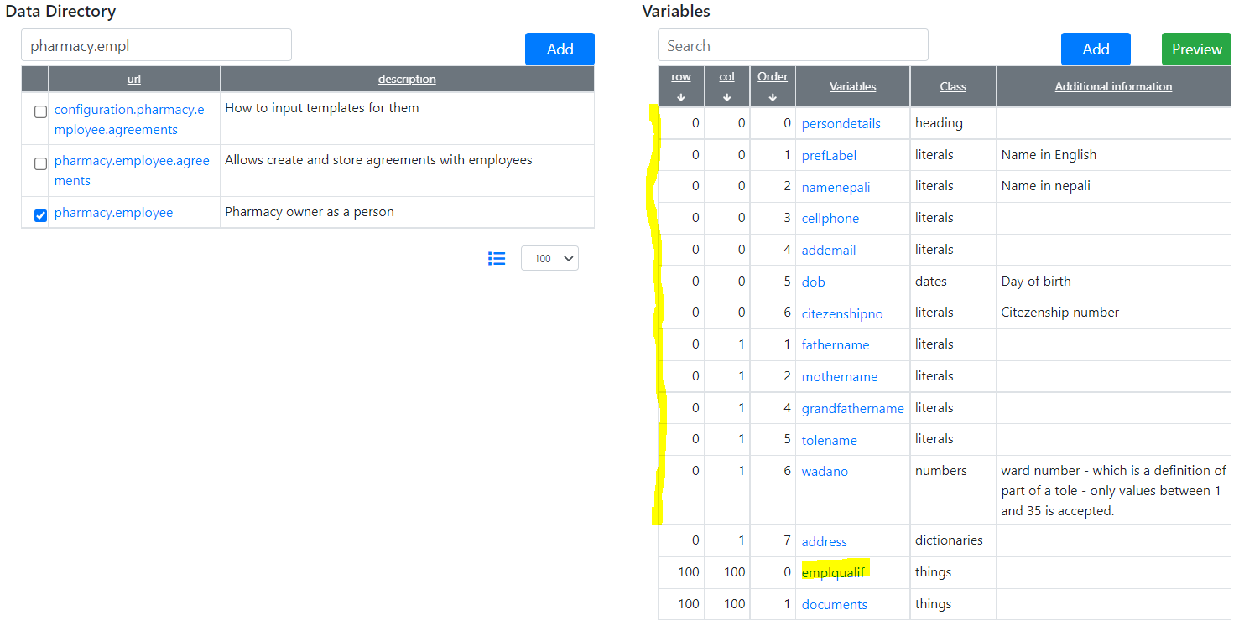

Owner

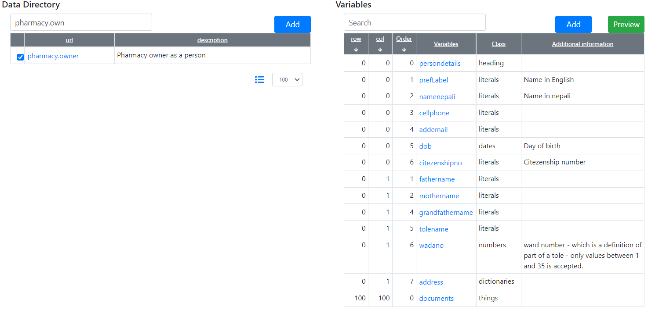

### New Pharmacist screen

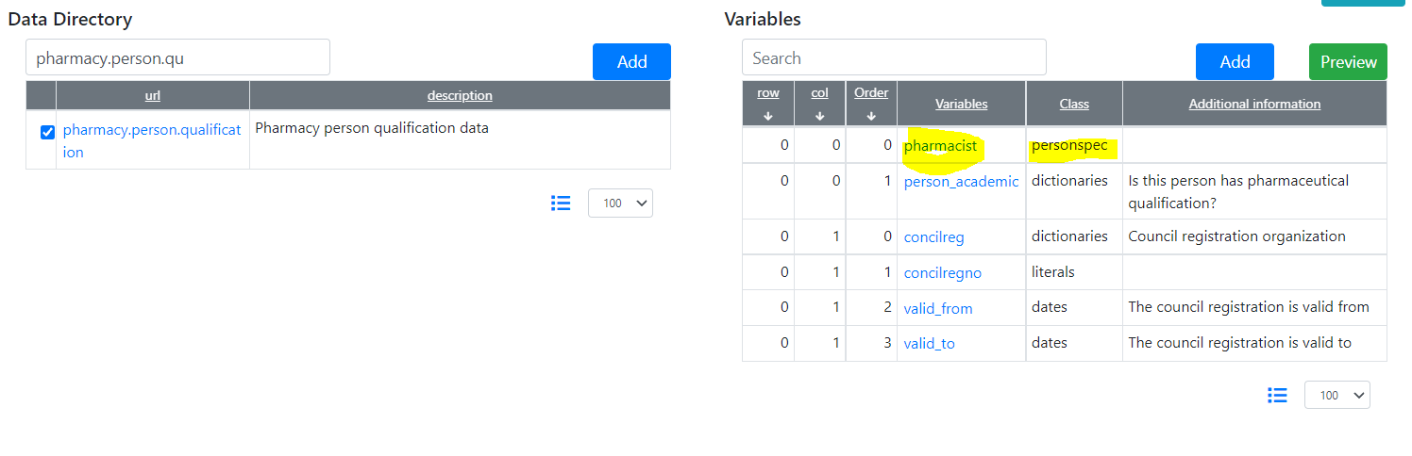

Allows selecting a person that will be declared as a pharmacist.

### Re-designed “pharmacy.site” class

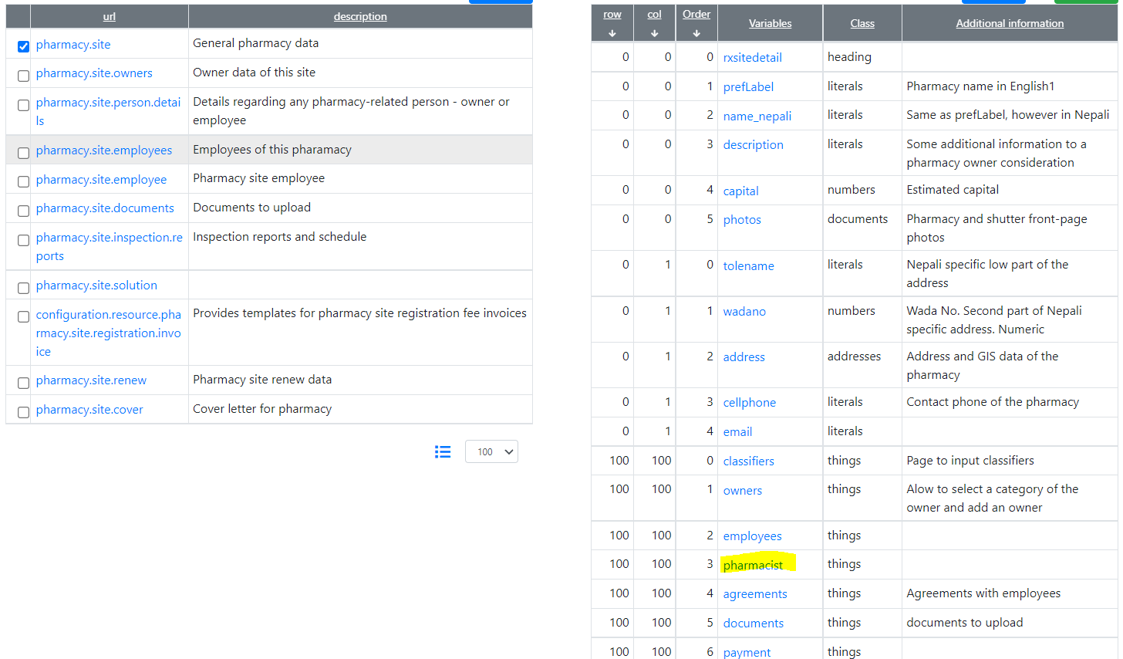

The pharmacist declaration has been inserted.