Pharmadex 2. Release Notes 2021-10-03

Contents

Motivation 1

Pre-requisite 2

Demo release particularities 2

Return to applicant 2

Motivation 2

Where to find 2

How to use 2

New EL expressions 4

Modification workflow 6

Idea 6

Configuration 6

Dictionary 6

Data 7

Workflow 8

Usage 8

# Motivation

The main goal in this release is the modification feature, and start to develop workflows for existing pharmacies/wholesalers.

The workflow for the existing pharmacies has been suspended, because of the necessity to use the DAMS data that we have not yet. Instead, the “Revert Application to Applicant” (issue #835) feature has been implemented. In the next week, this feature will be implemented regardless of the DAMS data. We can’t wait for it anymore.

The modification feature has been completely re-designed to suit the modification details from issue #1054. The details we received on Oct 1, thus the configuration of it can be demonstrated only from the sandbox and can be transferred to the demo server in 1-2 days next week after integration testing will be completed.

In addition, the new EL expressions for the pharmacist have been implemented. These expressions are available here http://redmine.inka.in.ua/documents/77

# Pre-requisite

You must have a Gmail account that has not been registered in the Pharmamadex 2 database. You should know the login and password for the supervisor user.

# Demo release particularities

This release may contain errors, bad user interface behavior, and inconsistencies. Please, report them to [alex.kurasoff@gmail.com](mailto:alex.kurasoff@gmail.com).

The workflow implementation contains mistakes.

The database will not be reset to the initial state until the notification.

**Please do not make any configurations, except labels and dictionaries translation.**

# Return to applicant

## Motivation

The possibility to return the application to the applicant should be implemented at any step of the workflow

## Where to find

Open an application as a member of DDA staff on any step of a workflow. Suppose, on the screening step.

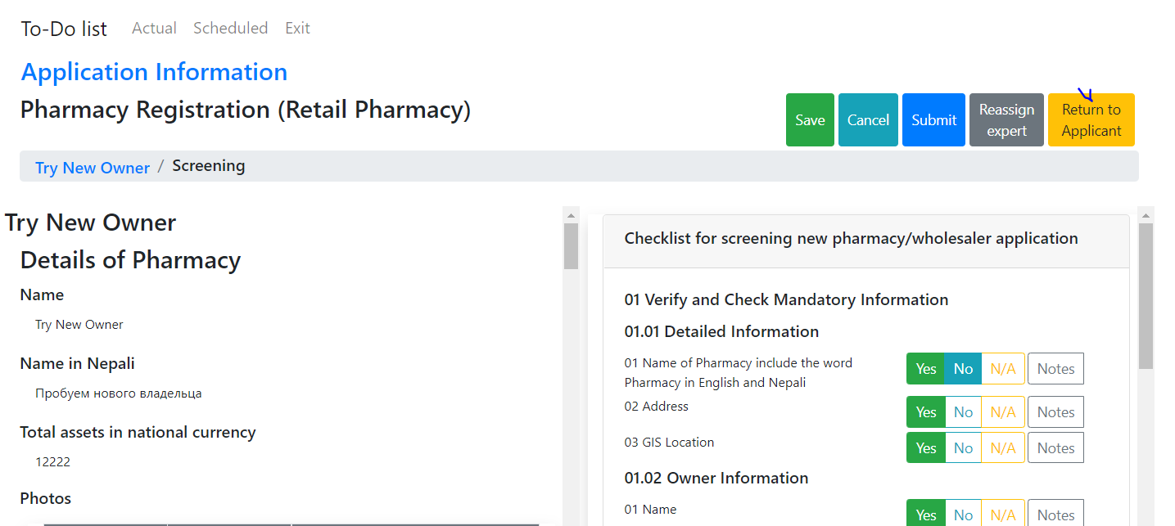

## How to use

Press the “Return To Applicant” button. The system asks for the following actions. Select “Reject” and then enter the notes. After, press Send.

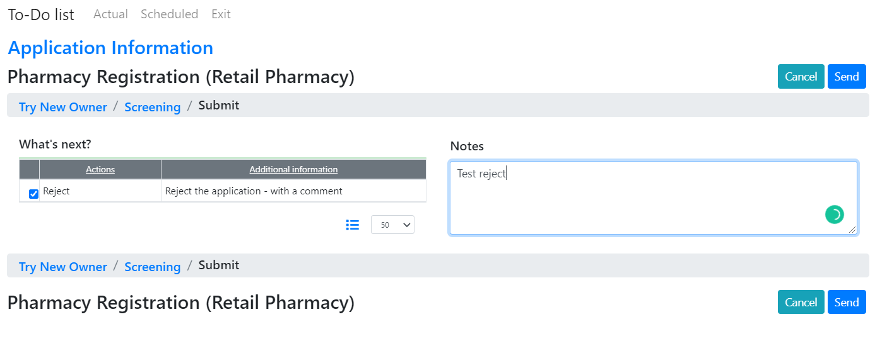

The application will be returned to the applicant. To ensure:

Log in as an applicant and, then select Applications-Pharmacy Registration

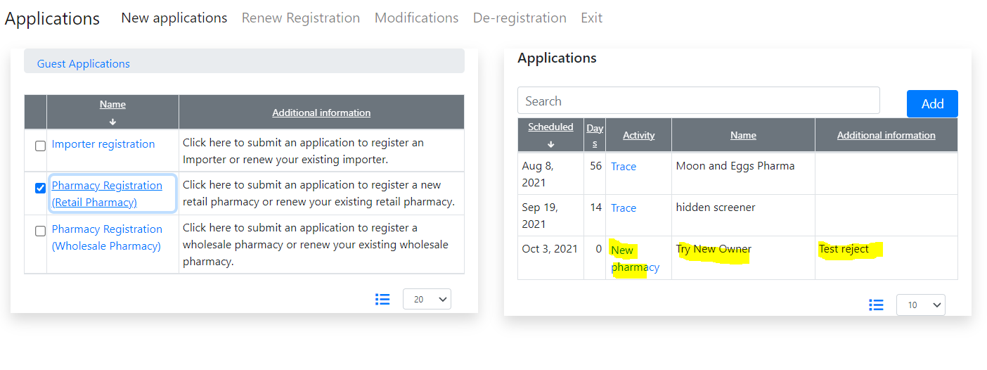

Full history of the application will be available for an applicant.

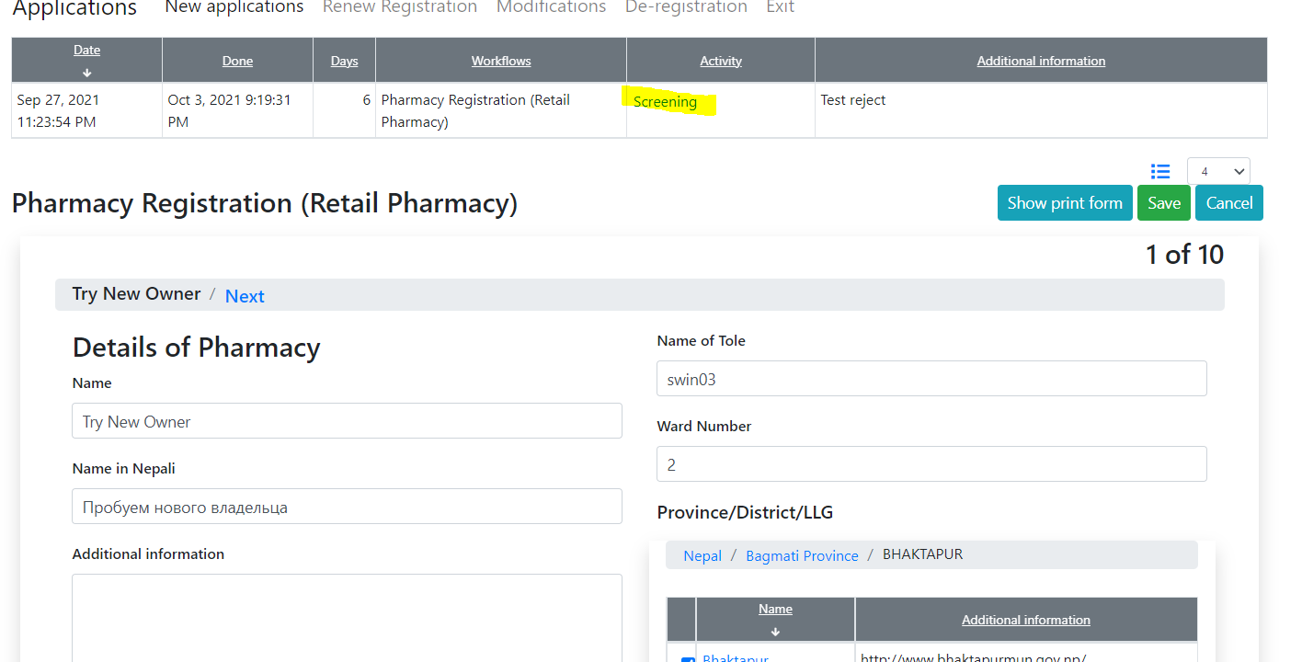

An applicant can fix errors and, then, send the application again to the screener.

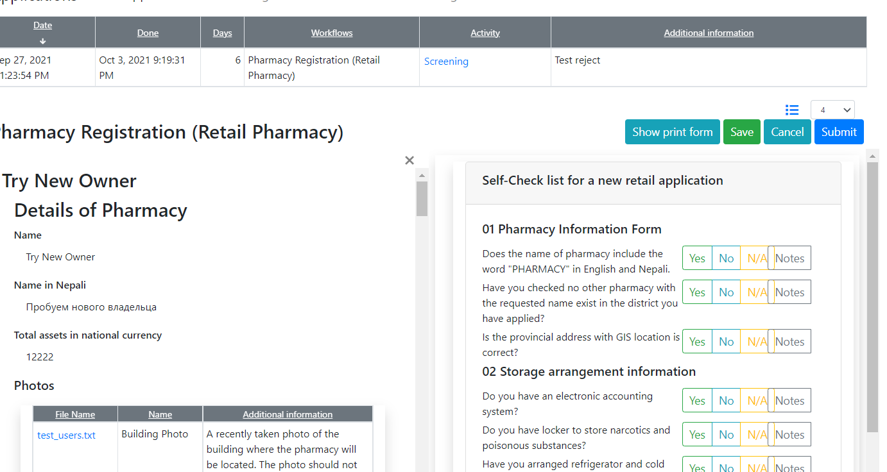

## New EL expressions

The approach to defining a pharmacist has been changed in the previous version of Pharmadex 2

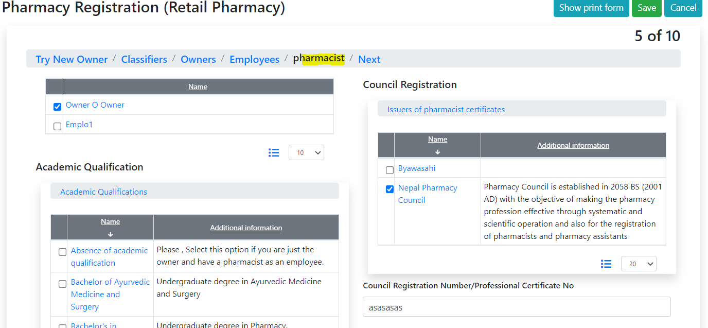

Thus, the old EL expressions will not work. The new can be found here here <http://redmine.inka.in.ua/documents/77>.

For convenience, the full list is below

Name:

Engl ${character/pharmacist/prefLabel@literal}

Nepali ${character/pharmacist/namenepali@literal}

Address

tole name: ${character/pharmacist/tolename@literal}

ward no: ${character/pharmacist/wadano@number}

Province, district, LLC:

all: ${character/pharmacist/address@choice}

Provins: ${character/pharmacist/address@level1}

District: ${character/pharmacist/address@level2}

LLG: ${character/pharmacist/address@level3}

Pharmacist council ${character/pharmacist/pharmacist/concilreg@choice}

council reg. number ${character/pharmacist/pharmacist/concilregno@literal}

Qualification ${character/pharmacist/pharmacist/person_academic@choice}

# Modification workflow

## Idea

Let’s use the existing workflow engine to implement modifications. However, some modifications will be required. The basic use case is:

1. The Applicant selects the type of the modification, i.e. “Address modification”
2. The system provides a list of objects with the addresses (sites)
3. The applicant selects an object as the first step of data enter
4. The system provides a set of configurable screens to enter data and the screen “Conclude” at the end
5. The Applicant sends the application
6. The system starts the workflow for NMRA staff, i.e. Screenenig, Review, Approval, Finalization
7. The NMRA staff approves and finalizes the modification
8. The system[1]:
   1. Stores the old version of the modified data
   2. Applies the new modified data

## Configuration[2]

### Dictionary

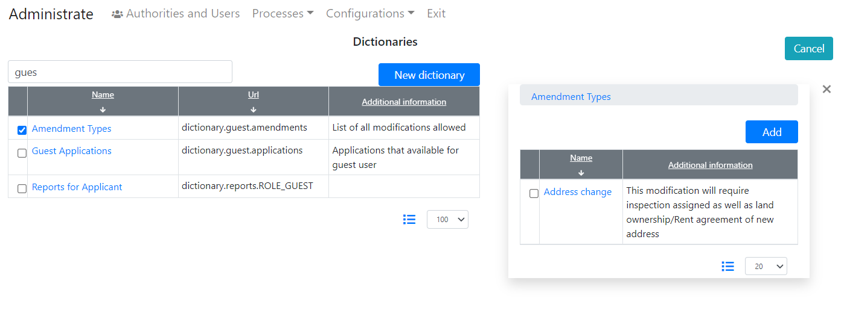

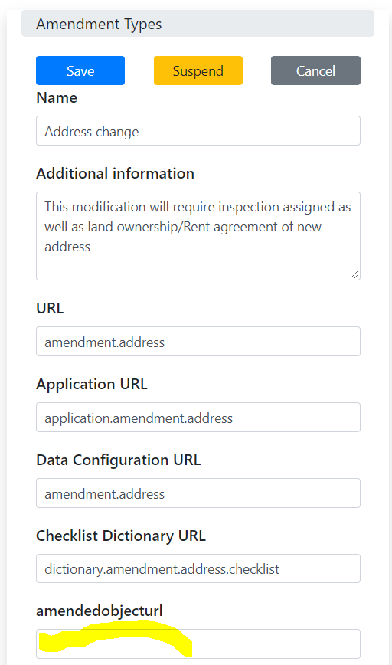

### Data

Like any other data

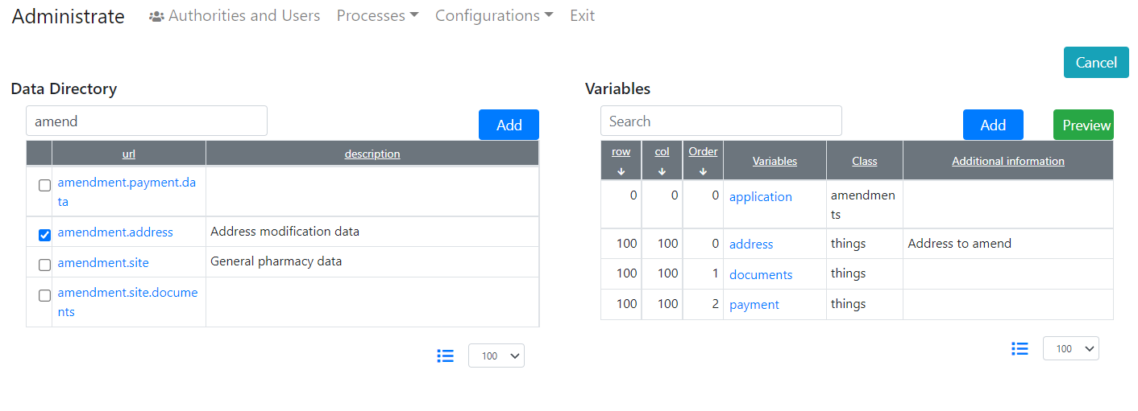

### Workflow

Will be configured here, not configured yet. The amendment is the first time application!

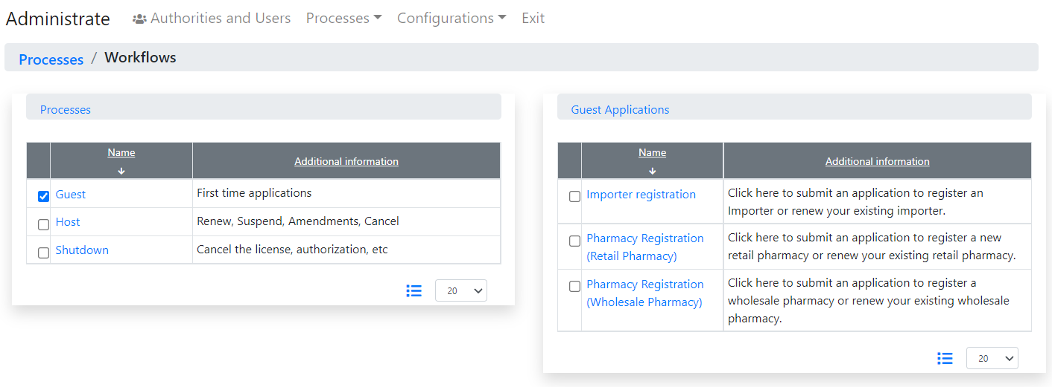

### Usage

Log in as an applicant and, then from the menu “Modification”

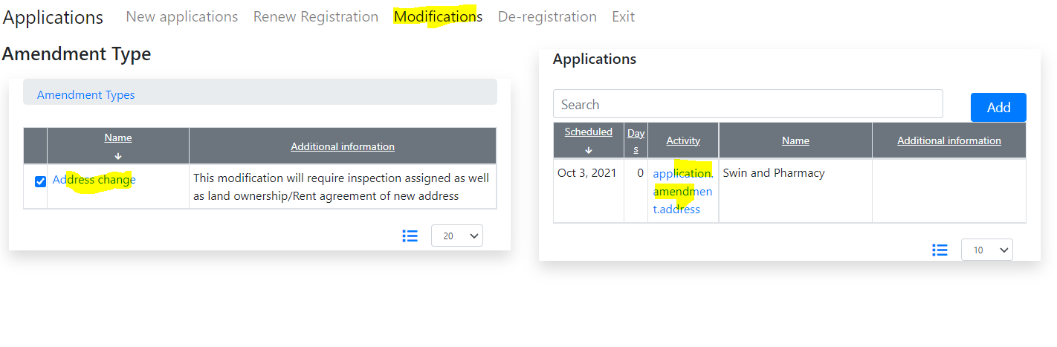

Everything is unified with the new application. No additional learning curve is required.

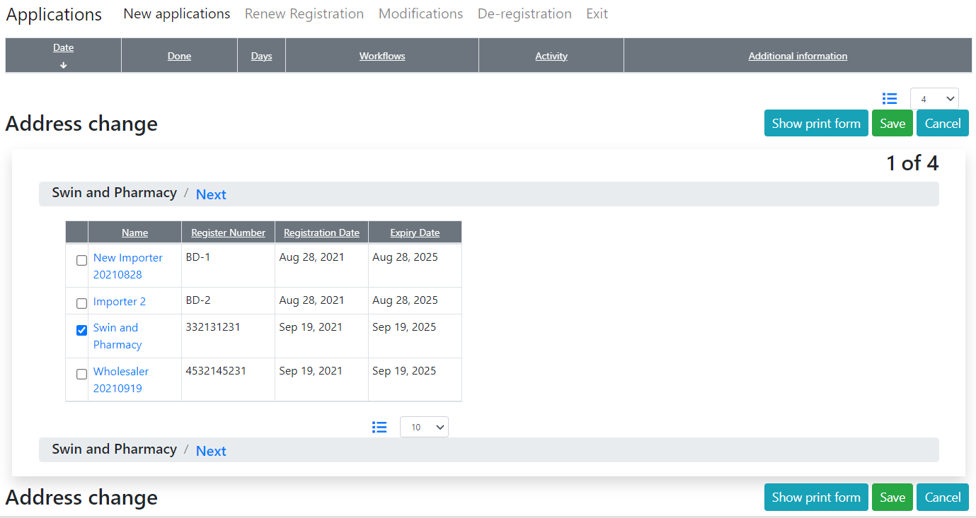

1. Not implemented yet
2. For current available only in the sandbox