Pharmadex 2. Release Notes 2021-10-10

Contents

Motivation 1

Pre-requisite 1

Demo release particularities 2

Modification workflow 2

How to start 2

How to conduct 7

Variations of finalization 12

Motivation 12

Where to find 12

Example 12

# Motivation

The main goal in this release is still the modification feature, and workflows for existing pharmacies/wholesalers.

The modification feature has been implemented for site address modification for pharmacies, wholesalers, and importers. After the acceptance, this workflow will be cloned for other types of modifications

The implementation of workflow for the existing pharmacies has been started from the design of database structure to which legacy data will be placed and a component that will use these legacy data. In addition, this implementation should be grounded on the improved (amendable) data blocks - see below

The data structure and workflow implementation are trivial and will be concluded by the current configuration feature.

In addition, the “Finalization variations” (issue #844) feature has been implemented.

# Pre-requisite

You must have a Gmail account that has not been registered in the Pharmamadex 2 database. You should know the login and password for the supervisor user.

# Demo release particularities

This release may contain errors, bad user interface behavior, and inconsistencies. Please, report them to [alex.kurasoff@gmail.com](mailto:alex.kurasoff@gmail.com).

The workflow implementation contains mistakes.

The database will not be reset to the initial state until the notification.

**Please do not make any configurations, except labels and dictionaries translation.**

# Modification workflow

## How to start

Log in as an Applicant and select Application-Modifications-Address Change

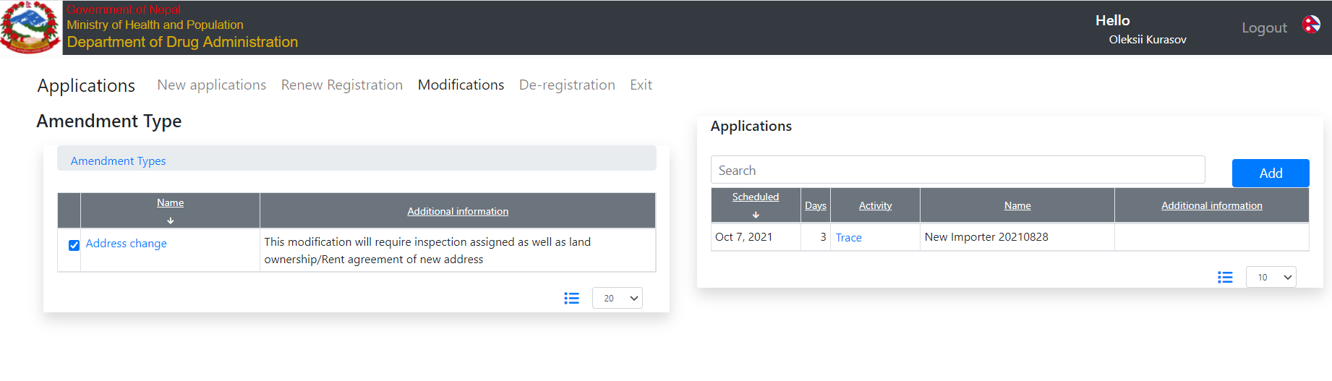

Press Add to add a new workflow and select an object to amend

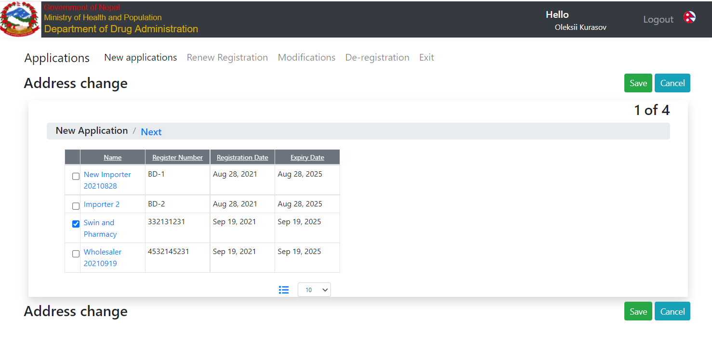

Fill out and amended data on the next screen. Please note, that the original data is still untouched until the end of the workflow[1].

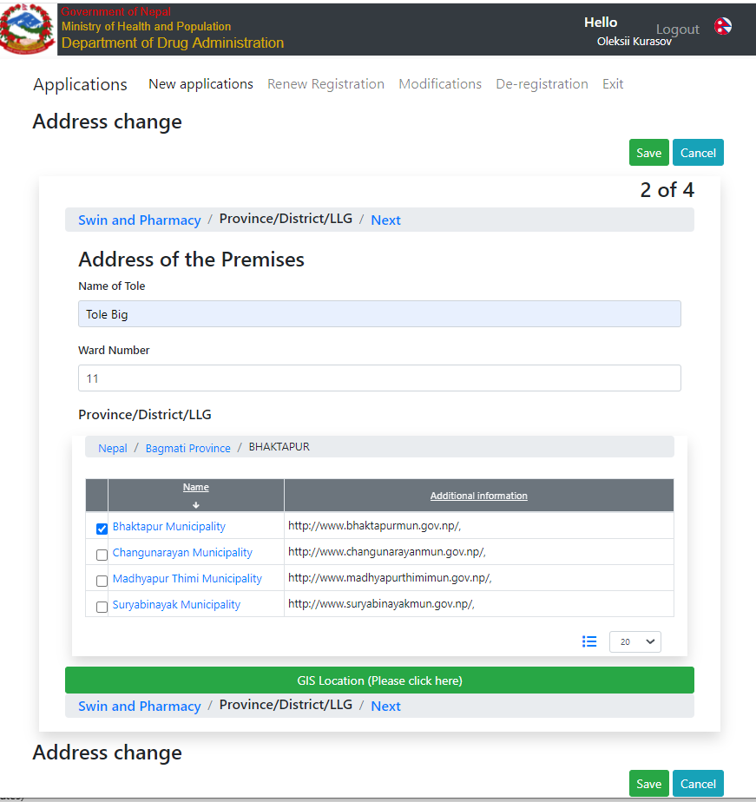

As you can see, the on-screen forms are near the same as for an application.

The rest of the screens are documents that related solely to the amendment – tax, and payments

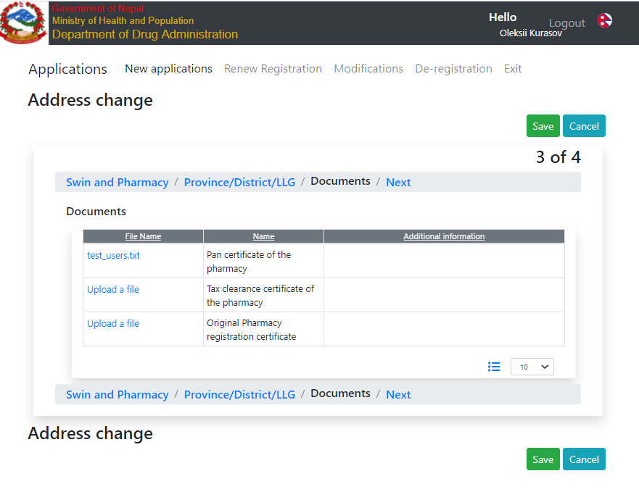

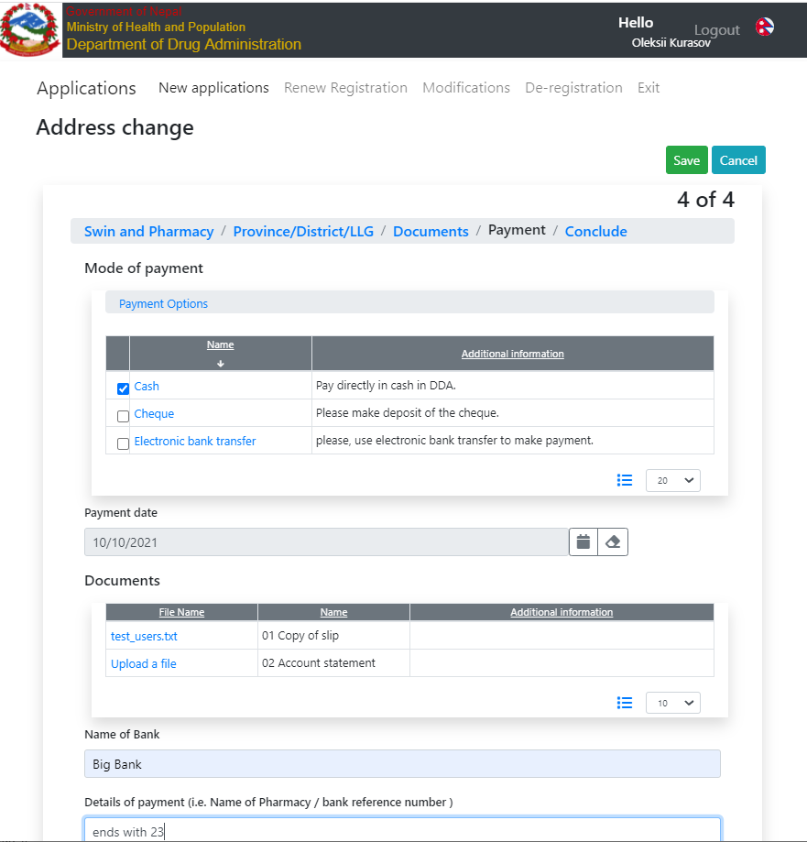

and, at last, Conclude screen with the checklist

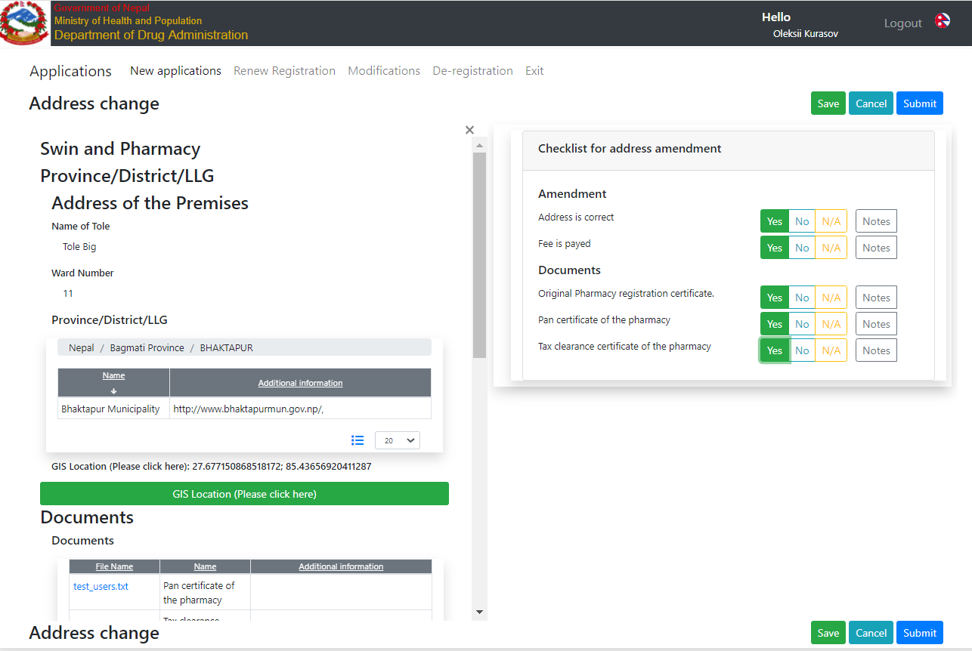

Press “Submit” to submit the amendment application

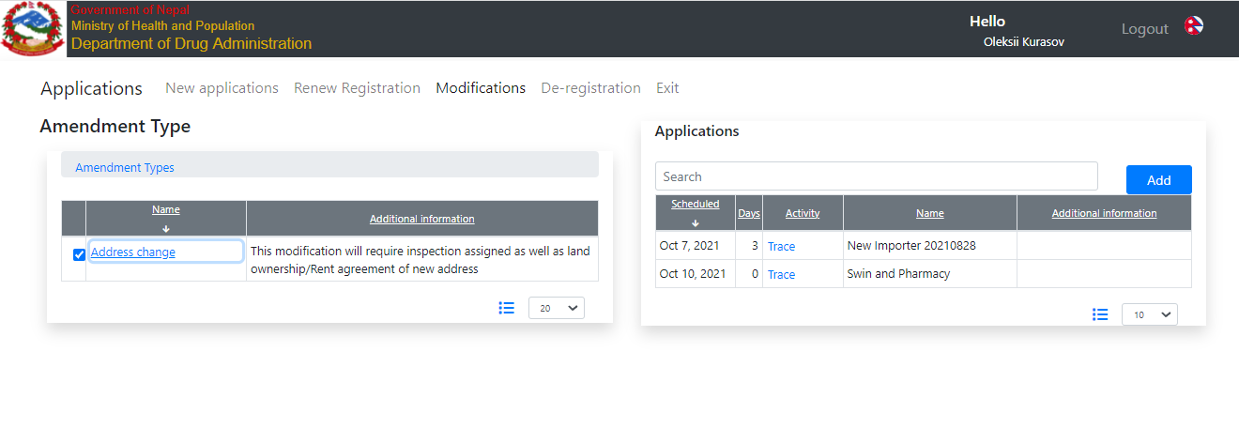

## How to conduct

Log in as an Initiator and perform Screening as usual

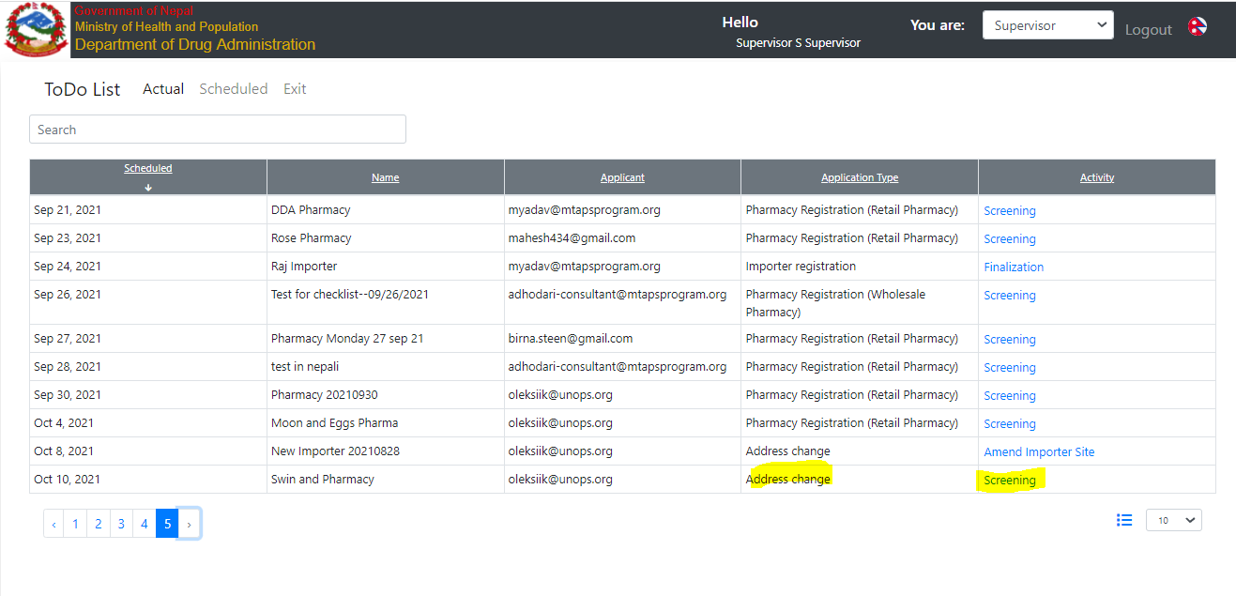

Everything is the same

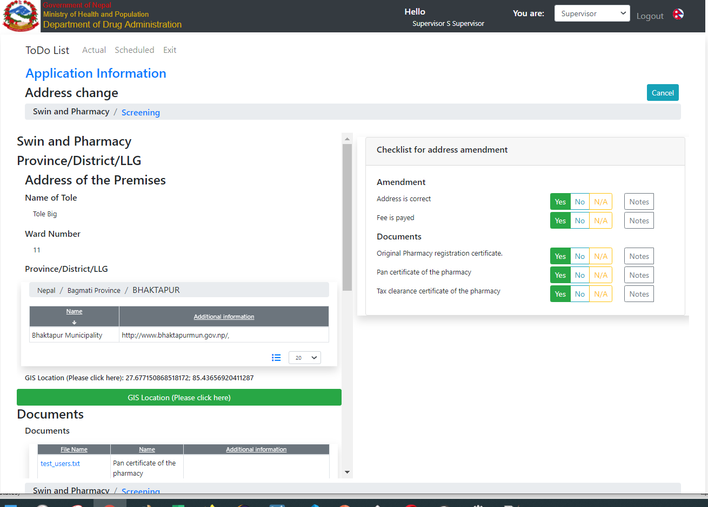

The previous address is available in the report

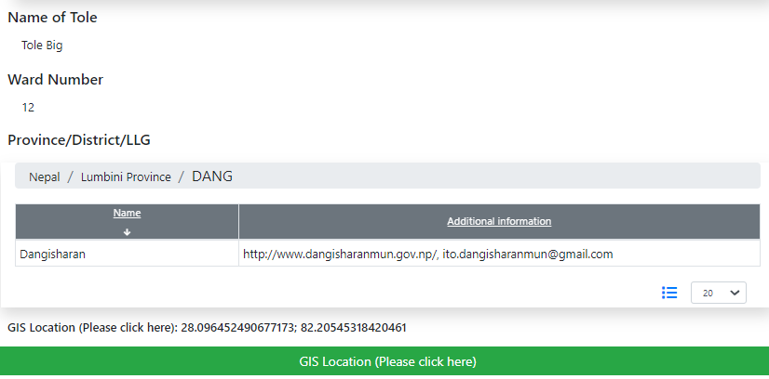

Submit to Review

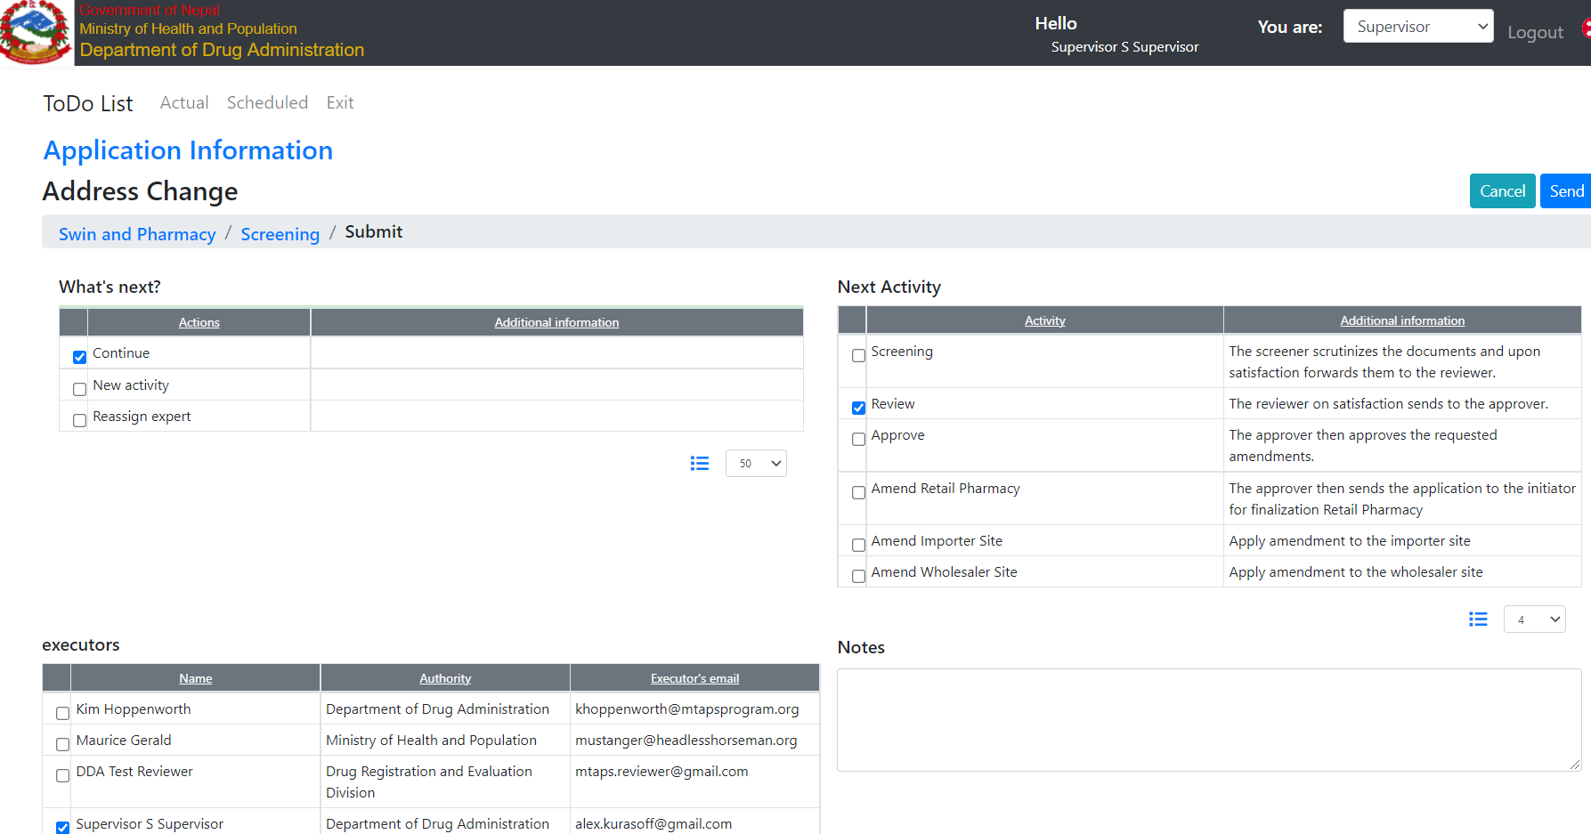

and review

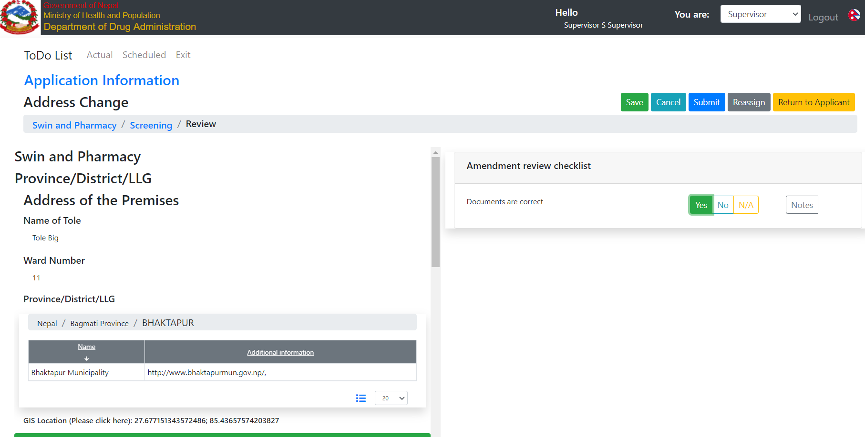

And Approval

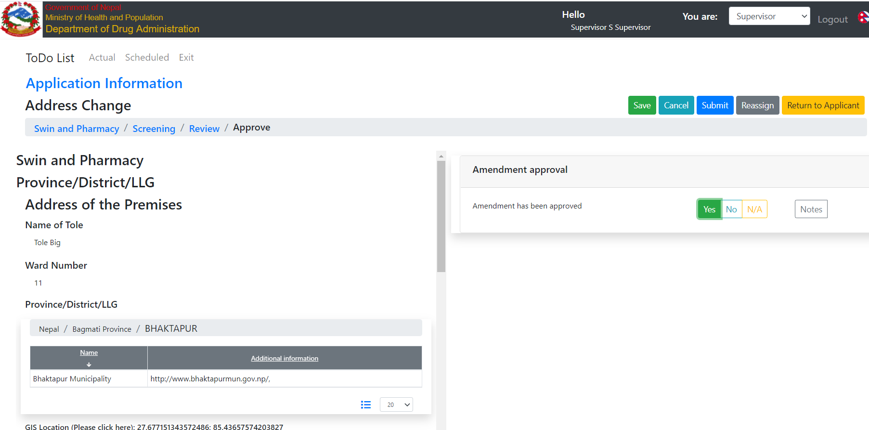

And on the submit, you should select one of the alternative finalization scenarios

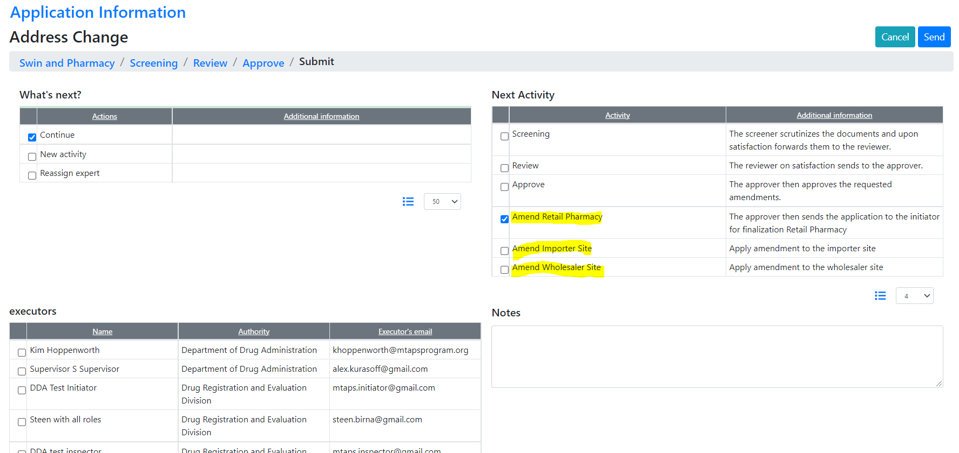

Because the data for Pharmacy, Importer, and Wholesaler are very similar, Pharmadex 2 cannot select the scenario implicitly.

For correctly selected scenario the registration number will be shown, for incorrect – no

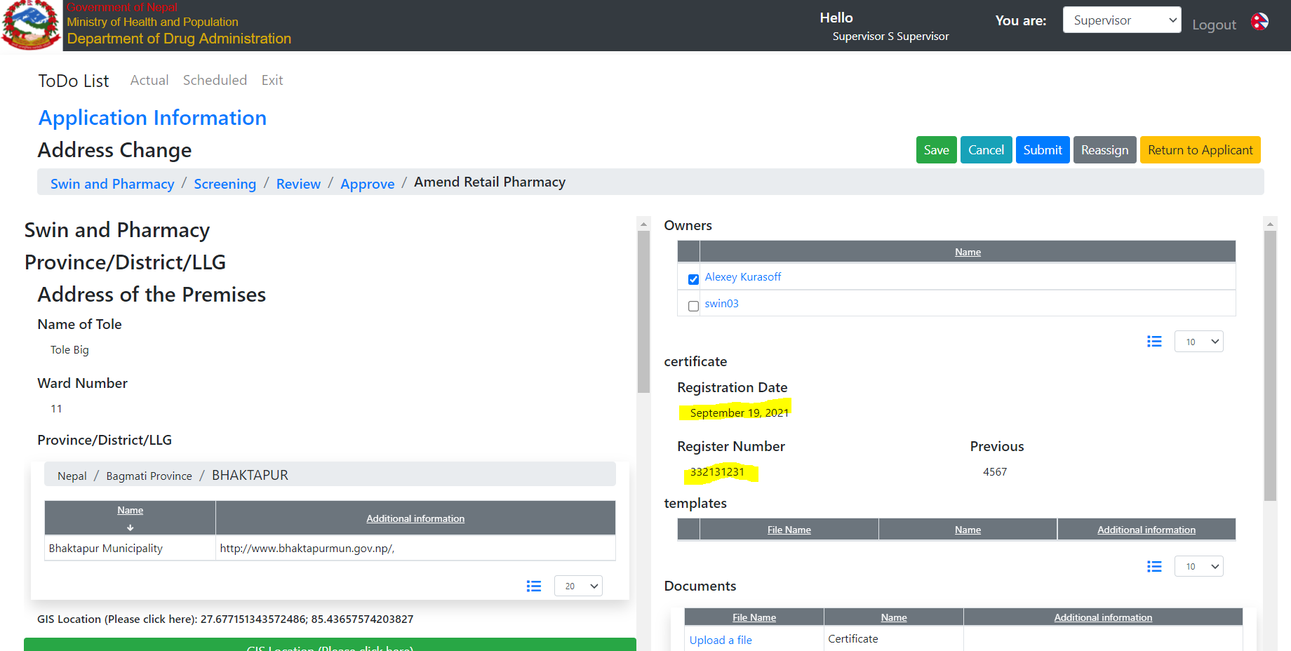

Let’s consider incorrect finalization scenario

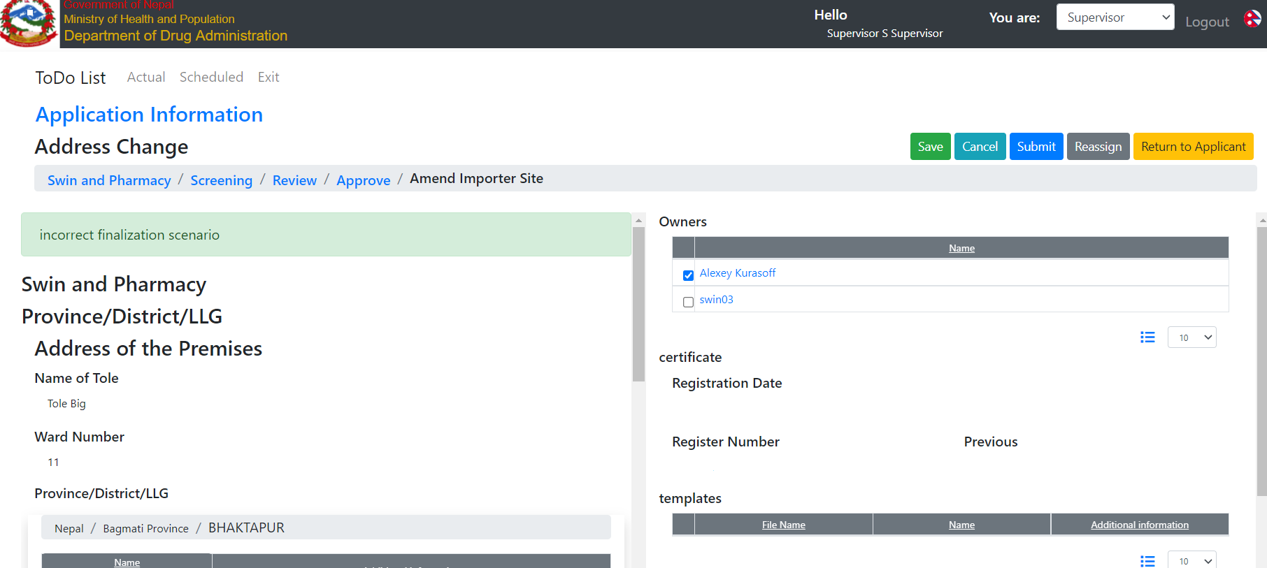

In this case, you should execute Reassign

Submit after an amendment is suspended to implement because future clarification will be needed, i.e. data blocks improvement and follow-up workflows – inspection, etc.

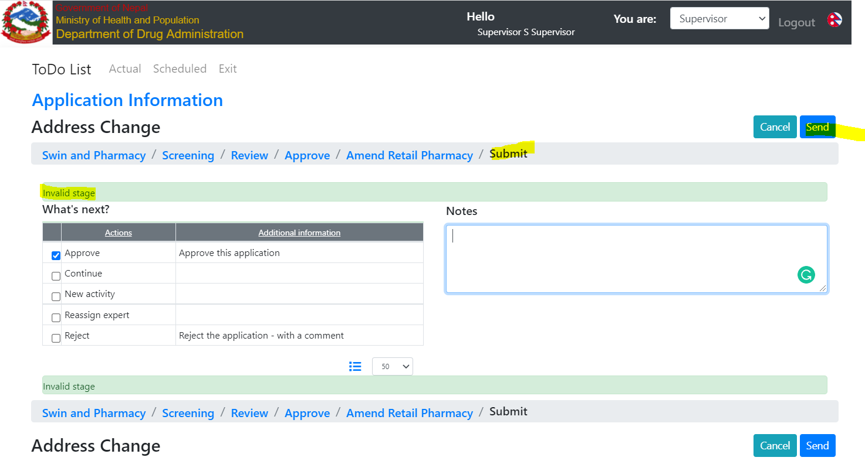

# Variations of finalization

## Motivation

* The finalization step of the workflow may depend on the result - approve/rejected as well as on the data
* Currently, available only approve and return to the applicant

Therefore, we will need more than one variation of the finalization step

## Where to find

Log in as a Supervisor and open Administrate-Processes-Workflow. The amendment “Address Change” is a good example

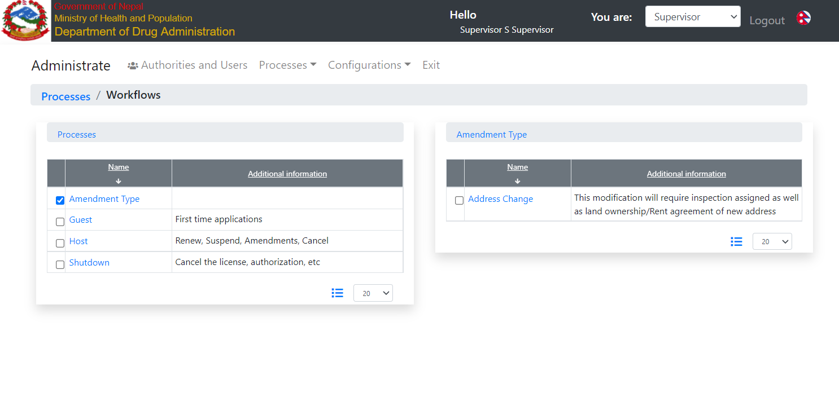

## Example

Open Address Changes and go to the first finalization scenario. The new Finalization field is Yes. IT means that This activity can start the Approve process for Pharmacy Address change. The checklist and Data Configuration URLs point to the data configured solely for Pharmacy. Thus, this scenario may be used only to implement amendments to the Pharmacy address. It is despite that the whole workflow is suited for Pharmacy, Wholesaler, and Importer.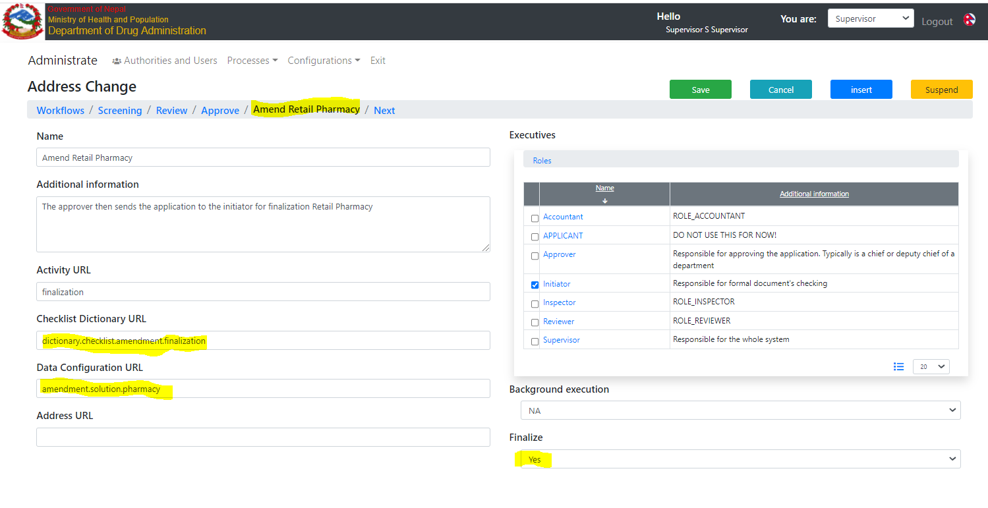

The next finalization scenarios are for Wholesaler and Importer.

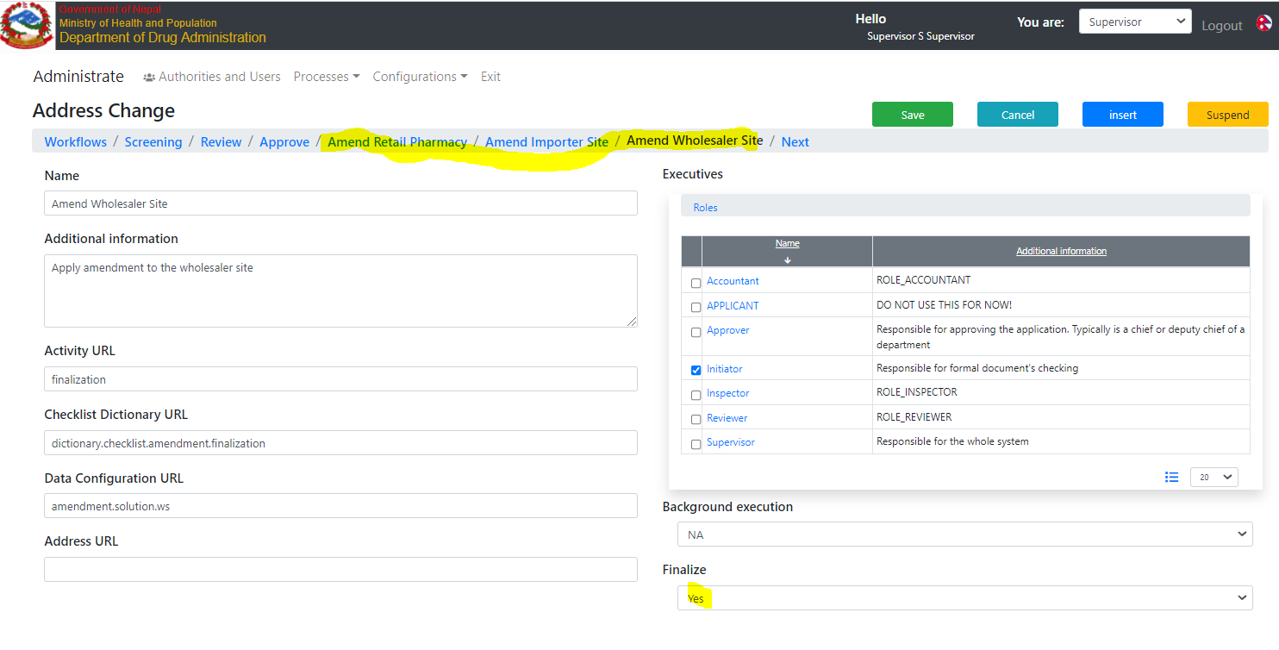

For current, the alternative scenarios should be selected manually by the executor. It is because the system in most cases cannot determine the scenario simplicity.

An example of how to execute it is in the previous chapter.

1. To avoid a mess in the change management, the data imput screen should be re-considered. For example, changes of address weill require changes in some specific documents, photos, etc. The amendment will work only for a one high cohesion data block, not a group of them. It is a common best practice for change management in accordance with ISO 9001 standards family. Thus, for this particular case the Premise data group or tab should be introduced. For capital change the tab Capital with the all documents, etc