Pharmadex 2. Release Notes 2021-10-17

Contents

Motivation 1

Pre-requisite 1

Demo release particularities 2

New data structure example 2

Where to find 2

How to use 2

# Motivation

The automated modification feature requires an “amendable” data structure. It means that the current data layout should be reworked under this guide <http://redmine.inka.in.ua/documents/89>

We’ve created an example based on the retail pharmacy data input. After a discussion, it will be easily cloned to Wholesaler and Importer workflows.

In addition, this implementation includes new single language data input fields.

# Pre-requisite

You must have a Gmail account that has not been registered in the Pharmadex 2 database. You should know the login and password for the supervisor user.

# Demo release particularities

This release may contain errors, bad user interface behavior, and inconsistencies. Please, report them to [alex.kurasoff@gmail.com](mailto:alex.kurasoff@gmail.com).

The file uploaders are unstable!

The workflow implementation contains mistakes.

The database has been reset to the state at 2021-10-16.

**Please do not make any configurations, except labels and dictionaries translation.**

# New data structure example

## Where to find

Log in as an applicant. The demo release is here

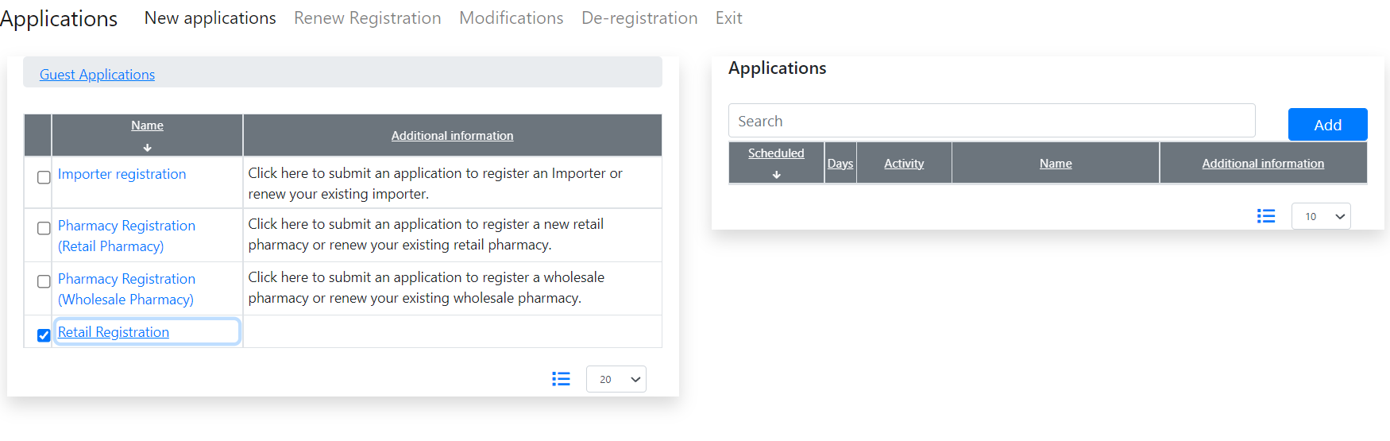

## How to use

Start a data input. Please, put your attention to that each screen contains only related data, thus amendable.

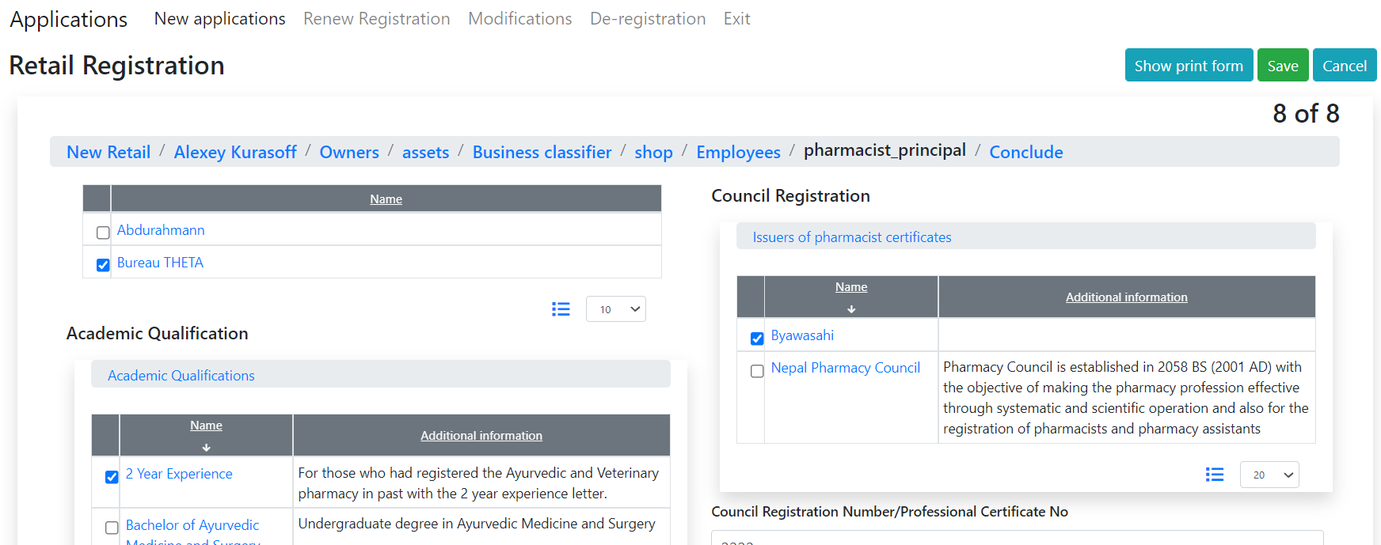

The screens are subject to discussion.

The invoicing and Schedule 8 will be the same, should be not implemented in this demo data input.