Pharmadex 2. Release Notes 2021-10-24

Contents

Motivation 1

Pre-requisite 1

Demo release particularities 2

Where to find 2

How To use 2

Annex A 3

Application data 3

Workflow steps 4

# Motivation

The new improved retail pharmacy registration workflow has been implemented. The data input structure is new. The workflow is a copy of the previous one.

In addition, have been implemented:

* A feature that almost avoids redundant data input in a case when owners and pharmacists are the same persons.
* New improved document upload/download control
* Found and fixed 3 errors related to the user experience and the corresponded server software. Most of them are related to “bounce” and its consequences.

To finalize this workflow may be completed in a week. It will be necessary:

1. Implement a new set of EL expressions under the latest DDA requirements to owners and pharmacists.
2. Implement new sets of reports
3. Revise the current workflow steps (see Annex A)
4. Revise the data dictionaries (see Annex A)
5. Revise the data validation rules
6. Prepare new multi owners, multi pharmacists templates in the Nepali language:
   1. cover letter
   2. certificates
   3. invoices
   4. Inspection reports (if necessary)

# Pre-requisite

You must have a Gmail account that has not been registered in the Pharmadex 2 database. You should know the login and password for the supervisor user.

# Demo release particularities

This release may contain errors, bad user interface behavior, and inconsistencies. Please, report them to [alex.kurasoff@gmail.com](mailto:alex.kurasoff@gmail.com).

The file uploaders are unstable!

The workflow implementation contains mistakes.

**Please do not make any configurations, except labels and dictionaries as a part of the dictionaries revise job.**

# Where to find

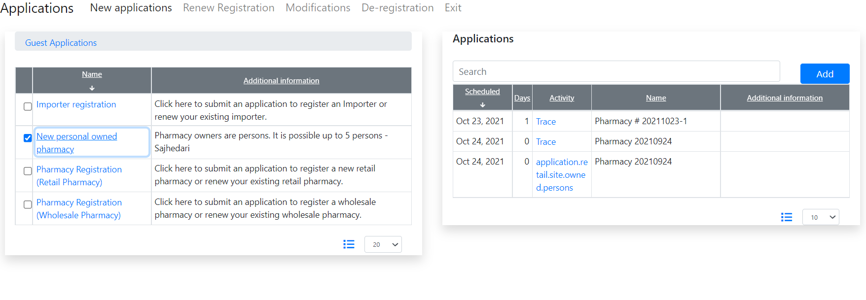

# How To use

You can pass this workflow to the Finalization. Please do not execute this step until:

* The workflow will be verified
* The new set of reports will be ready

# Annex A

# Application data

|  |  |  |  |
| --- | --- | --- | --- |
| **Screen** | **Dictionaries** | **Documents** | **Templates** |
| Pharmacy site |  | dictionary.site.tenancy |  |
|  |  | dictionary.pharmacy.site.photos |  |
| Classifiers | dictionary.product.system.category.h |  |  |
|  | dictionary.pharmacy.service.category |  |  |
| Owner |  | dictionary.person.passport |  |
|  |  | dictionary.person.photo |  |
| Pharmacist |  | dictionary.person.passport |  |
|  |  | dictionary.person.photo |  |
| Pharmacist Qualification | dictionary.object.person.academic |  |  |
|  | dictionary.pharmacist.council |  |  |
| Pharmacist Agreements |  | dictionary.employee.agreements | dictionary.resources.pharmacy.employee.agreements |
| Report Payment | dictionary.payment.type | dictionary.payment.proof.documents |  |
| Schedule 8 |  |  | dictionary.application.cover.letter |
|  |  | dictionary.cover.letters |  |
| Checklist | dictionary.application.pharmacy.new.init |  |  |

# Workflow steps

| **Step** | **Dictionaries** | **Documents** | **Templates** |
| --- | --- | --- | --- |
| Screening | dictionary.application.pharmacy.new.init |  |  |
| Check payment | dictionary.checklist.payment |  |  |
| Inspection | dictionary.checklist.inspection.new.pharmacy | dictionary.pharmacy.site.inspection.documents | dictionary.pharmacy.site.inspection.documents |
| Review | dictionary.checklist.review.new.pharmacy |  |  |
| Verification | dictionary.checklist.verification.new.pharmacy |  |  |
| Finalization | dictionary.checklist.finalization.new.pharmacy |  | dictionary.pharmacy.site.solution.documents |
|  |  | dictionary.pharmacy.site.solution.documents |  |