Pharmadex 2. Release Notes 2021-10-31

Contents

Motivation 1

Pre-requisite 1

Demo release particularities 1

EL Expressions 1

Registration number 2

Host processes 2

Reports 3

# Motivation

Get new process for registration person owned pharmacy ready to pilot operation:

* Revised EL expressions
* Auto assigned registration number
* Host processes, e.g., renewal, inspection currently may be uniform for all guest processes.
* New reports are added

# Pre-requisite

You must have a Gmail account that has not been registered in the Pharmadex 2 database. You should know the login and password for the supervisor user.

# Demo release particularities

This release may contain errors, bad user interface behavior, and inconsistencies. Please, report them to [alex.kurasoff@gmail.com](mailto:alex.kurasoff@gmail.com).

The file uploaders are unstable!

The workflow implementation contains mistakes.

**Please do not make any configurations, except labels and dictionaries as a part of the dictionaries revise job.**

# EL Expressions

EL expressions intend to extract data from the database directly to an MS Word document. It allows templating for most documents like letters, certificates, reports, etc.

The guide on how to create, test, and use EL expressions is scheduled for the next week. The current set of ready and tested EL expressions can be found here <http://redmine.inka.in.ua/documents/77>

EL expressions that start from “/” (root) are for extracting data from a whole application. An example is ${/classifiers/product@choice} means authorized products classifier for the application

An application data may contain more than one pharmacist. To get data regarding a particular pharmacist from pages related to the pharmacist, use EL that starts from “~” (home). Example is ${~/pharmacist_qualification/person_academic@choice} – academic qualification data.

Sometimes, it will be needed data from the page that is not saved to the database yet. A good example is the Finalization step of a workflow. For such cases, use EL start from the word “this”. An example is ${this/certificate@expiredBS1} – expiration date of the certificate in short Nepal format.

Please, wait for the guide.

# Registration number

Pharmadex provides component “Register” to allow organize own filing system numeration or use an existing one. Since this release, the component can propose automatically the next sequence number in the year, as for any standard filing system. In addition, it is possible to configure a prefix for a number as the standard filing systems do. The most common format of the prefix is “Document Type”-“Case to file”. For example, 01-12/234 means 01 document type, which should be filed to the case 12 with number 234.

A register may be configured as read-only or writable. Accordingly, a number may be assigned or proposed by Pharmadex 2.

An example is the application registration number for a person-owned retail pharmacy. This number is assigned by Pharmadex 2.

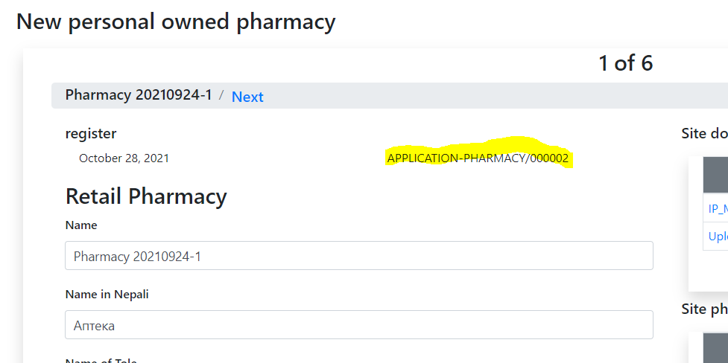

# Host processes

Host processes are processes that follow up a workflow to serve registered sites and products. Examples are Pharmacy Renewal and Pharmacy Inspection. Before this release, it was necessary to create separate host processes for each workflow. For current it is possible to use an existing one that suits a purpose.

# Reports

For the new retail pharmacy registration workflow, a new report has been added. In the next release will be introduced external report configurator, which is currently under development.

