Pharmadex 2. Release Notes 2021-11-07

Contents

Motivation 1

Pre-requisite 1

Demo release particularities 1

System documentation 2

EL expressions guide 2

Workflow development guide 2

Issues 2

Refactoring 3

# Motivation

The main goals of this release are to transfer the system to the Nepal server, development of system documentation, resolving of urgent features, and refactor codes.

The Demo version of the Pharmadex 2 has been successfully transferred to the “Himalaya Cloud” hosted service. The new address is pdx2demo.ddanet.org

Alfa versions of EL expressions and workflow development guides are ready for revision and discussion.

# Pre-requisite

You must have a Gmail account that has not been registered in the Pharmadex 2 database. You should know the login and password for the supervisor user.

# Demo release particularities

From this release, the web address will be http://pdx2demo.ddanet.org/

This release may contain errors, bad user interface behavior, and inconsistencies. Please, report them to [alex.kurasoff@gmail.com](mailto:alex.kurasoff@gmail.com).

The workflow implementation contains mistakes.

**Please do not make any configurations, except labels and dictionaries as a part of the dictionaries revise job.**

# The installation

The software and the database are up and running on the server with address 103.198.9.145. The address of the virtual server is pdx2demo.ddanet.org.

Following components have been installed and configured:

Data schema pdx2 has been installed under control of the current instance of MySQL server Community Edition r 5.7. To increase data security, all external connection is possible from one user with the longest name. Ask the password [alex.kurasoff@gmail.com](mailto:alex.kurasoff@gmail.com) by the secure procedure.

The software has been installed in the folder “applications\pharmadex2”. Components are:

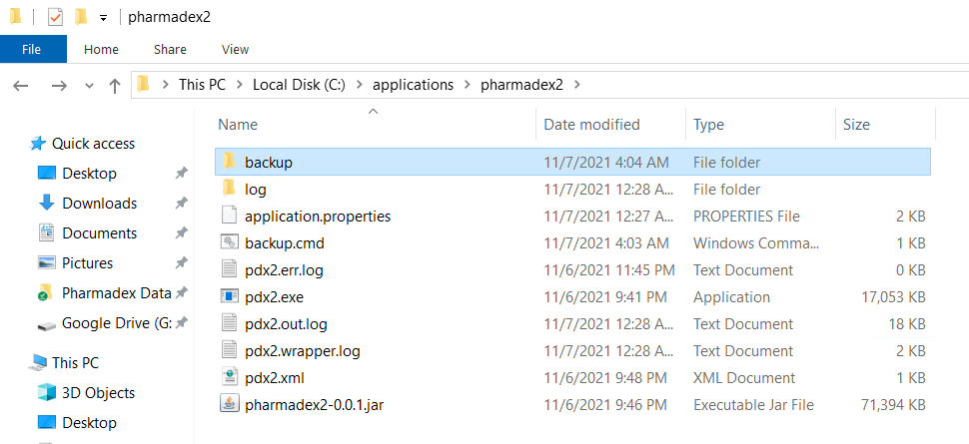

1. backup – folder to keep database backups
2. log – log files of the application
3. application.properties – parameters of the application
4. backup.cmd – executable file to create backups. This file creates rolling backups on odd and even dates
5. pdx2err.log – windows service installer/runner log
6. pdx2.exe – windows service wrapper
7. pdx2.out.log - windows service installer/runner log
8. pdx2.wrapper.log – windows service wrapper log
9. pdx2.xml – windows service wrapper parameters
10. pharmadex2-0.0.01.jar – the application

The backup is served by Windows Task Scheduler.

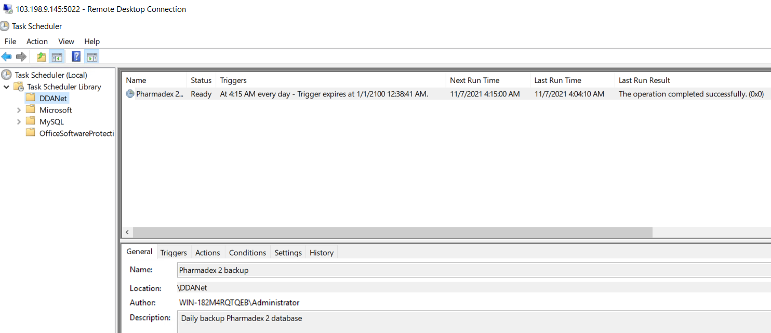

The backup consists of two files in folder backup – backup for odd days and backup for even days. The backup is a full database in MySQL dump format.

# System documentation

## EL expressions guide

The EL expressions guide can be found here <http://redmine.inka.in.ua/documents/77>. It is a PowerPoint presentation. The subject is heavy and unusual, thus, please do not hesitate to comment on it and ask questions.

## Workflow development guide

The workflow development guide can be found at <http://redmine.inka.in.ua/documents/103>.

This is the first guide in the series, however will be sequels as well as prequels. Please, access is this form of learning materials understandable?

# Issues

|  |  |  |
| --- | --- | --- |
| **#** | **Issue** | **Notes** |
| 1165 | Validation rules | Except for regular expressions |
| 1164 | Save functionality bug when moving backward | Fixed |
| 1153 | A login form contains the hard-coded name of the system | Currently, it is a schematic variable |
| 1152 | File upload control, sometimes twice upload because of bounce. Bouncy is the most important technical problem for now. | Fixed, but fight with the bounce is continue. The connection to the new server from here is relatively slow and with sufficient latency. It will be a great help. |
| 1144 | Logical variables display wrong in Read-Only mode | Resolved |
| 1002 | The same as 1166 |  |
| 974 | To data configuration added possibility to place web hyperlinks to the input-form, e.g. check certificate, etc. | Resolved, see Figure 1 Link to the external site |
| 966 | Warning message while re-assign expert | Completed |

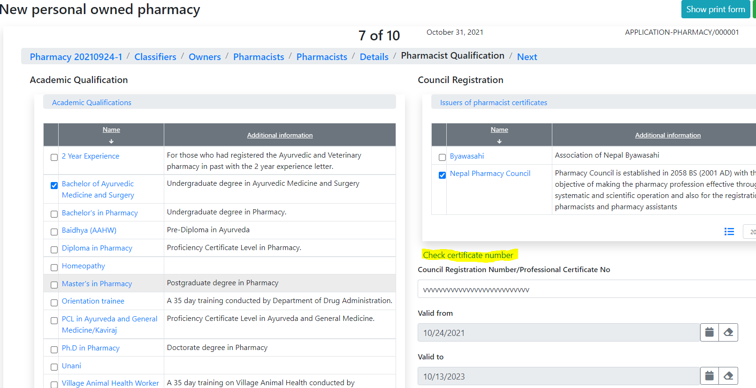

Figure 1 Link to the external site

# Refactoring

Refactoring is an internal software development activity to make sufficient changes in the source codes that do not impact functionality.

Such changes are not wasting time, because their main goal is to increase the reliability and readability of the source codes.