Pharmadex 2. Release Notes 2021-11-21

Contents

Motivation 1

Pre-requisite 1

Demo release particularities 2

Issues 2

Issue 893 On screen help 3

Where to find? 3

How it works? 3

Where to configure? 4

Issue 1175 Unique field 4

Limitations 5

Feature 1189. List of finalization scenarious 5

Why it is necessary? 5

Where to find? 5

How to use? 6

# Motivation

The main goals of this release are:

* The implementation of the on-screen help
* The configurations and interpretation of reports
* The finalization scenarios configuration
* Bug fixing

# Pre-requisite

You must have a Gmail account that has not been registered in the Pharmadex 2 database. You should know the login and password for the supervisor user.

# Demo release particularities

Because the pdx2demo server is down, the new release is available in pharmadex.irka.in.ua. We will perform the pdx2demo server update at the first opportunity.

This release may contain errors, bad user interface behavior, and inconsistencies. Please, report them to [alex.kurasoff@gmail.com](mailto:alex.kurasoff@gmail.com).

The workflow implementation contains mistakes.

**Please do not make any configurations, except labels and dictionaries as a part of the dictionaries revise job.**

# Issues

|  |  |  |
| --- | --- | --- |
| **#** | **Issue** | **Notes** |
| 893 | Detailed help for fields and dictionaries has been implemented | See below |
| 1175, 1185 | Add possibility to configure unique field validation. This feature has been implemented for the payment receipt number | See below |
| 1180, 1184 | The report configuration feature has been implemented the previous week. For current, reports are configured using this feature | See Report feature |
| 1189 | A new configuration has been added. The Submit feature has been improved | See below |
| 1181,1183 | Bugs are fixed |  |
| 1183 | The outdated 0:1 relation Activity-Register has been removed from the database | System issue |
| 1181 | The screen to add new organization has been adapted to the new dictionary approach. All data are kept intact. | System issue |

# Issue 893 On-screen help

## Where to find it?

The on-screen help is available by pressing (?) sign on the right upper and right bottom part of the application data screen. It works almost like the “validation-on-the-saving feature”, but doesn’t annoy a user.

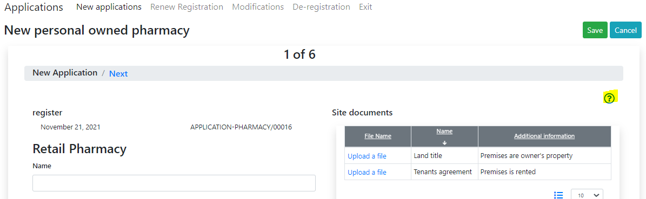

## How does it work?

When you press (?) Pharmadex 2 applies validation rules to all on-screen elements and returns the result. To avoid extra annoyance, for properly filled fields the help will not be displayed:

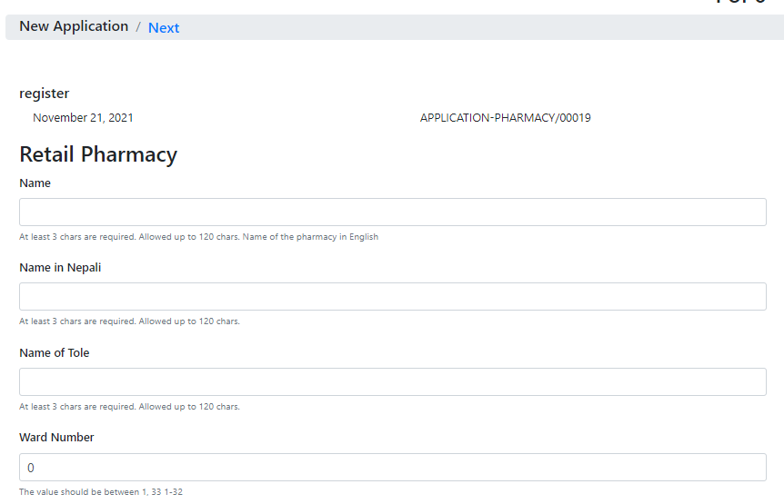

## Where to configure?

Any field with the label “Additional data” in the configuration, e.g.,

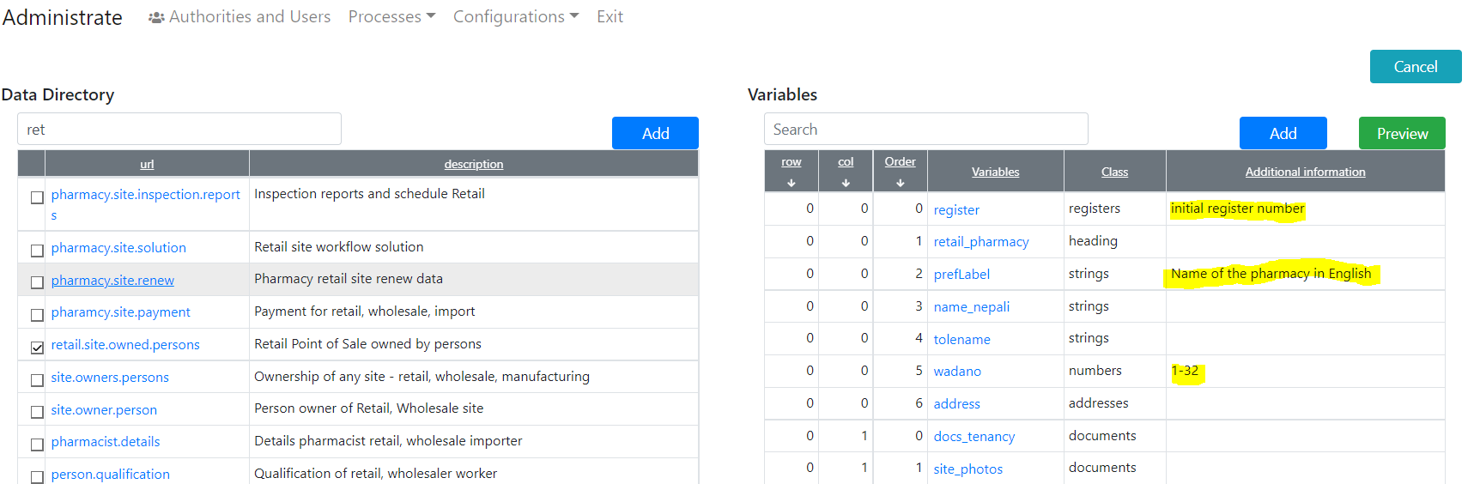

Please, fill free to define “Additional data” as much as possible. It is appreciated to define them in all languages.

# Issue 1175 Unique field

The constrain “unique” work for all fields with the same name, sored under the same URL. This works only for text fields.

The definition you can found in the Data Configuration feature

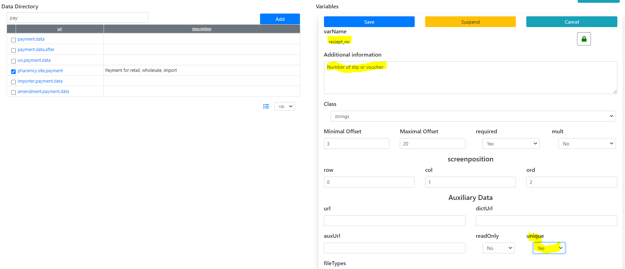

The result is

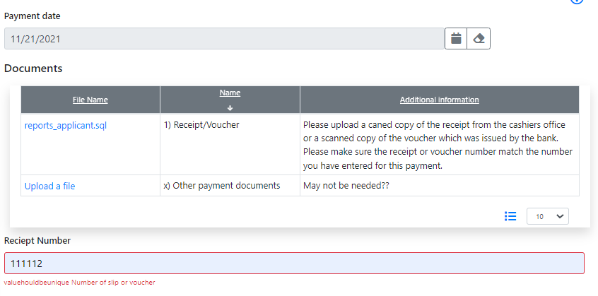

Please, input the right value for the label ‘valuehouldbeunique’, using the Message feature.

## Limitations

We cannot implement complex logic. Use the report feature instead.

# Feature 1189. List of finalization scenarios

## Why it is necessary?

The finalization of any workflow is very versatile. In addition, for the same workflow, we need to have more than one finalization scenario. Thus, we need a tool to configure finalization steps.

## Where to find it?

Administrate – Processes – Workflow

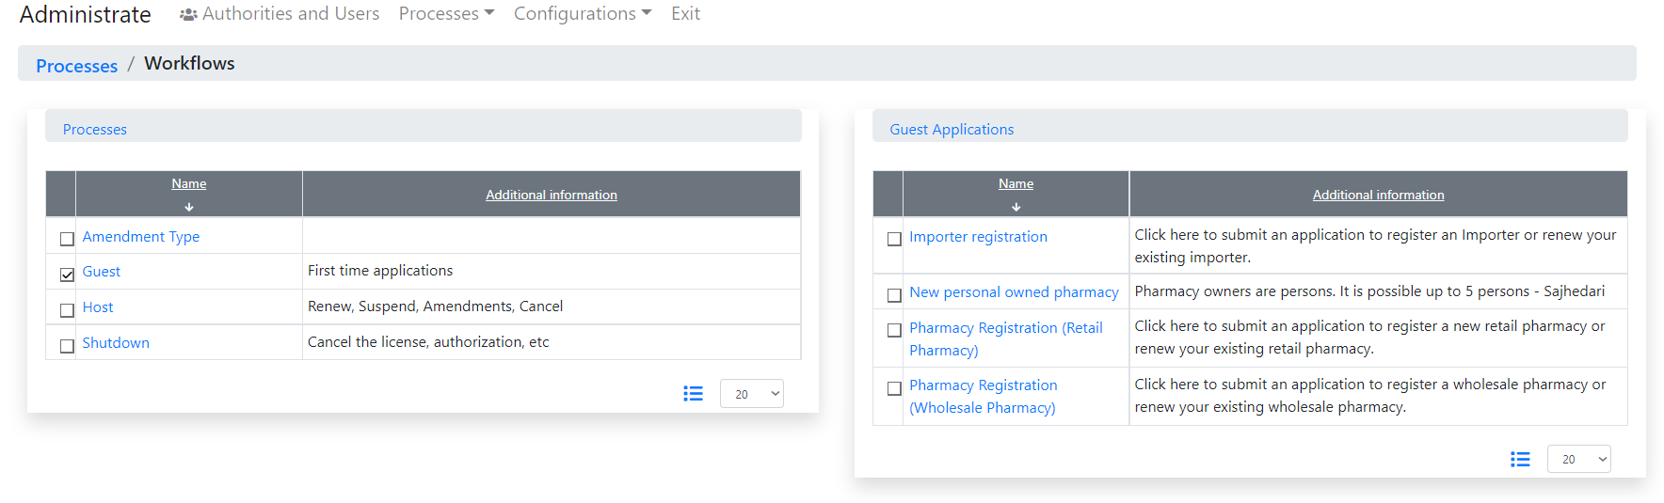

Page to define any activity

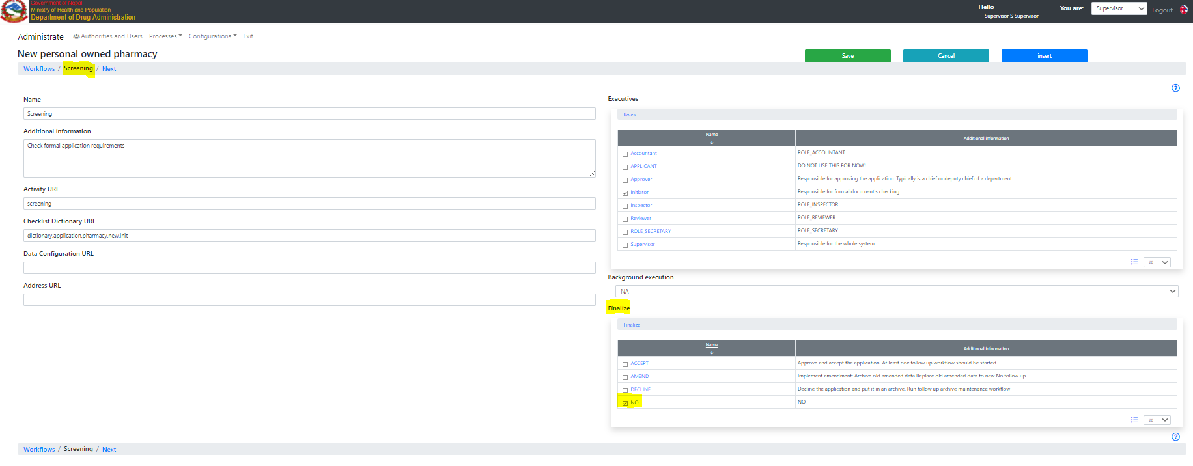

## How to use it?

The explanation is in the dictionary “Finalize”.

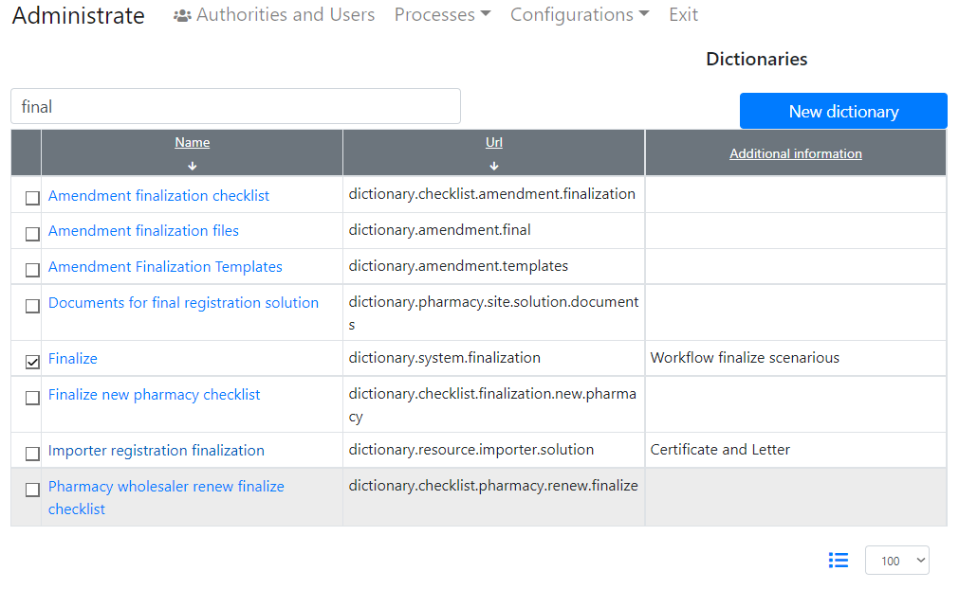

You can’t add a new item to this dictionary, but feel free to change names and descriptions as well as input these in any available language

