Pharmadex 2. Release Notes 2021-11-28

Contents

Motivation 1

Pre-requisite 1

Demo release particularities 2

Issues 2

EL for ages 2

Report configuration feature (Issue 1187) 3

Where to find it? 3

How does it work? 3

An example for a site 4

An example for a product 5

How to use reports? 6

System issue on the MSH server (Issue 1194) 8

The issue 8

The proof 8

The effect 9

# Motivation

The main goals of this release are:

* The finalization of reports for all workflow
* Additional EL for person’s age
* Restore installation on Nepal Demo server
* New installation to MSH server
* Bug fixing and documentation

# Pre-requisite

You must have a Gmail account that has not been registered in the Pharmadex 2 database. You should know the login and password for the supervisor user.

# Demo release particularities

Because the pdx2demo server is down, the new release is available in pharmadex.irka.in.ua. We will perform the pdx2demo server update at the first opportunity.

This release may contain errors, bad user interface behavior, and inconsistencies. Please, report them to [alex.kurasoff@gmail.com](mailto:alex.kurasoff@gmail.com).

The workflow implementation contains mistakes.

Some reports may work slow. These reports are subject to optimization.

**Please do not make any configurations, except labels and dictionaries as a part of the dictionaries revise job.**

# Issues

|  |  |  |
| --- | --- | --- |
| **#** | **Issue** | **Notes** |
| 1190 | EL for ages | Completed for Gregorian and Nepal calendars. See below |
| 1187 | Applicant name for product report. Report configuration | Uniform configuration for any report/ See below |
| 1198 | Restore pdx2demo | It works. The software and database are the latest. |
| 1194 | Install demo and learning versions on MSH server | **Failed, because of the system issue. See below** |
| 1188 | Improved on-screen behavior of tiles. Convenient hotspot using and avoiding the flutter echo |  |
| 1199 | Software improvement | Nex step should be optimization. The most non-optimal procedure is the site_address. |

# EL for ages

Age is calculated from the date to the current date exclusive. It means that for a person who was born on 12 Apr 1962, the age at 12 Apr 1982 will be 19 full years by the Gregorian calendar.

It should be noted, that full years by Nepali calendar and by Gregorian calendar may be different because of different lengths of years.

The latest examples of EL expressions can be found here <http://redmine.inka.in.ua/documents/77>. Below is a quote regarding age-related EL expressions:

| **Data type** | **Description** | **Convertor** | **Returns** |
| --- | --- | --- | --- |
| Age | Full years from the current date | @years | Years using the Gregorian calendar, Arabic numbers |
|  |  | @yearsBS | Years using the Gregorian calendar, Nepali numbers |
|  |  | @yearBS1 | Years using Nepali calendar, Nepali numbers |

# Report configuration feature (Issue 1187)

## Where to find it?

Administrate-Configuration-Reports

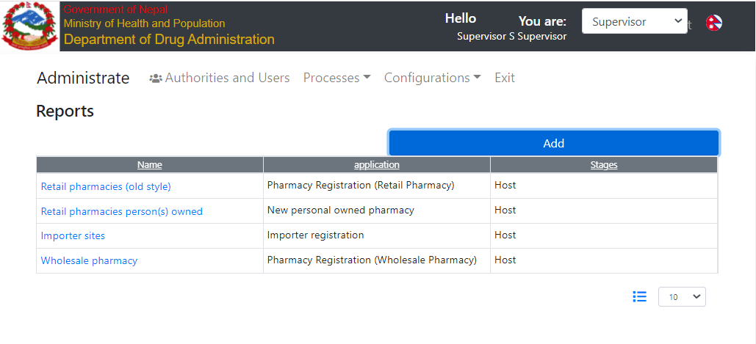

## How does it work?

A report is a table that contains basic information about sites or products. Any given report intends to provide information regarding an application at some stage of its lifecycle. Examples are:

* The retail pharmacy with valid registration
* Importer sites that are not registered yet
* Wholesalers pharmacies that lost registration certificate

The Pharmadex 2 deals with two classes of objects:

* Sites - something that has a name, an address, and owners, like pharmacies, manufacturers plants
* Products – something that suits Medicinal Product in standard HL7 (<http://hl7.org/fhir/medicinalproduct.html>)

The basic information sets for a product and a site are different.

For any report should be created a configuration record. See examples below. This full report configuration guide will be coming soon.

## An example for a site

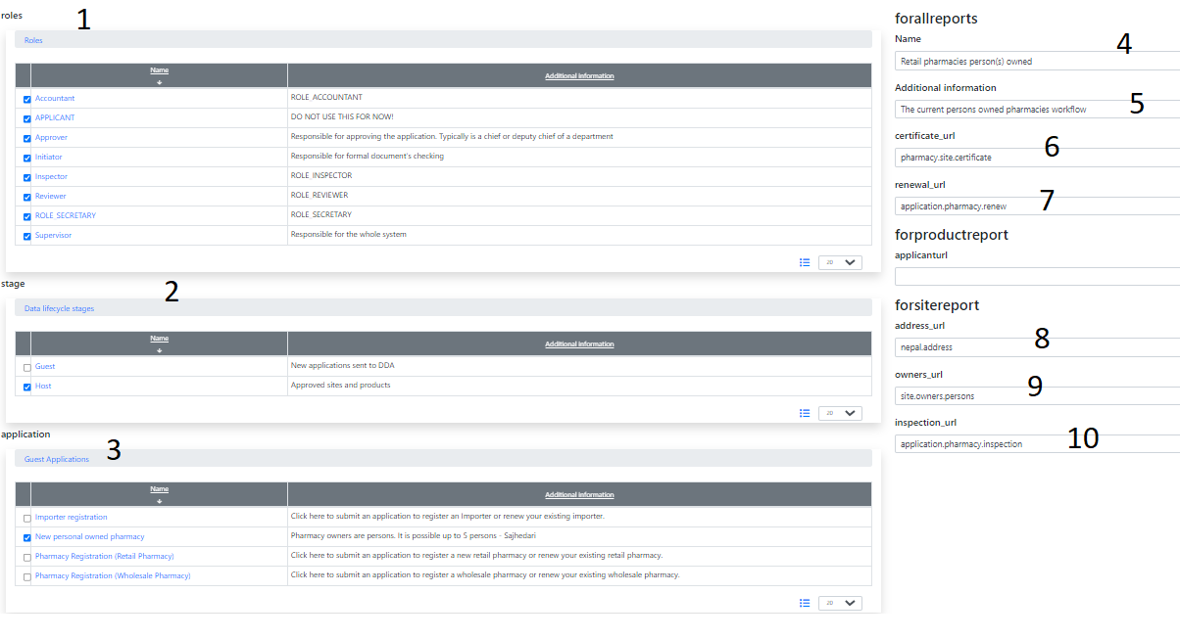

1. Who can access this report?
2. Which stage of the lifecycle covers this report?
3. An application, which data is reporting
4. Visible name of a report in User Interface. It allows multi-language.
5. The help text. It allows multi-language.
6. URL of the register contains certificate number
7. URL of the renewal application
8. URL of the site addresses
9. URL of the site owners (a UI form contains
10. Inspection application URL

## An example for a product

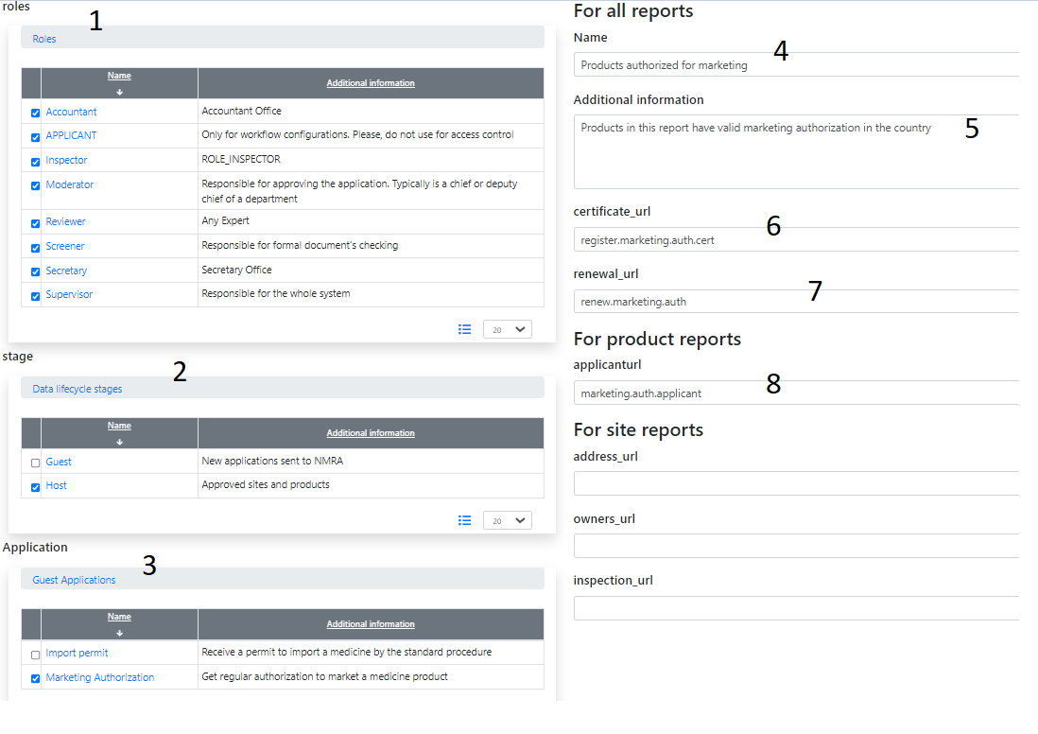

1. Who can access this report?
2. Which stage of the lifecycle covers this report?
3. An application, which data is reporting
4. Visible name of a report in User Interface. It allows multi-language.
5. The help text. It allows multi-language.
6. URL of the register contains certificate number
7. URL of the renewal application
8. URL of the applicant

## How to use reports?

Open Reports and select a report



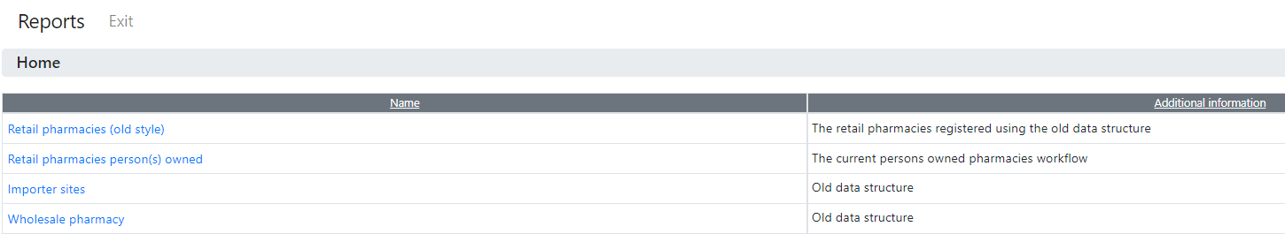

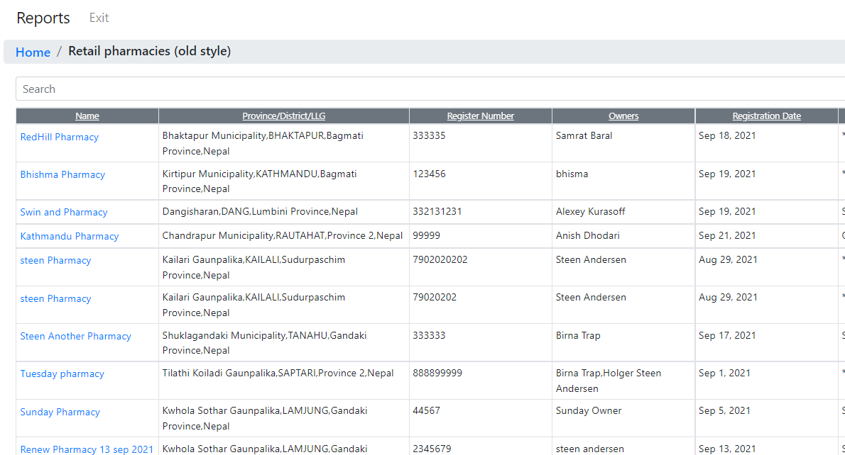

You can drill down to a site or product

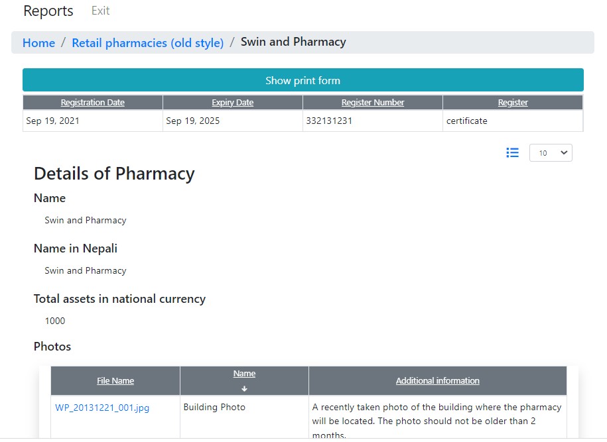

or get it in Excel format

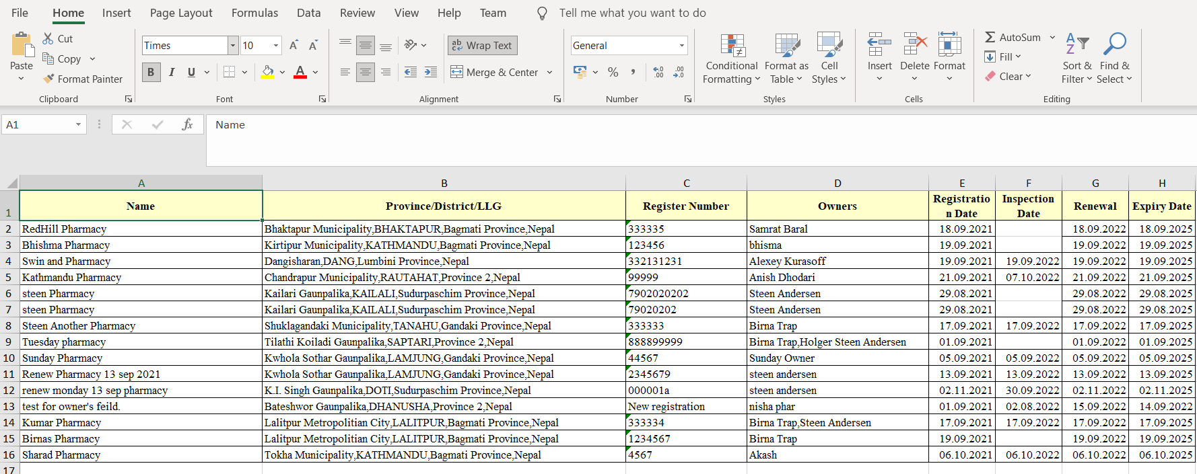

# System issue on the MSH server (Issue 1194)

## The issue

The Google login feature requires the right system time on the server. The Pharmadex 2 is using the Google login feature. The system time in the MSH network domain is wrong. Thus, it is impossible to use MSH servers to host Pharmadex 2 before this issue will be resolved.

## The proof

A screenshot from the server

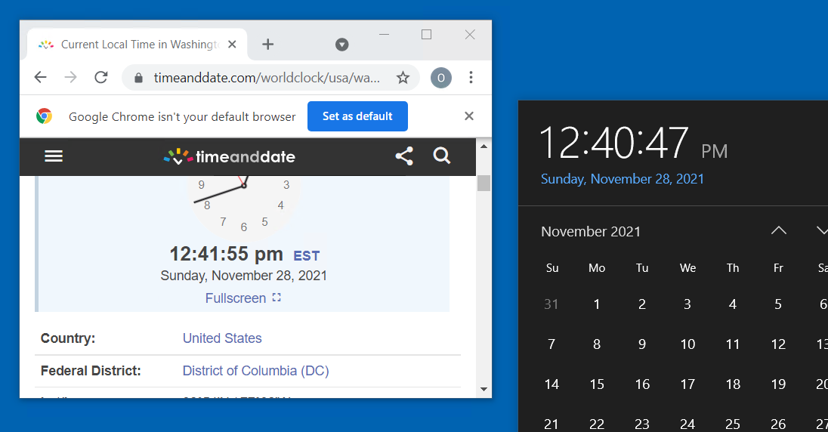

## The effect

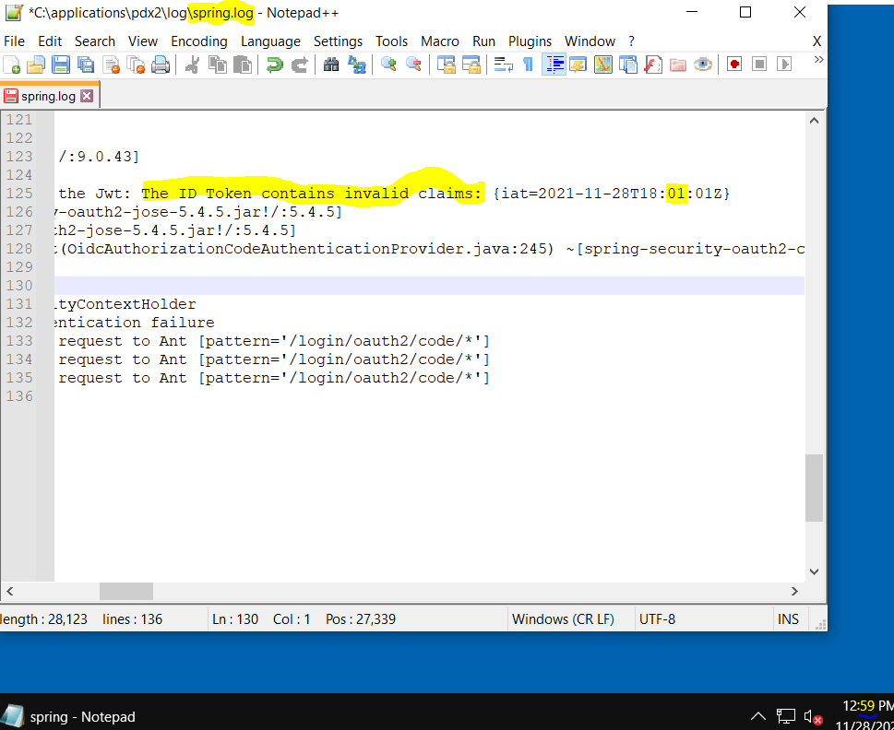

Above is another screenshot from the server. On this screenshot is a fragment of the Pharmadex 2 log file and system clock on the server, just after an attempt to login using Google.

Google sends an electronic key (ID Token) that proves the user’s right to use an application. However, for the server, this token looks like sent from the future - 1 min difference[1]. Indeed, the security software of Pharmadex 2 will not trust this token.

1. The date and hours are in a different tome zone, but absolute time for MSH server is about 1 min later then for the Google server. Thus, from MSH server’s point of view, the Google server is working in a future.