Pharmadex 2. Release Notes 2021-12-12

Contents

Motivation 1

Pre-requisite 1

Demo release particularities 1

Issues 1

Modification feature implementation 2

Pharmacist qualification medification process has been added 2

Modified data is marked. Original data is available 2

After modification mark from modified data will be removed 3

# Motivation

The main goal of this release is the continue to implement the modification feature. In addition, were fixed errors have been collected by the QA team in two weeks.

# Pre-requisite

You must have a Gmail account that has not been registered in the Pharmadex 2 database. You should know the login and password for the supervisor user.

# Demo release particularities

The modification feature is not fully tested yet. Currently fully tested only strings, literals, dates, numbers, and logical values modification. Dictionaries, addresses, and files are partially implemented, thus not fully tested yet.

This release may contain errors, bad user interface behavior, and inconsistencies. Please, report them to [alex.kurasoff@gmail.com](mailto:alex.kurasoff@gmail.com).

The workflow implementation contains mistakes.

Some reports may work slow. These reports are subject to optimization.

# Issues

|  |  |  |
| --- | --- | --- |
| **#** | **Issue** | **Notes** |
| 1238, 1236, 1234, 1222, 1219, 1217,  1205 | Errors collected in two previous weeks | Resolved |
| 1216 | Long time to next inspection | The role changed to the secretary |
| 1149 | Monitoring list enhancement | Converted to an ad-hoc report |
| 974 | Link to NMRC site | Added |
| 841 | Additional error message | Duplicated at the bottom line |
| 1201 | Modification feature | See below |

# Modification feature implementation

## Pharmacist qualification modification process has been added

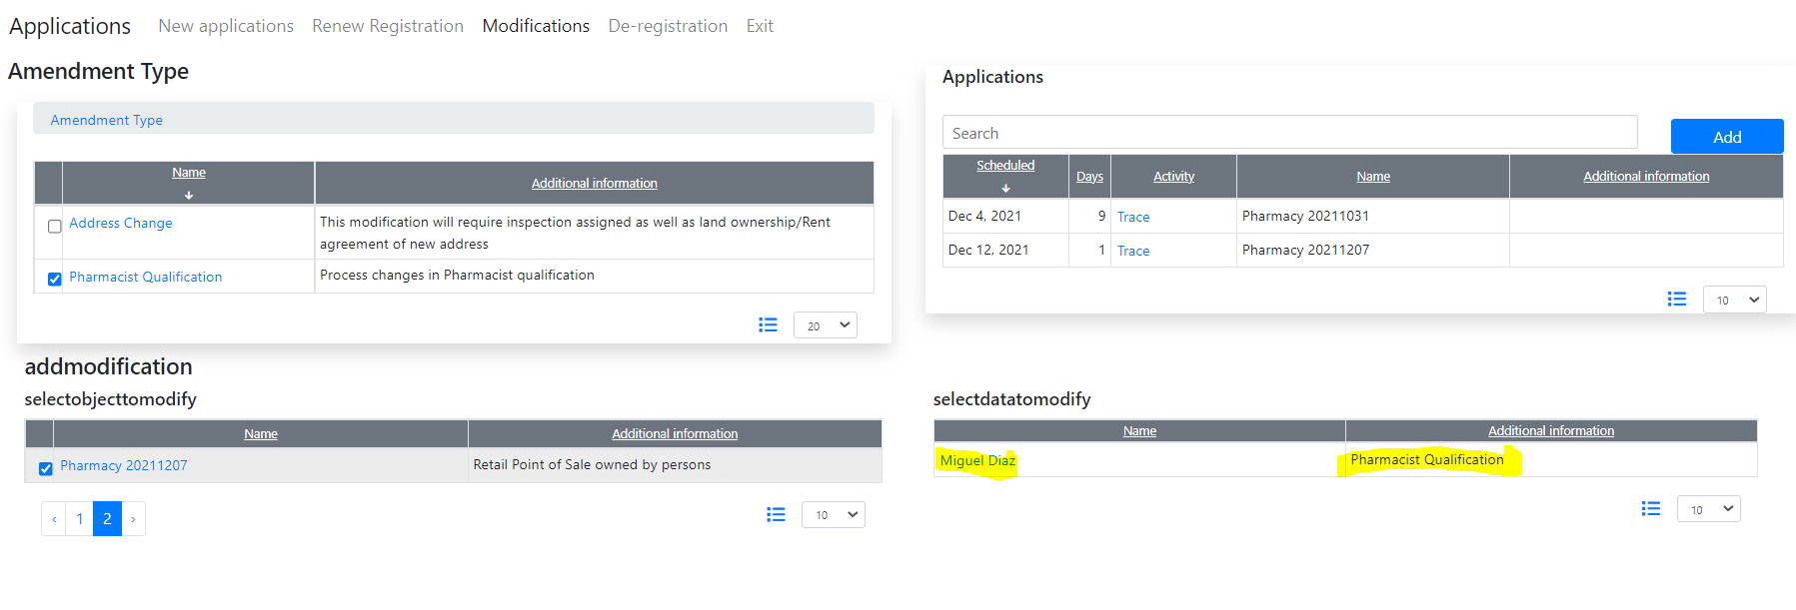

## Modified data is marked. Original data is available

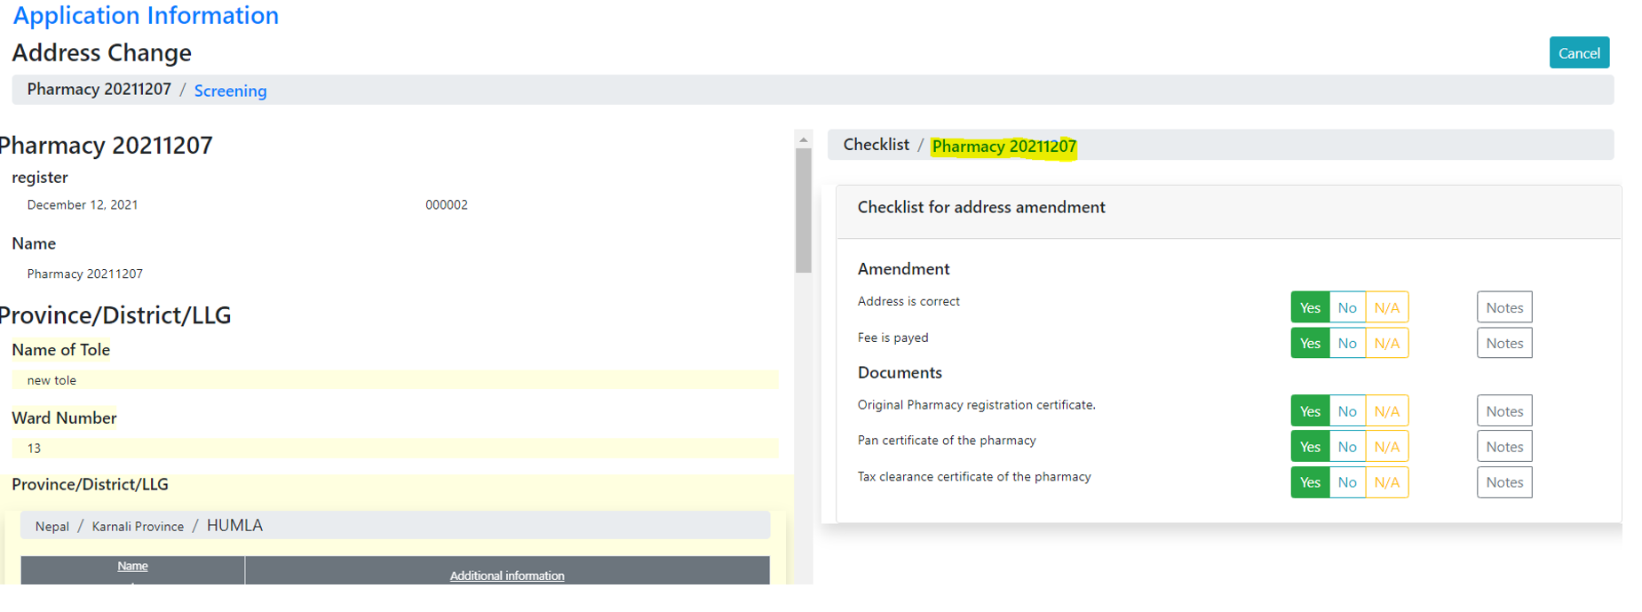

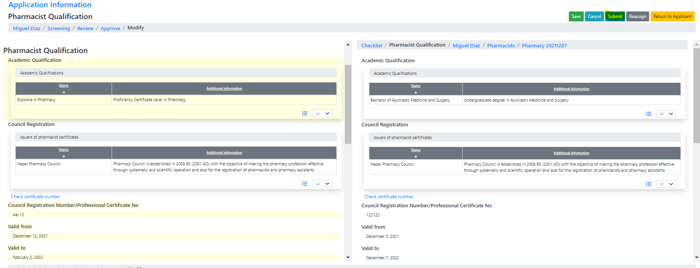

## After modification, the modified data will be unmarked (for demo only!)

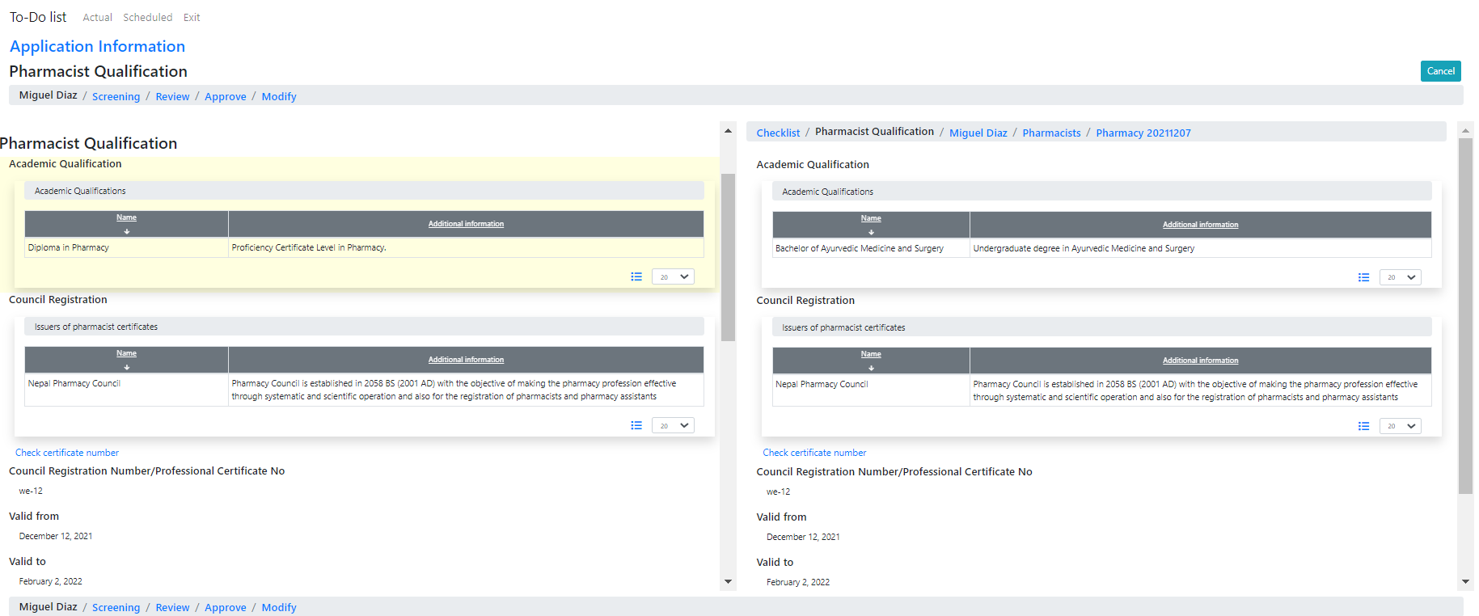

Dictionaries, addresses, and files will be tested and represented soon.