Pharmadex 2. Release Notes 2021-12-19

Contents

Motivation 1

Pre-requisite 1

Demo release particularities 1

Issues 1

Modification feature 1

# Motivation

The competition the modification feature and errors fixing

# Pre-requisite

You must have a Gmail account that has not been registered in the Pharmadex 2 database. You should know the login and password for the supervisor user.

# Demo release particularities

The modification feature is not fully tested yet. Currently fully tested only strings, literals, dates, numbers, and logical values modification. Dictionaries, addresses, and files are partially implemented, thus not fully tested yet.

This release may contain errors, bad user interface behavior, and inconsistencies. Please, report them to [alex.kurasoff@gmail.com](mailto:alex.kurasoff@gmail.com).

The workflow implementation contains mistakes.

Some reports may work slow. These reports are subject to optimization.

**Old modification applications have been removed, because of an error**

# Issues

|  |  |  |
| --- | --- | --- |
| **#** | **Issue** | **Notes** |
| 1201 | Modification feature | See below |
| 1237 | EL expressions for modification application is the same as for the main application | Completed |

# Modification feature

The inception of modification is the same as in the previous release

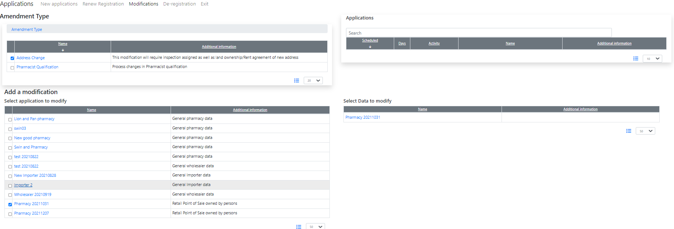

It is possible to configure the same workflow for different modification data. In the example below “Address modification” and “Pharmacist Qualification Modification” are assigned to the same DDA workflow

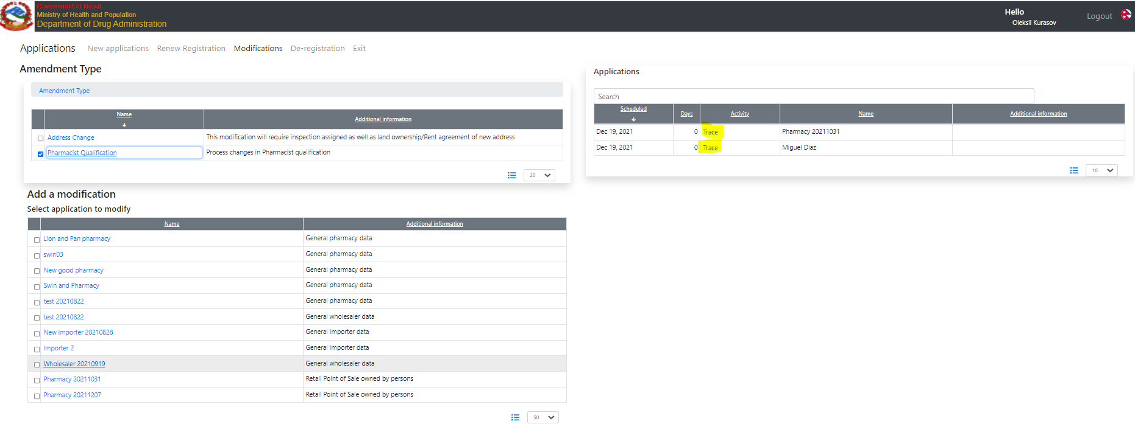

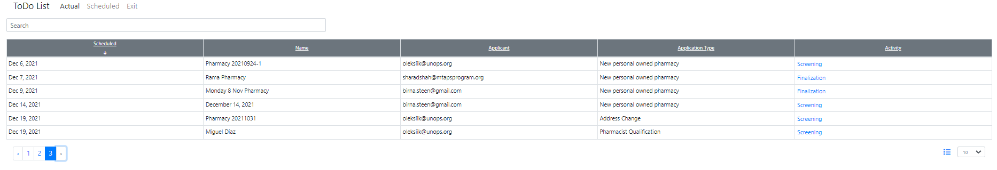

The modification will be applied to the real data before the finalization step. It allows the creation of the right documents (certificates, etc) at the finalization step

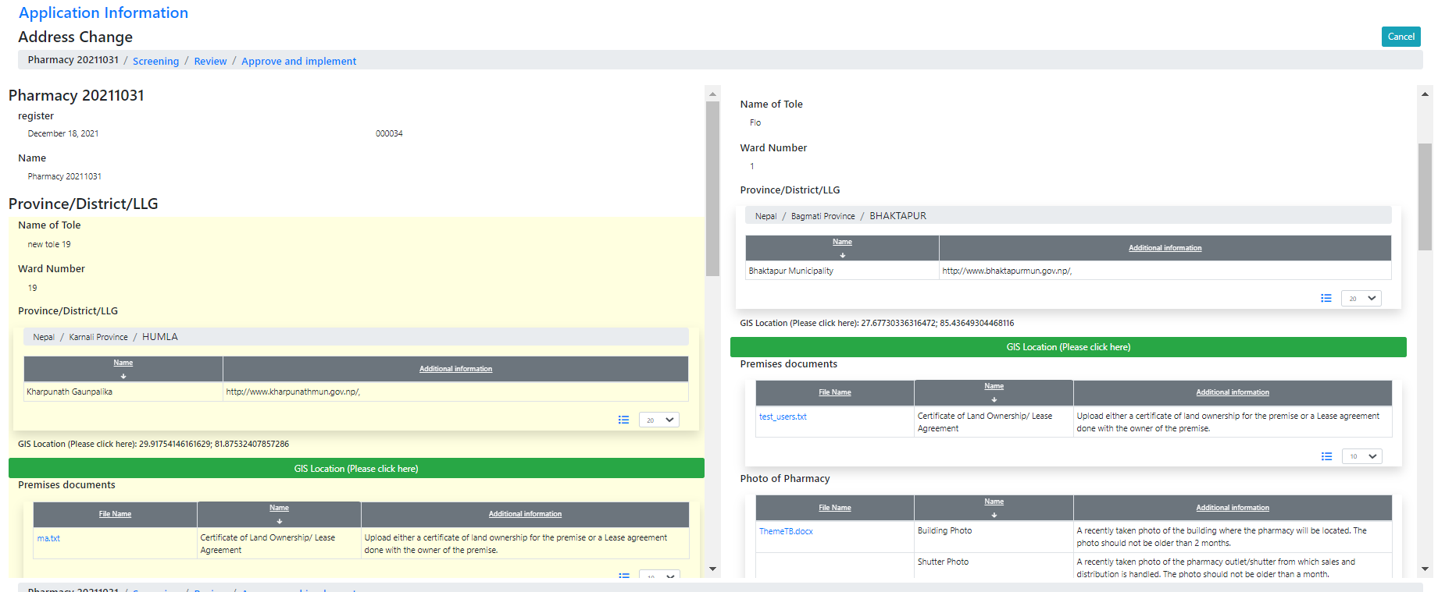

Submit to the finalization

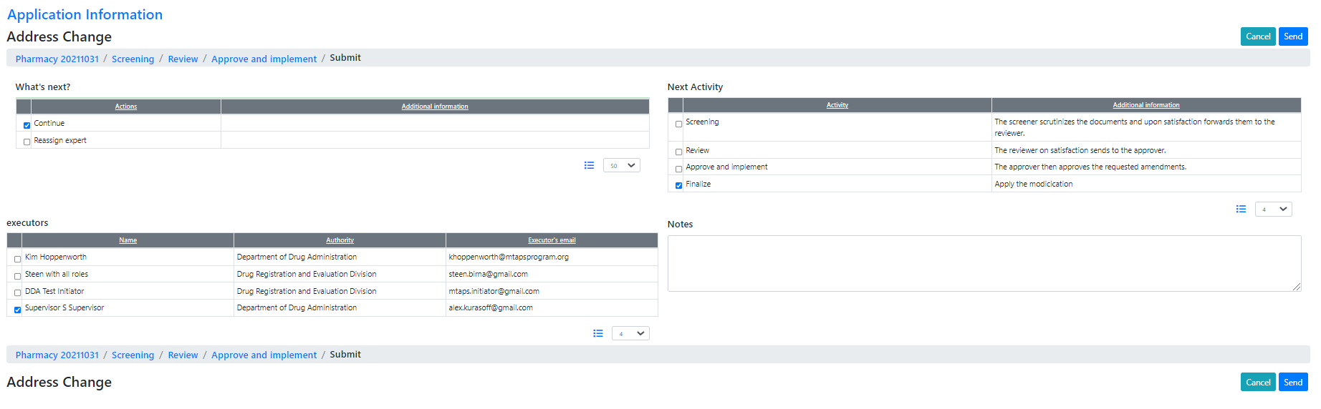

On the finalization step, the modification is applied to the data

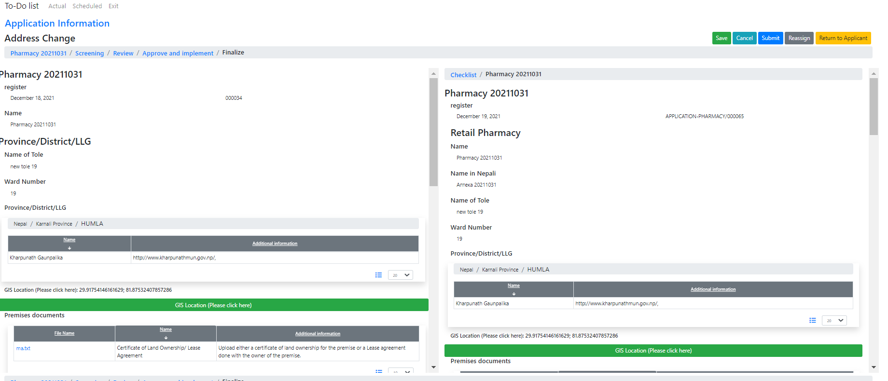

The finalization step is marked as Modification (The label “Amendment” may be easily changed in the configuration)

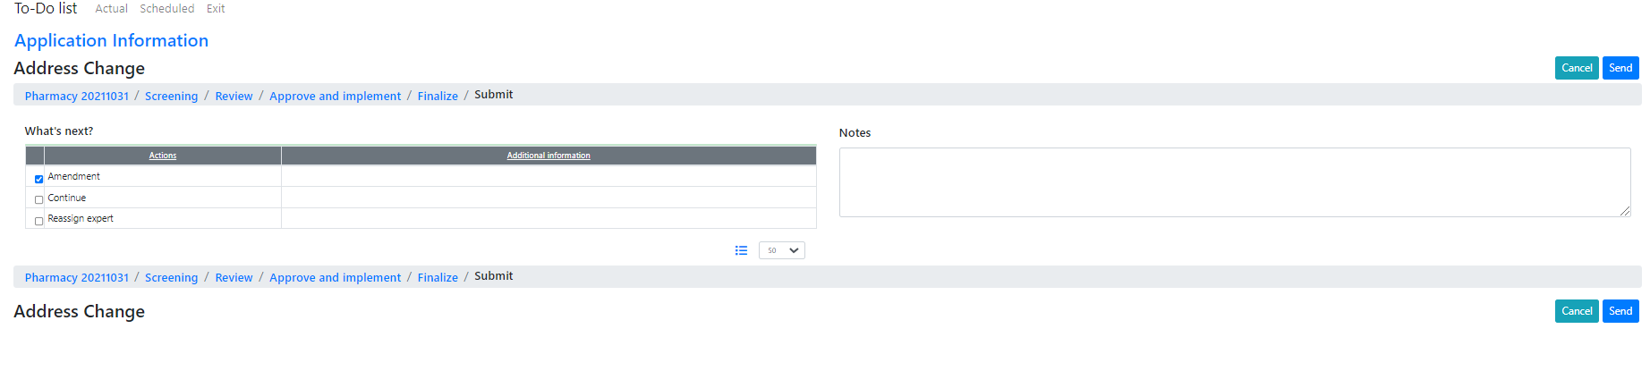

After finalization, the modification application will be gone from the To-Do list

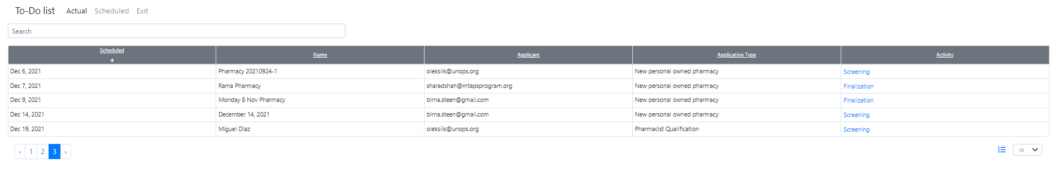

The history of modifications will be available soon in the “Reports” feature.