Pharmadex 2. Release Notes 2022-01-18

Contents

Motivation 1

Pre-requisite 1

Demo release particularities 1

Documentation in form of e-learning courses 1

Implementation of the Regular Expressions 2

Motivation 2

Where to find 2

Examples and Refrences 5

# Motivation

Prepare documentation set noted as deliverables.

Introduce RegEx validation for text fields (Issue Feature #1133)

# Pre-requisite

You must have a Gmail account that has not been registered in the Pharmadex 2 database. You should know the login and password for the supervisor user.

# Demo release particularities

This release may contain errors, bad user interface behavior, and inconsistencies. Please, report them to [alex.kurasoff@gmail.com](mailto:alex.kurasoff@gmail.com).

The workflow implementation contains mistakes.

Some reports may work slow. These reports are subject to optimization.

**Old modification applications have been removed, because of an error**

# Documentation in form of e-learning courses

The latest ones can be found here

<http://redmine.inka.in.ua/documents/116> - the deployment guide

<http://redmine.inka.in.ua/documents/118> - the USer Guide, learning course

<http://redmine.inka.in.ua/documents/117> - the Database Guide, learning course

# Implementation of the Regular Expressions

## Motivation

To provide the additional validation for the text fields for which known the format. Examples are eMail, phone number SSN, credit cards, etc.

The short explanation may be found in Wikipedia. A detailed explanation may be found in https://www.regular-expressions.info/.

## Where to find

The regular expression to validate a text field should be placed to the data configuration. For the retail pharmacy application, it is in Figure 1

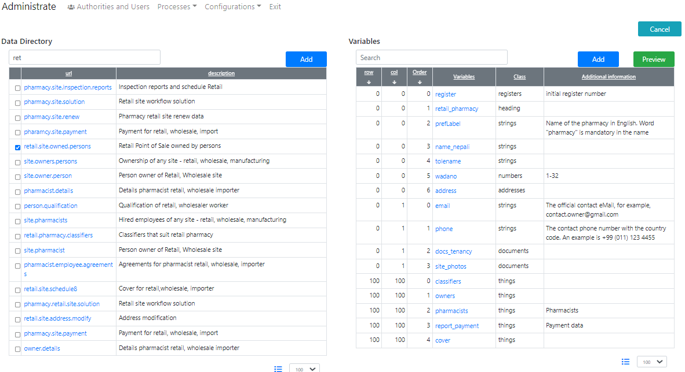

Figure . The data configuration for the application

The pattern should be placed in the field “The pattern…” (Figure 2)

It is possible to make mandatory the word “pharmacy” in the name of a pharmacy (Figure 2).

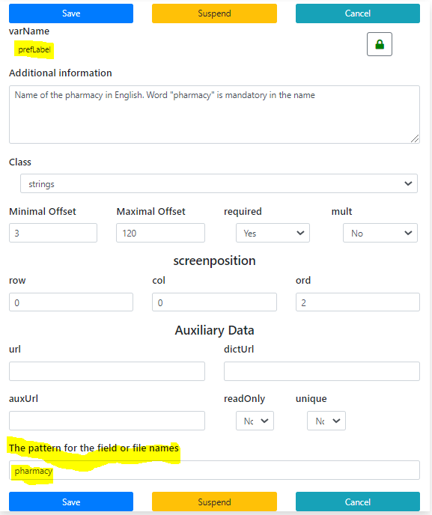

Figure . The word "pharmacy" should be somewhere in the name

The eMail check is the more complex pattern. The pattern from Figure 3 is not the most complex of the possible ones.

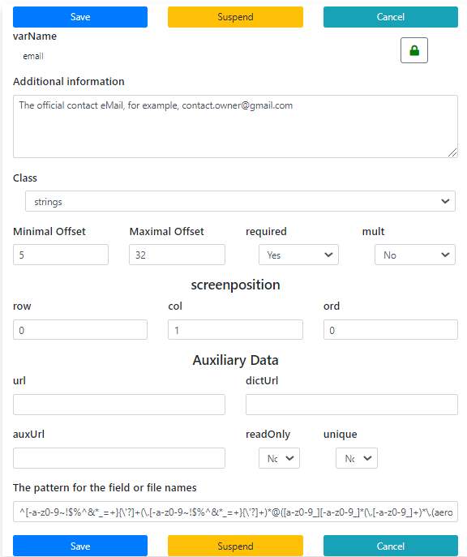

Figure . The pattern for eMails

And, at least, a pattern for the international phone number (Figure 4). Please, put your attention to that example of input that should be provided in case of the regular expression usage.

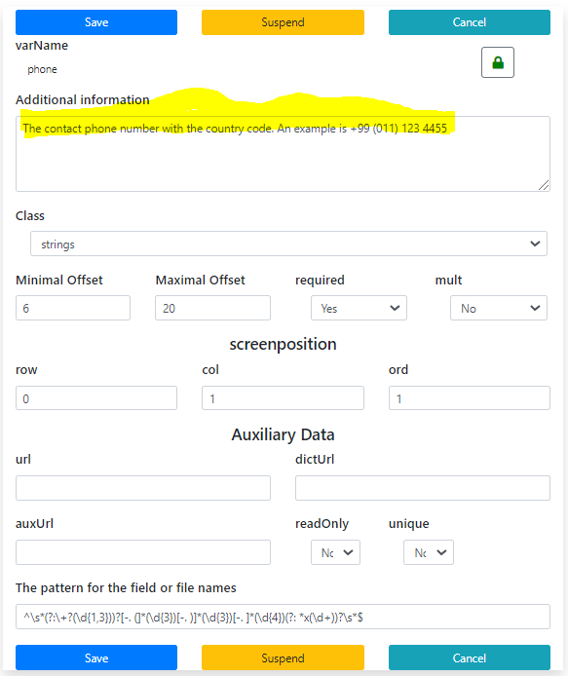

Figure . International phone number validation

## Examples and References

There are many incompatible dialects of the regular expression language. The Pharmadex 2 uses Java dialect.

For most cases the regular expression’s patterns are complex. However, for the common cases, it is possible to find the solution on the Internet and check them by using the tools available.

The patterns are used for examples:

**eMail**

^[-a-z0-9~!$%^&*_=+}{\'?]+(\.[-a-z0-9~!$%^&*_=+}{\'?]+)*@([a-z0-9_][-a-z0-9_]*(\.[-a-z0-9_]+)*\.(aero|arpa|biz|com|coop|edu|gov|info|int|mil|museum|name|net|org|pro|travel|mobi|[a-z][a-z])|([0-9]{1,3}\.[0-9]{1,3}\.[0-9]{1,3}\.[0-9]{1,3}))(:[0-9]{1,5})?$

**Phone**

^\s*(?:\+?(\d{1,3}))?[-. (]*(\d{3})[-. )]*(\d{3})[-. ]*(\d{4})(?: *x(\d+))?\s*$

The good source of the patterns and a tool to chck them may be found here:

https://www.freeformatter.com/java-regex-tester.html#ad-output