Pharmadex 2. Release Notes 2022-01-25

Contents

Motivation 1

Pre-requisite 1

Demo release particularities 2

The Branch Office 2

Objective 2

How to distinguish the main and the branch offices? 2

How to distinction applications? 4

The responsibility of the expert 8

The assignment procedure 9

EL expression for the image 9

The version and the release number 11

# Motivation

Issues:

* 1154 Define geographical area for DDA users / introduce Branch office
* 908 The image of a pharmacist in EL expression
* 1263 Version number and release date in the design

# Pre-requisite

You must have a Gmail account that has not been registered in the Pharmadex 2 database. You should know the login and password for the supervisor user.

# Demo release particularities

This release may contain errors, bad user interface behavior, and inconsistencies. Please, report them to [alex.kurasoff@gmail.com](mailto:alex.kurasoff@gmail.com).

* The workflow implementation contains mistakes.
* Some reports may work slow. These reports are subject to optimization.
* The configurations described here are only for demonstration purposes.

# The Branch Office

## Objective

There are main and branches DDA offices. Some types of workflows should be processed by the Main Office, some by the Branches. For example, the pharmacy registration workflows should be processed by a Branch Office, the Marketing Authorization – by the Main Office.

Thus, should exist a way to determine which office will process a particular workflow. It will be possible to do automatically if:

1. It is possible to distinguish between main and branch offices.
2. For a branch office, it is possible to determine the geographical area this office is responsible
3. It is possible to distinct applications that should be processed by the main office and by a branch office.
4. For the applications processed by a branch office it is possible to select the office unambiguously
5. Should be defined experts to process the application

## How to distinguish the main and the branch offices?

The Pharmadex 2 provides a tool (Figure 1) to keep minimal necessary information regarding offices and experts. This structure is hierarchical. It means that the main offices are on the top of the left column and each main office is expandable to sub-offices – departments and branches.

For any office should be determined experts. They can be found in the right column.

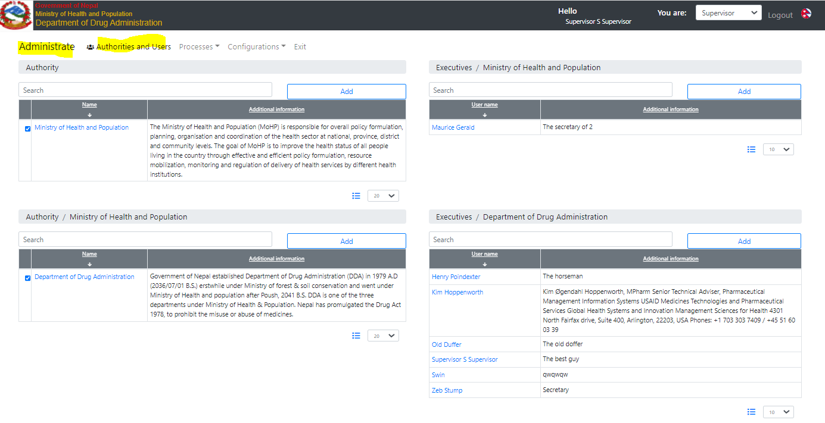

Figure . Departments and experts

Each office (Figure 2, Figure 3) may be linked to the geographical area. The geographical area is a set of districts.

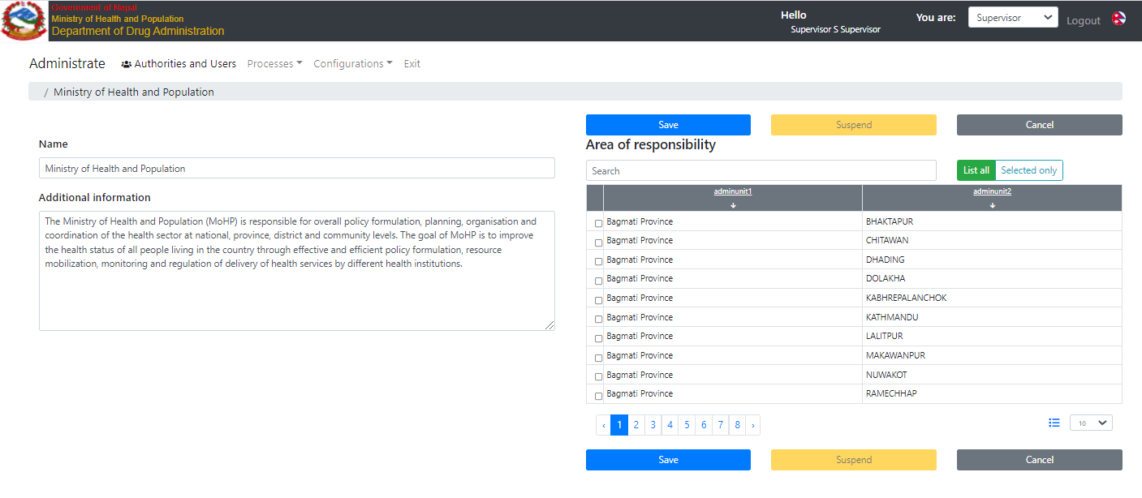

Figure . The Main office

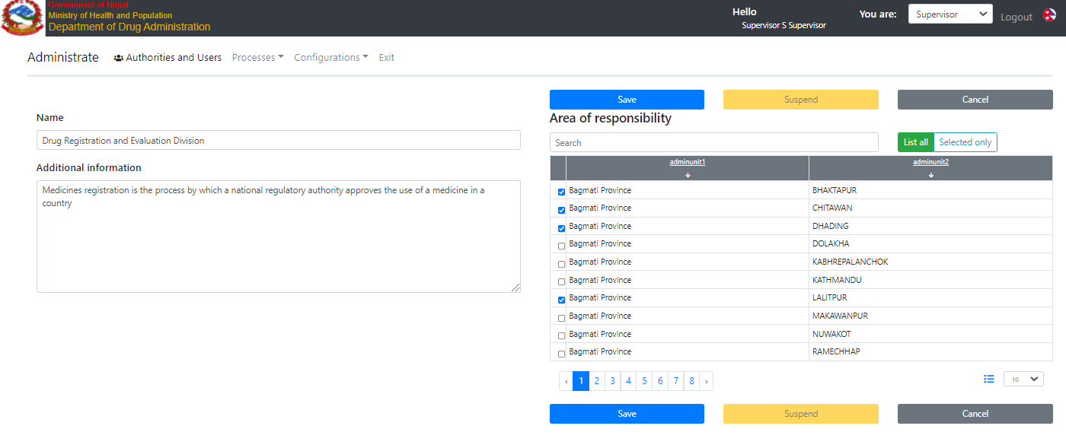

Figure . The branch office

**The office that has at least one link to a district is the branch office. The office that has not any links to a district is the main office.**

The geographical responsibility should be configured for each office separately. It means that a sub-office does not inherit the geographical responsibility of the office

## How to distinction applications?

The Pharmadex 2 provides a tool to configure workflows (Figure 4). The workflows initiated by an applicant are “Guest” and “Amendment Type”

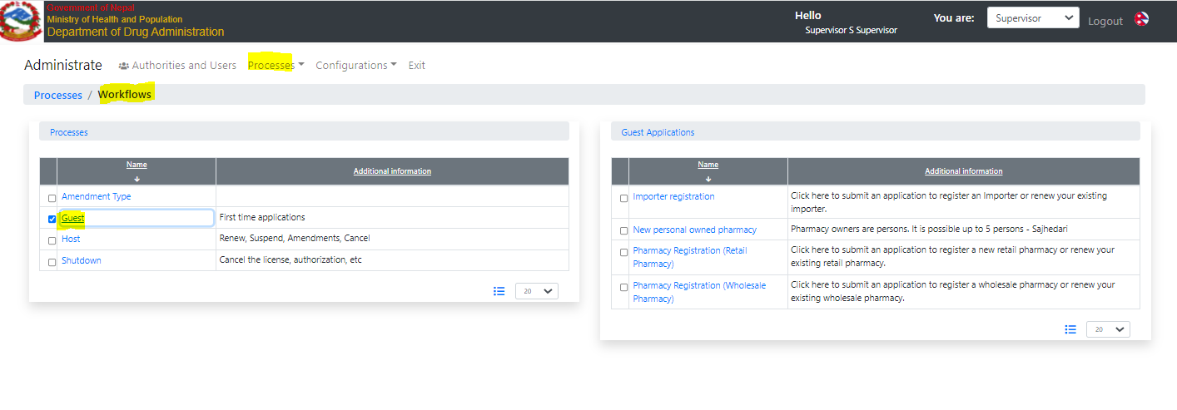

Figure . The Workflow Configurer

The configuration of the first step of a workflow initiated by the applicant contains a field “Address URL”. For workflows that should be processed by a branch office, this field should be filled properly. Otherwise, the workflow will be processed by experts from the Main office.

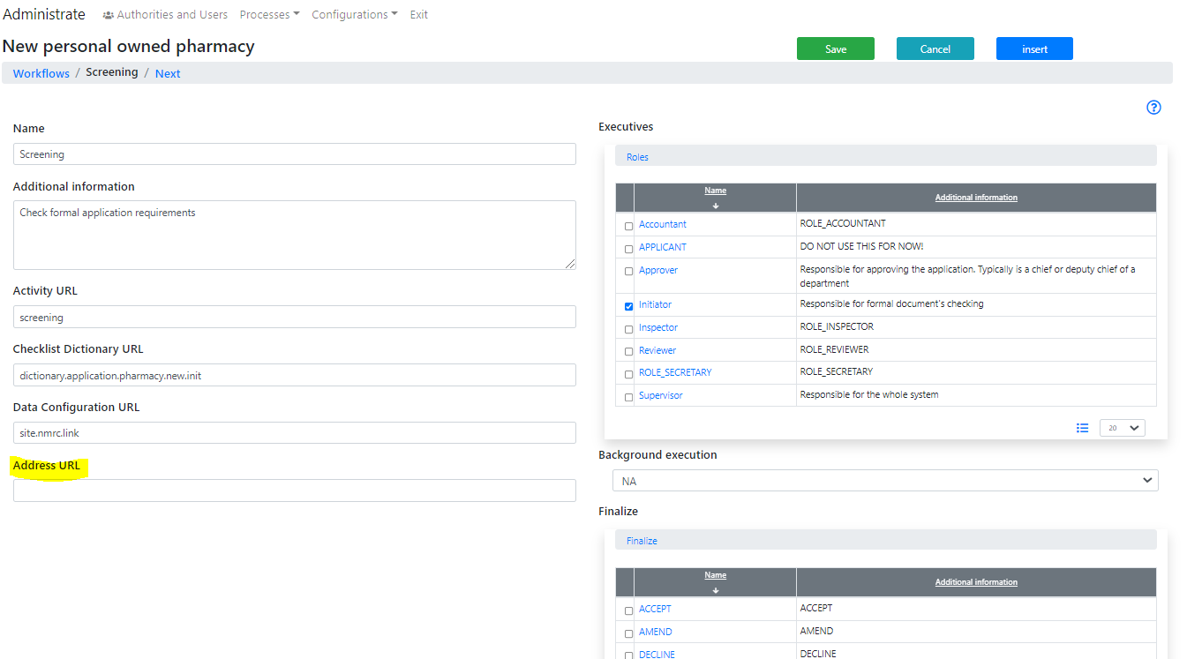

Figure . The first activity configuration

The address URL is a URL of any address from the application data. Consider the example below.

The “New personal owned pharmacy” is an application that initiated the “guest workflow”. All guest workflows are configured in the “dictionary.guest.applications” (Figure 6)

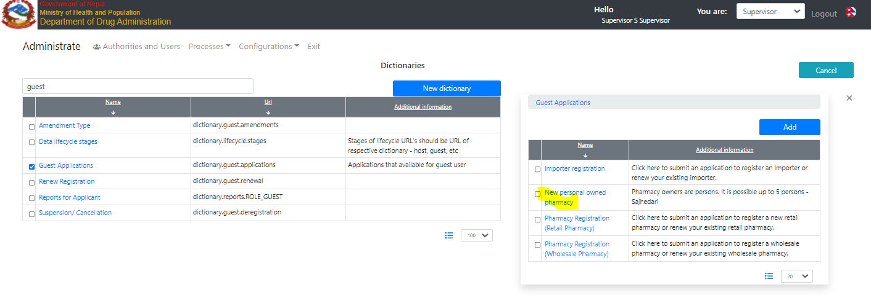

Figure . Guest workflows

The data of this workflow is configured () under URL “retail.site.owned.persons”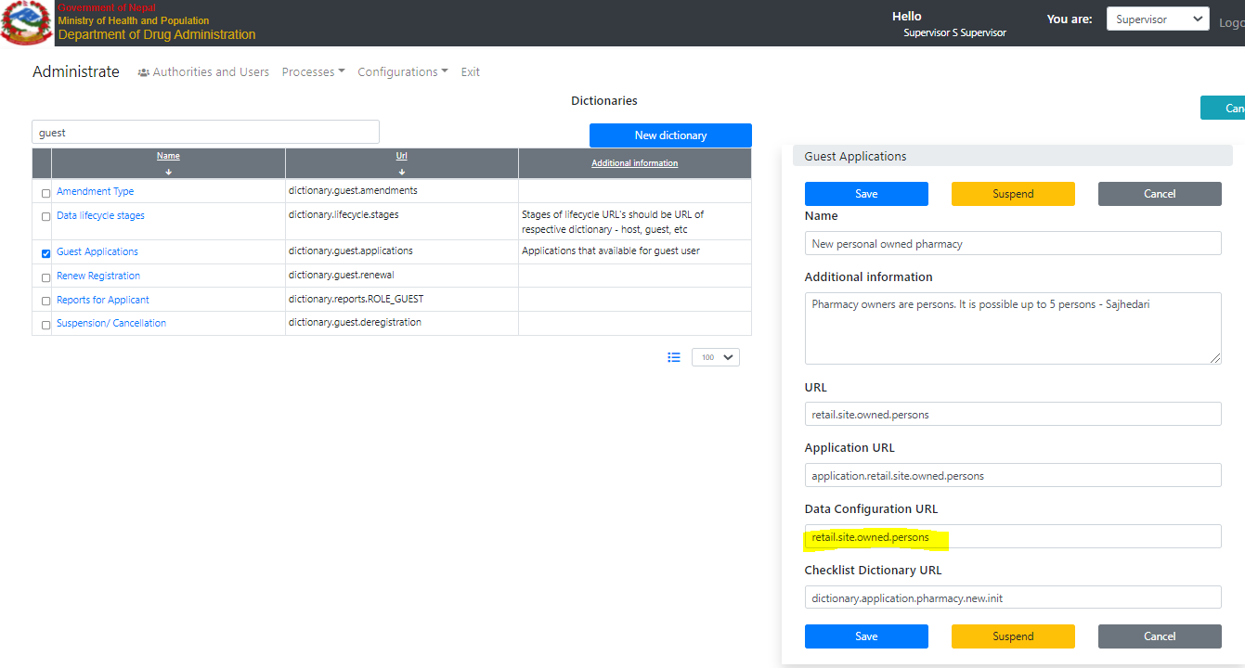

Figure . The workflow metadata

The data configuration can be found in the Data Configurator

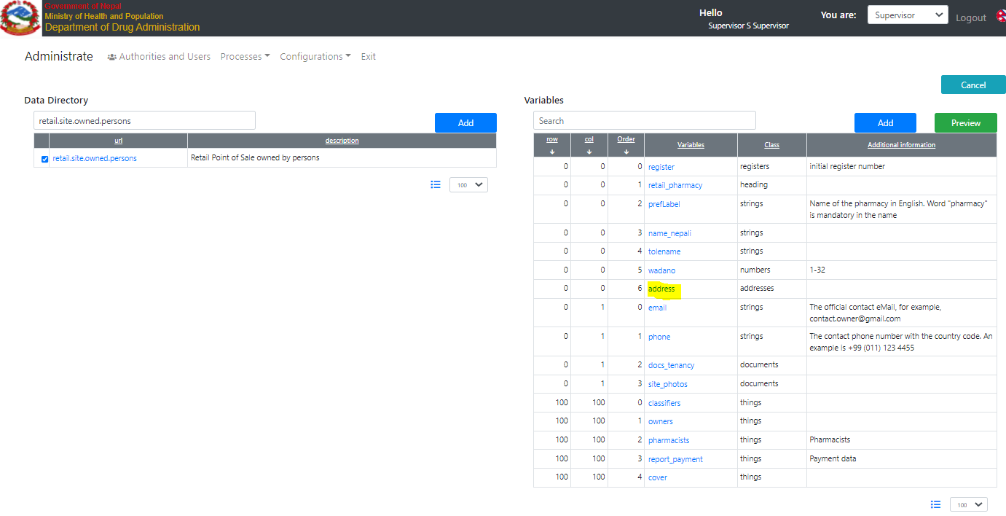

Figure . The application data configurator

The address of a pharmacy is stored under the URL “nepal.address”

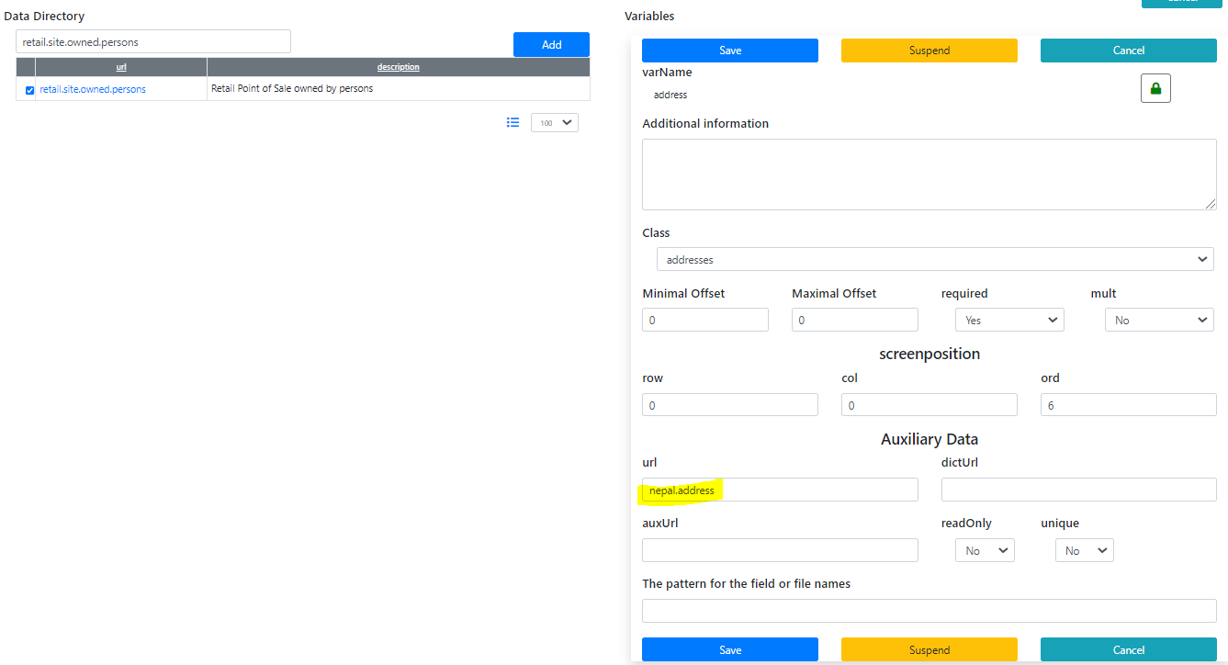

Figure . Pharmacy address configuration

Thus, to make this application processed by a branch office, it is necessary to put the URL into the field Address URL in the first step of the workflow configuration.

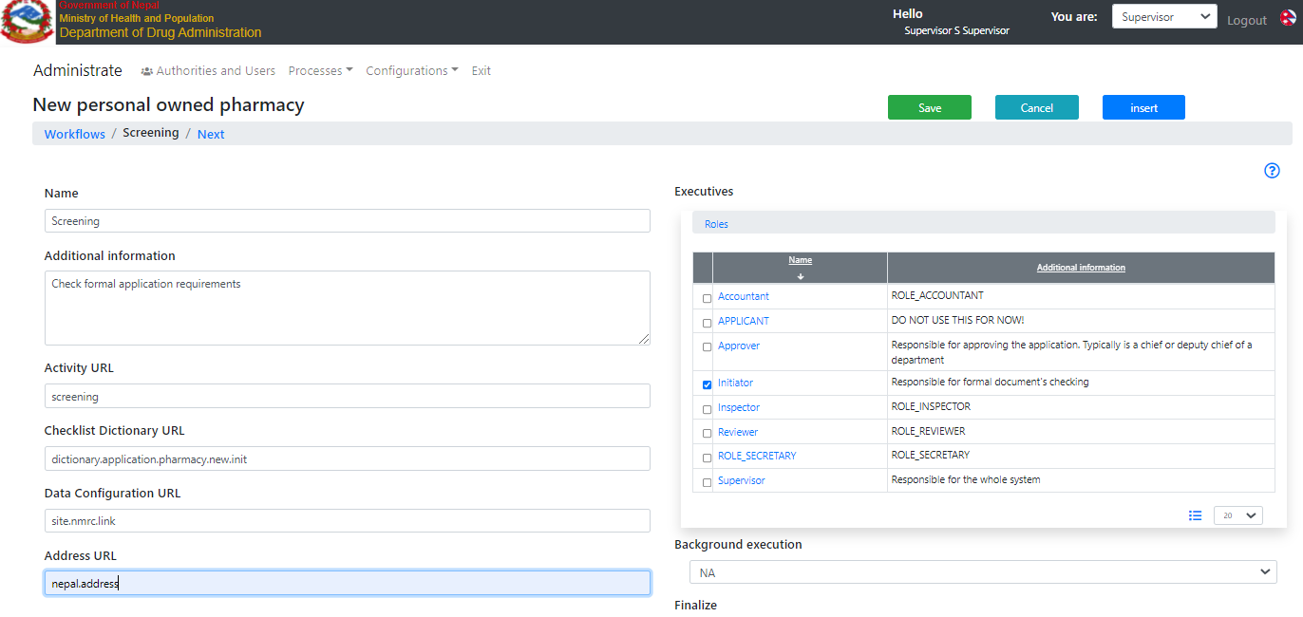

Figure . The workflow is for a branch office

## The responsibility of the expert

The responsibility of an expert is defined as an intersection of expert role and applications responsibility. The configuration of experts (Figure 11) is in the right column

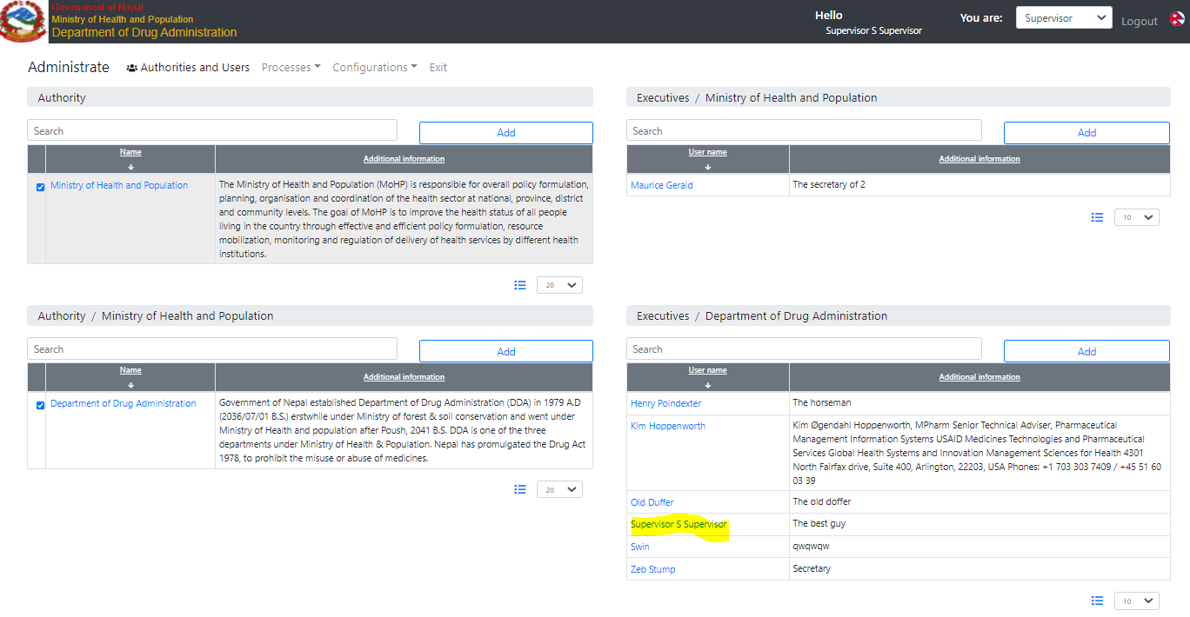

Figure . The experts' configuration

The responsibility of the expert is the intersection of roles and application types assigned

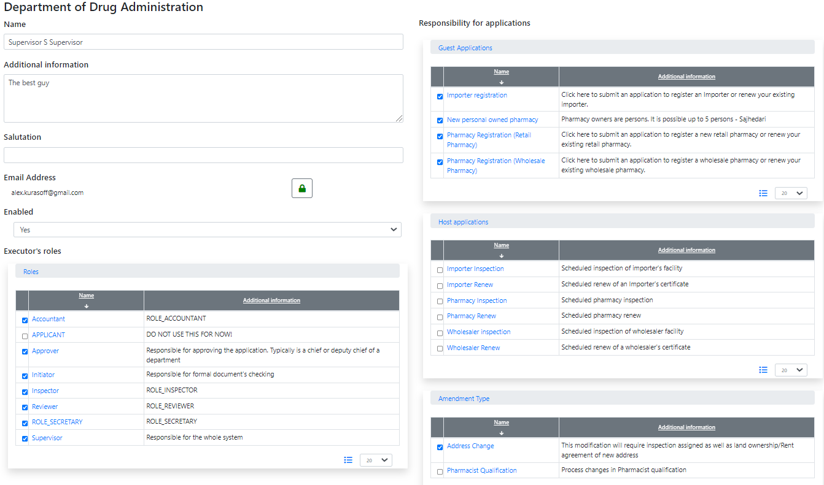

Figure . The responsibility of an expert

## The assignment procedure

1. The assignment of the first experts should be automated:
   1. select an office by the administrative unit.
   2. select experts from the selected office by appropriate competency and specialization
   3. In case the expert cannot be selected, the secretary of the first appropriate office should be assigned
   4. In case the appropriate office cannot be selected, all supervisors should be assigned
2. The selection of experts by other experts should be manual, using the list of all experts with the appropriative competency and specialization.
3. The manual selection of experts by the applicant is unacceptable

# EL expression for the image

Since this release is possible to apply the “@image” convertor for the “documents” variable. This converter will take the first document and try to insert it as a JPEG or PNG image. Any other formats are not supported. It will be a good idea to configure only one document in an image resource.

Consider an example for the first owner. The owner data configuration contains variable “photos” with type “documents”

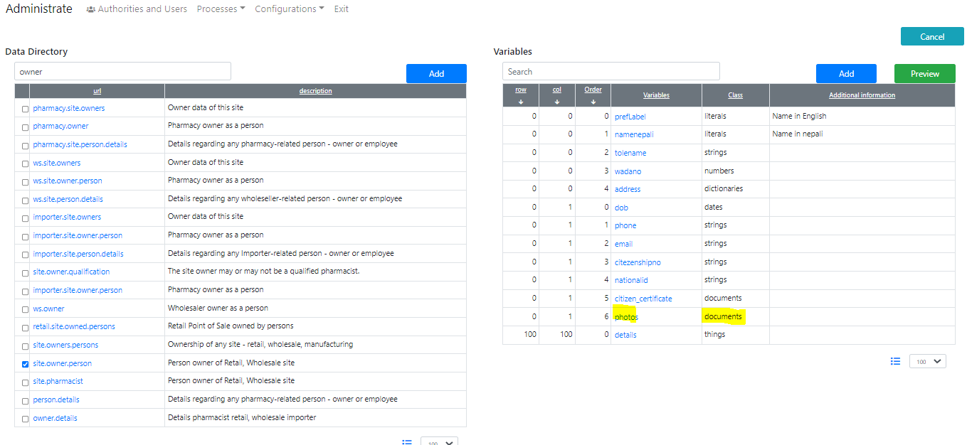

Thus, for the first owner, the EL expression to extract a photo will be

${/owners/owners/0/photos@image}

The full example is here <http://redmine.inka.in.ua/documents/77>

The file name is owner_image.docx

In case the image insertion became failed, a special image will be inserted.

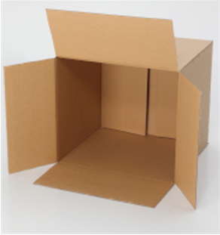

# The version and the release number

Since this release can be found on the footer.

