Pharmadex 2. Release Notes 2022-02-01

Contents

Motivation 1

Pre-requisite 1

Demo release particularities 1

“Register existing personally owned pharmacy” application 1

The function 1

How to start 2

How to process 4

The extended monitoring and application history 5

# Motivation

* Provide database and component for legacy data lookup, issue #1268,
* Configure “Register existing personally owned pharmacy” application – data and workflow, issue #907
* Extend content in the monitoring and application history features. The gone and canceled records currently are visible.

# Pre-requisite

You must have a Gmail account that has not been registered in the Pharmadex 2 database. You should know the login and password for the supervisor user and have another login and password to log in as a business user, i.e., an applicant.

# Demo release particularities

This release may contain errors, bad user interface behavior, and inconsistencies. Please, report them to [alex.kurasoff@gmail.com](mailto:alex.kurasoff@gmail.com).

* **Please, check offices and users’ configurations. It became extremely important.**
* The workflow implementation contains mistakes.
* Some reports may work slow. These reports are subject to optimization.
* The configurations described here are only for demonstration purposes.

# “Register existing personally owned pharmacy” application

## The function

This application intends to migrate the legacy pharmacy data manually. The use case is:

* A business user looks up for pharmacy in the legacy data and fills out additional registration data.
* DDA checks this data and schedules inspection and renew

## How to start

Log in as an applicant and select the application

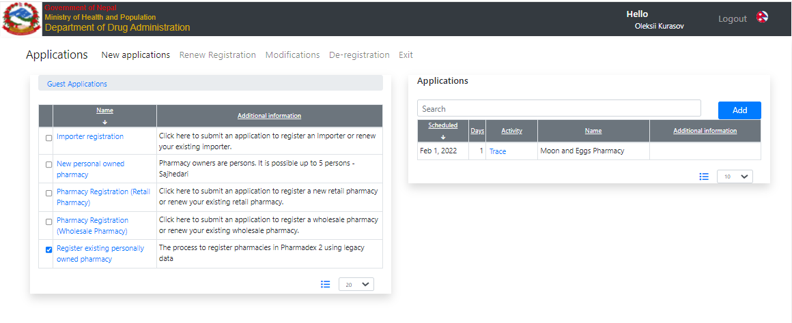

Figure . Start the application

On the first screen Figure 2, it is possible to lookup for a legacy pharmacy. The current list contains two examples. These examples are not real pharmacies.

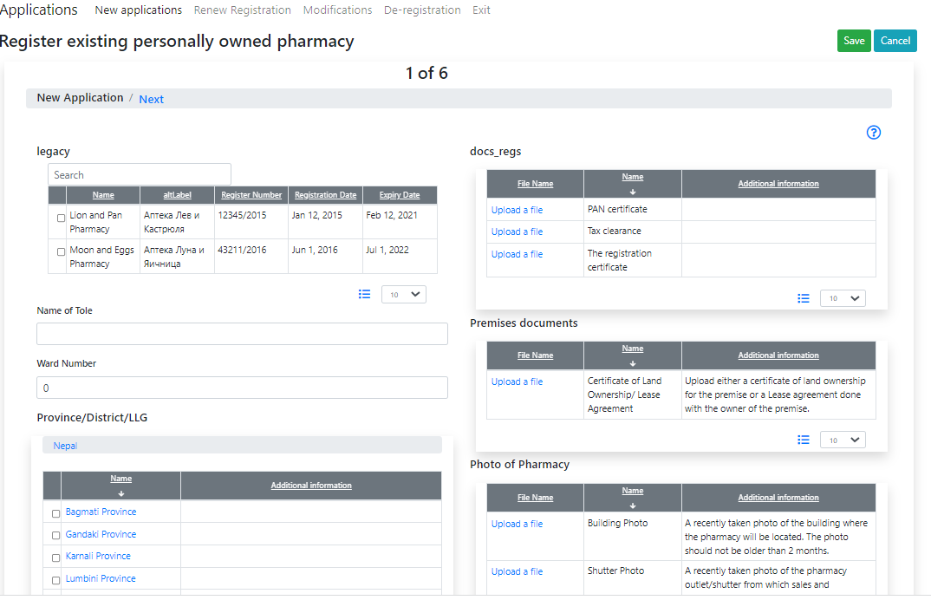

Figure . The first screen. A new component to look up for a legacy data

Fill out the rest of the forms and apply in the usual way.

## How to process

Log in as a DDA staff member on the initiator role or the supervisor.

The workflow is configured to use the address of the pharmacy to select the first executor. In case this executor will not available for you, it is possible to use the “Monitoring” feature (Figure 3) to re-assign the first executor (Figure 4)

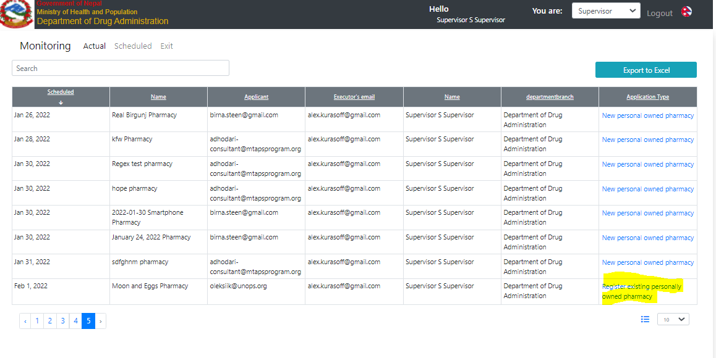

Figure The monitoring feature for the Supervisor

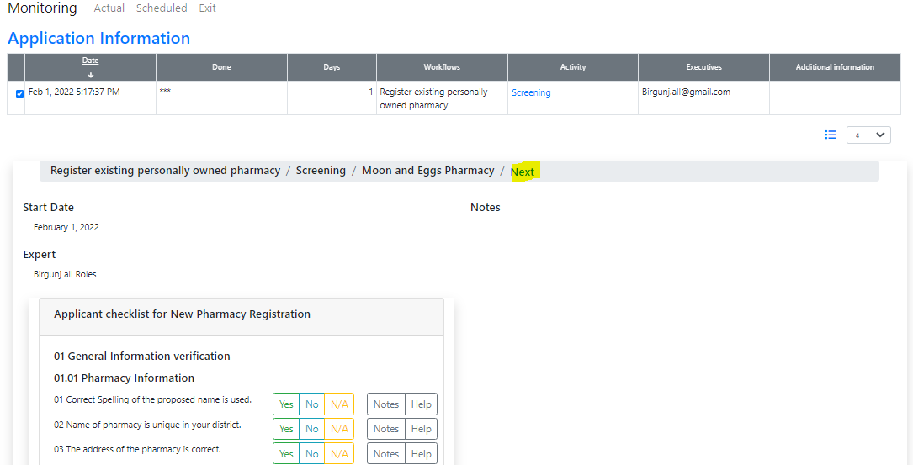

Figure The application information allows to re-assign the first executor

# The extended monitoring and application history

The Supervisor’s monitoring feature now contains only monitoring records assigned to the supervisor, not for all supervisors. Thus, any confusion should be avoided.

The “application history” feature now contains data about canceled events. Thus, it is possible to inspect all workflow activities including canceled ones.