Pharmadex 2. Release Notes 2022-02-08

Contents

Motivation 1

Pre-requisite 2

Demo release particularities 2

Where to find and how to use? 2

# Motivation

Configure applications:

* New PVT owned pharmacy
* Registered PVT owned pharmacy
* Capital modification

# Pre-requisite

You must have a Gmail account that has not been registered in the Pharmadex 2 database. You should know the login and password for the supervisor user and have another login and password to log in as a business user, i.e., an applicant.

It is necessary to configure access the new applications implicitly. For current, only users below can process the applications

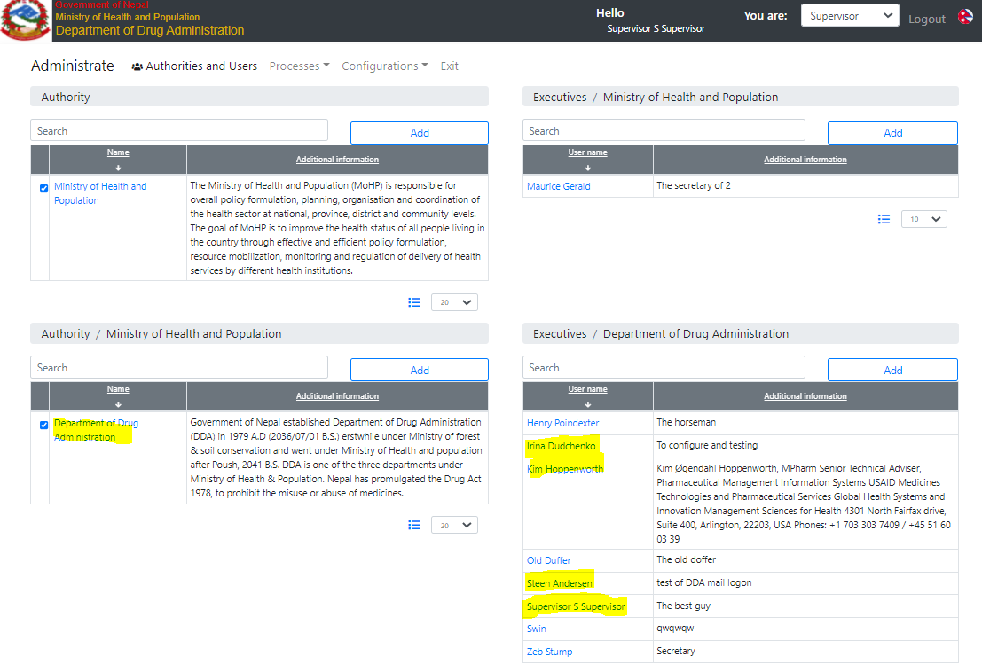

Figure . Test users to process the new applications

# Demo release particularities

This release may contain errors, bad user interface behavior, and inconsistencies. Please, report them to [alex.kurasoff@gmail.com](mailto:alex.kurasoff@gmail.com).

* **Please, check offices and users’ configurations. It became extremely important.**
* The workflow implementation contains mistakes.
* Some reports may work slow. These reports are subject to optimization.
* The configurations described here are only for demonstration purposes.

# Where to find and how to use?

The applications may be used as any regular “guest” and/or “modification” applications.