Pharmadex 2. Release Notes 2022-02-15

Contents

Motivation 1

Pre-requisite 2

Demo release particularities 2

Picture size control 2

# Motivation

* Fix bugs related to the extremally slow reporting
* Fixed bug related to the tiles (issue 1332)
* Picture size control has been introduced (see below)
* New modification workflow has been configured:
  + Add/remove the owner
  + Add/remove the pharmacist
  + Name of pharmacy

# Pre-requisite

You must have a Gmail account that has not been registered in the Pharmadex 2 database. You should know the login and password for the supervisor user and have another login and password to log in as a business user, i.e., an applicant.

It is necessary to configure access to the new applications implicitly. For current, only users below can process the applications

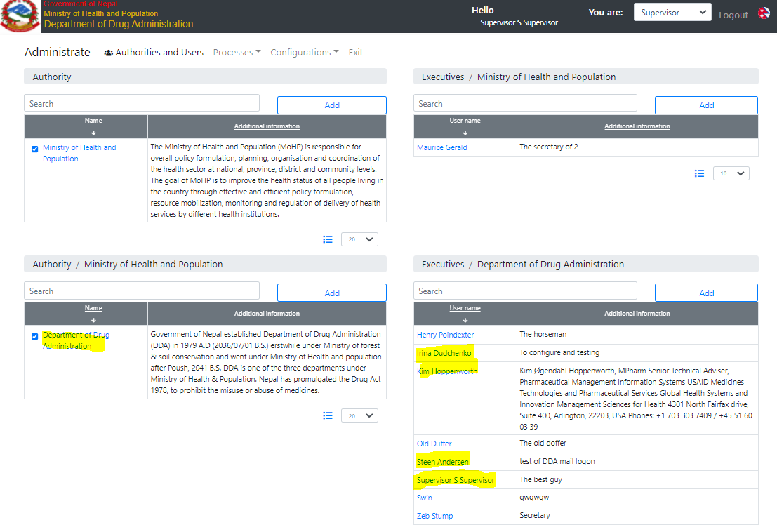

Figure Test users to process the new applications

# Demo release particularities

This release may contain errors, bad user interface behavior, and inconsistencies. Please, report them to [alex.kurasoff@gmail.com](mailto:alex.kurasoff@gmail.com).

* **Please, check offices and users’ configurations. It became extremely important.**
* The workflow implementation contains mistakes.
* Some reports may work slow. These reports are subject to optimization.
* The configurations described here are only for demonstration purposes.

# Picture size control

From this release, it is possible to configure the uploaded picture size constrain. This configuration is a part of data configuration.

Suppose, we need to allow upload only 132px/170px pictures only as a photo of the pharmacy owner. To do this:

Collect a list of all data configurations for pharmacies. To do this, use “dictionary.guest.applications”.

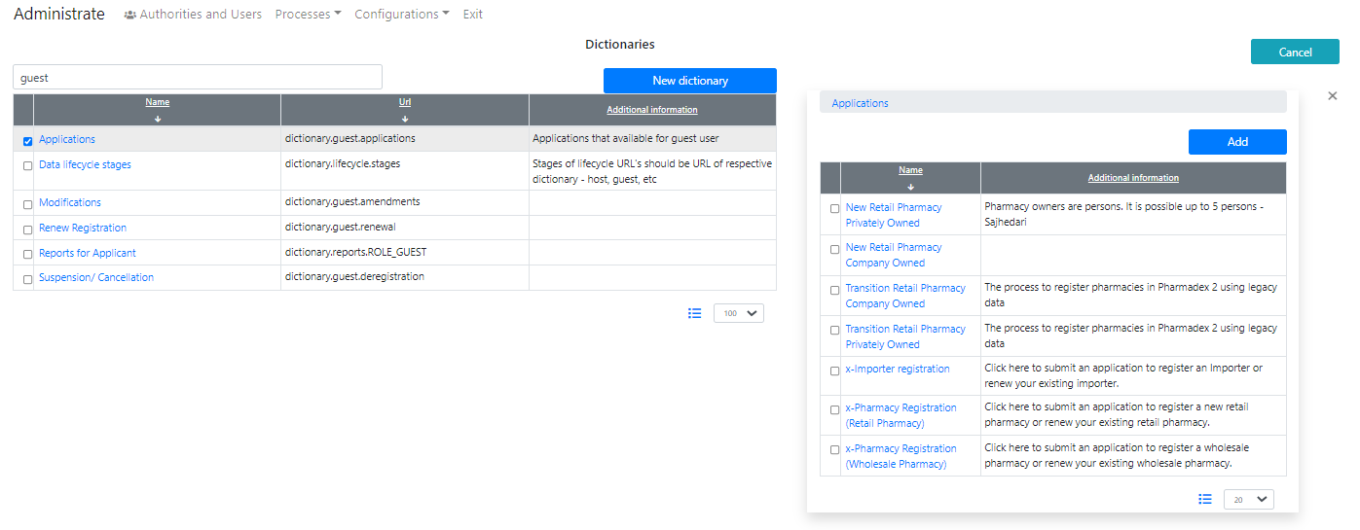

Open each application and determine data URLs:

* retail.site.owned.persons
* retail.site.owned.pvt
* retail.site.owned.pvt.registered
* pharmacy.retail.registered
* importer.site
* pharmacy.site
* ws.site

Using data configuration, determine URLs for owners (URL) and an owner (auxURL) data:

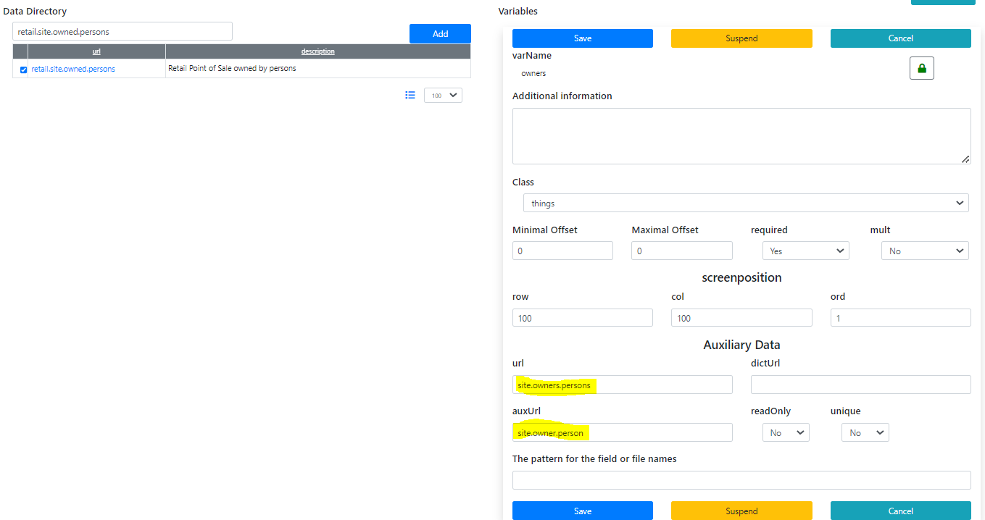

The result is:

* site. owner.person
* importer.site.owners
* pharmacy.owner
* ws.owner

For each data configuration the constrain should be set. For example, for “site.owner.person”:

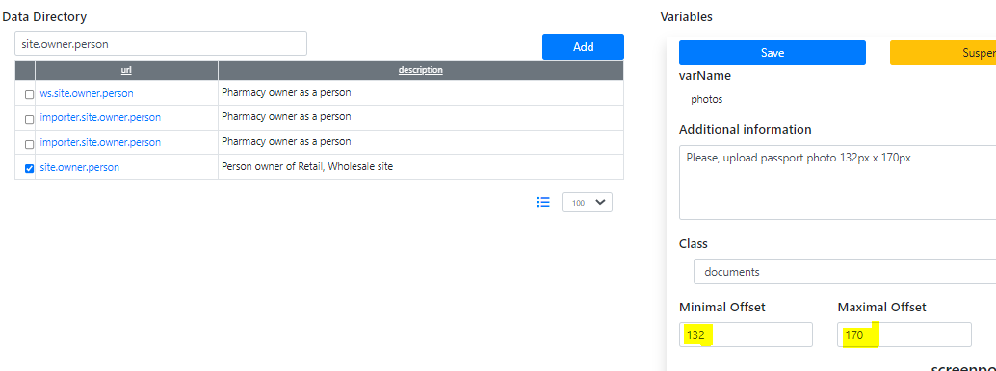

Figure . Picture size constrain configuration