Pharmadex 2. Release Notes 2022-02-22

Contents

Motivation 1

Pre-requisite 2

Demo release particularities 2

Monitoring functionality (#1149, #1333) 2

Unified monitoring tables 2

Supervisor 2

Moderator 2

Other executors 3

Applicant 3

Re-configuration of workflows 3

Workflows 3

Dictionaries 3

Resources 4

# Motivation

* Main – improve monitoring functionality (#1149, #1333)
* Item:
  + re-configuration of a workflow (#1228)
  + fix bugs related to 500 error (#1340)

# Pre-requisite

You must have a Gmail account that has not been registered in the Pharmadex 2 database. You should know the login and password for the supervisor user and have another login and password to log in as a business user, i.e., an applicant.

# Demo release particularities

This release may contain errors, bad user interface behavior, and inconsistencies. Please, report them to [alex.kurasoff@gmail.com](mailto:alex.kurasoff@gmail.com).

* The workflow implementation contains mistakes.
* The configurations described here are only for demonstration purposes.

# Monitoring functionality (#1149, #1333)

The main issues were:

* Unclear data in tables (row and column sets)
* Unclear requirements to functionality.

The solution is unified data queries internally implemented as MySQL stored procedures. The previous approach – individual database queries. The advantage is the possibility to use it by ETL (extract, transform, load) process of any Data Warehouse.

## Unified monitoring tables

### Supervisor

All unfinished activities that fit the competency of a supervisor. The main task of a supervisor is resolving of executor’s re-assignment and stalled processes. To do this, the supervisor should receive access to all processes and the possibility to find an activity quickly.

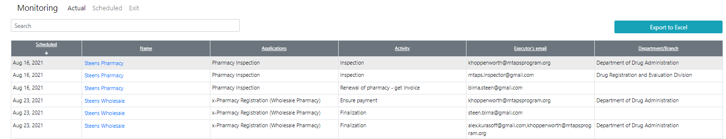

### Moderator

The moderator is the owner of all processes that fit the competency of the moderator. The main task of a moderator is to track that a process is executing properly. Thus, a moderator can see all activities in all processes that are under a moderator competency. The competency of the moderator is workflow. In case, if a moderator is an employee in a territorial office, the additional office restriction will be applied. If the office has no territory restriction, it means all countries.

### Other executors

Typically, other executors like an accountant, reviewers, etc. do not need monitoring functionality. All they need are on the To-Do list. Nevertheless, the monitoring functionality may be added to provide a more convenient look at the data. The executor can access only his/her activities.

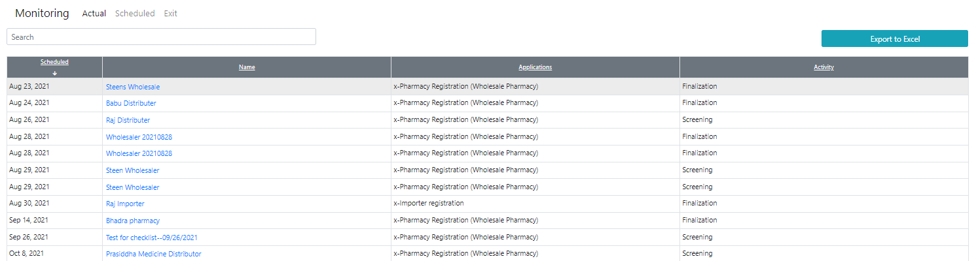

### Applicant

Typically, other executors like an accountant, reviewers, etc. do not need monitoring functionality. All they need are on the To-Do list. Nevertheless, the monitoring functionality may be added to provide a more convenient look at the data. The applicant can access only processes under the application data initiated by the applicant.

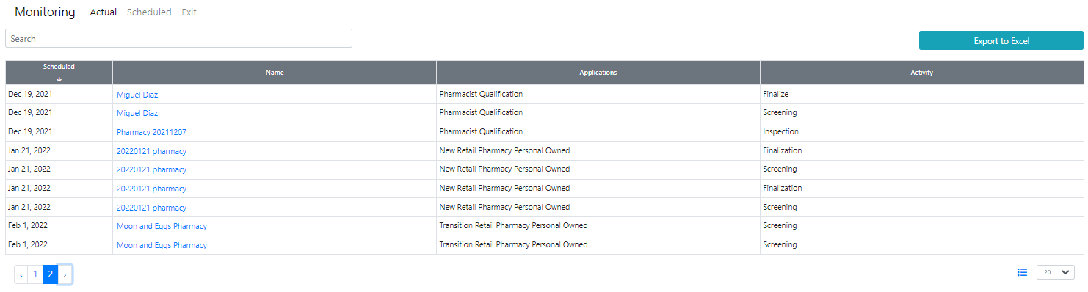

# Re-configuration of workflows

## Workflows

Issue #1228 is about only the re-configuration of workflow using the Administrator feature. I’ve configured all necessary design elements; however, I can’t fill out the real data for them. Below are the URLs of them.

## Dictionaries

|  |  |
| --- | --- |
| URL | Purpose |
| dictionary.employee.agreements | Agreements for Pharmacist to upload |
| dictionary.resources.pharmacy.employee.agreements | Agreements for Pharmacist for download - resource pharmacy.employee.agreements |
| dictionary.cover.letters | Schedule 8 |
| dictionary.application.cover.letter | Schedule 8 for download - resource pharmacy.new.cover |

## Resources

|  |  |
| --- | --- |
| URL | Purpose |
| pharmacy.employee.agreements | Agreements for Pharmacist |
| pharmacy.new.cover | Schedule 8 |

Regarding “PVT Limited Data”, please check it. The QA team will check for bugs and inconsistencies as well.